Date: 24 Feb 2026
PDF Viewer Sample Application
VERSION: 1.0.1

Overview:
The PDF Viewer sample application is for viewing the PDFs within the app, it supports all types of PDF’s like base64, remote and local PDF picking and rendering. This sample has the PDF viewer component, which renders the PDFs with the help of local html files.
Requirements:
- Volt MX Iris

Devices:
- Mobile
- Tablet

Platforms:
- Android
- iOS

Features:
1. This sample app has the PDF viewer component which renders the PDF within the component.
2. It supports all types of rendering like base64, local and remote PDFs.
A. App Functionality:
- When you build and run the app, you will see the form with the PDF rendered from the different sources.

B. Importing the app:
To import the PDF Viewer sample application into your workspace, follow these steps:
- Open Volt MX Iris
- On the main menu select Forge/Browse.
- Search for the PDF Viewer Sample application, and then click Import to Workspace. The app is imported to your workspace. A dialog box appears, confirming that the app has been imported. Click OK.
- Switch to your project containing the PDFViewer sample application. To switch to your project, click File/Open/Reference Architecture/<project name>
C. Building the app:
After performing all the above steps, you can build your app and run it on your device. For more information, you can refer to the Building and Viewing an Application section of the Volt MX User Guide.
You can then run your app to see the PDF Viewer work in real time.

D. Configure the UI and settings of the PDFViewer sample application
The PDFViewer sample application looks like the below attached screenshots.
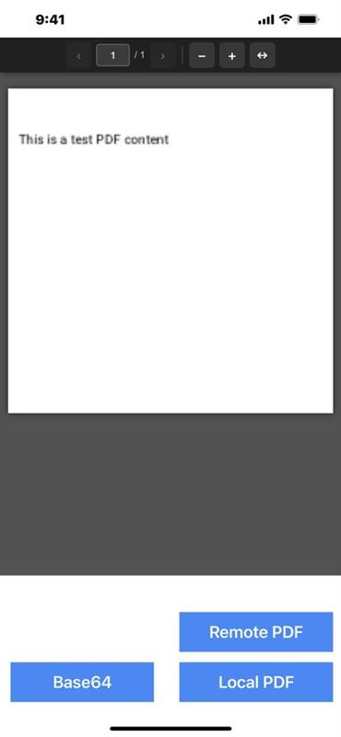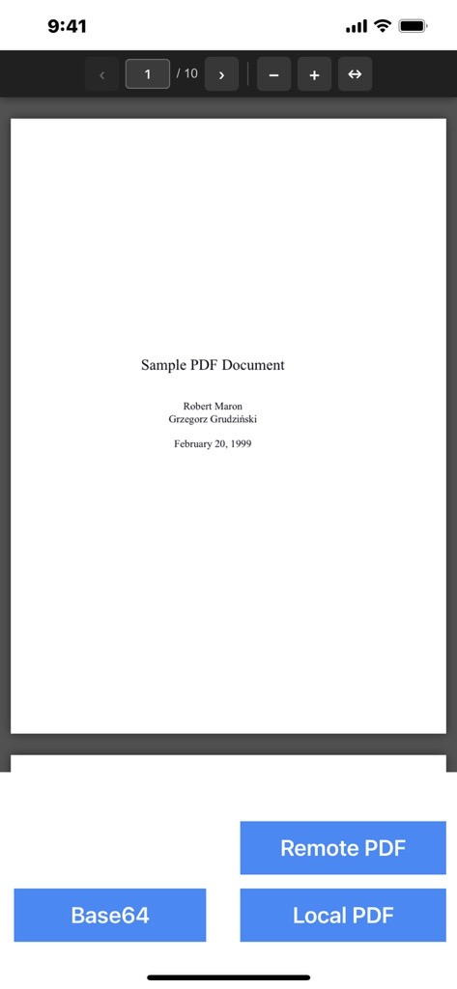

Configuring Settings:
Follow the steps below to import and use PDFViewer component from PDFViewer sample application to your project
- Copy Pdfjs-1 folder from PDFViewer sample app/Modules/Web/Localfiles to the same location of your project.
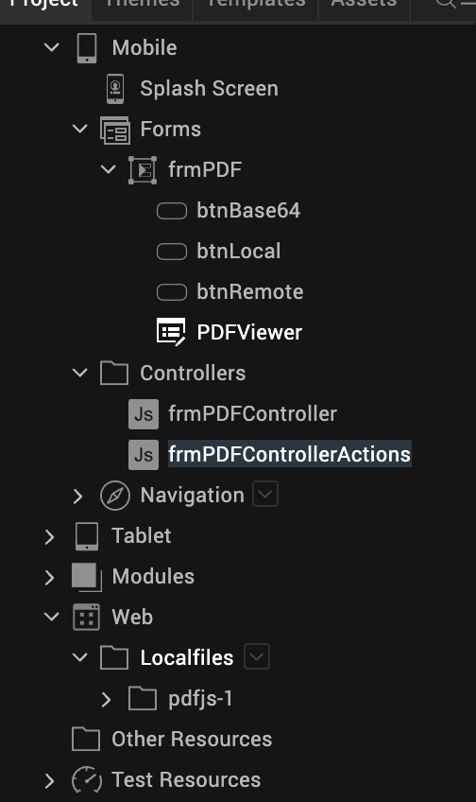

- Export PDFViewer component from this sample at Templates/Components/com.hcl.technohub.PDFViewer/ right click and Export.

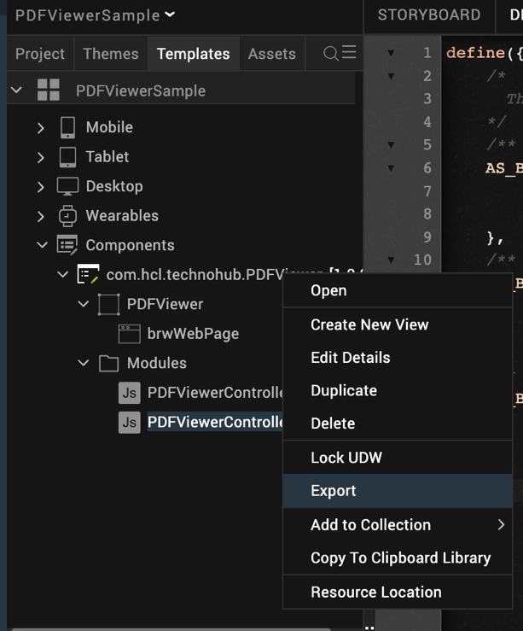

- Import exported component into your project at Iris/Project/Import/Component into the Library/choose the above exported zip file.

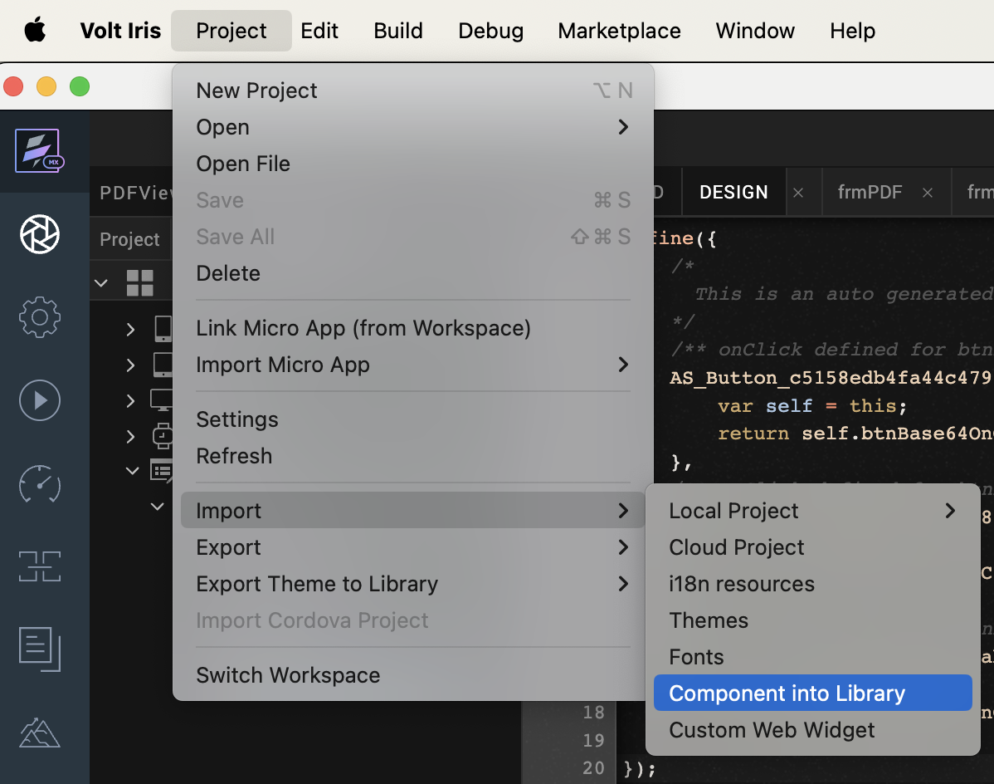

- After importing the Component just ensure Iris/Edit/Manage native Function API(s)Android/PdfNfi and Iris/Edit/Manage Native Function API(s)/iOS/PdfNfi zips are updated into your project. If not, import them manually.

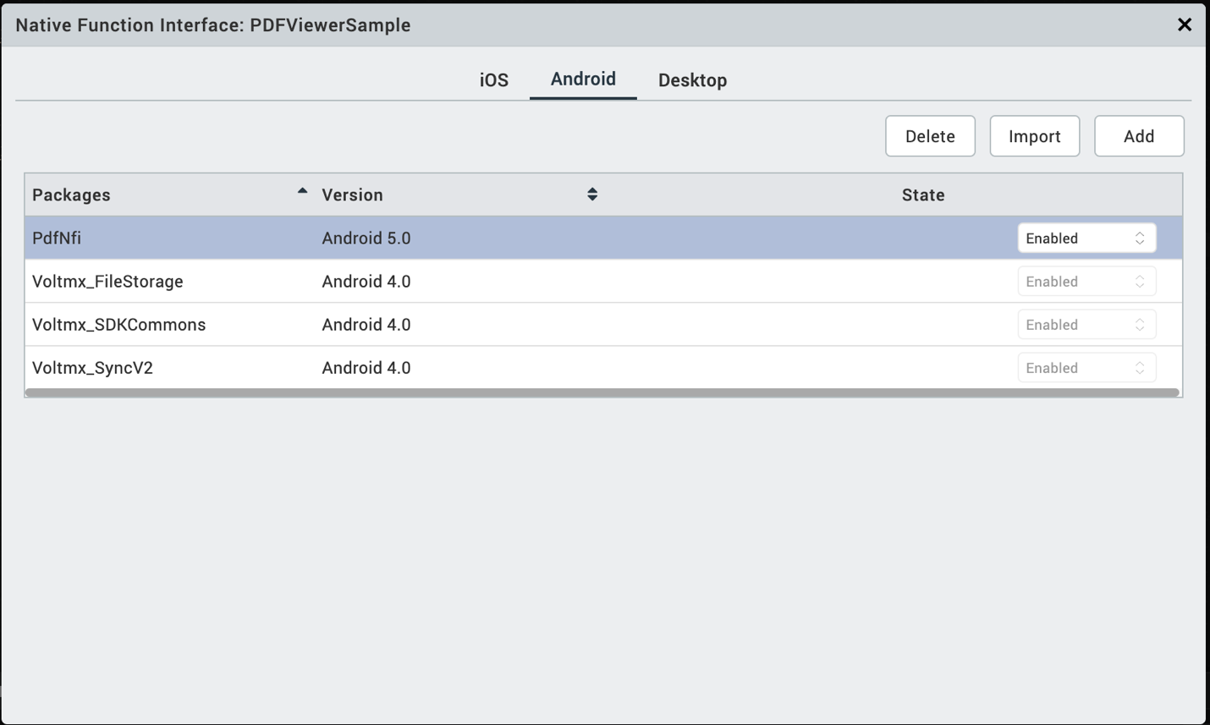

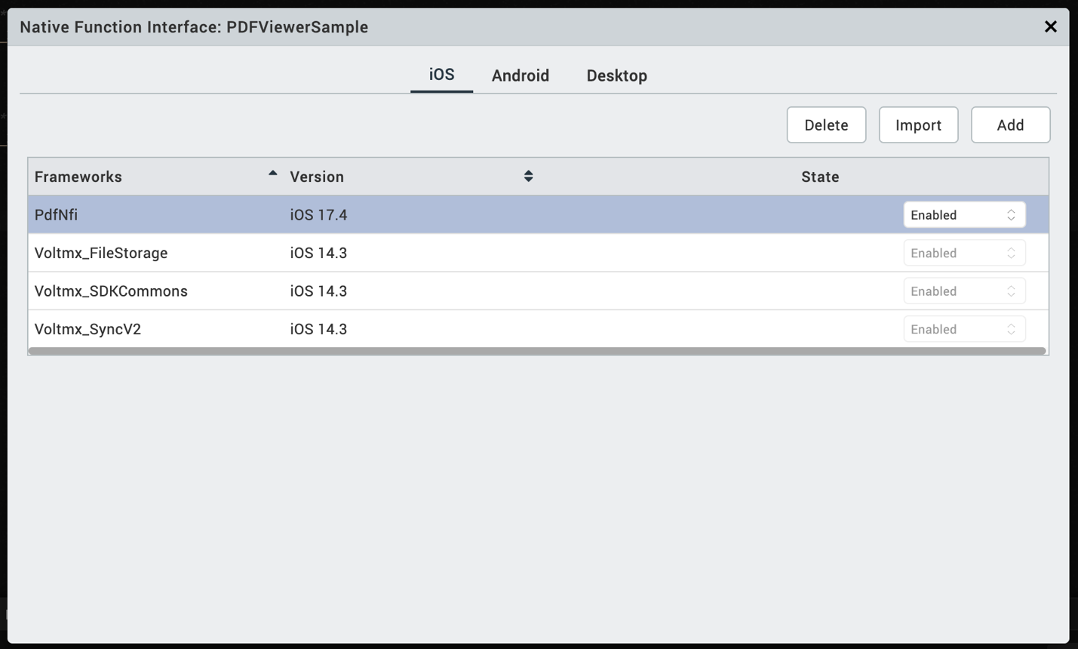

Configuring Native Settings (Android):
To configure the native settings for Android, follow these steps:
- From the left navigation menu, click Project Settings.
- In the Project Settings window, go to Native → Android Mobile/Tablet.
- Add below application tab attributes at Project Settings/Android Mobile/Tablet/Manifest Permissions, Tags and Gradle Build Entries/Tags/Application Tag attributes
android:largeHeap="true"
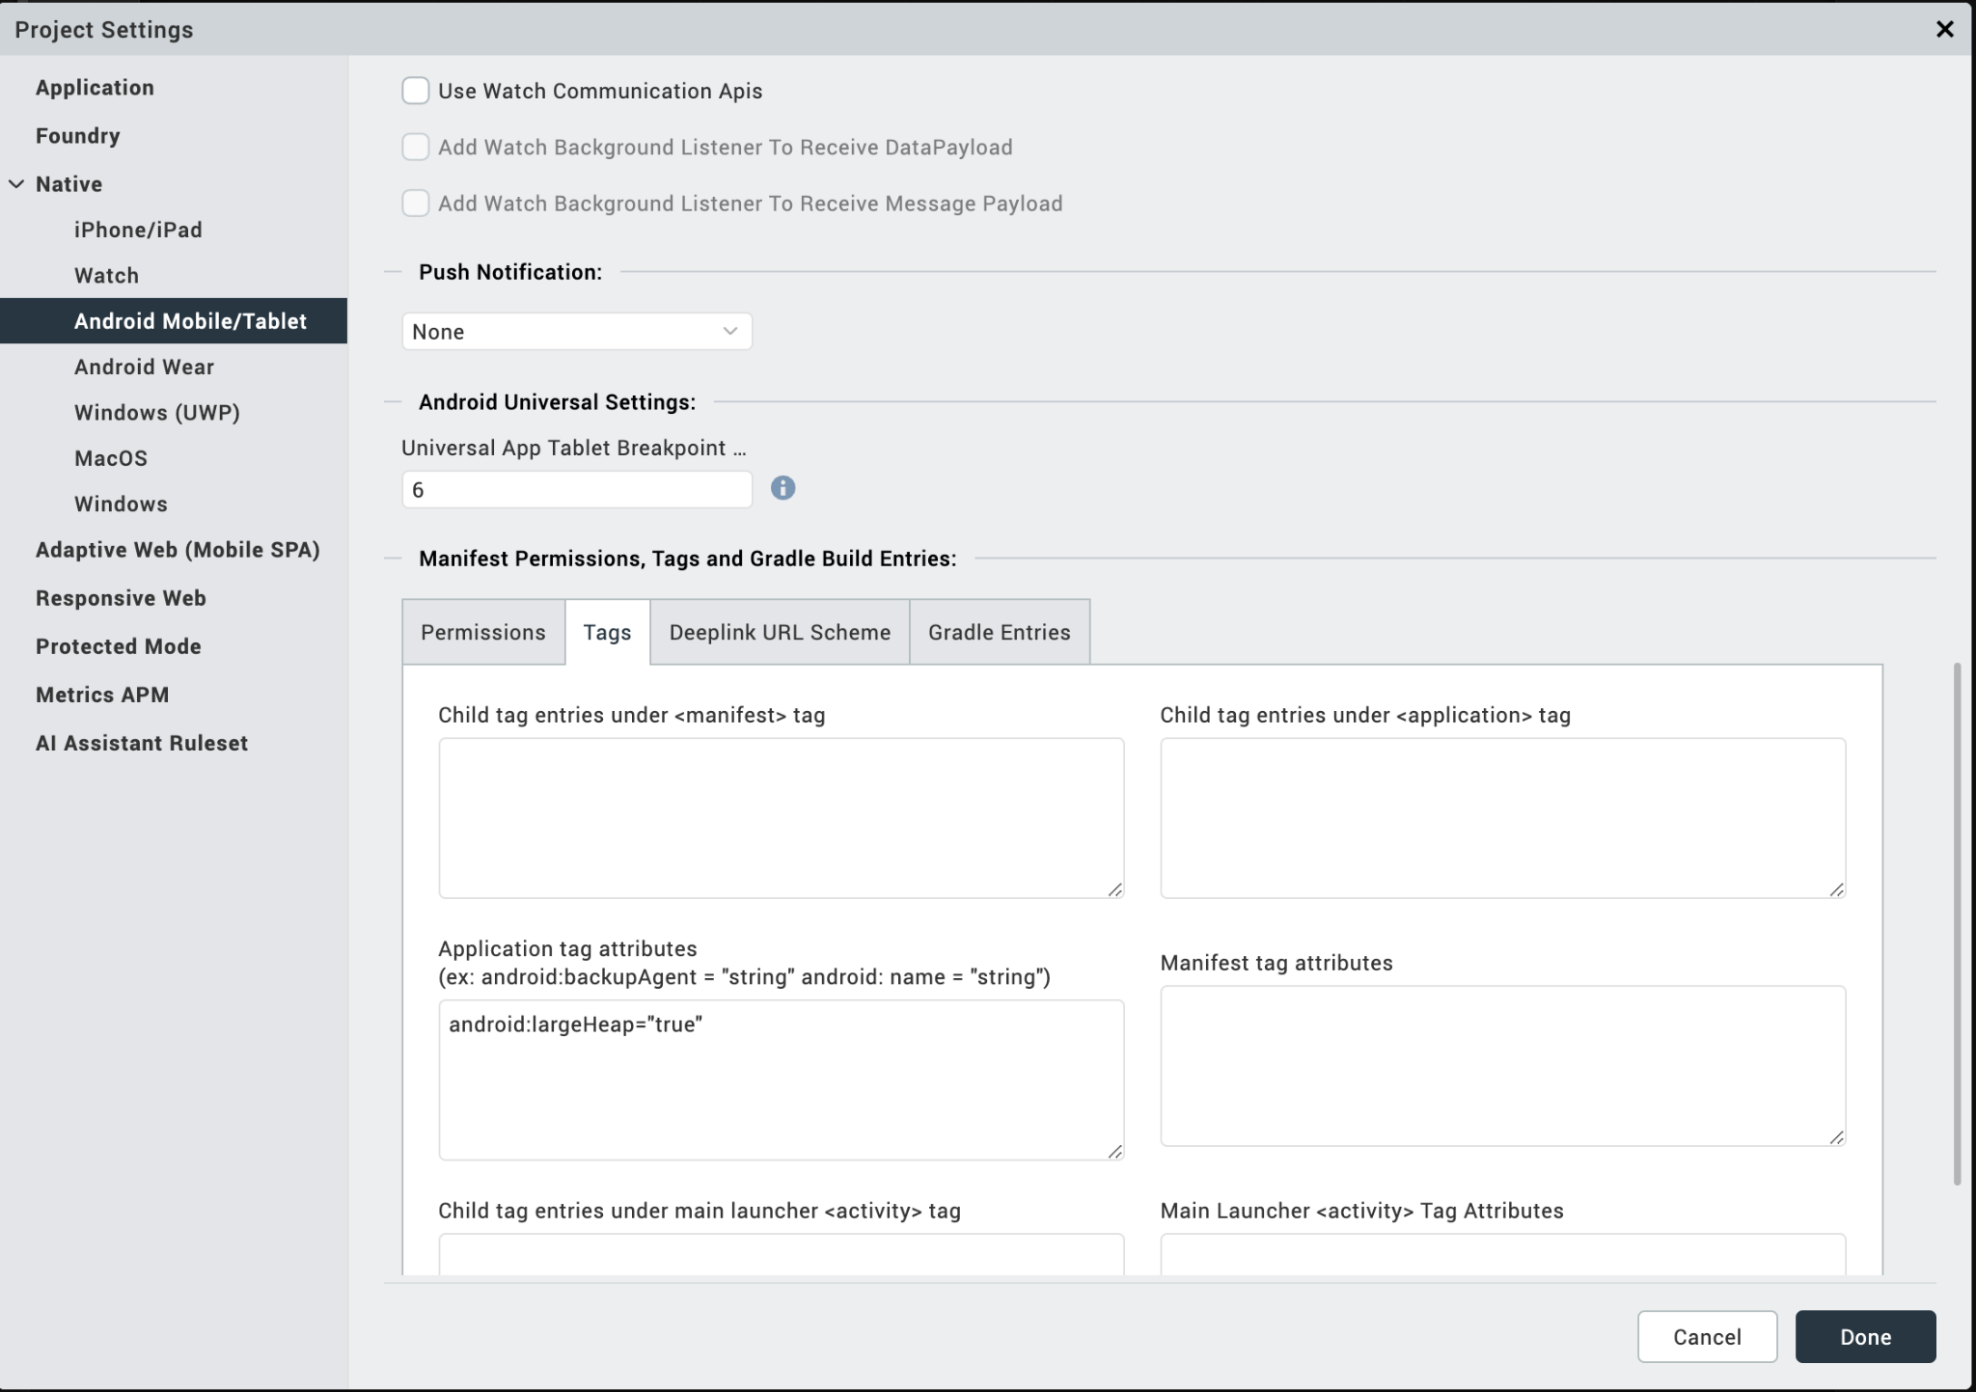

NOTE:
- If you do not add the gradle entries to your project, the app crashes.
After you configure the native settings, you can Build and Run your app to see the component work in real time.

APIs

loadBase64

Description: | Renders the PDF from the base64 string.
Syntax: | loadBase64(<String>)
Parameters: | String, base64 value of the PDF
Return Value: | None
Remarks: | NA
Example: | this.view.PDFViewer.loadBase64(this.base64);

loadUrl

Description: | Renders the PDF from the remote URL.
Syntax: | loadUrl(<String>)
Parameters: | String, remote URL of the PDF
Return Value: | None
Remarks: | NA
Example: | this.view.PDFViewer.loadUrl(this.url);

pickAndLoadLocalPdf

Description: | Picks the device stored PDF and renders the PDF
Syntax: | pickAndLoadLocalPdf ()
Parameters: | NA
Return Value: | None
Remarks: | NA
Example: | this.view.PDFViewer.pickAndLoadLocalPdf();

Limitations:
- This component supports only 64-bit devices.
- Requires internet connection when using CDN-hosted PDF.js; offline usage is not supported.
- Large PDF files (especially documents above ~50 MB) may cause high memory usage, slow rendering, or application crashes
- When using PDF.js version 5.4.149 (ES module build), this component requires iOS 17.5 or later in WKWebView. Earlier iOS may encounter execution failures due to WebKit limitations in ES module and module worker handling.
Known issues:
- CORS Restriction While Loading External PDFs
When loading PDF files using PDF.js from an external URL, the request may fail due to Cross-Origin Resource Sharing (CORS) restrictions imposed by the host server. If the PDF server does not include the required Access-Control-Allow-Origin header in its response, browsers will block the request with a CORS error (e.g., origin 'null' has been blocked).
This is a server-side limitation and not an issue with the PDF.js library itself.

