07 September 2023

Password Protect(1.0.0)

# Overview

Password Protect is a complete application that allows a user to self-register to the application and once registered, it allows the user to securely store their passwords for all of their different systems.

With a single click the passwords are retrieved and unencrypted and placed into the devices clipboard to be used to for logging in.

The app can be run natively on Phone and Tablet and also as a PWA responsive web app, so you can store your passwords once and then retrieve them from any device.

## Use case

### Securely store and retirve your passwords on any device.

## Percentage of re-use:

Approximately 100% reusable.

## Features.

User self-register

Encrypt password to be stored in the backend

Unencrypt password and place into the devices clipboard

Update and delete passwords as required.

# Getting Started

## Prerequisites

Before you start using the Password Protect component, ensure the following:

• [HCL Foundry](https://manage.hclvoltmx.com/)

• Volt MX Iris

## Platforms Supported

### PWA & Responsive Web

### Native

## Importing the app

**To import the Password Protect application, do the following:**

#### Open your app project in Volt MX Iris. Make sure you are logged into your Foundry environment.

#### Click on Project -> Import -> Local Project -> Open as new project -> From an archive

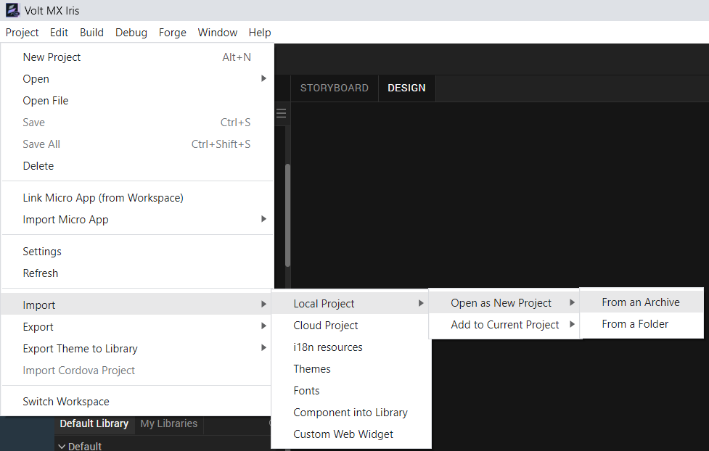

#### Select the application zip file and then agree to import the Foundry application during the import process

## Building and previewing the app

After performing all the above steps, you can build your app and run .For more information, you can refer to the [Building and Viewing an Application](https://opensource.hcltechsw.com/volt-mx-docs/docs/documentation/Iris/iris_user_guide/Content/Cloud_Build_in_VoltMX_Iris.html#cloud) section of the Volt MX User Guide.

You can then run your app to see the Password Protect application work in real time

# Revision History

App version 1.0.0:

## Known Issues

NA

## Limitations

NA