Date : 23-02-2024

OTT Details

verSION:1.0.0

# **Overview**

This Data Adapter will get Streaming details of Movie and TV Shows. It supports 150+Streaming. platforms in US and India such as HBO, YouTube, Netflix, Prime Video, Hot star, Hulu, etc. . (Use the OTT Providers endpoint to get the full list OTT

providers we support). In addition to streaming info, it also provides basic details on any given movie title.

2.**Getting Started**

## Prerequisites

* Volt Foundry

## Importing the adapter

**To import the Data Adapter to Volt Foundry, do the following:**

1. Sign in to the  [HCL Foundry](https://manage.hclvoltmx.com/).
2. From the left navigation menu, select **API Management**.
3. In **API Management**, select **Custom Data Adapters**.  
   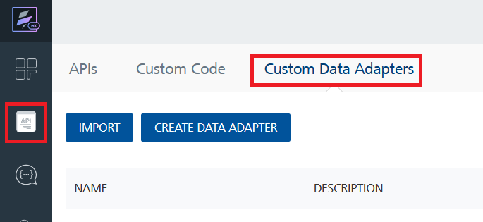
4. Click **IMPORT** to import a custom data adapter.  
   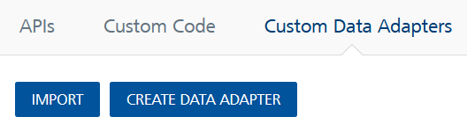
5. On the Import Data Adapter dialog box, click browser to import.  
   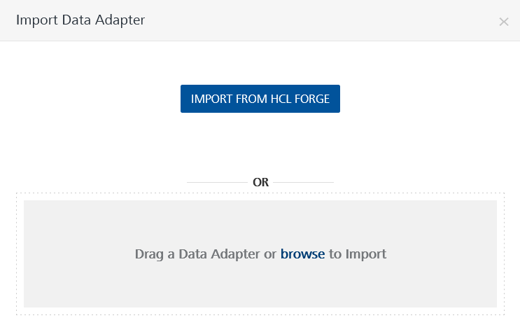
6. Select ottdetails. zip file and click **IMPORT**.

After you import the data adapter, Volt Foundry opens a window that shows the metadata of the data adapter.

After you import the data adapter, you can view it on the Custom Data Adapters page and use it to create services on Volt Foundry.



## [Creating an Integration service](javascript:void(0);)

After you import the data adapter into Volt Foundry, you can use it to create an Integration Service.

Follow the given steps to create an Integration service using the OTTDetails Data Adapter.

1. Sign in to the [HCL Foundry](https://manage.hclvoltmx.com/).
2. From the left navigation menu, select **API Management**.
3. In **API Management**, select **Integration**.  
   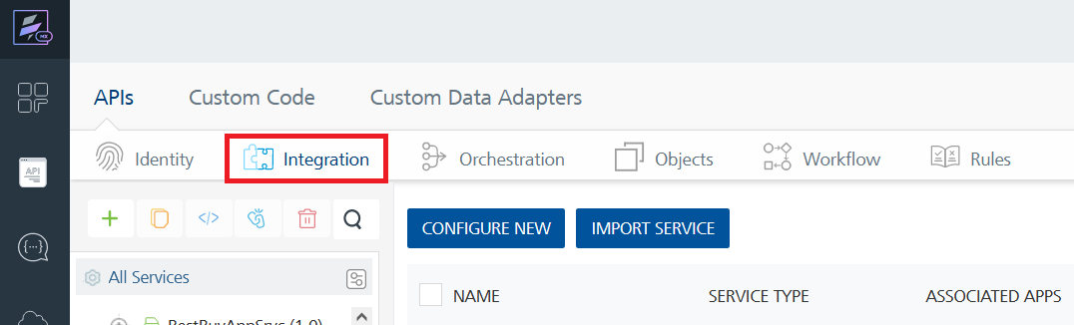
4. To create a new service, click the **+** button or the **CONFIGURE NEW** button.  
   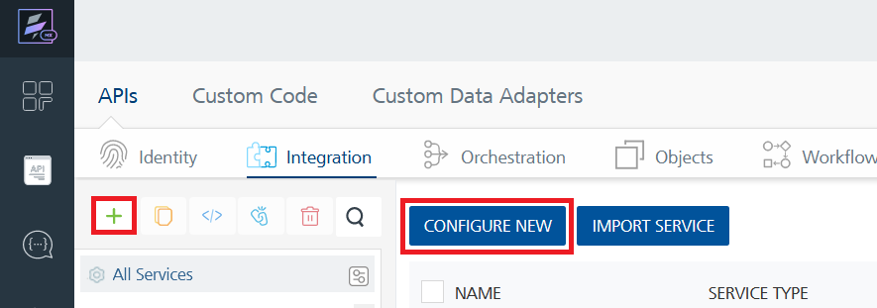
5. On the Service Definition tab, select the service type as OTTDetails, and click **SAVE**.

Alternatively, you can also create a Foundry app and create an Integration service inside it.

E. [Creating and Executing operations](javascript:void(0);)



After you create an integration service, you can create and execute operations using the service.

#### Creating an operation

* In **API Management/Foundry app you created**, in the **Integration** section, select the service that you created.
* After you select the service, navigate to the **Operation List** tab.  
  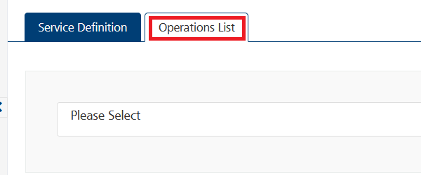
* From the drop-down list, select an operation that you want to execute, and click **ADD OPERATION**.
* Executing an operation

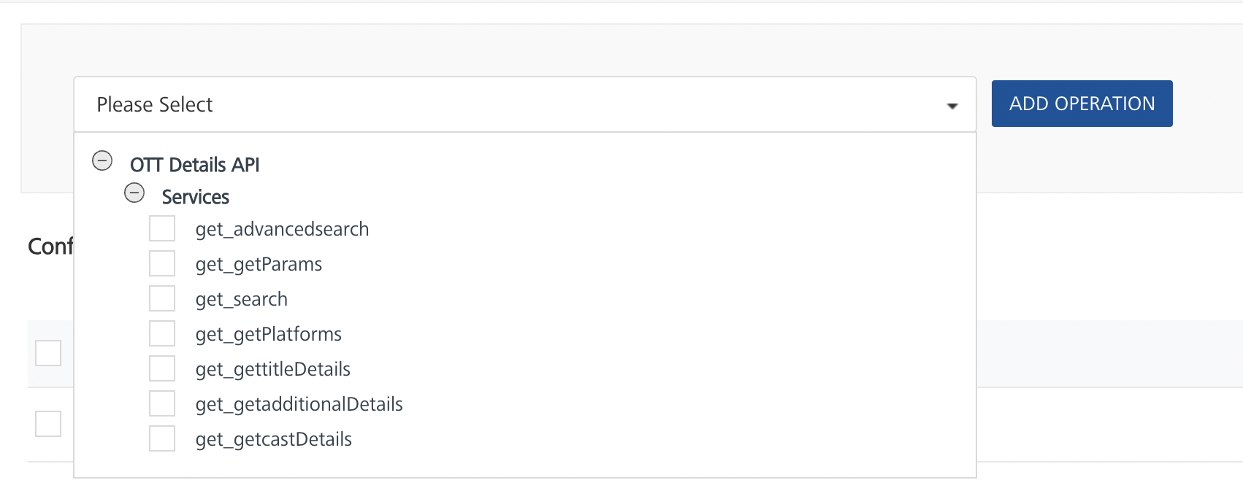

* From the **Operations List** tab, in the **Configured Operations** section, select the operation you want to execute.



* On the Operation Page, in the Request Input tab, enter a TEST VALUE for all the fields.
* Select a run-time environment and click **Save and Fetch Response** to get a response based on your inputs.

## [Publishing your application](javascript:void(0);)

If you want to use the services in client applications, you need to publish an app to a run-time environment. You can create the service (as described above) in an application or import the service into an application and publish the application.

# References

## Endpoint Documentation

**1.** **get Advanced Search**

This endpoint allows you to search for a movie or TV show based on various parameters such as release year , imdb rating , genre , language etc.

GET https://ott-details.p.rapidapi.com/advancedsearch?start_year=1970&end_year=2020&min_imdb=6&max_imdb=7.8&genre=action&language=english&type=movie&sort=latest&page=1" -H "X-RapidAPI-Host: ott-details.p.rapidapi.com" -H "X-RapidAPI-Key: YOUR_RAPIDAPI_KEY

|  |  |  |
| --- | --- | --- |
| s.no | Parameter | Description |
| 1 | start_year | Start year of the movie |
| 2 | end_year | End year of the movie |
| 3 | max_imdb | Minimum rating |
| 4 | min_imdb | Maximum rating |
| 5 | genre | Type of movie |
| 6 | language | language |

**2. get Params**

Get array of values that can be used as params in Advanced Search .

curl -X GET "https://ott-details.p.rapidapi.com/getParams?param=genre" -H "X-RapidAPI-Host: ott-details.p.rapidapi.com" -H "X-RapidAPI-Key: YOUR_RAPIDAPI_KEY"

|  |  |
| --- | --- |
| parameter | Description |
| Param | input 'genre' or 'language' to get array of genre or languages that can be used as filter in advanced search . |

**3.get search**

This endpoint allows you to search for a movie or tvshow based on the given 'title '.

GET "https://ott-details.p.rapidapi.com/search?title=Endgame&page=1" -H "X-RapidAPI-Key: 68cb1822dfmsh0dbd01affde55f9p19f00djsnc1e077567345" -H "X-RapidAPI-Host: ott-details.p.rapidapi.com"

|  |  |
| --- | --- |
| parameter | Description |
| title | allows you to search for a movie or tvshow based on the given 'title |

## **4.get OTT Providers**

## Get information on OTT platforms we suuport.

## GET "https://ott-details.p.rapidapi.com/getPlatforms?region=IN" -H "X-RapidAPI-Key: 68cb1822dfmsh0dbd01affde55f9p19f00djsnc1e077567345" -H "X-RapidAPI-Host: ott-details.p.rapidapi.com"

|  |  |
| --- | --- |
| parameters | Description |
| Region | currently only USA and India region is supported enter param 'US' for USA and 'IN' for India. |

## **5.get Title Details**

## Get basic information on a movie or tv show such as imdbid , title , genre , runtime , imdbrating , language , synopsis , type , imageurl , Streaming platforms info etc.

## GET "https://ott-details.p.rapidapi.com/gettitleDetails?imdbid=tt9904802" -H "X-RapidAPI-Key: 68cb1822dfmsh0dbd01affde55f9p19f00djsnc1e077567345" -H "X-RapidAPI-Host: ott-details.p.rapidapi.com"

|  |  |
| --- | --- |
| Parameter | Description |
| imdbid | Required imdbid |

## **6.get Additional Title Details**

## Get additional details for a movie or tv show like reviews , quotes , plotsummary , number of votes , trailer url , cast details etc.

## GET "https://ott-details.p.rapidapi.com/gettitleDetails?imdbid=tt7286456" -H "X-RapidAPI-Key: 68cb1822dfmsh0dbd01affde55f9p19f00djsnc1e077567345" -H "X-RapidAPI-Host: ott-details.p.rapidapi.com"

|  |  |
| --- | --- |
| Parameter | Description |
| imdbid | Required imdbid |

## **7.get Basic Info**

## Get additional details for a movie or tv show like reviews , quotes , plot summary , number of votes , trailer url , cast details etc.

## GET "https://ott-details.p.rapidapi.com/getadditionalDetails?imdbid=tt7286456" -H "X-RapidAPI-Key: 68cb1822dfmsh0dbd01affde55f9p19f00djsnc1e077567345" -H "X-RapidAPI-Host: ott-details.p.rapidapi.com

|  |  |
| --- | --- |
| Parameter | Description |
| imdbid | Required imdbid |

## For more information regarding API endpoint please check out the [OTTDetails](https://rapidapi.com/gox-ai-gox-ai-default/api/ott-details)

# Revision History

Adapter version 1.0.0:

## Limitations

No Limitations