Date :  13-10-2023

Open Weather Map adapter (1.0.0)

# Overview

This is a simple weather adapter.

It receives data from Open Weather Map API, which then can be displayed or processed into weather information forecast. Currently it can display weather forecast for current day. Note that you can only search for weather forecast for cities with this adapter.

It makes it easy for you to call Open Weather API.

It helps you develop use cases related to displaying current weather in a city within your apps.

# Getting Started

## Prerequisites

* Volt Foundry
* Register yourself at Open Weather Map (https://home.openweathermap.org/users/sign_up) and generate an API key.
* Click on “Create an Account”.

* Input your details and click on “Create Account” option.

* You will receive an email from Open Weather to verify your email.

* Click on “Verify your email”, to verify your email address.
* Once your email is verified you will receive another email with your API key. Please note the API key is masked in below screen shot.

* You can now login into Open Weather MAP using (https://home.openweathermap.org/users/sign_in)

* Once you login, you can find your API key at “Your profile 🡪 My API keys” menu option as shown in the below screen shot. Please note that the API key is masked in the below screen shot.

## Importing the adapter

**To import the Data Adapter to Volt Foundry, do the following:**

1. Sign in to the  [HCL Foundry](https://manage.hclvoltmx.com/).
2. From the left navigation menu, select **API Management**.
3. In **API Management**, select **Custom Data Adapters**.  
   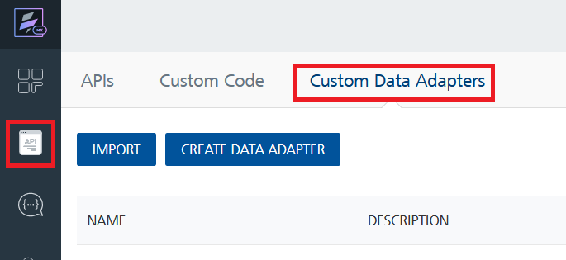
4. Click **IMPORT** to import a custom data adapter.  
   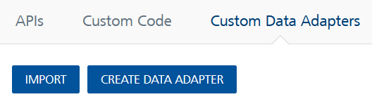
5. On the Import Data Adapter dialog box, click browser to import.  
   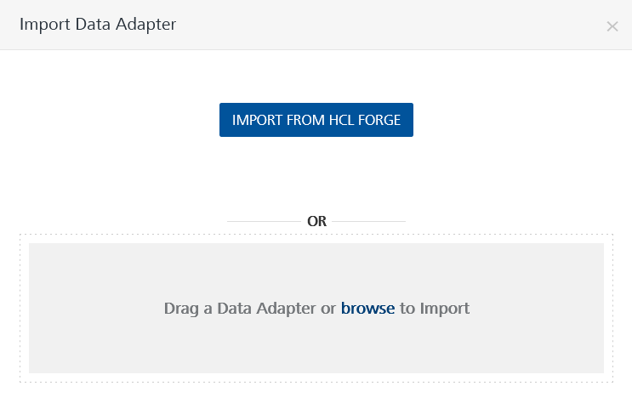
6. Select Open Weather Map Adapter zip file and click **IMPORT**.

After you import the data adapter, Volt Foundry opens a window that shows the metadata of the data adapter.

After you import the data adapter, you can view it on the Custom Data Adapters page and use it to create services on Volt Foundry.

## [Creating an Integration service](javascript:void(0);)

After you import the data adapter into Volt Foundry, you can use it to create an Integration Service.

Follow the given steps to create an Integration service using the Open Weather Map Adapter.

1. Sign in to the [HCL Foundry](https://manage.hclvoltmx.com/).
2. From the left navigation menu, select **API Management**.
3. In **API Management**, select **Integration**.  
   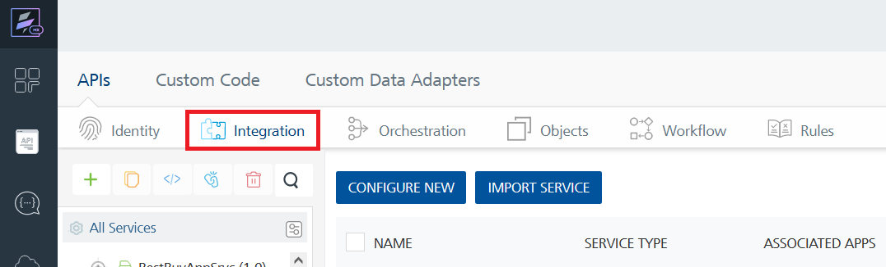
4. To create a new service, click the **+** button or the **CONFIGURE NEW** button.  
   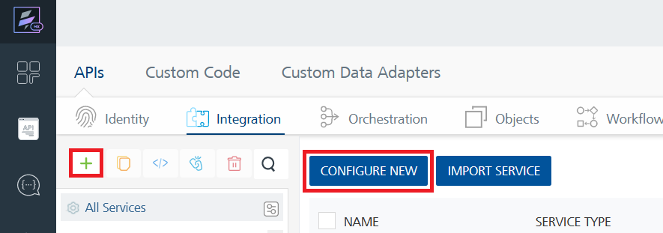
5. On the Service Definition tab, select the service type as Open Weather Map Adapter, and click **SAVE**. A screenshot of a computer

   Description automatically generatedA screenshot of a computer

   Description automatically generated

Alternatively, you can also create a Foundry app and create an Integration service inside it.

E. [Creating and Executing operations](javascript:void(0);)



After you create an integration service, you can create and execute operations using the service.

#### Creating an Operation

* In **API Management/Foundry app you created**, in the **Integration** section, select the service that you created.
* After you select the service, navigate to the **Operation List** tab.  
  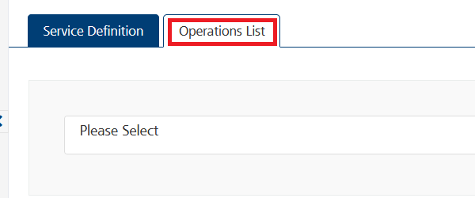
* From the drop down list, select an operation that you want to execute, and click **ADD OPERATION**.  
  A screenshot of a computer

  Description automatically generatedA screenshot of a computer

  Description automatically generated

#### Executing an Operation

* From the **Operations List** tab, in the **Configured Operations** section, select the operation you want to execute.  
  A screenshot of a computer

  Description automatically generated
* On the Operation Page, in the Request Input tab, enter a TEST VALUE for all the fields.  
  A screenshot of a computer

  Description automatically generated
* Select a run-time environment and click **Save and Fetch Response** to get a response based on your inputs.  
  A screenshot of a computer

  Description automatically generatedA screenshot of a computer

  Description automatically generated

## [Publishing your application](javascript:void(0);)

If you want to use the services in client applications, you need to publish an app to a run-time environment. You can create the service (as described above) in an application or import the service into an application and publish the application.

# References

## Endpoint Documentation

|  |  |  |  |
| --- | --- | --- | --- |
| **API** | https://api.openweathermap.org/data/2.5/weather?q={city name}&appid={API key} | | |
| **Example** | https://api.openweathermap.org/data/2.5/weather?q=London&appid={API key} | | |
| **Input Parameters** | | | |
| q | | Required | City name, state code and country code divided by comma, please refer to ISO 3166 for the state codes or country codes.You can specify the parameter not only in English. In this case, the API response should be returned in the same language as the language of requested location name if the location is in our predefined list of more than 200,000 locations. |
| appid | | Required | Your unique API key (you can always find it on your Open Weather Map account page under the "API key" tab) |

# Revision History

Adapter version 1.0.0:

## Known Issues

NA

## Limitations

* + Currently this adapter can display weather forecast for current day.
  + You can only search for weather forecast for cities with this adapter.