NOTE: Sections marked in red will need to be updated with asset specific details. Optional section(s) can be removed if not applicable. Delete this note prior to upload.

Date : 19-10-2023

Open Graph (1.0.0)

Overview

Welcome to the API documentation for Opengraph.io! With our API, you can easily parse HTML from URLs provided for Open Graph tags.

Getting Started

Prerequisites

Volt Foundry
- Account and api key from open graph.
- Sign up in https://www.opengraph.io/and login into the account and get the api key.

Importing the adapter
To import the Data Adapter to Volt Foundry, do the following:
- Sign in to the HCL Foundry.
- From the left navigation menu, select API Management.
- In API Management, select Custom Data Adapters.
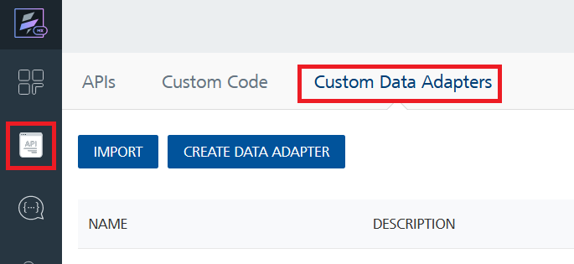
- Click IMPORT to import a custom data adapter.
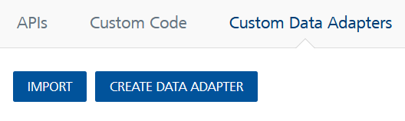
- On the Import Data Adapter dialog box, click browser to import.
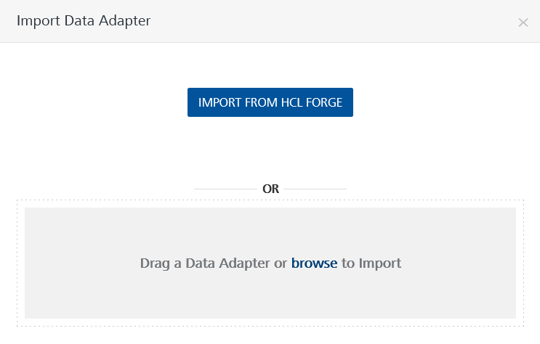
- Select OpenGraph zip file and click IMPORT.
After you import the data adapter, Volt Foundry opens a window that shows the metadata of the data adapter.
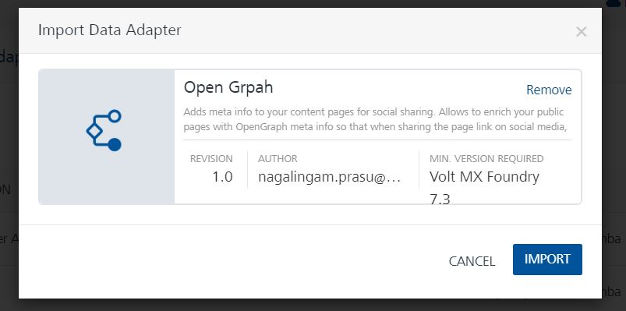
After you import the data adapter, you can view it on the Custom Data Adapters page and use it to create services on Volt Foundry.
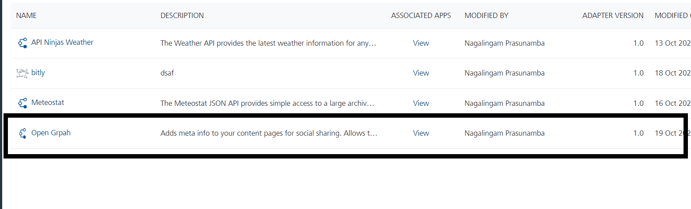

Creating an Integration service
After you import the data adapter into Volt Foundry, you can use it to create an Integration Service.
Follow the given steps to create an Integration service using the OpenGraph Adapter.
- Sign in to the HCL Foundry.
- From the left navigation menu, select API Management.
- In API Management, select Integration.
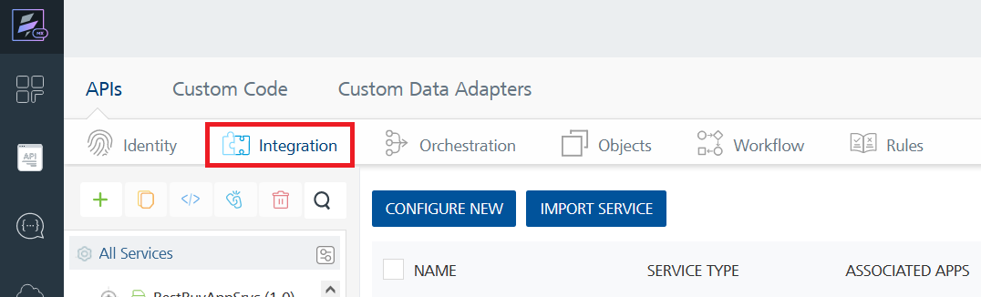
- To create a new service, click the + button or the CONFIGURE NEW button.
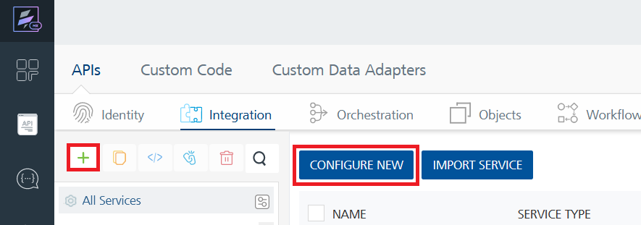
- On the Service Definition tab, select the service type as OpenGraph, and click SAVE.
- 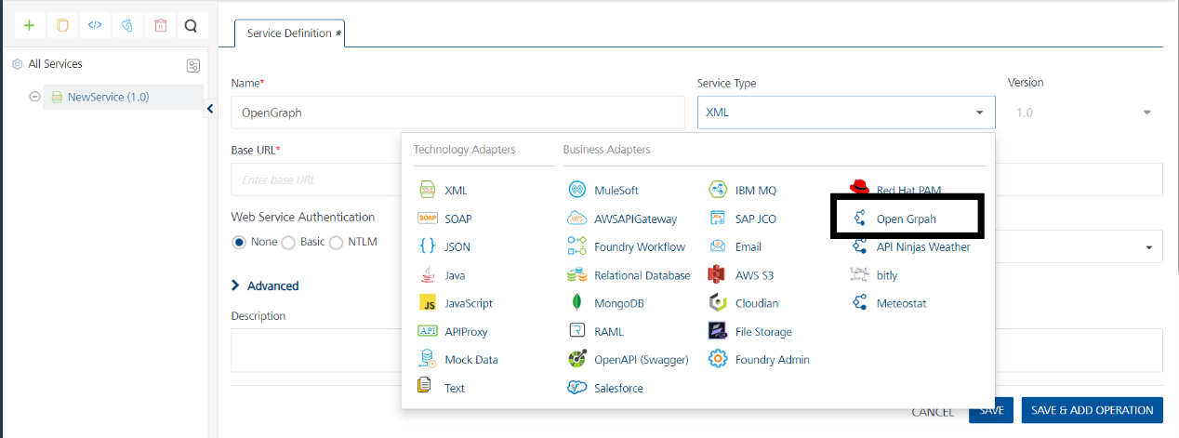
Alternatively, you can also create a Foundry app and create an Integration service inside it.
E. Creating and Executing operations
After you create an integration service, you can create and execute operations using the service.

Creating an Operation
- In API Management/Foundry app you created, in the Integration section, select the service that you created.
- After you select the service, navigate to the Operation List tab.
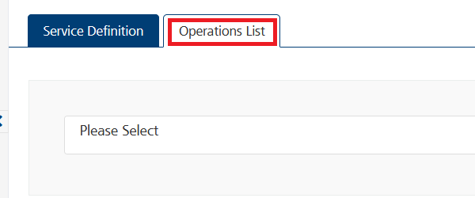
- From the drop down list, select an operation that you want to execute, and click ADD OPERATION.
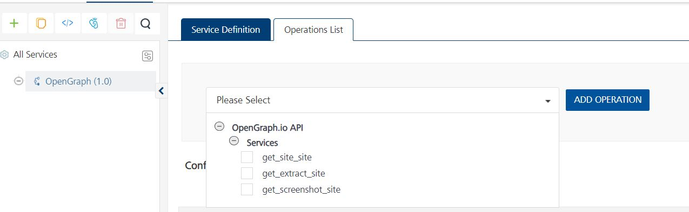

Executing an Operation
- From the Operations List tab, in the Configured Operations section, select the operation you want to execute.
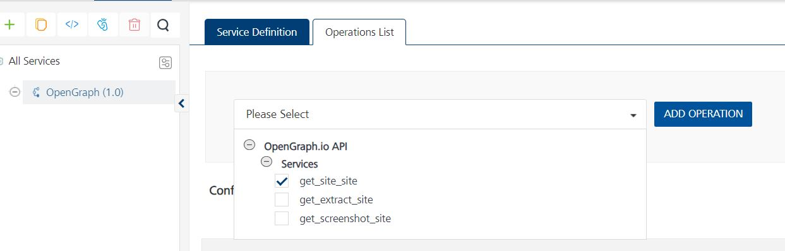
- On the Operation Page, in the Request Input tab, enter a TEST VALUE for all the fields.
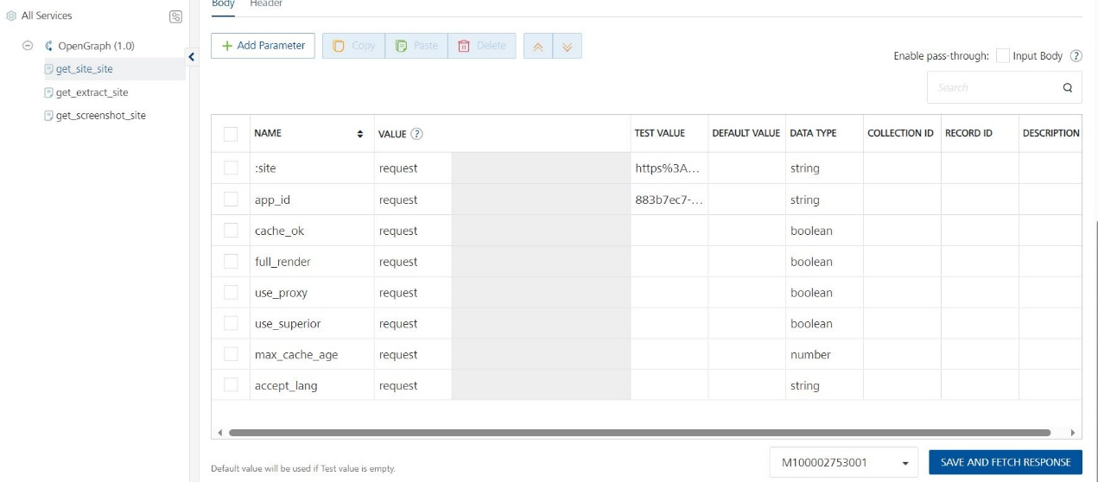
- Select a run-time environment and click Save and Fetch Response to get a response based on your inputs.
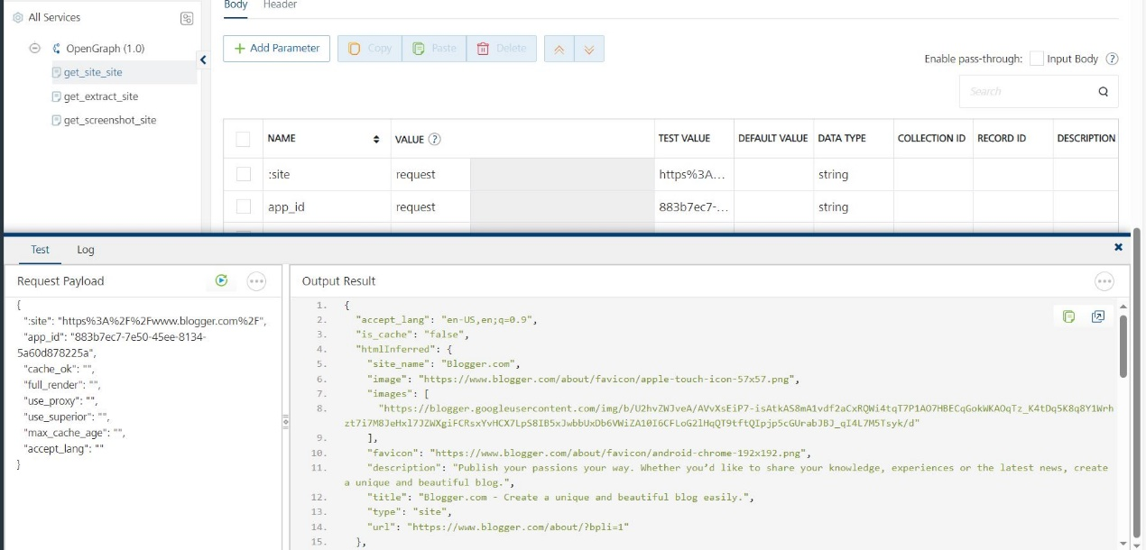

Publishing your application
If you want to use the services in client applications, you need to publish an app to a run-time environment. You can create the service (as described above) in an application or import the service into an application and publish the application.

References

Endpoint Documentation

Get Open Graph

GET https://opengraph.io/api/1.1/site/<URL encoded site URL>?app_id=xxxxxx

Parameter | Required | Type | Default | Description
site | TRUE | Path | N/A | An encoded URL of the website from which you want open graph information.
app_id | yes | Query | - | The API key for registered users. Create an account to receive your app_id.
cache_ok | no | Query | false | This will force the servers to pull a fresh version of the site being requested (default is true).
full_render | no | Query | false | Fully render the site using a Chrome browser before parsing its contents (helpful for single page applications and JS redirects). This may slow down the response time by around 1.5 seconds.
use_proxy | no | Query | false | Route your request through residential and mobile proxies to avoid bot detection. This may slow down requests by 3-10 seconds and can cause requests to time out. Proxies are a limited resource and expensive for the team to maintain. Free accounts share a small pool of proxies. If you plan on using proxies often, paid accounts provide dedicated concurrent proxies for your account.
use_superior | no | Query | false | The superior proxy feature is designed to tackle the most demanding scraping scenarios, allowing you to overcome the challenges posed by highly restrictive websites. By leveraging the superior proxy option, you can bypass bot detection mechanisms and access data from even the toughest sources.
max_cache_age | no | Query | 432000000 | This specifies the maximum age in milliseconds that a cached response should be. If not specified, the value is set to 5 days (5 days * 24 hours * 60 minutes * 60 seconds * 1000 ms = 432,000,000 ms).
accept_lang | no | Query | en-US,en;q=0.9 auto | This specifies the request language when requesting the URL. Useful if you want to get the site in languages other than English. The default setting will return an English version of a page if it exists. If you specify the value "auto," the API will use the same language settings as your current request.

Extract site

GET https://opengraph.io/api/1.1/extract/:site?app_id=xxxxxx
URL Parameters
Parameter | Required | Description
:site | true | An encoded URL of the website for open graph information.
Query Parameters
Parameter | Required | Example | Description
app_id | yes | - | The API key for registered users. Create an account (no credit card required) to receive your app_id.
html_elements | no | h1,h2,h3,p,span | An optional parameter specifying the HTML elements to extract from the website. Default elements include h1, h2, h3, h4, h5, p, and title.
cache_ok | no | false | Forcing servers to pull a fresh version of the site being requested. By default, this value is set to true.
full_render | no | false | Fully rendering the site using a Chrome browser before parsing its contents. Useful for single-page applications and JS redirects but slows down the response by approximately 1.5 seconds.
use_proxy | no | false | Routing requests through residential and mobile proxies to avoid bot detection. May slow down requests by 3-10 seconds and can cause timeouts. Note that proxies are a limited resource and expensive to maintain. Free accounts share a small pool of proxies. For more dedicated and concurrent proxies, consider paid accounts.
use_superior | no | false | The superior proxy feature is designed to tackle the most demanding scraping scenarios, allowing you to overcome the challenges posed by highly restrictive websites. By leveraging the superior proxy option, you can bypass bot detection mechanisms and access data from even the toughest sources.
max_cache_age | no | 432000000 | Specifies the maximum age in milliseconds for a cached response. If not specified, the default value is set to 5 days (432,000,000 milliseconds).
accept_lang | no | en-US,en;q=0.9 auto | Specifies the requested language when accessing the URL. Useful for obtaining sites in languages other than English. The default setting will return an English version of a page if it exists. If you specify the value "auto," the API will use the same language settings as your current request. For more information on what to supply for this field, please see: Mozilla Developer Network - Accept-Language.

Screenshot Site

GET https://opengraph.io/api/1.1/screenshot/:site?app_id=xxxxxx
URL Parameters
Parameter | Required | Description
:site | true | An encoded URL of the website for open graph information.
Query Parameters
Parameter | Required | Default Value | Description
app_id | yes | - | The API key for registered users. Create an account (no credit card required) to receive your app_id.
full_page | no | false | Determines whether the screenshot should capture the visible viewport or the entire content of the page.
dimensions | no | md | Sets the viewport dimensions of the screen.
quality | no | 80 | Specifies the quality of the screenshot.

Revision History
Adapter version 1.0.0:

Known Issues
-

Limitations
-

