Date : 12-Mar-26

OLLAMA

VERSION: 1.0.0

OVERVIEW
The Ollama API is a local, open-source REST service that provides a unified interface to run Large Language Models (LLMs) directly on your own hardware. It supports popular open-source models such as Llama 3, Mistral, Gemma, Phi, Qwen, and CodeLlama, allowing developers to run AI models locally without sending data to external cloud providers.
The service offers OpenAI-compatible endpoints, making it easy to integrate with existing applications. It supports a wide range of capabilities including text generation, chat completions, streaming responses, embeddings, vision (multi-modal) processing, and model management. This enables developers to build powerful AI applications with complete data privacy, zero cloud costs (for local usage), and full control over model deployment.
Ollama also supports cloud-based features via ollama.com, where authentication is required. It provides two authentication methods:
- Signing in: By signing in through the local Ollama installation, authentication is handled automatically when interacting with ollama.com services.
- API Keys: Developers can use API keys for programmatic access to Ollama’s cloud APIs, enabling secure integration with external applications.
.
- Use case:

- Local AI Development & Testing
Build and test AI applications locally without cloud dependencies or API costs, with full control over data privacy.
- Offline AI Applications
Create applications that work completely offline, ideal for environments with limited internet connectivity or strict data residency requirements.
- Private Document Processing
Process sensitive documents locally using vision, summarization, and analysis models without sending data to external services.
- Internal Knowledge Base & Search
Build internal search and Q&A systems using locally-hosted embeddings and LLMs for complete data privacy and control.
- Code Generation & Development Tools
Integrate code completion, documentation generation, and development assistance using locally-run code models like CodeLlama.
- Cost-Effective AI at Scale
Run AI workloads at scale without per-token cloud costs, ideal for high-volume applications and prototyping.
.

- Features:
- Local LLM Hosting
Run 50+ open-source models (such as Llama 2, TinyLlama, Gemma, Moondream, etc.) directly on your hardware.
- OpenAI-Compatible API
Provides a drop-in replacement for OpenAI APIs, including endpoints like /v1/chat/completions, enabling easy migration of existing applications.
- Zero Cloud Costs
Eliminates API usage fees by running everything locally, allowing unlimited requests on your own infrastructure.
- Complete Data Privacy
All processing happens on your machine—no external API calls, ensuring maximum data security.
- Multi-Modal Support
Supports a wide range of capabilities including text generation, chat, streaming responses, embeddings, and vision models like LLaVA and BakLLaVA.
- Easy Model Management
Offers simple commands to pull, list, delete, and switch between models, making model handling seamless.
- Flexible Authentication (for Cloud Integration)
When using ollama.com services, Ollama supports:
Signing in: Automatically handles authentication via local login
API Keys: Enables secure programmatic access to cloud APIs
- Percentage of Reuse:
- Approximately 80–90% reuse.

GETTING STARTED

I . Local Ollama Data Adapter setup :

Prerequisites
Before using the Ollama Data Adapter, ensure you have the following:
- HCL Foundry
- Volt MX Iris
- Ollama Installed:Ollama server running on local machine or accessible server
- Downloaded Models - At least one LLM model pulled from Ollama (e.g., `llama3`, `mistral`, `gemma`) on local machine or accessible server
- Network Access – Network connectivity to the local Ollama server (default: `http://localhost:11434`)
- Cloud Ollama : To sign in to ollama.com from your local installation of Ollama, run : ollama signin

Importing the Dataadapter
You can import Ollama Data Adapter into HCL Foundry directly from the Volt MX Forge website or by importing the data adapter zip file.
To import Data Adapter to Volt Foundry, do the following:
1.Sign in to the HCL Foundry.
2.From the left navigation menu, select API Management.
3. In API Management, select Custom Data Adapters.

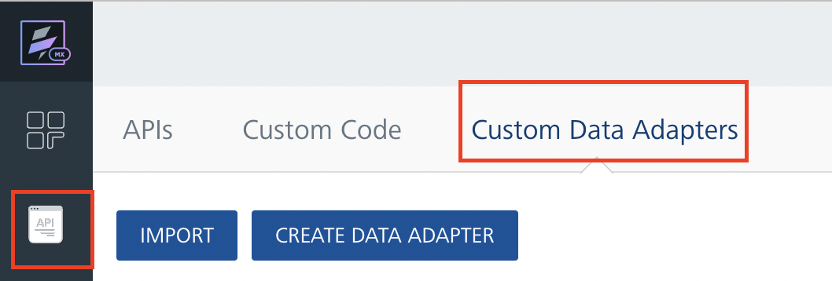
4. Click IMPORT to import a custom data adapter.
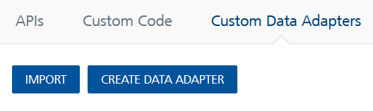
5. On the Import Data Adapter dialog box, click browser to import.

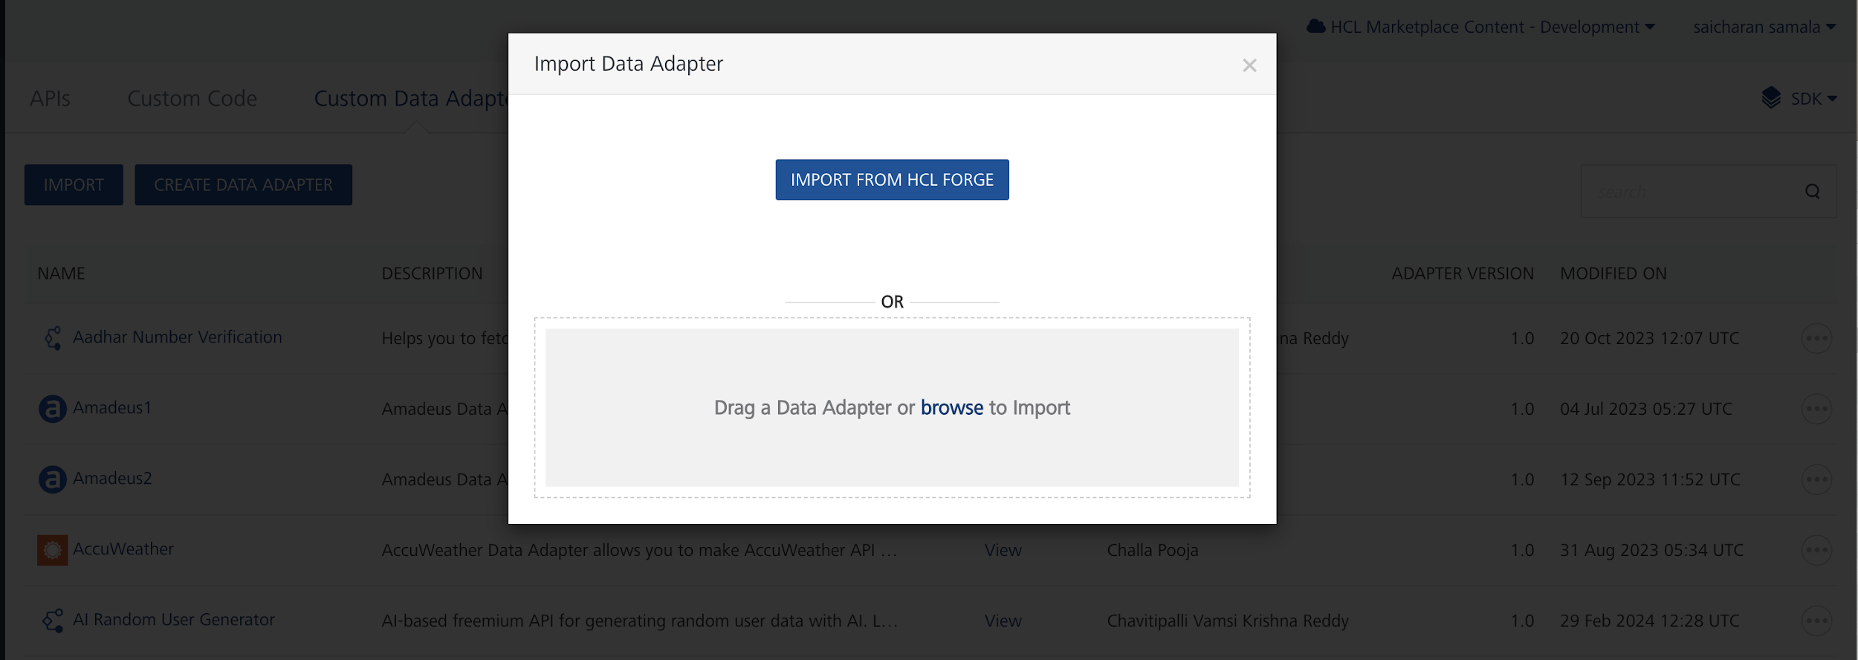

6. Click IMPORT FROM HCL FORGE. The Import Data Adapter from HCL Forge dialog appears with a list of available data adapters.
Click Import. Ollama data adapter is listed on the Custom Data Adapters page.
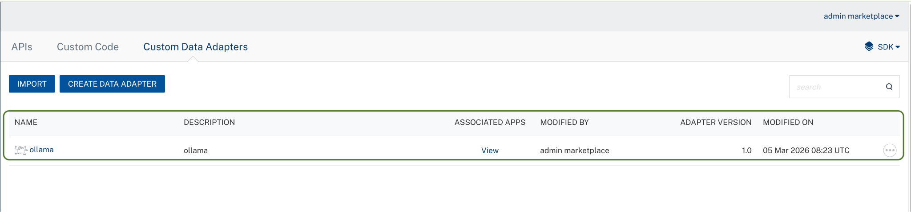

To import the data adapter zip file, do the following:
- Perform steps 1 to 4 in the above procedure
- Drag the data adapter zip file into the Drag a Data Adapter box.
Or
Click browse. The Open dialog appears.
Navigate to the location where you downloaded the data adapter (zip file) on your computer, select the data adapter, and click Open. The Import Data Adapter dialog shows the selected data adapter.
Note: Click Remove if the selected data adapter is not the one that you want to import.

Creating an integration service with Ollama
After you import Ollama Data Adapter into Foundry, you must create an integration service with service type as Ollama.
To create an integration service with Ollama, do the following:
- Log on to your HCL Foundry. The Dashboard page appears by default.
- In the left pane, click the API Management menu. The APIs tab opens by default.
- Click the Integration tab. The Integration tab opens with a list of existing integration services.
- Click CONFIGURE NEW. The Service Definition tab opens.
- In the Name box, type a unique name for your service.
- From the Service Type list, select Ollama.
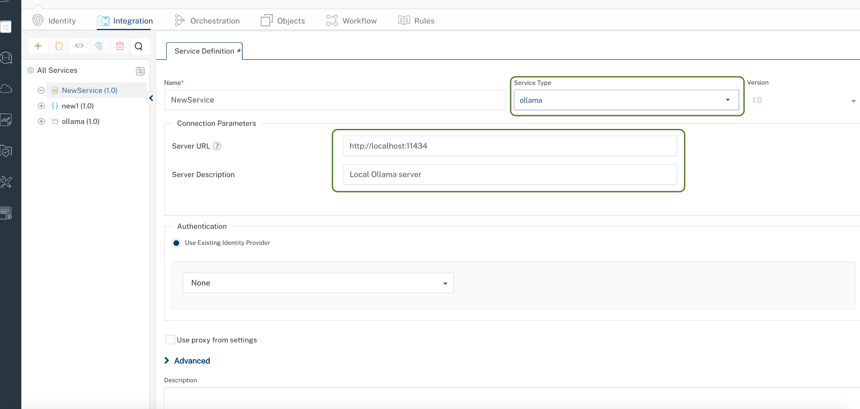
- Click Save

Creating an Operation
To make any API call in the HCL Foundry console, you must create an operation for the respective API and then execute the operation. Executing an operation involves making the API call and displaying the response.
This section provides steps to create an operation for the Ollama.
Steps to create an operation for the Ollama:
- Log on to your HCL Foundry. The Dashboard page appears by default.
- In the left pane, click the API Management menu. The APIs tab opens by default.
- Click the Integration tab. The Integration page appears with a list of existing integration services.
- From the list of integration services, select the integration service that you have created with the service type as Ollama. The Service Definition tab of the selected integration service opens by default.
- Click the Operations List tab. The Operations List tab opens.
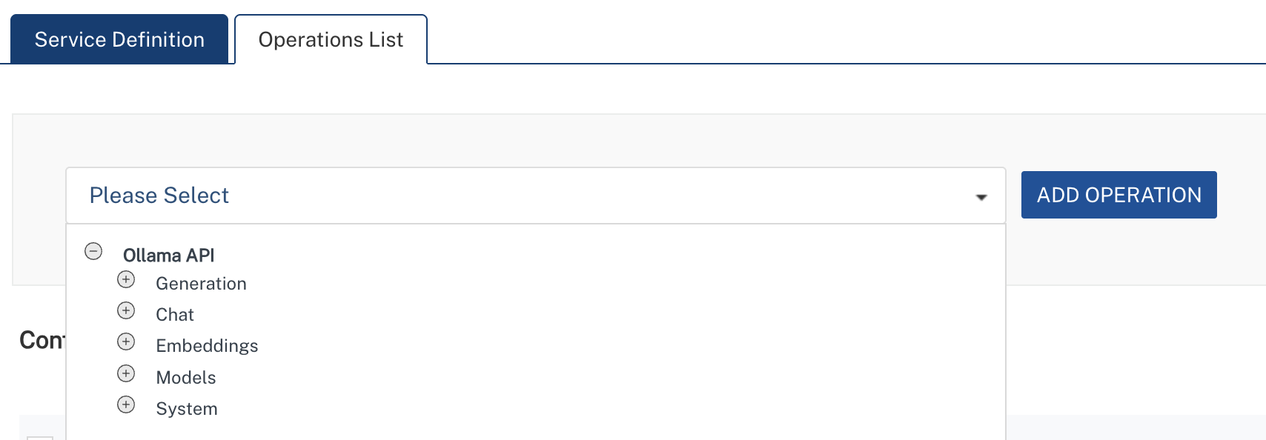
Available Operations:
- chat_completion- Generate chat-based responses using conversation history
- generate - Generate text completions from a prompt
- embeddings - Generate vector embeddings for text
- list_models - List all locally available models
- show_model - Get detailed information about a specific model
- pull_model - Download a model from Ollama library
- delete_model - Remove a model from local storage

- Select Operation and Click Add Operation.
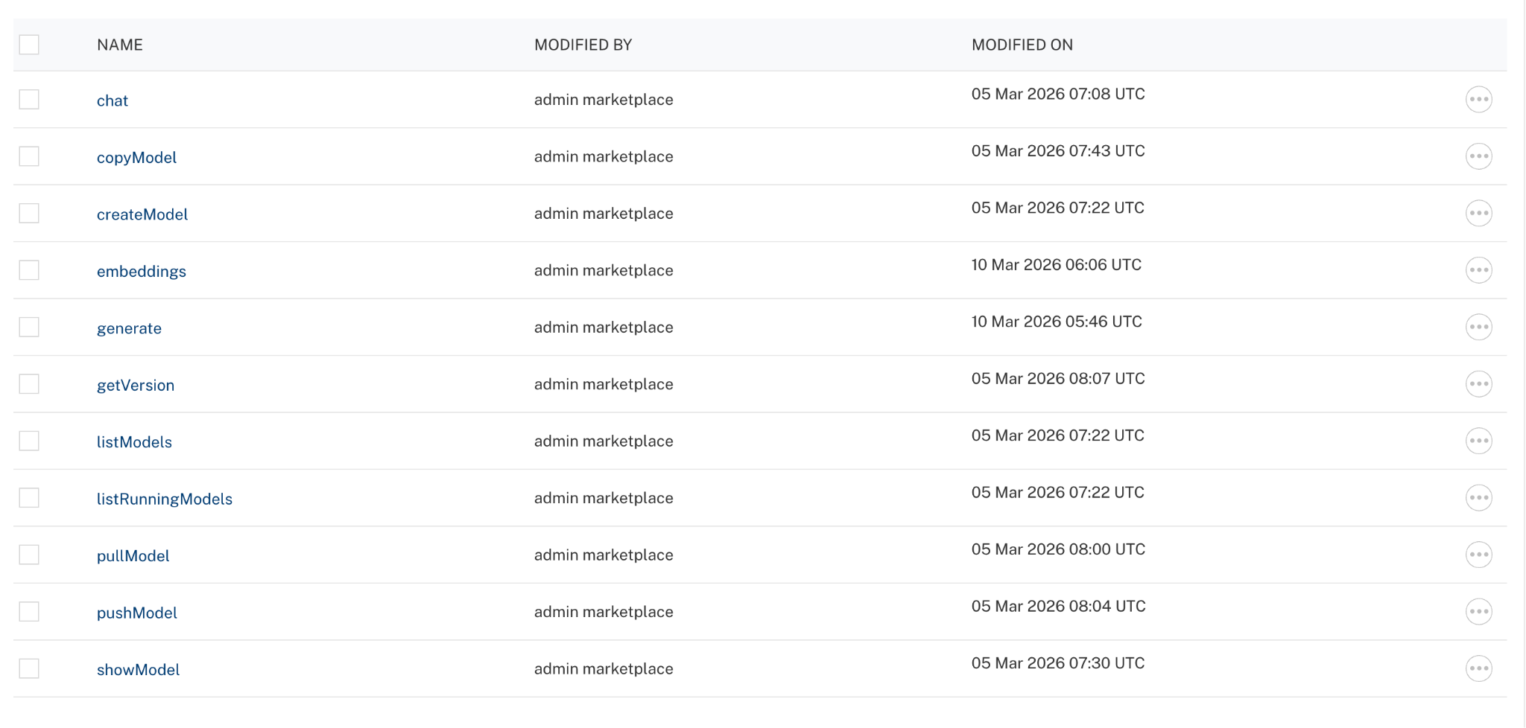

Executing Operation
Executing an operation involves making the API call by setting the necessary parameters and displaying the response. The procedure to execute any operation is the same, but the request parameters of the APIs vary. This section provides steps to execute the Generate operation (explained in Creating an Operation).
Steps to execute the askQuestion operation:
- Log on to your Hcl Foundry. The Dashboard page appears by default.
- In the left pane, click the API Management menu. The APIs tab opens by default.
- Click the Integration tab. The Integration tab opens with a list of existing integration services.
- From the list of integration services, select the integration service that you have created with service type as Ollama. The Service Definition tab of the selected integration service opens by default.
Click the Operations List tab.
In the Name box, the name of the operation is displayed by default. If you want, you can change the name.
On the Request Input tab, in the Body section, for the following parameters, specify the values in the respective boxes under the Test Value column.
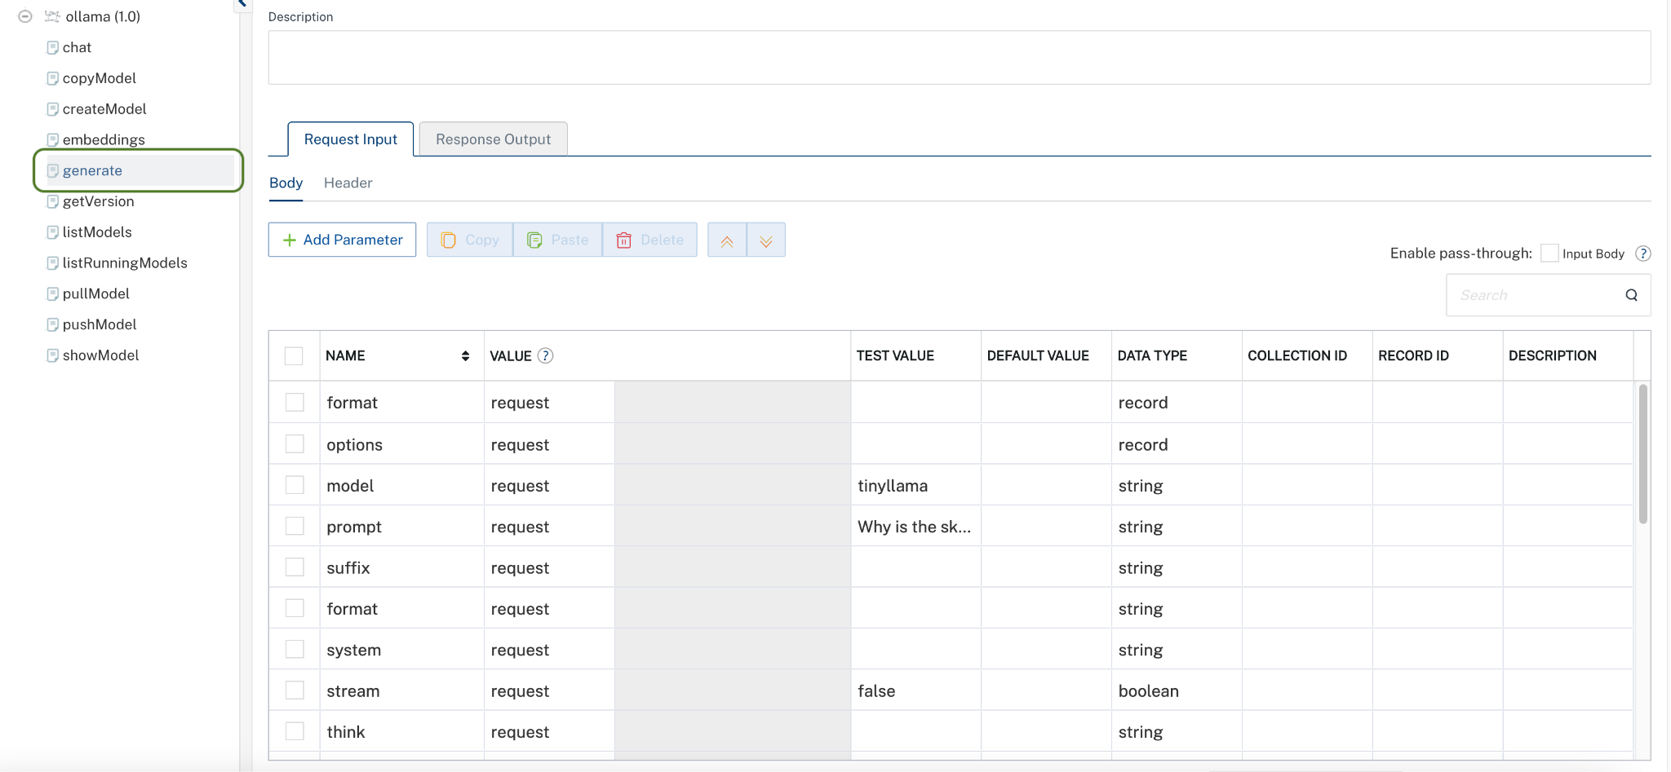

Click Header sub-tab. The Header section opens.
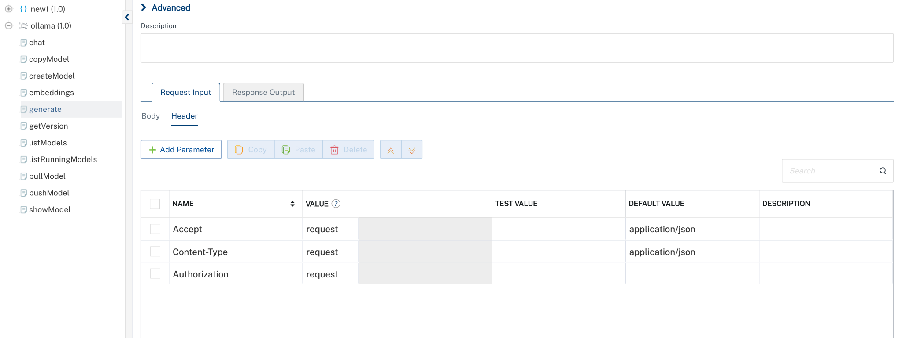
Click SAVE AND FETCH RESPONSE. The Output Result dialog appears with the response. Otherwise, the Output Result shows an error.
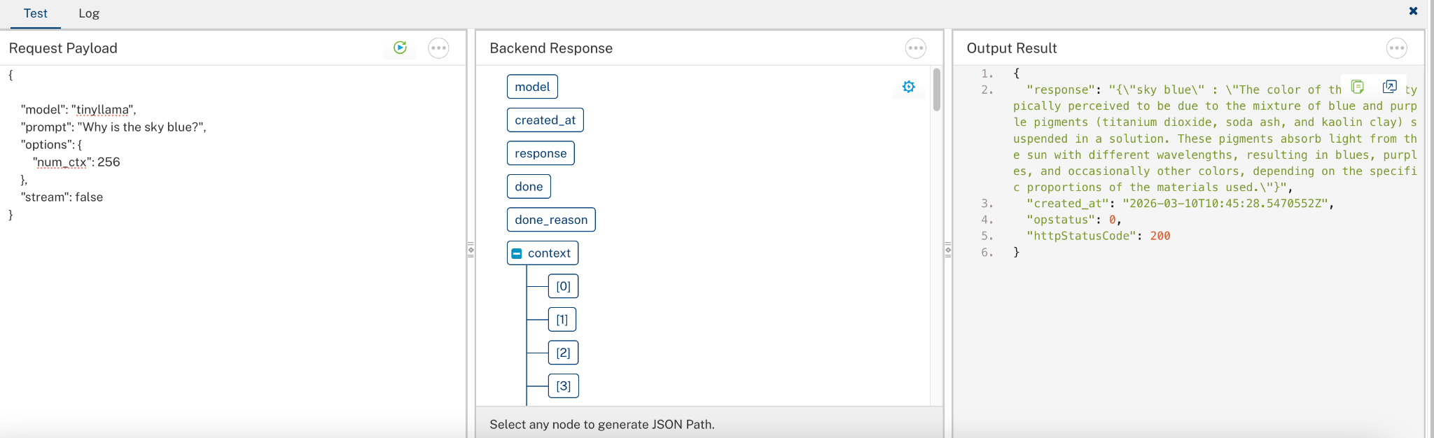
Note: In VoltMX Foundry, always provide values for required parameters. Optional parameters should only be included when you have valid values. Avoid sending empty strings, empty objects, or empty arrays for optional fields, as this may lead to validation errors. The request example includes all available parameters only for reference.

Setting Up Ollama Localhost Server in VS Code:
Step 1: Install Ollama
For macOS:
# Download and install Ollama from https://ollama.com/download
curl -fsSL https://ollama.com/install.sh | sh
# Or use Homebrew
brew install ollama
For Linux:
# Download and install Ollama from https://ollama.com/download
curl -fsSL https://ollama.com/install.sh | sh
For Windows:
Download the Ollama installer from https://ollama.com/download
Run the installer and follow the prompts
Step 2: Verify Installation
Open a terminal and verify Ollama is installed:
ollama --version
If installed correctly, the Ollama version will be displayed.

Step 3: Start Ollama Server
Start the Ollama service:
# Start Ollama server (runs on http://localhost:11434 by default)
ollama serve
Note: On macOS and Windows, Ollama runs as a background service automatically. On Linux, you may need to run ollama serve manually.
Step 4: Pull a Model
Download your first model:
# Pull Llama 3 (8B parameters)
ollama pull llama3
# Or pull other popular models
ollama pull tinyllama
ollama pull embeddinggemma
ollama pull moondream
Step 5: Test the Model
Test the model in the terminal:
ollama run tinyllama

# Or test with a single prompt
ollama run llama3 "Explain quantum computing in simple terms"
Step 6: Verify API Access
Test the API endpoint:
# Test the chat completion endpoint
curl http://localhost:11434/api/chat -d '{
"model": "llama3",
"messages": [
{
"role": "user",
"content": "Hello, how are you?"
}
]
}'
Step 7: List Available Models
Check all downloaded models:
ollama list
OLLAMA API ENDPOINTS
1. Chat Completion
Endpoint: POST /api/chat
Generate conversational responses.
Request:
{
"model": "llama2",
"messages": [
{"role": "system", "content": "You are a helpful assistant."},
{"role": "user", "content": "What is AI?"}
],
"stream": false
}
2. Generate
Endpoint: POST /api/generate
Generate text from a prompt.
Request:
{
"model": "llama3",
"prompt": "Explain machine learning",
"stream": false
}
3. Embeddings
Endpoint: POST /api/embeddings
Generate vector embeddings.
Request:
{
"model": "llama3",
"prompt": "The quick brown fox"
}
4. List Models
Endpoint: GET /api/tags
List all downloaded models.
5. Show Model Info
Endpoint: POST /api/show
Get model details.
Request:
{
"name": "llama3"
}
6. Pull Model
Endpoint: POST /api/pull
Download a model.
Request:
{
"name": "llama2"
}
7. Delete Model
Endpoint: DELETE /api/delete
Remove a model.
Request:
{
"name": "llama3"
}
POPULAR OLLAMA MODELS
Model Size Use Case
llama3 8B General-purpose chat and text generation
llama3:70b 70B Advanced reasoning and complex tasks
mistral 7B Fast, efficient general-purpose model
gemma 7B Google's lightweight model
phi3 3.8B Microsoft's small, efficient model
codellama 7B Code generation and understanding
llava 7B Multi-modal vision and text
qwen 7B Multilingual support
To pull any model:
ollama pull <model-name>

Publishing the App in Foundry
After adding the Ollama Data Adapter to your app and configuring the necessary configurations, you must publish the app to HCL Foundry. For more information, refer to Publish a foundry app.
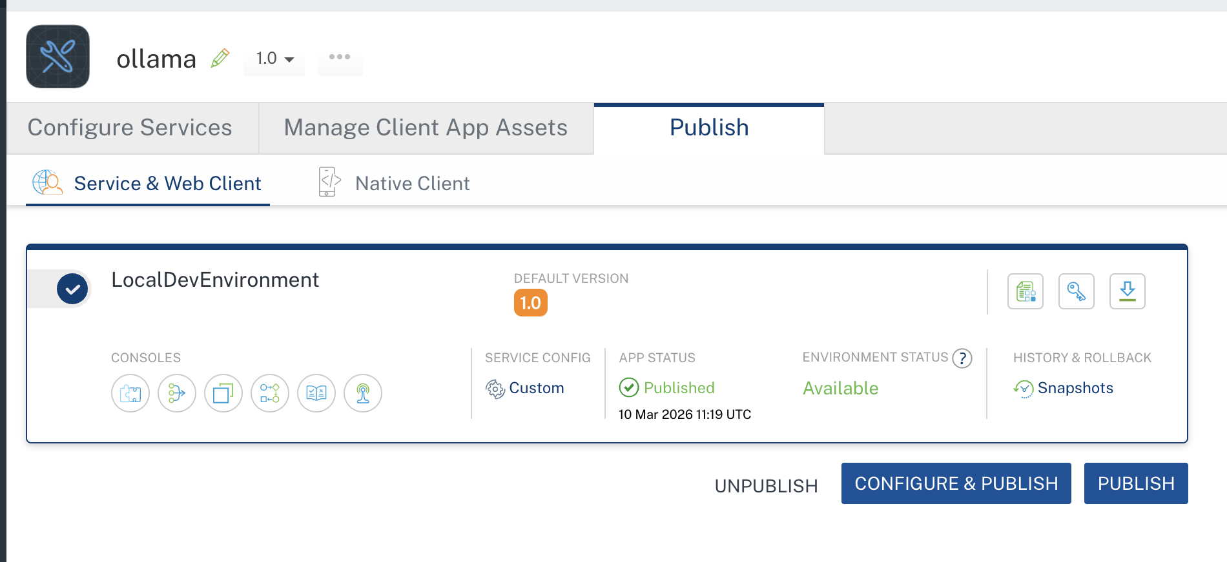

Reference documentation link: https://docs.ollama.com/api/introduction

II. Cloud Ollama Data Adapter setup :

Prerequisites
Before using the Ollama Data Adapter, ensure you have the following:
- HCL Foundry
- Volt MX Iris
- Ollama Server
Ensure the Ollama server is running locally or accessible via a configured environment.
- Cloud Ollama Access
Ollama provides two authentication methods to access cloud services:
1. Signing In (Recommended for Local Development)
Run the following command from your local machine:
ollama signin
This automatically authenticates your local Ollama setup with ollama.com, allowing seamless access to cloud-hosted models without additional configuration.
2. API Key (Recommended for Programmatic Access / Production)
      - Generate an API key from ollama.com
      - Use the API key in your application requests (e.g., headers or configuration)
      - Suitable for integrating with external applications, services, or deployments like Foundry
    - Example: Authorization: Bearer <your_api_key>

Importing the data adapter
You can import Ollama Data Adapter into HCL Foundry directly from the Volt MX Forge website or by importing the data adapter zip file.
To import Data Adapter to Volt Foundry, do the following:
1.Sign in to the HCL Foundry.
2.From the left navigation menu, select API Management.
- In API Management, select Custom Data Adapters.

4. Click IMPORT to import a custom data adapter.
5. On the Import Data Adapter dialog box, click browser to import.

6. Click IMPORT FROM HCL FORGE. The Import Data Adapter from HCL Forge dialog appears with a list of available data adapters.
Click Import. Ollama data adapter is listed on the Custom Data Adapters page.
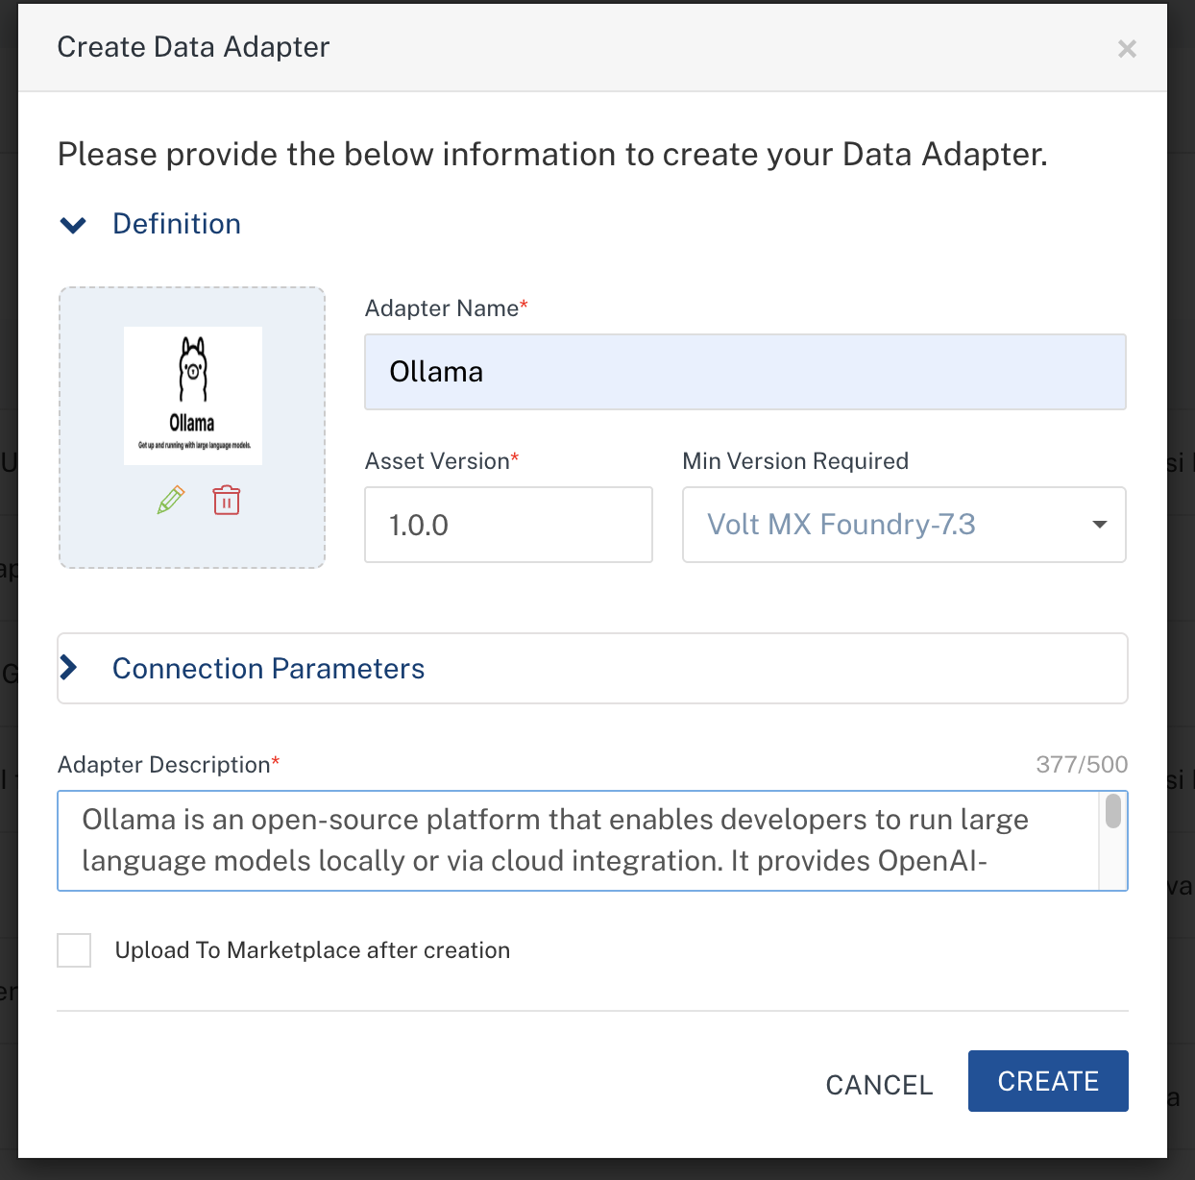
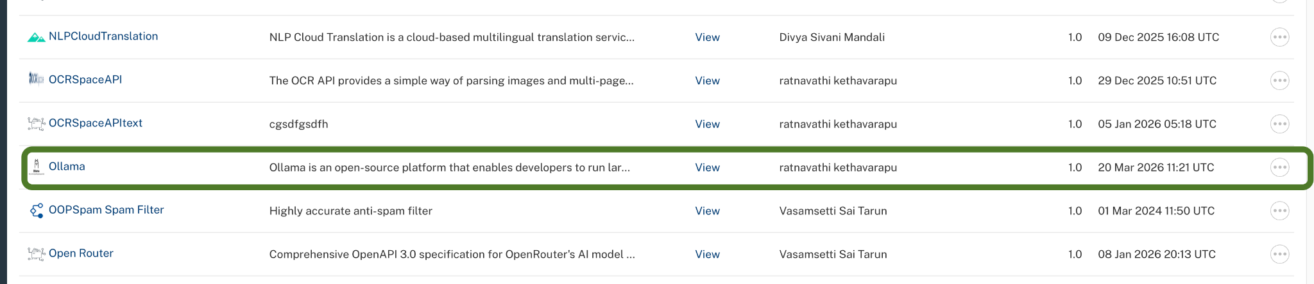

To import the data adapter zip file, do the following:
- Perform steps 1 to 4 in the above procedure
- Drag the data adapter zip file into the Drag a Data Adapter box.
Or
Click browse. The Open dialog appears.
Navigate to the location where you downloaded the data adapter (zip file) on your computer, select the data adapter, and click Open. The Import Data Adapter dialog shows the selected data adapter.
Note: Click Remove if the selected data adapter is not the one that you want to import.

Creating an Integration Service with Ollama:
After you import Ollama Data Adapter into Foundry, you must create an integration service with service type as Ollama.
To create an integration service with Ollama, do the following:
- Log on to your HCL Foundry. The Dashboard page appears by default.
- In the left pane, click the API Management menu. The APIs tab opens by default.
- Click the Integration tab. The Integration tab opens with a list of existing integration services.
- Click CONFIGURE NEW. The Service Definition tab opens.
- In the Name box, type a unique name for your service.
- From the Service Type list, select Ollama.
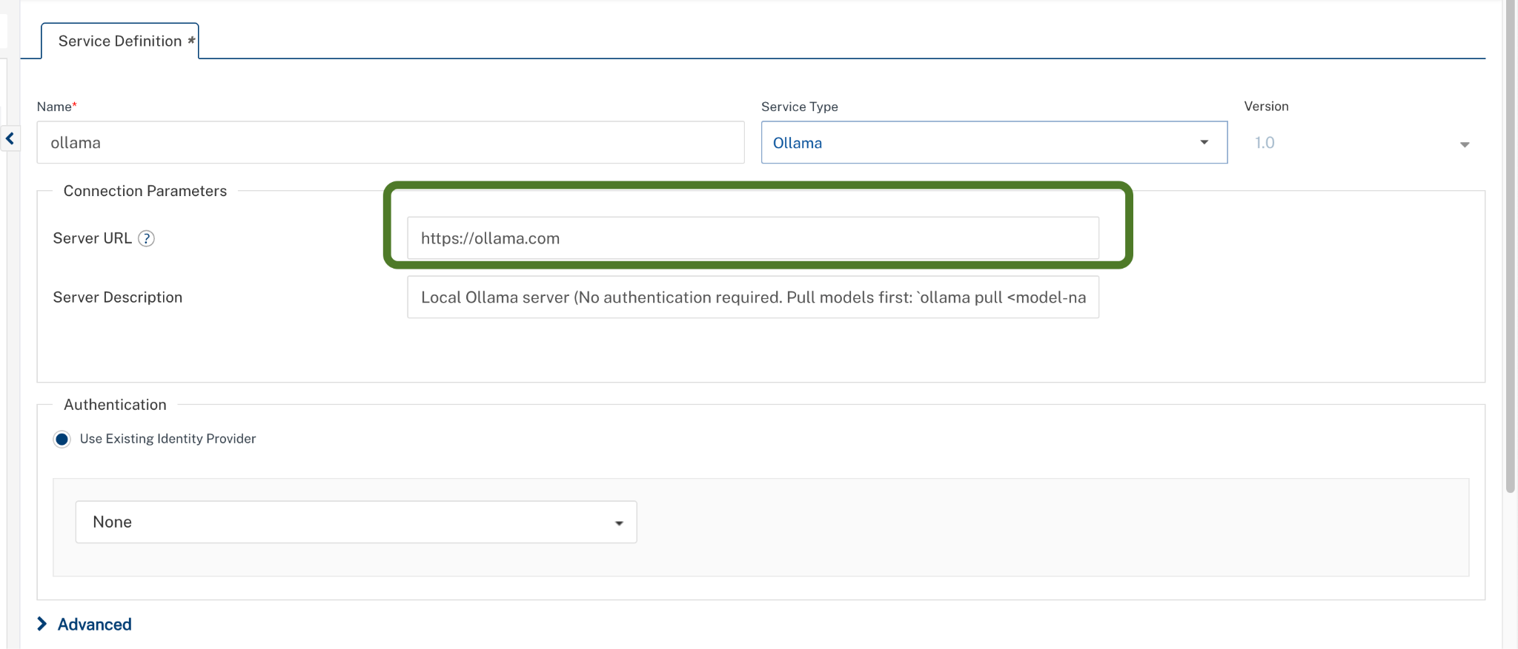
- Click Save

Creating an Operation
To make any API call in the HCL Foundry console, you must create an operation for the respective API and then execute the operation. Executing an operation involves making the API call and displaying the response.
This section provides steps to create an operation for the Ollama.
Steps to create an operation for the Ollama:
- Log on to your HCL Foundry. The Dashboard page appears by default.
- In the left pane, click the API Management menu. The APIs tab opens by default.
- Click the Integration tab. The Integration page appears with a list of existing integration services.
- From the list of integration services, select the integration service that you have created with the service type as Ollama. The Service Definition tab of the selected integration service opens by default.
- Click the Operations List tab. The Operations List tab opens.
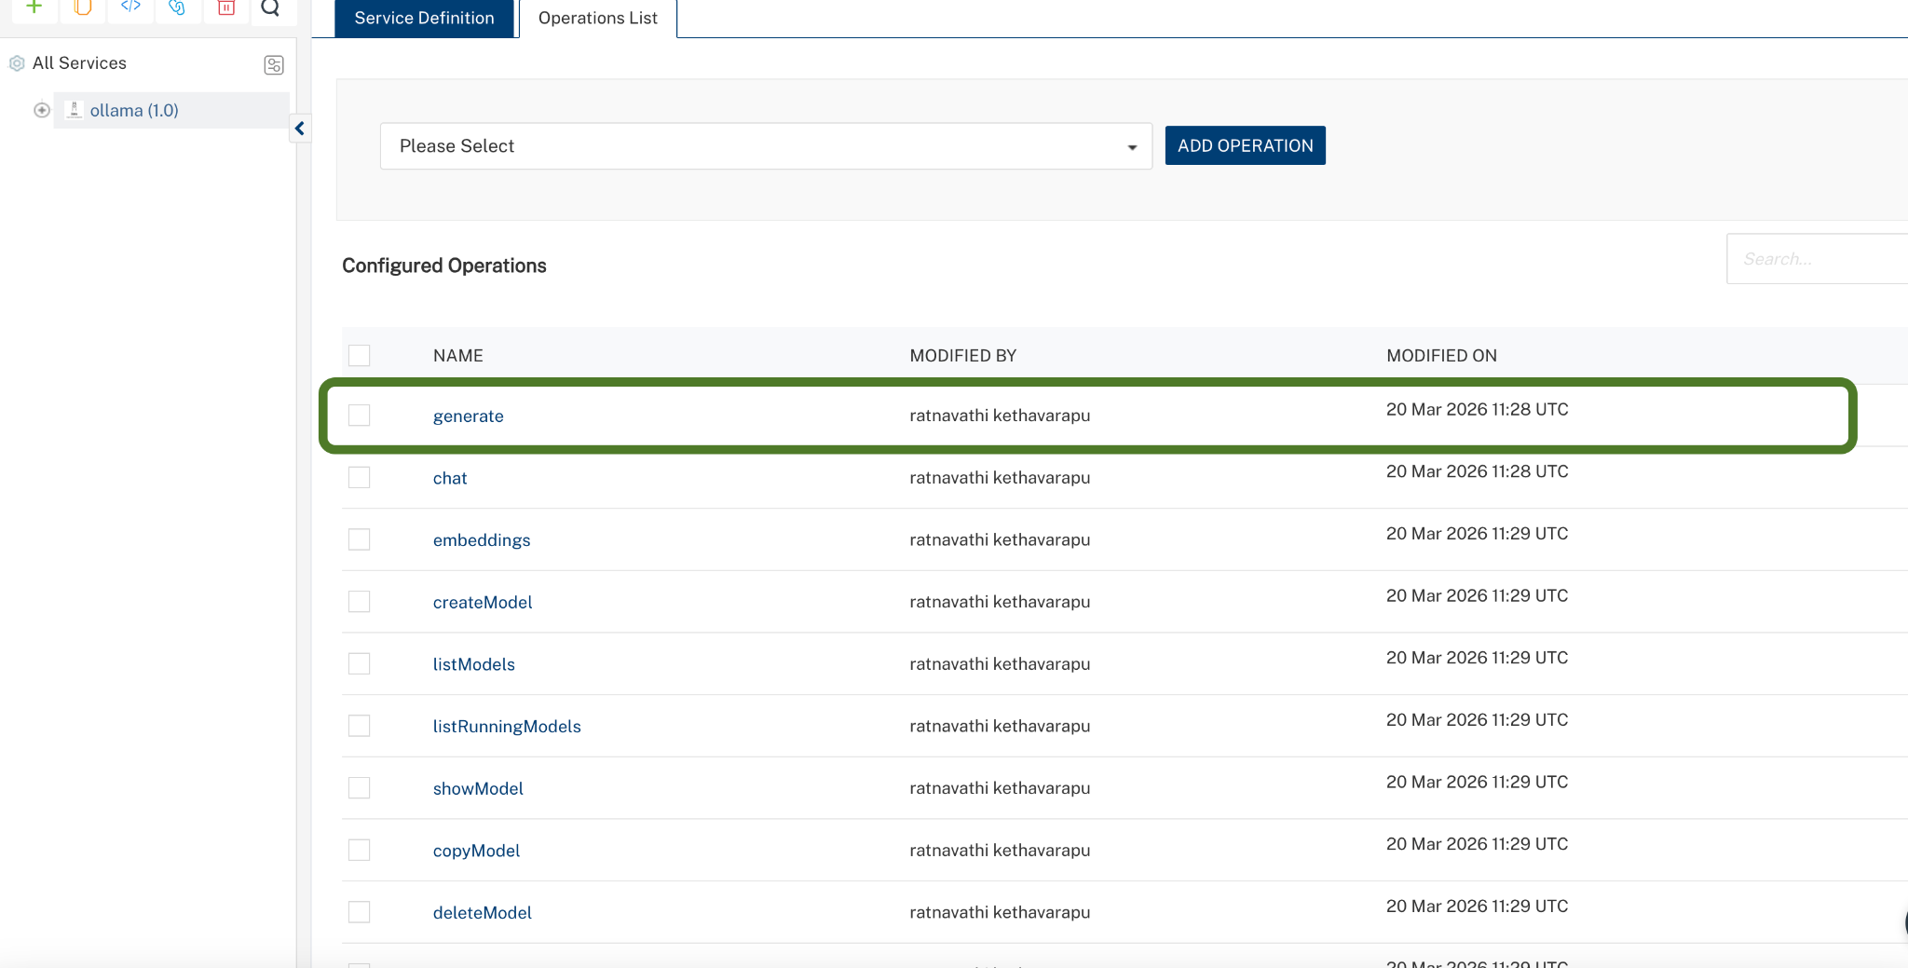
Available Operations:
- chat_completion- Generate chat-based responses using conversation history
- generate - Generate text completions from a prompt
- embeddings - Generate vector embeddings for text
- list_models - List all locally available models
- show_model - Get detailed information about a specific model
- pull_model - Download a model from Ollama library
- delete_model - Remove a model from local storage
- Select Operation and Click Add Operation.

Executing Operation
Executing an operation involves making the API call by setting the necessary parameters and displaying the response. The procedure to execute any operation is the same, but the request parameters of the APIs vary. This section provides steps to execute the Generate operation (explained in Creating an Operation).
Steps to execute the askQuestion operation:
- Log on to your Hcl Foundry. The Dashboard page appears by default.
- In the left pane, click the API Management menu. The APIs tab opens by default.
- Click the Integration tab. The Integration tab opens with a list of existing integration services.
- From the list of integration services, select the integration service that you have created with service type as Ollama. The Service Definition tab of the selected integration service opens by default.
Click the Operations List tab.
In the Name box, the name of the operation is displayed by default. If you want, you can change the name.
On the Request Input tab, in the Body section, for the following parameters, specify the values in the respective boxes under the Test Value column.
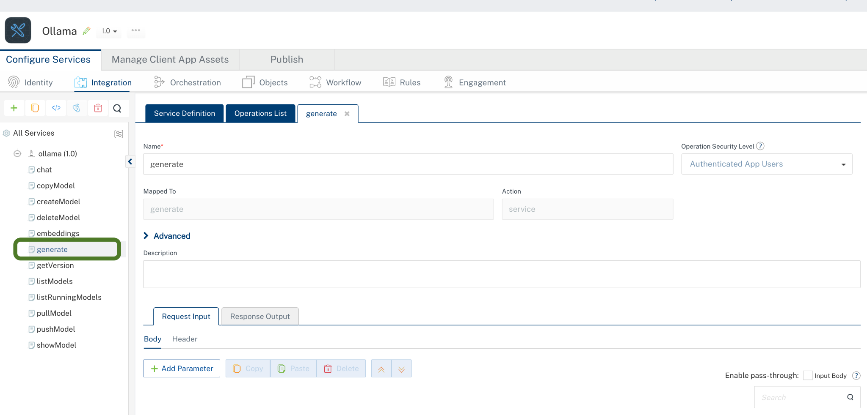

Click Header sub-tab. The Header section opens.
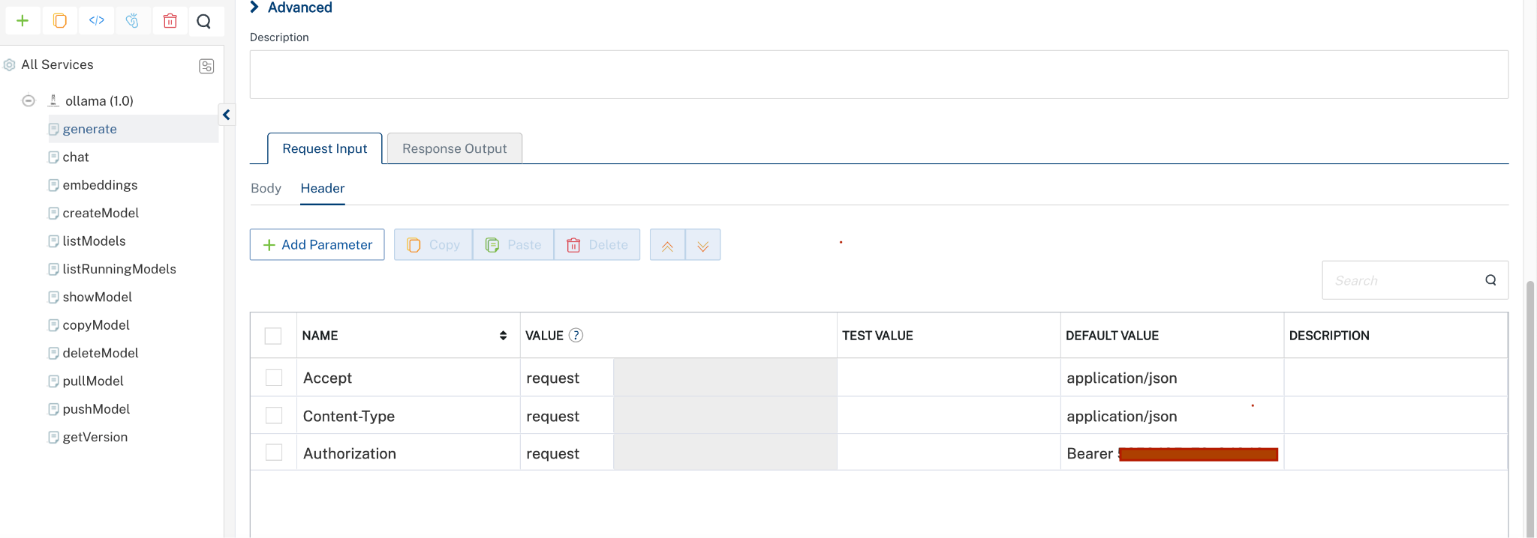
Click SAVE AND FETCH RESPONSE. The Output Result dialog appears with the response. Otherwise, the Output Result shows an error.
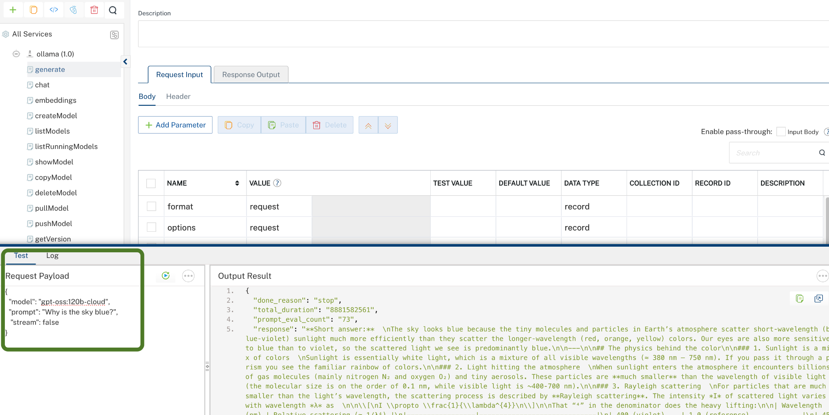
Note: In VoltMX Foundry, always provide values for required parameters. Optional parameters should only be included when you have valid values. Avoid sending empty strings, empty objects, or empty arrays for optional fields, as this may lead to validation errors. The request example includes all available parameters only for reference.

Publishing the App in Foundry
After adding the Ollama Data Adapter to your app and configuring the necessary configurations, you must publish the app to HCL Foundry. For more information, refer to Publish a foundry app.
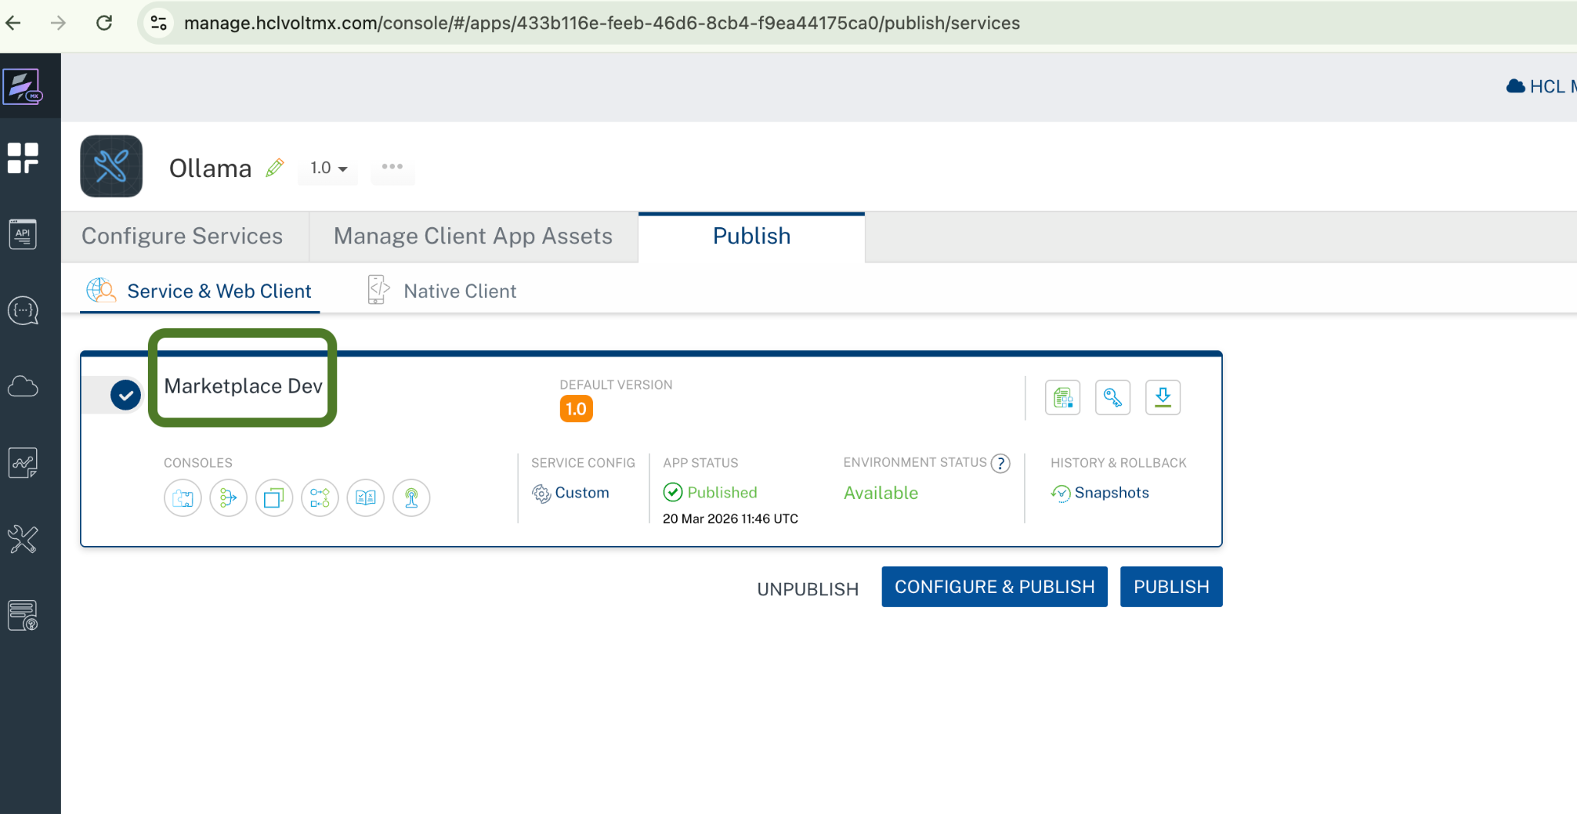

REVISION HISTORY
Adapter version 1.0.0:

Known Issues
None

Limitations
None

