2nd May 2023

Scan credit card in offline

Overview
The OfflineCCScan component scan the credit/debit card through the camera and returns the data

Use case
1. Instead of manually entering the card details by using this component details can be scanned very easily.

B .Percentage of re-use:
Approximate 90% of reuse. It sets an expectation of how much can be used out of the box, and how much needs to be customized for a specific app.

C. Features

- The component utilizes CardReader third party library to scan the card.
- Uses NFI 3.0

2. Getting Started

A. Prerequisites
Before you start using the OfflineCCScan component, ensure the following:
• HCL Foundry
• Volt MX Iris

Platforms Supported

Mobile

iOS

Tablets

Importing the app

You can import the Forge components only into the apps that are of the Reference Architecture type.

To import the OfflineCCScan component, do the following:

Open your app project in Volt MX Iris.
2. In the Project Explorer, click the Templates tab.
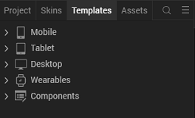
3.Right-click Components, and then select Import Component. The Import Component dialog box appears.
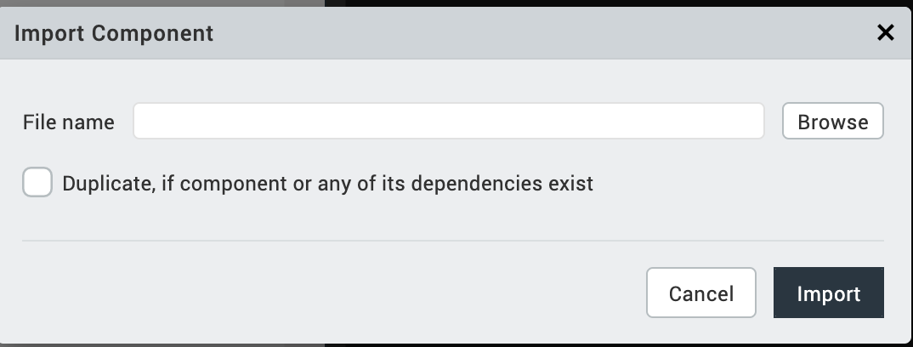
4.Click Browse to navigate to the location of the component, select the component, and then click Import. The component and its associated widgets and modules are added to your project.

Once you have imported a component to your project, you can easily add the component to a form. For more information, refer Add a Component to a Form

Building and previewing the app
After performing all the above steps, you can build your app and run it on your device. For more information, you can refer to the Building and Viewing an Application section of the Volt MX User Guide.
You can then run your app to see the OfflineCCScan work in real time.

References

Dynamic Usage
You can also add OfflineCCScan component dynamically. To do so,

1. In the Project Explorer, on the Projects tab, click Controllers section to access the respective Form Controller. Create a method and implement the code snippet similar to the sample code mentioned below.

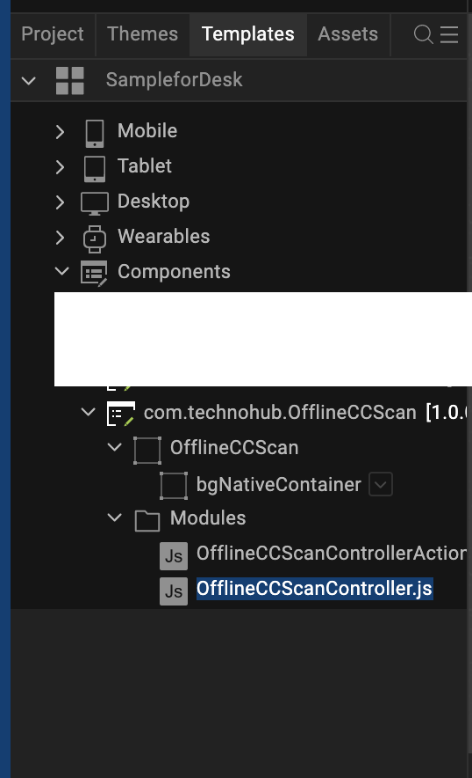

/* Creating OfflineCCScan component instance */

var OfflineCCScan = new com.technohub.OfflineCCScan ({
"height": "50%",
"id": “OfflineCCScan",
"isVisible": true,
"left": "0dp",
"masterType": constants.MASTER_TYPE_USERWIDGET,
"isModalContainer": false,
"skin": "slFbox",
"top": "0dp",
"width": "100%",
"zIndex": 1,
"overrides": {
"OfflineCCScan": {
"right": "viz.val_cleared",
"bottom": "viz.val_cleared",
"minWidth": "viz.val_cleared",
"minHeight": "viz.val_cleared",
"maxWidth": "viz.val_cleared",
"maxHeight": "viz.val_cleared",
"centerX": "viz.val_cleared",
"centerY": "viz.val_cleared"
}
}
}, {
"overrides": {}
}, {
"overrides": {}
});

/*Adding the OfflineCCScan component to a Form*/

this.view.add(OfflineCCScan);
In the code snippet, you can edit the properties of the component as per your requirement. For more information, see Setting Properties.
2. Save the file

Configuring Native Settings (iOS)
To configure the native settings for iOS, follow these steps:
- From the Project explorer, go to Assets and expand Media.
- Right-click Common, and then select Resource Location. Volt MX Iris opens the common resources folder in a file explorer.
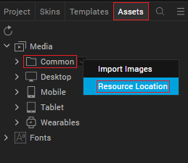
- Open the infoplist_configuration.json file with a text or code editor.
- At the end of the file, type the following code. You can change the description based on your preference.
"NSCameraUsageDescription" : "Your Description"

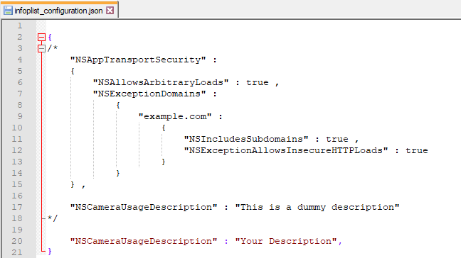

5. Save the file.

Configuring Deployment Target
- From the left navigation menu, click Project Settings.
- In the Project Settings window, go to Native → iPhone/iPad.
- Under Target Versions, from the iOS Version list, select 11.0 or higher.
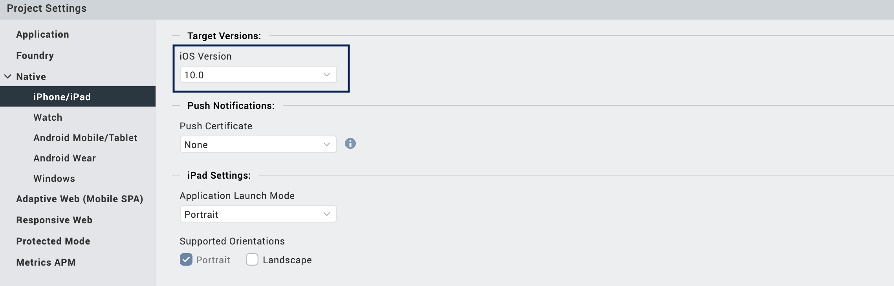

1. Events:

1. resultCallback

Description: | Returns the card details within this callback.
Syntax: | resultCallback
Parameters: | Callback as a parameter
Remarks: | None
Example: | postShow(){  kony.runOnMainThread(function(){  this.view.OfflineCCScan.resultCallback(this.callBackHandler);  }.bind(this), []);  },  callBackHandler: function(data) {  var self = this;  kony.runOnMainThread(function() {  self.view.imgResult.base64 = data;  }, []);  }

App version 1.0.0:

Limitations

B. Known Issue

