Date : 14-May-26

NVIDIA NIM

VERSION: 1.0.0

OVERVIEW
NVIDIA NIM (Inference Microservices) delivers hosted AI inference through a single OpenAI-compatible REST API. It provides access to LLMs, vision-language models, and embedding models across providers like Mistral, Meta Llama, and NVIDIA Nemotron — all via consistent, JSON-only endpoints.
Designed for enterprise readiness, NIM integrates directly with platforms like VoltMX Foundry without requiring binary uploads, streaming payloads, or provider-specific configurations.
NIM eliminates the complexity of managing individual model deployments by offering a standardized API surface across NVIDIA-curated and third-party model families, including Mistral, Meta Llama, NVIDIA Nemotron, and others available in the NVIDIA Model Catalog. With free-tier endpoints and scalable inference infrastructure, NIM is well-suited for rapid prototyping, enterprise automation, and seamless integration

Use case:

Conversational AI: Multi-turn chatbots and assistants.

Content Generation: Emails, summaries, and structured text via.

Multimodal Chat: VLMs that accept image_url or video_url in JSON and return text.

Semantic Search & RAG: High-dimensional embeddings for retrieval pipelines.

Enterprise Automation: AI workflows integrated into VoltMX Foundry using standard JSON adapters.

Dynamic Model Switching: List and swap free-tier models at runtime via.

Features:

Unified API Interface: Access chat, image, video, embeddings, and audio APIs through a single REST interface.

Multi-Provider Support: Integrates multiple providers (GPT, Anthropic, Gemini, Midjourney, Runway, etc.).

Dynamic Model Selection: Easily switch models using request parameters.

Flexible Configuration: Customize requests with parameters like tokens, duration, resolution, etc.

Scalable & Efficient: Designed for high performance and real-time applications.

Structured Responses: Consistent JSON responses for easy integration.

Volt MX Integration Ready: Easily integrates with Volt MX Foundry for enterprise apps.

GETTING STARTED

Prerequisites
Before you start using the Nvidia NIM Adapter, ensure you have the following:

- HCL Foundry
- Volt MX Iris
- https://docs.api.nvidia.com/
- API key - https://build.nvidia.com/settings/api-keys
Reference document: Nvidia NIM

B. Importing the Nvidia NIM data adapter

You can import the Nvidia NIM Data Adapter into HCL Foundry directly from the Volt MX Forge website or by importing the data adapter zip file.

To import Data Adapter to Volt Foundry, do the following:
- Sign in to the HCL Foundry.
- From the left navigation menu, select API Management.
- In API Management, select Custom Data Adapters.

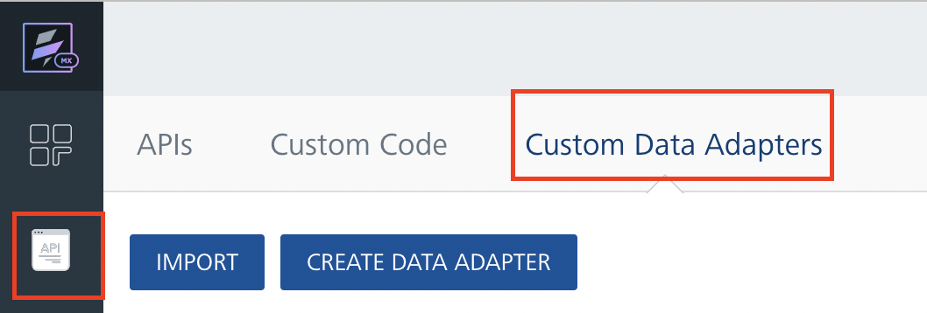
4. Click IMPORT to import a custom data adapter.
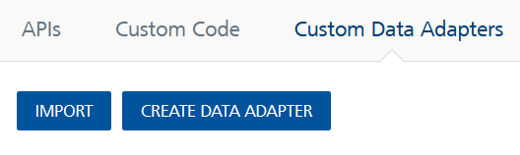
5. On the Import Data Adapter dialog box, click browser to import.

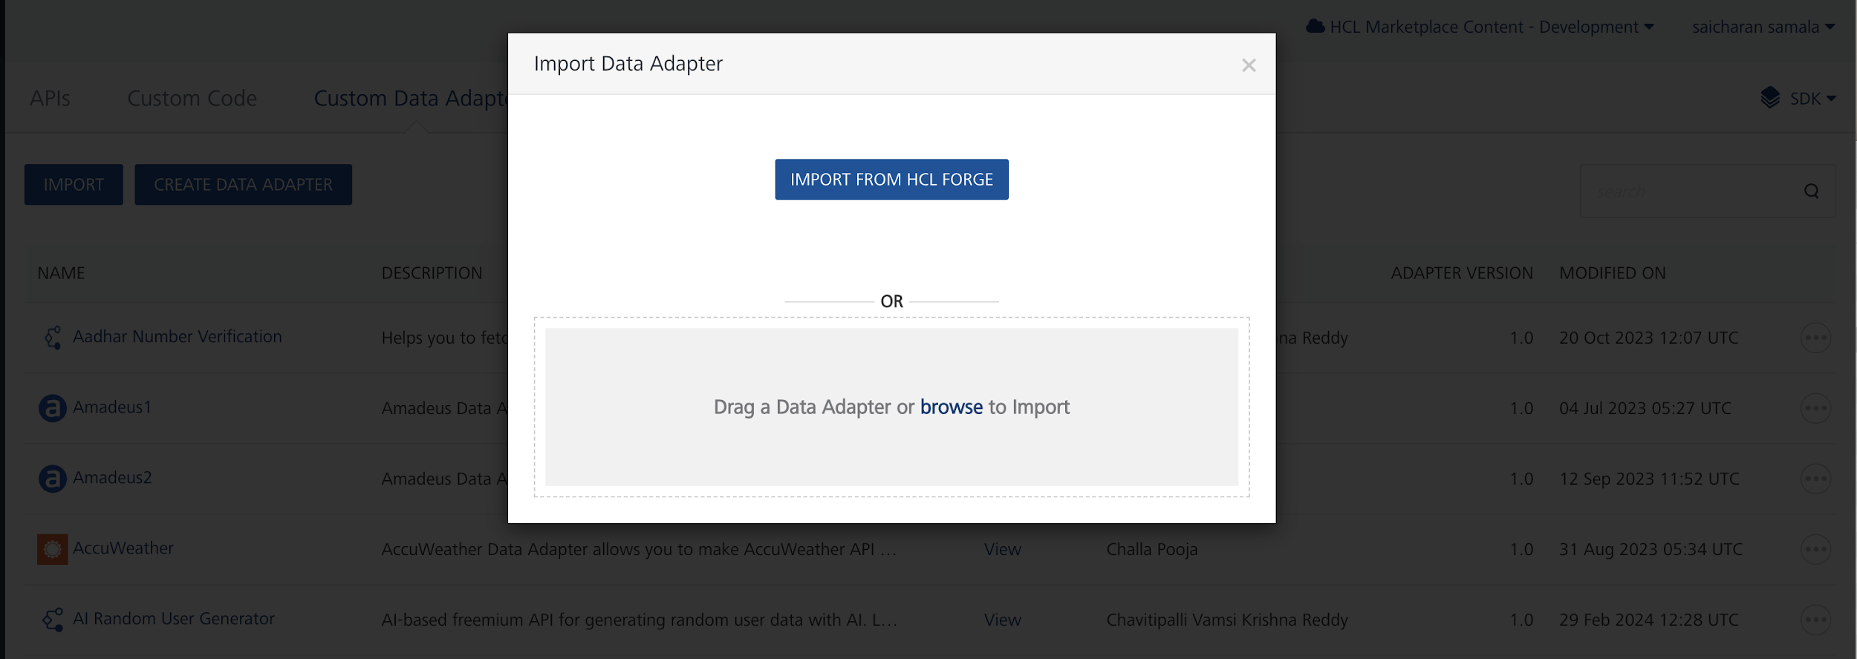

6. Click IMPORT FROM HCL FORGE. The Import Data Adapter from HCL Forge dialog appears with a list of available data adapters.
Click Import. Nvidia NIM Data adapter is listed on the Custom Data Adapters page.
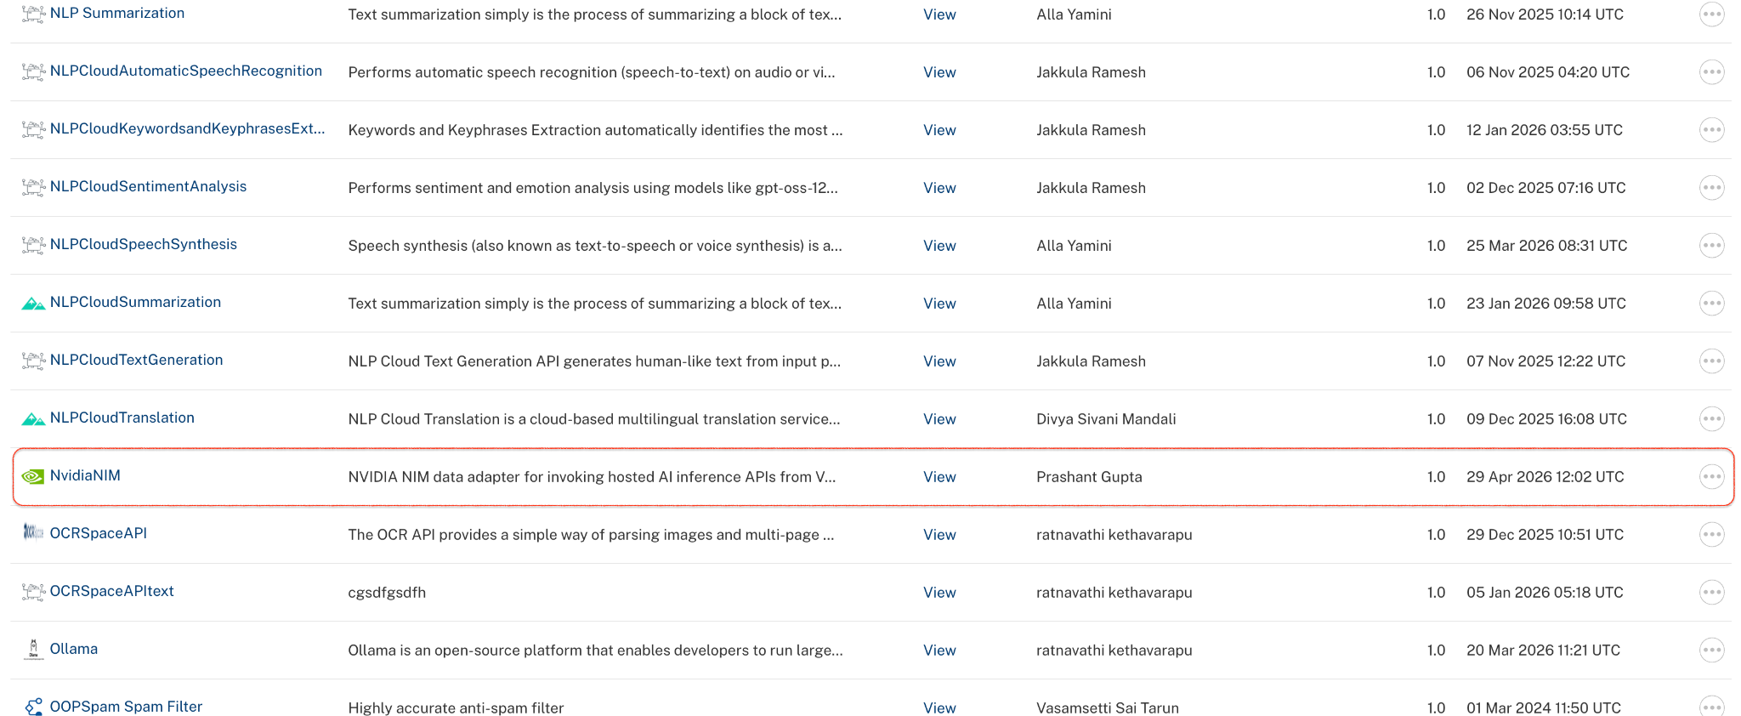
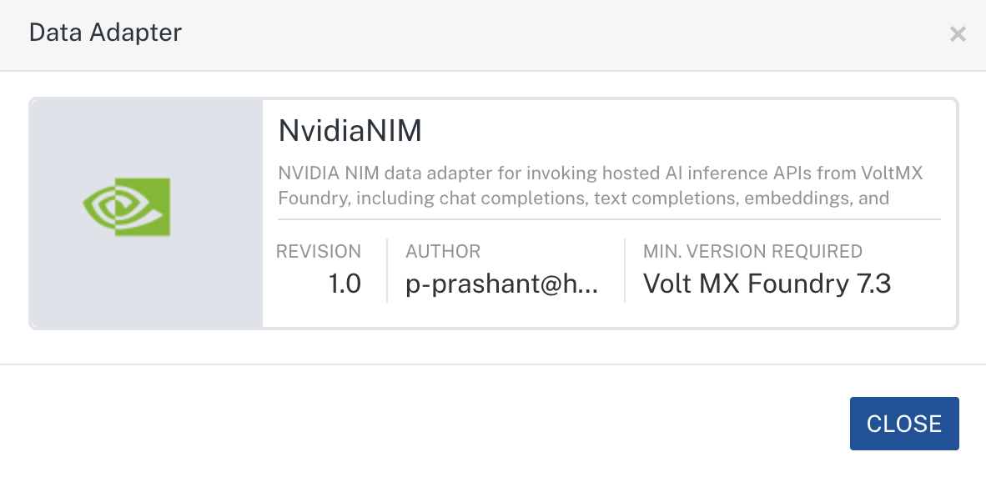
To import the data adapter zip file, do the following:
- Perform steps 1 to 4 in the above procedure
- Drag the data adapter zip file into the Drag a Data Adapter box.
Or
Click browse. The Open dialog appears.
Navigate to the location where you downloaded the data adapter (zip file) on your computer, select the data adapter, and click Open. The Import Data Adapter dialog shows the selected data adapter.
Note: Click Remove if the selected data adapter is not the one that you want to import.

C. Creating an Integration Service with Nvidia NIM:
After you import the Nvidia NIM Data Adapter into Foundry, you must create an integration service with service type Nvidia NIM.
To create an integration service with Nvidia NIM, do the following:
- Log on to your HCL Foundry. The Dashboard page appears by default.
- In the left pane, click the API Management menu. The APIs tab opens by default.
- Click the Integration tab. The Integration tab opens with a list of existing integration services.
- Click CONFIGURE NEW. The Service Definition tab opens.
- In the Name box, type a unique name for your service.
- From the Service Type list,Nvidia NIM.
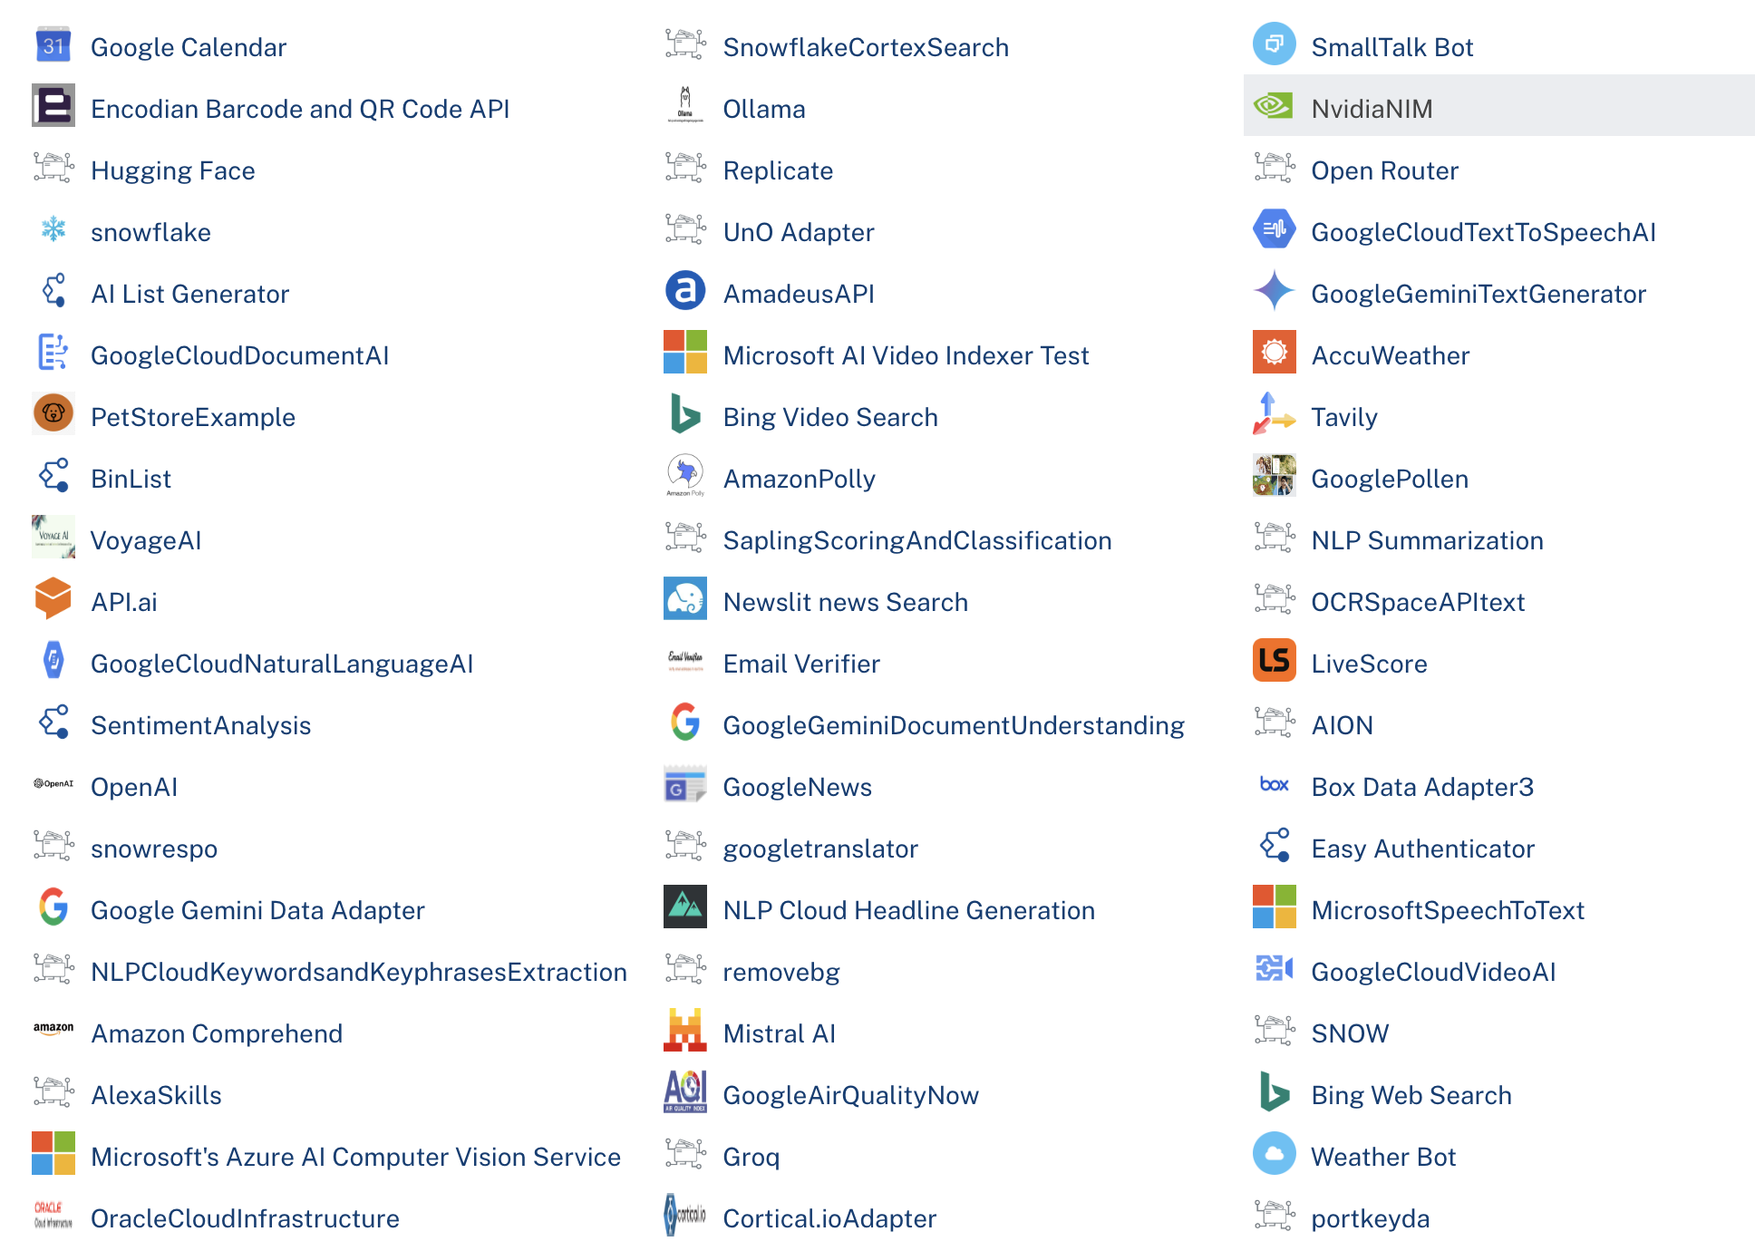
- Click Save

D. Creating an Operation
To make any API call in the HCL Foundry console, you must create an operation for the respective API and then execute the operation. Executing an operation involves making the API call and displaying the response.
This section provides steps to create an operation for the Nvidia NIM.
Steps to create an operation for the Nvidia NIM:
- Log on to your HCL Foundry. The Dashboard page appears by default.
- In the left pane, click the API Management menu. The APIs tab opens by default.
- Click the Integration tab. The Integration page appears with a list of existing integration services.
- From the list of integration services, select the integration service that you have created with the service type as Nvidia NIM. The Service Definition tab of the selected integration service opens by default.
- Click the Operations List tab. The Operations List tab opens.
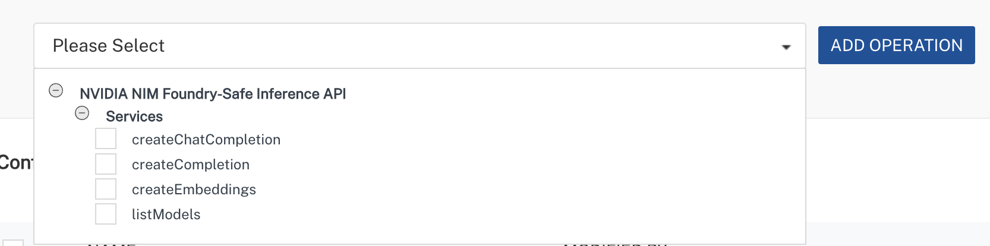
- Select chatCompletions and Click Add Operations.
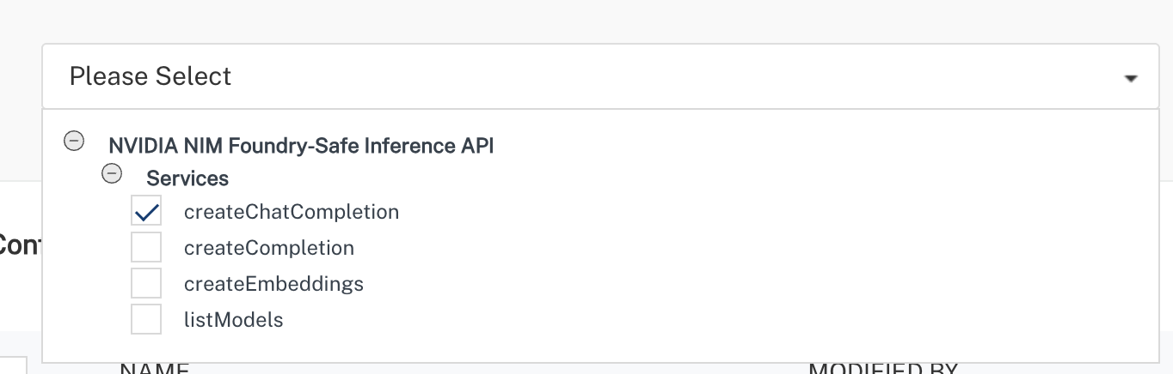

E. Executing Operation
Executing an operation involves making the API call by setting the necessary parameters and displaying the response. The procedure to execute any operation is the same, but the request parameters of the APIs vary. This section provides steps to execute the createChatCompletions(explained in Creating an Operation).
Steps to execute the createChatCompletions operation:
- Log on to your Hcl Foundry. The Dashboard page appears by default.
- In the left pane, click the API Management menu. The APIs tab opens by default.
- Click the Integration tab. The Integration tab opens with a list of existing integration services.
- From the list of integration services, select the integration service that you have created with service type Nvidia NIM. The Service Definition tab of the selected integration service opens by default.
- Click the Operations List tab.
- In the Name box, the name of the operation is displayed by default. If you want, you can change the name.
- On the Request Input tab, in the Body section, for the following parameters, specify the values in the respective boxes under the Test Value column.
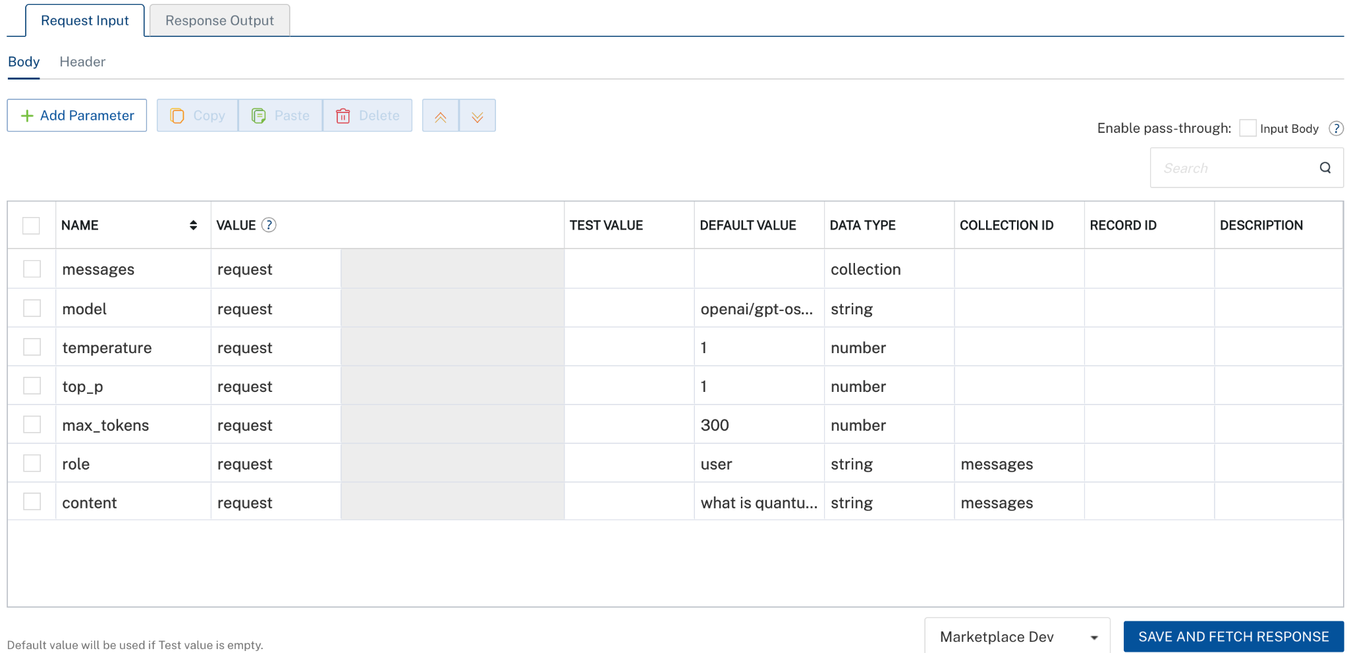
- Click SAVE AND FETCH RESPONSE. The Output Result dialog appears with the response. Otherwise, the Output Result shows an error.
. 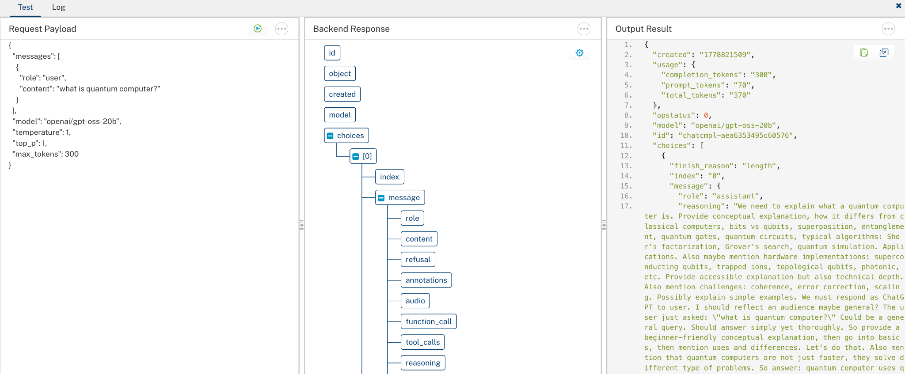

3. Publishing the App in VoltMX FOUNDRY:
After adding the Nvidia NIM Data Adapter to your app and configuring the necessary configurations, you must publish the app to HCL Foundry. For more information, refer to Publish a foundry app.
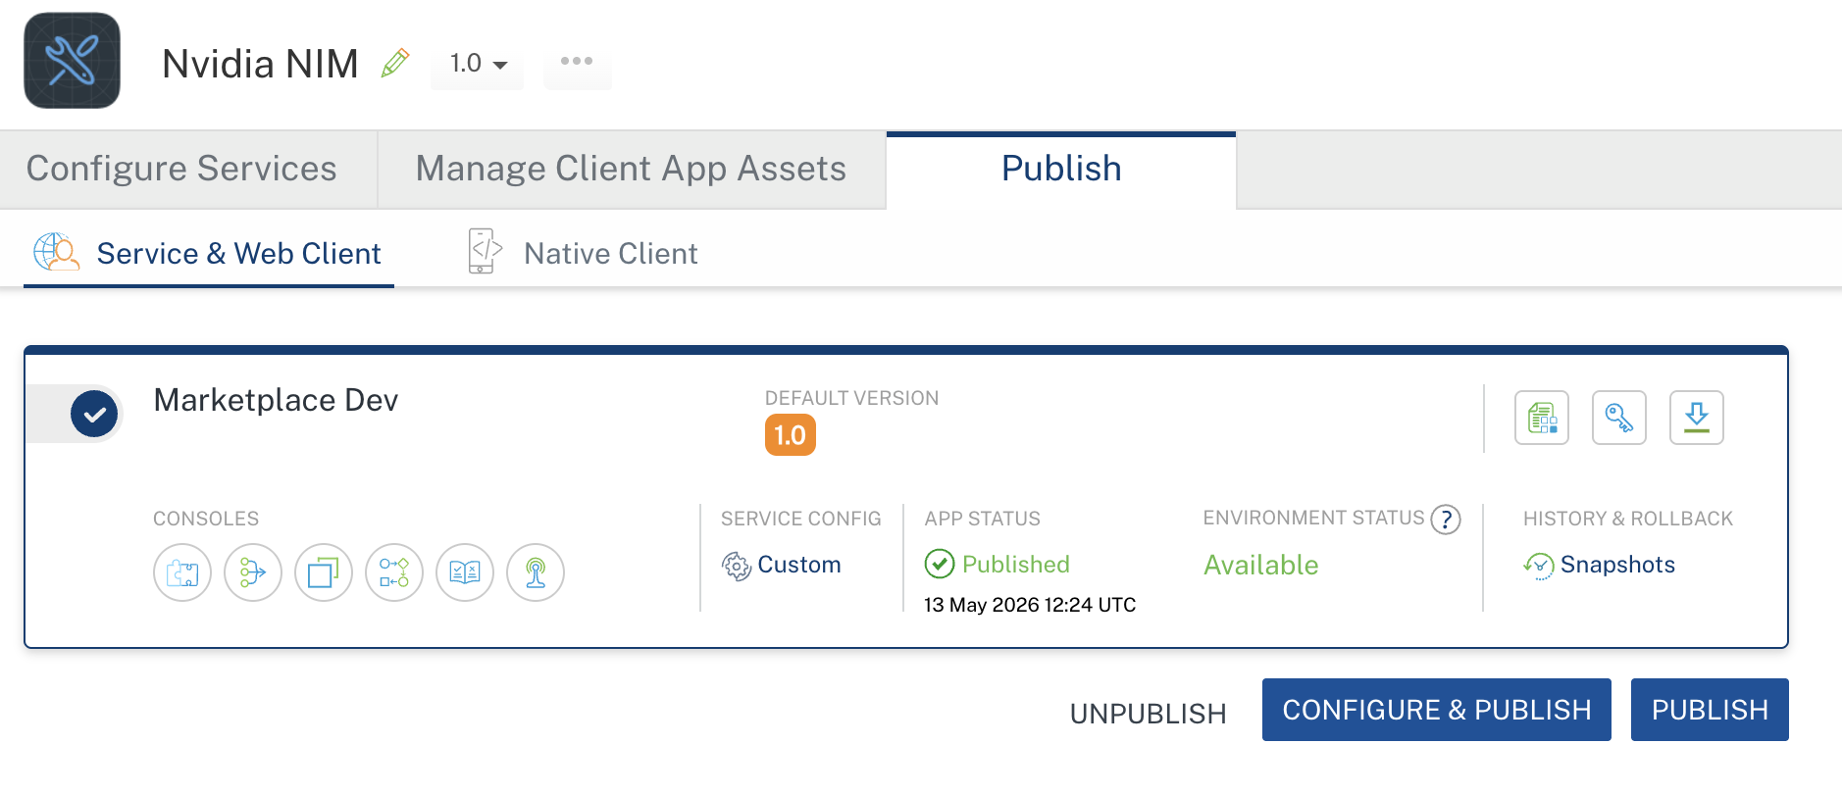

4. REFERENCES

Endpoint documentation
Nvidia NIM

5. REVISION HISTORY
Adapter version 1.0.0:

Known Issues
None

Limitations
None

