Date :  20-10-2023

Nutrition API (1.0.0)

# Overview

The Nutrition API extracts nutrition information from text using natural language processing. From food blogs to menus to recipes, it can read any text and calculate the corresponding nutrition data.

An intelligent feature of this API is custom portioning: if your text specifies quantities of individual food items or ingredients, the algorithm will automatically scale the nutrition data in the result accordingly.

# Getting Started

## Prerequisites

* Volt Foundry
* [Api-ninjas Nutirtion API](https://api-ninjas.com/profile)
* API Key to authenticate requests

## Importing the adapter

**To import the Data Adapter to Volt Foundry, do the following:**

1. Sign in to the  [HCL Foundry](https://manage.hclvoltmx.com/).
2. From the left navigation menu, select **API Management**.
3. In **API Management**, select **Custom Data Adapters**.  
   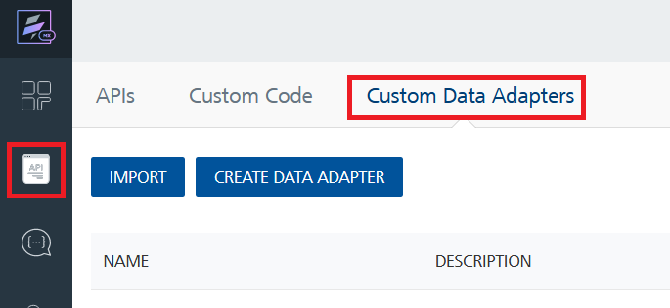
4. Click **IMPORT** to import a custom data adapter.  
   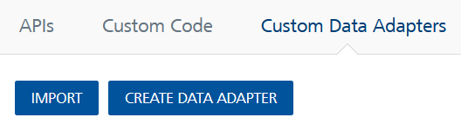
5. On the Import Data Adapter dialog box, click browser to import.  
   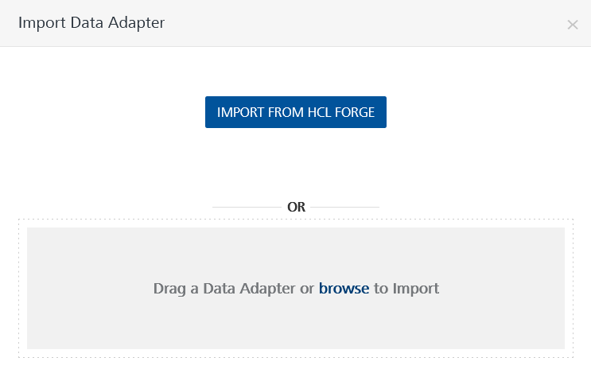
6. Select **Nutrition API** zip file and click **IMPORT**.

After you import the data adapter, Volt Foundry opens a window that shows the metadata of the data adapter.

After you import the data adapter, you can view it on the Custom Data Adapters page and use it to create services on Volt Foundry.

## [Creating an Integration service](javascript:void(0);)

After you import the data adapter into Volt Foundry, you can use it to create an Integration Service.

Follow the given steps to create an Integration service using the **Nutrition API** Adapter.

1. Sign in to the [HCL Foundry](https://manage.hclvoltmx.com/).
2. From the left navigation menu, select **API Management**.
3. In **API Management**, select **Integration**.  
   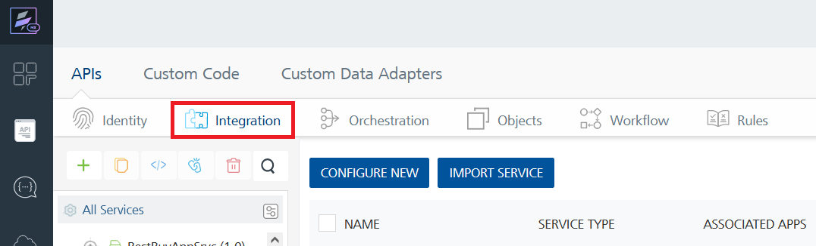
4. To create a new service, click the **+** button or the **CONFIGURE NEW** button.  
   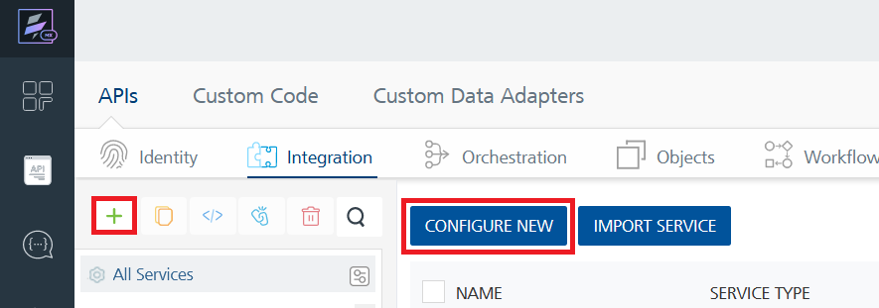
5. On the Service Definition tab, select the service type as **Nutrition API,** and click **SAVE**.  
   A screenshot of a computer

   Description automatically generated

Alternatively, you can also create a Foundry app and create an Integration service inside it.

D. [Creating and Executing operations](javascript:void(0);)



After you create an integration service, you can create and execute operations using the service.

#### Creating an Operation

* In **API Management/Foundry app you created**, in the **Integration** section, select the service that you created.
* After you select the service, navigate to the **Operation List** tab.  
  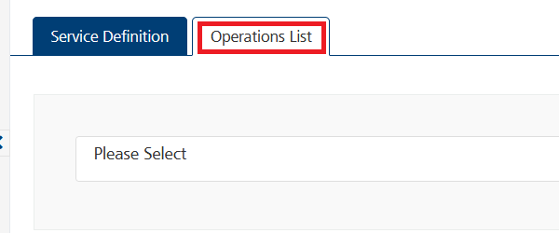
* From the drop down list, select an operation that you want to execute, and click **ADD OPERATION**.  
  A screenshot of a computer

  Description automatically generated

#### Executing an Operation

* From the **Operations List** tab, in the **Configured Operations** section, select the operation you want to execute.

* On the Operation Page, in the Request Input tab, enter a TEST VALUE for all the fields.  
  A screenshot of a computer

  Description automatically generated

* Select a run-time environment and click **Save and Fetch Response** to get a response based on your inputs.

## E. Publishing your application

If you want to use the services in client applications, you need to publish an app to a run-time environment. You can create the service (as described above) in an application or import the service into an application and publish the application.

# References

## Endpoint Documentation

### **Requests Input Parameters for “get_v1_nutrition” operation**

| **Name** | **Location** | **Type** | **Required** | **Description** |
| --- | --- | --- | --- | --- |
| query | Query | string | Yes | A string containing food or drink items. If you wish to calculate a specific quantity, you may prefix a quantity before an item. For example, 3 tomatoes or 1lb beef brisket. If no quantity is specified, the default quantity is **100 grams**. Queries cannot exceed **1500 characters**. |
| X-Api-Key | Header | string | Yes | API Key associated with your account [Api-ninjas Nutirtion API](https://api-ninjas.com/profile) |

### **Response Output Parameters for “get_v1_nutrition” operation**

| **Field** | **Type** | **Description** |
| --- | --- | --- |
| name | string | The name of the food item |
| calories | number | Calories per 100g of the food item |
| serving_size_g | number | Serving size in grams |
| fat_total_g | number | Total fat content in grams |
| fat_saturated_g | number | Saturated fat content in grams |
| protein_g | number | Protein content in grams |
| sodium_mg | number | Sodium content in milligrams |
| potassium_mg | number | Potassium content in milligrams |
| cholesterol_mg | number | Cholesterol content in milligrams |
| carbohydrates_total_g | number | Total carbohydrates content in grams |
| fiber_g | number | Fiber content in grams |
| sugar_g | number | Sugar content in grams |

## **Reference Document:** Refer this document[**API Ninjas - Nutrition API**](https://api-ninjas.com/api/nutrition)know more information about the request input, request header and response output parameters.

# Revision History

Adapter version 1.0.0:

## Known Issues

### No Known Issues

## Limitations

### No limitations