Date: 24-12-2025

NLP Cloud SENTIMENT ANALYSIS
version: 1.0.0

OVERVIEW
NLP Cloud Sentiment Analysis is a cloud-based REST API used to classify sentiment and emotion from input text using advanced transformers and LLM models such as gpt-oss-120b finetuned-llama-3-70b and llama-3-1-405b.

The API helps evaluate whether text expresses Positive, Negative, or Neutral emotions, and return emotion (joy, anger, love, sadness and others) classification with confidence scores.

Why use the NLP Cloud Sentiment Analysis

NLP Cloud Sentiment Analysis can help integrate AI sentiment and emotion analysis capabilities into your applications.

- Customer review & feedback monitoring
- Real-time sentiment and emotion classification
- Multilingual sentiment analysis support

Features:
- Customer Feedback Monitoring: Businesses can analyze customer reviews, comments, and feedback to understand the sentiment behind them help in identifying areas for improvement and addressing customer concerns, ultimately enhancing customer satisfaction.
- Product Review Classification: Gives product teams insights into what users like or dislike about features, quality, performance, etc.
- Multilingual Sentiment Analysis: Use multilingual models to analyze sentiment in over 50 supported languages.
- Emotion Detection: Identify emotional tones such as anger, frustration, joy, or excitement—to help businesses understand the intensity of customer feelings and prioritize responses accordingly.
This makes it easy to add sentiment and emotion analysis features.

Percentage of re-use:
Approximately (80-90) % of reuse.

GETTING STARTED

Prerequisites

Before you start using the NLP Cloud Sentiment Analysis Adapter, ensure the following:
- HCL Foundry
- Volt MX Iris
- NLP Cloud API Key

Creating an NLP Cloud Account and API Key:

- Go to https://nlpcloud.com/ and create a free account.
- After signing up, go to the Dashboard.
- Navigate to API Key and Copy the generated API key and store it securely.

Importing the Data Adapter

You can import NLP Cloud Sentiment Analysis Data Adapter into HCL Foundry directly from the Volt MX website or by importing the data adapter zip file.

To import the Data Adapter to Volt Foundry, do the following:
- Sign in to the HCL Foundry.
- From the left navigation menu, select API Management.
- In API Management, select Custom Data Adapters.
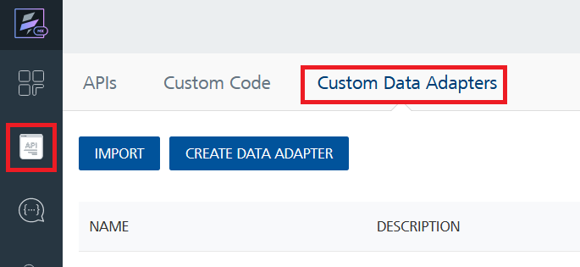
- Click IMPORT to import a custom data adapter.
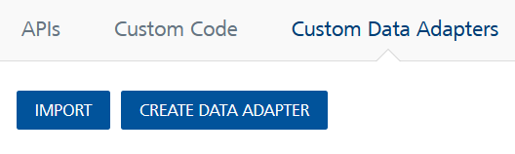

- On the Import Data Adapter dialog box, click browser to import.
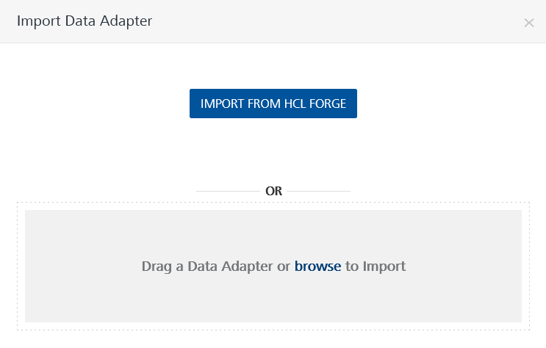
- Drag the data adapter zip file into the Drag a Data Adapter box.
Or
Click browse. The Open dialog appears.
Navigate to the location where you downloaded the data adapter (zip file) on your computer, select the data adapter, and click Open. The Import Data Adapter dialog shows the selected data adapter.
Note: Click Remove if the selected data adapter is not the one that you want to import.

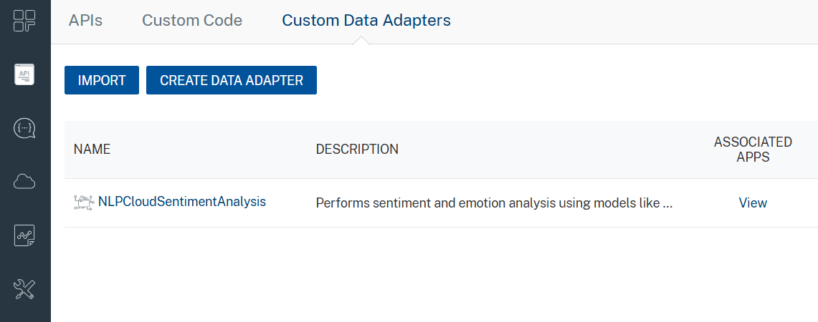

To import the data adapter zip file, do the following:
- Perform steps 1 through 4 in the above procedure
- Drag the data adapter zip file into the Drag a Data Adapter box.
Or
Click browse. The Open dialog appears.
Navigate to the location where you downloaded the data adapter (zip file) on your computer, select the data adapter, and click Open. The Import Data Adapter dialog shows the selected data adapter.

Note: Click Remove if the selected data adapter is not the one that you want to import.

Creating an Integration Service with NLP Cloud Sentiment Analysis
After you import NLP Cloud Sentiment Analysis Data Adapter into Foundry, you must create an integration service with service type as NLPCloudSentimentAnalysis to connect with your NLP Cloud Sentiment Analysis developer site.
To create an integration service with NLP Cloud Sentiment Analysis, do the following:
- Log on to your Foundry. The Dashboard page appears by default.
- In the left panel, click the API Management menu. The APIs tab opens by default.
- Click the Integration tab. The Integration tab opens with a list of existing integration services.
- Click CONFIGURE NEW. The Service Definition tab opens.
- In the Name box, type a unique name for your service.
- From the Service Type list, select NLPCloudSentimentAnalysis.
Note: The NLPCloudSentimentAnalysis is listed only after you import the NLPCloudSentimentAnalysis Data Adapter into Volt MX Foundry.
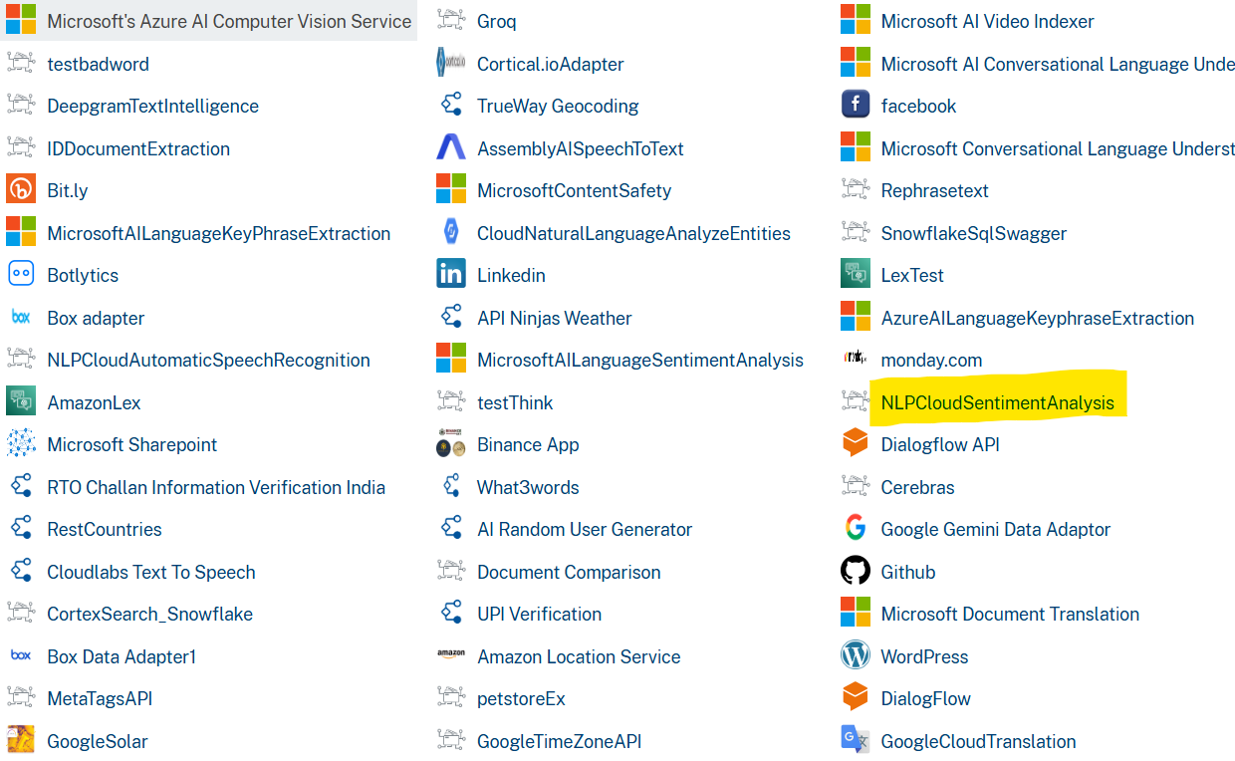

- Click Save.
If the details provided are valid, the Foundry service connects to your NLP Cloud Sentiment Analysis developer site and allows you to make the API calls.
Refer to Integration Services for more information on creating and using integration services.

- Creating an operation

To make any API call in the Foundry console, you must create an selected operation for the respective API and then execute the operation. Executing an operation involves making the API call and displaying the response. For more information, see Executing an operation.

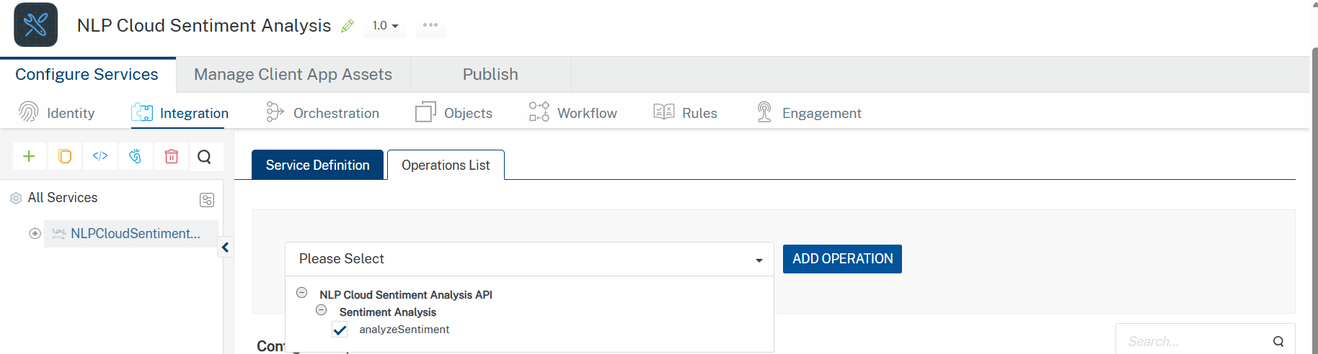

- Executing an operation

Under the Configured Operations section, click the operation. The Request Input sub-tab opened by default. Provide Body and Headers.

- Provide the required parameters, such as text (the input text) and model_name (the AI model to use).
- The remaining parameter target is optional. You can use it as needed for your use case.
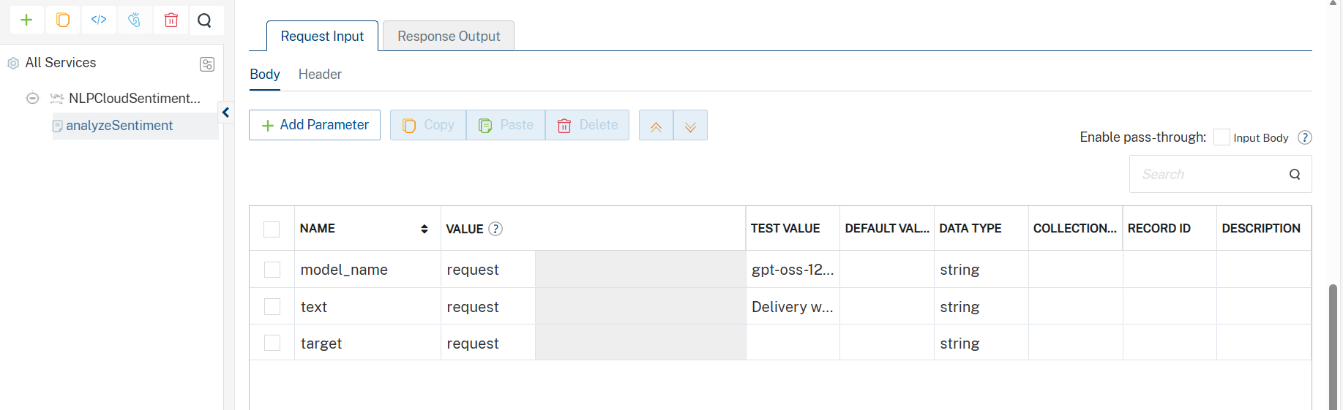

Enter the value of the API key as the default value created during the Creating an NLP Cloud Account and API Key.
NLP Cloud Sentiment Analysis accepts the API key in the format: Token YOUR_API_KEY in the Headers.

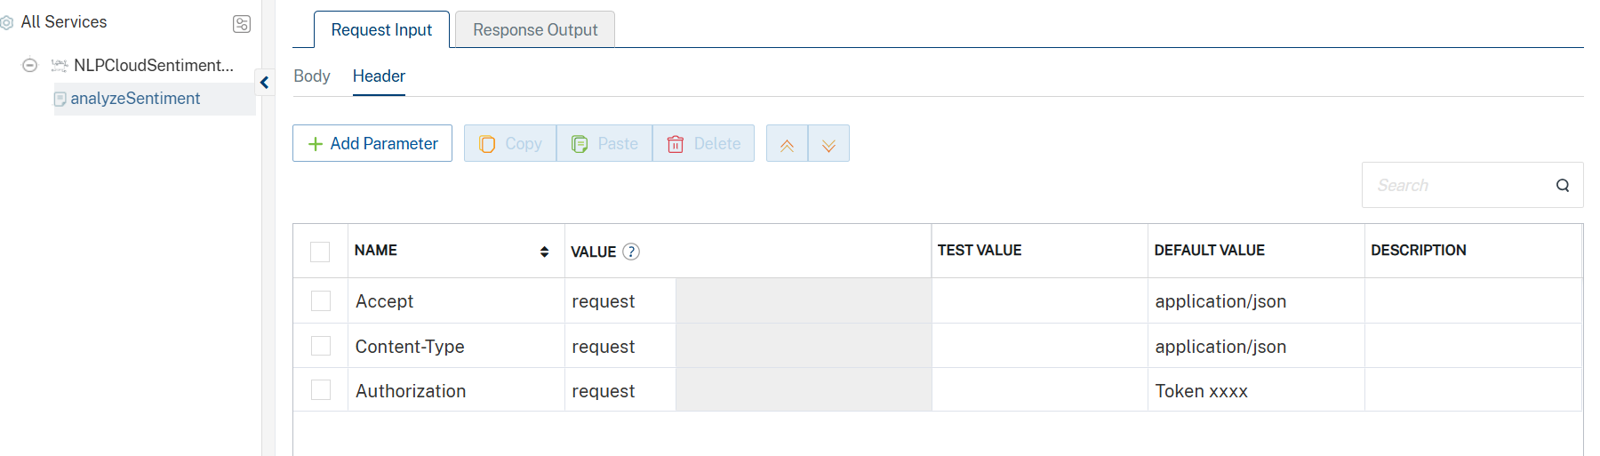

- Click SAVE AND FETCH RESPONSE. The Output Result dialog appears with the response. Otherwise, the Output Result shows an error.

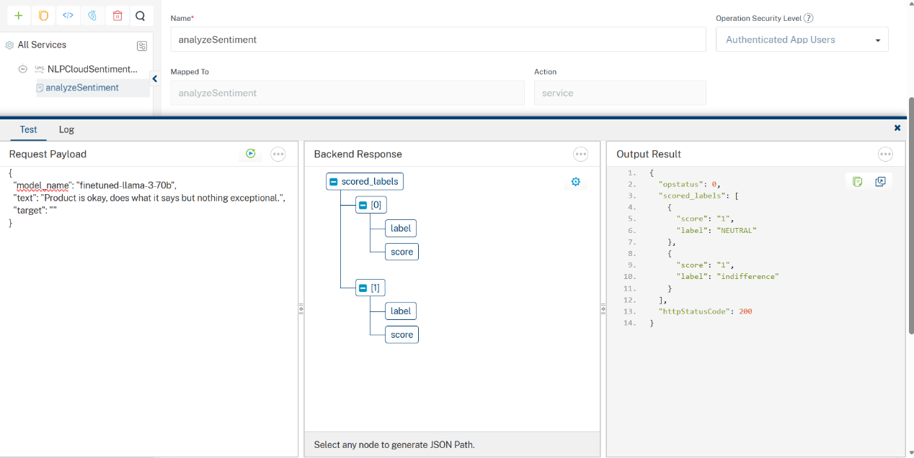

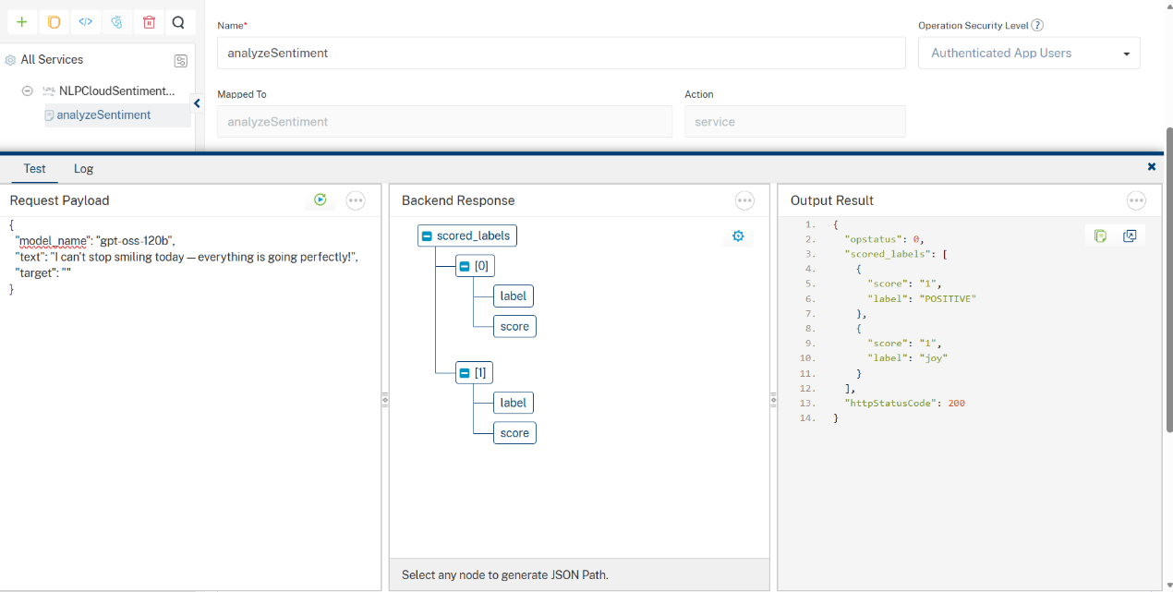

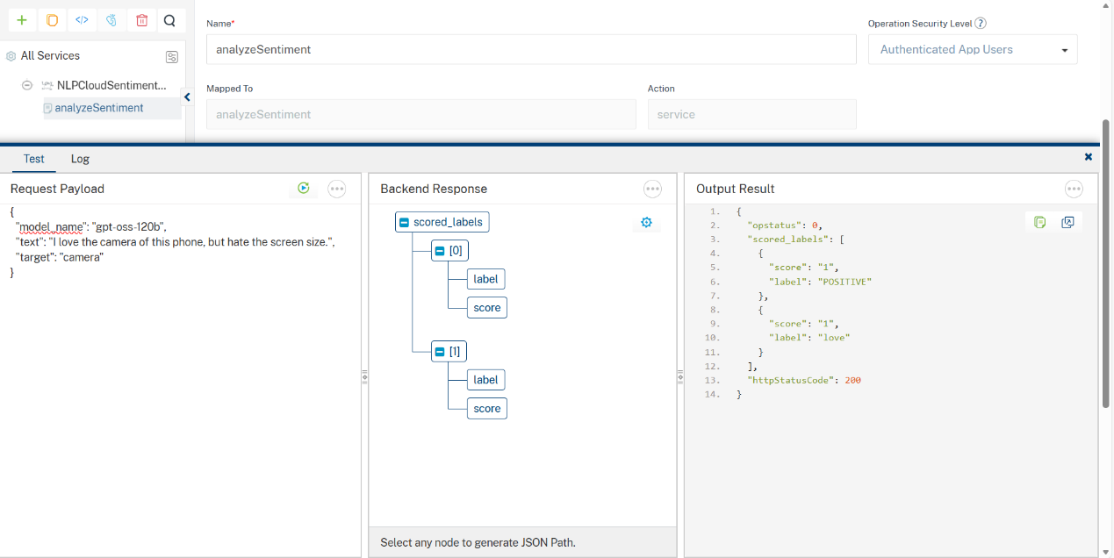

Publishing your application
If you want to use the services in client applications, you need to publish an app to a run-time environment. You can create the service (as described above) in an application or import the service into an application and publish the application.

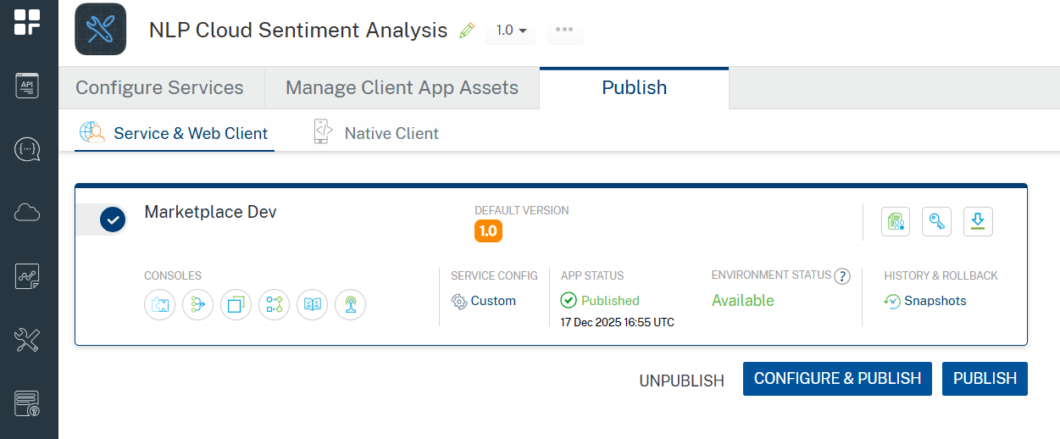

References

Endpoint Documentation
https://nlpcloud.com/pricing.html

https://docs.nlpcloud.com/#sentiment-analysis

Revision History
App version 1.0.0:

Known Issues
- No Known Issues

Limitations
- Input Size Limits: Maximum input sizes vary depending on the model. more info refers to https://docs.nlpcloud.com/#sentiment-analysis .
- The Sentiment Analysis adapter has been configured to use the GPU endpoint (/v1/gpu/<model_name>/sentiment>), as this endpoint consistently supports models like gpt-oss-120b, llama-3-1-405b, and finetuned-llama-3-70b, while also reliably returning both sentiment and emotion analysis outputs.
During initial testing and validation using Postman, we noticed that the default endpoint referenced in the official documentation https://docs.nlpcloud.com/#sentiment-analysis behaved inconsistently.
Some models responded with "GPU only available", while others failed due to unsupported model. Based on these observations, we updated the endpoint to the GPU, after which responses became stable and consistent across the few models (gpt-oss-120b, llama-3-1-405b, and finetuned-llama-3-70b).

