Date : 25-Nov-25

NLP CLOUD QUESTION ANSWERING COMPONENT

VERSION: 1.0.0

OVERVIEW
The NLP Cloud Question Answering Component is a reusable component that provides a minimal UI for sending user text input to an external NLP service (such as NLP Cloud Question Answering). It acts purely as an input + trigger, while all API responses are returned through events, making the component easy to embed in larger low-code or no-code applications.
NLP Cloud Question Answering API is a cloud-based REST service that uses advanced Natural Language Processing (NLP) models to accurately extract or generate answers to user questions from text. You can optionally provide context (a block of text) for the model to use in answering the question. It supports multilingual input (via the multilingual add-on) and works with powerful generative models (e.g., GPT-OSS 120B, LLaMA 3.1 405B, fine-tuned LLaMA 3.3 70B).
The service enables developers to integrate intelligent Q&A capabilities directly into their applications, allowing users to ask natural language questions and instantly receive precise, context-aware answers. Typical use cases include enterprise search, document assistants, knowledge retrieval, customer support bots, and Q&A over internal document repositories.
- Use case:
Question Answering can be usefully used in the "real world". Here are a couple of examples.
- Customer Support Automation:
Extract specific answers from FAQ databases or knowledge bases, reducing agent workload.
- Contracts Questions: Chat bots are used more and more everyday, both to answer customer questions and internal collaborators questions. Imagine that a customer is asking a legal question about his contract. You could perfectly use a question answering model for that and pass the contract as a context.
- Chatbots and Virtual Assistants:
Enable question answering capabilities for user queries within conversational systems.
- E-Learning and Knowledge Platforms:
Enhance learning systems by answering questions from textbooks or uploaded notes.
- Features:
- Context-Aware Answering: Provides accurate answers by using the supplied context text, ensuring responses are grounded in your documents.
- Multilingual Question Support: Allows questions and context in multiple languages through multilingual-enabled models.
- Works With or Without Context: Can answer general questions without context or deliver domain-specific answers when context is provided.
- Production-Ready API: Scalable cloud REST API with secure processing, low latency, and easy integration into applications or chatbots.
- Percentage of Reuse:
- Approximately 80–90% reuse.

GETTING STARTED

Prerequisites
Before using the NLP Cloud Question Answering Component, ensure you have the following:
- HCL Foundry
- Volt MX Iris
- NLP Cloud API Key

Creating an NLP Cloud Account and API Key:

- Go to https://nlpcloud.com/ and create a free account.
- After signing up, go to the Dashboard.
- Navigate to API Key and Copy the generated API key and store it securely - you will need it while configuring the integration service in Foundry.

Platforms Supported

Mobile

iOS

Android

Importing the component

You can import the Forge components only into the apps that are of the Reference Architecture type.

To import the NLP Cloud Question Answering Component, do the following:

Open your app project in Volt MX Iris.
  - In the Project Explorer, click the Templates tab.
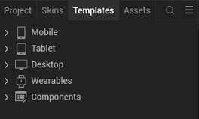

  - Right-click Components, and then select Import Component. The Import Component dialog box appears.
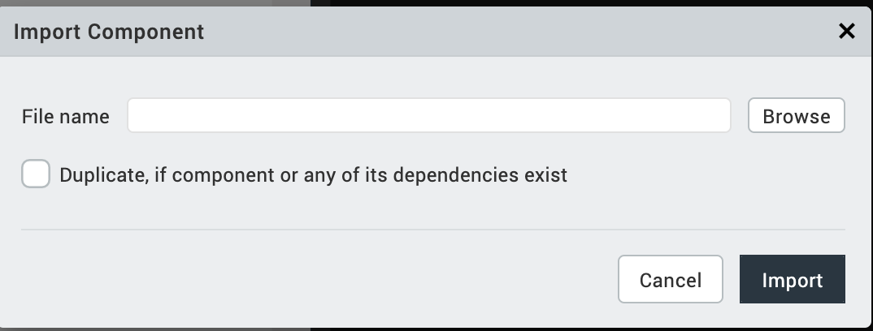
  - Click Browse to navigate to the location of the component, select the component, and then click Import. The component and its associated widgets and modules are added to your project.
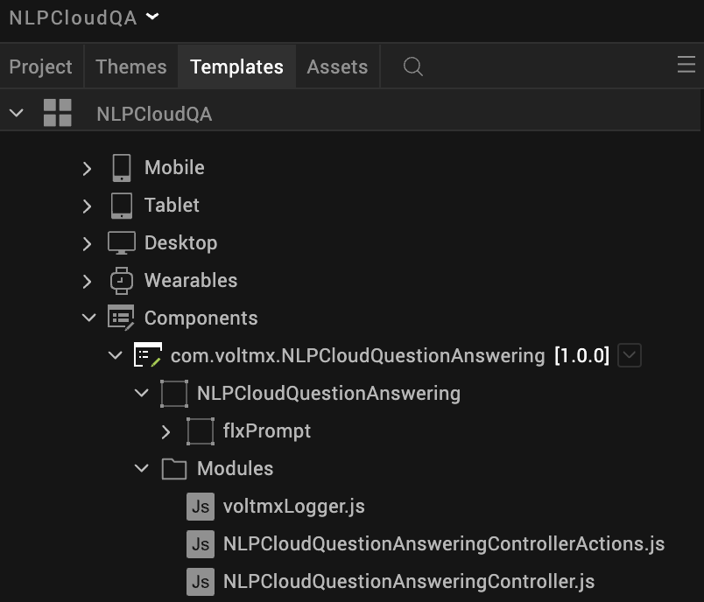

Once you have imported a component to your project, you can easily add the component to a form. For more information, refer Add a Component to a Form

Foundry APP Setup
When you import the component to your Volt MX Iris project, the HCL Volt MX Foundry services of the NLP Cloud Question Answering are added to the HCL Volt MX Foundry app, which is associated with the Volt MX Iris project. While importing the NLP Cloud Question Answering Component to your Volt MX Iris project, if there is no HCL Volt MX Foundry app associated with the existing Volt MX Iris project, a new HCL Volt MX Foundry app is automatically added to your HCL Volt MX Foundry environment and is associated with your Volt MX Iris.
To set the Foundry app, follow these steps:
- Click the HCL Volt MX Foundry app associated with your Volt MX Iris project from the Project Explorer. Click DATA & SERVICES
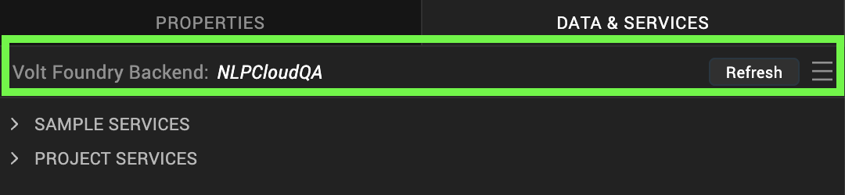
- Under the Configure Services tab, click Integration and can see the NLPCloudQA service. Click on Integration service to add the keys.
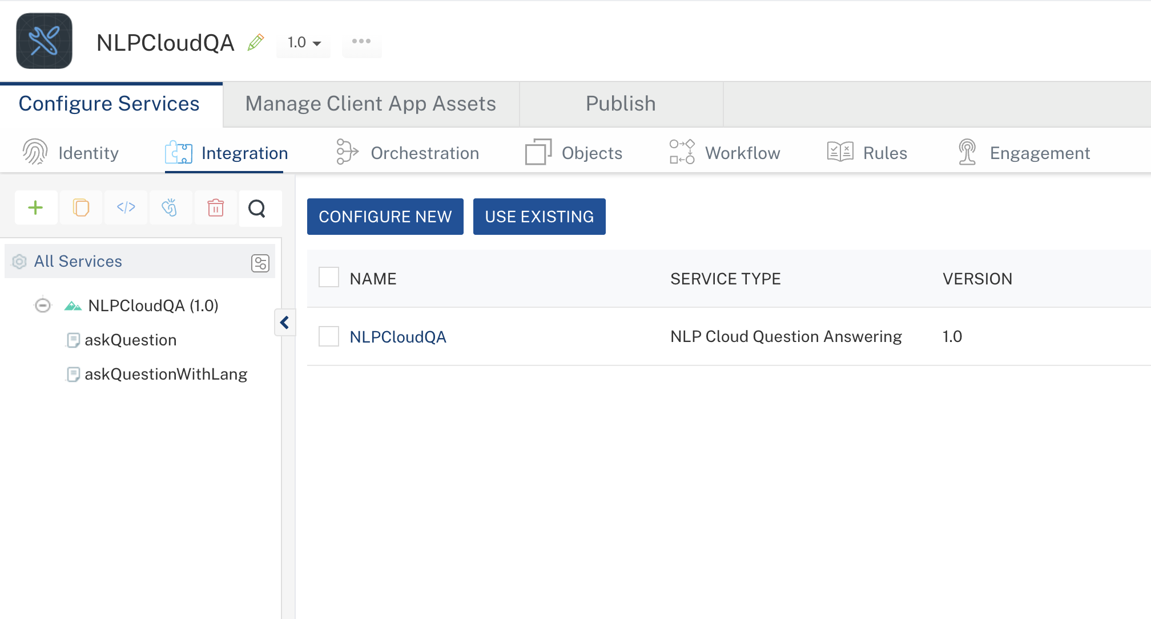
- Click the NLPCloudQA Integration service. On the right pane, expand the NLPCloudQA service and then select the askQuestion operation.
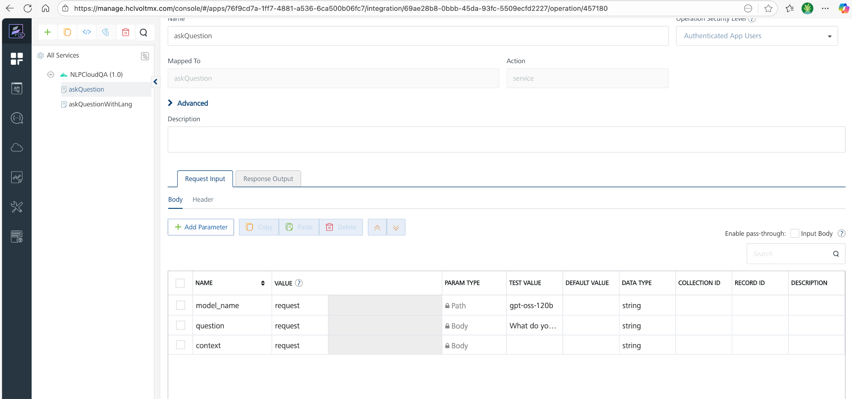
- The askQuestion tab opens with the Request Input sub-tab opened by default.
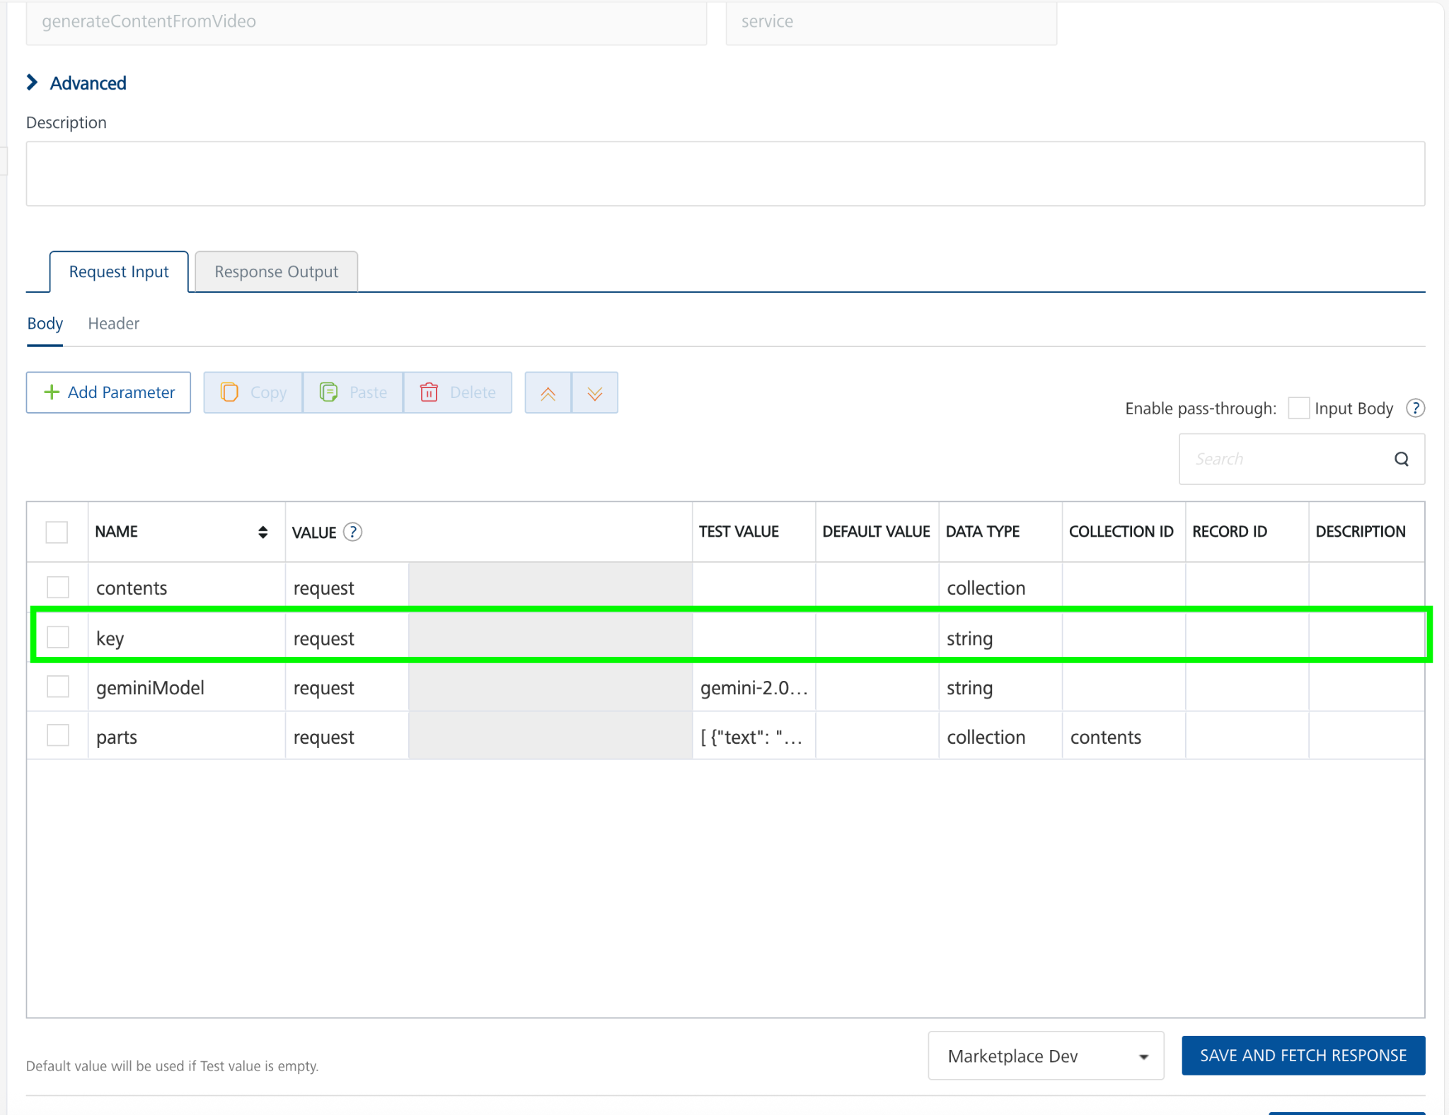
- On the Request Input tab, in the Body section, for the following parameters, specify the values in the respective boxes under the Test Value column.
Parameter | Description | Syntax example
model_name (or similar) | Identifies which model to use for the QA endpoint (e.g., “gpt-oss-120b”). You can find the available models here https://docs.nlpcloud.com/#question-answering | "model_name": "gpt-oss-120b"
question | The question you’re asking the model. | "question": "What is the warranty period on the HP LaserJet Pro?"
context | (Optional) A block of text/document the model may use to find the answer. | "context": "Every HP printer comes with at least a one-year HP commercial warranty..."
NOTE: For askQuestionWithLang operation the language_code parameter specifies the input language of your question and context when using the Multilingual Add-On.
This ensures NLP Cloud automatically translates the input to English, performs question answering, and then translates the answer back to the specified language.
E.g. "hin_Deva" for Hindi, "mar_Deva" for Marathi, "eng_Latn" for English — using codes from the language-list dropdown. You can find the full list of supported language codes in the NLP Cloud documentation: https://docs.nlpcloud.com/#multilingual-add-on
- Click Header sub-tab. The Header section opens.
- For Authorization, In the box under the DEFAULT VALUE column, type the API Key generated from https://nlpcloud.com/home/token.
Syntax: Token Your_API_KEY
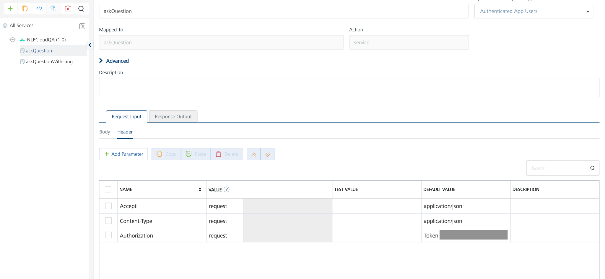
- Click SAVE AND FETCH RESPONSE. The Output Result dialog appears with the response. Otherwise, the Output Result shows an error.
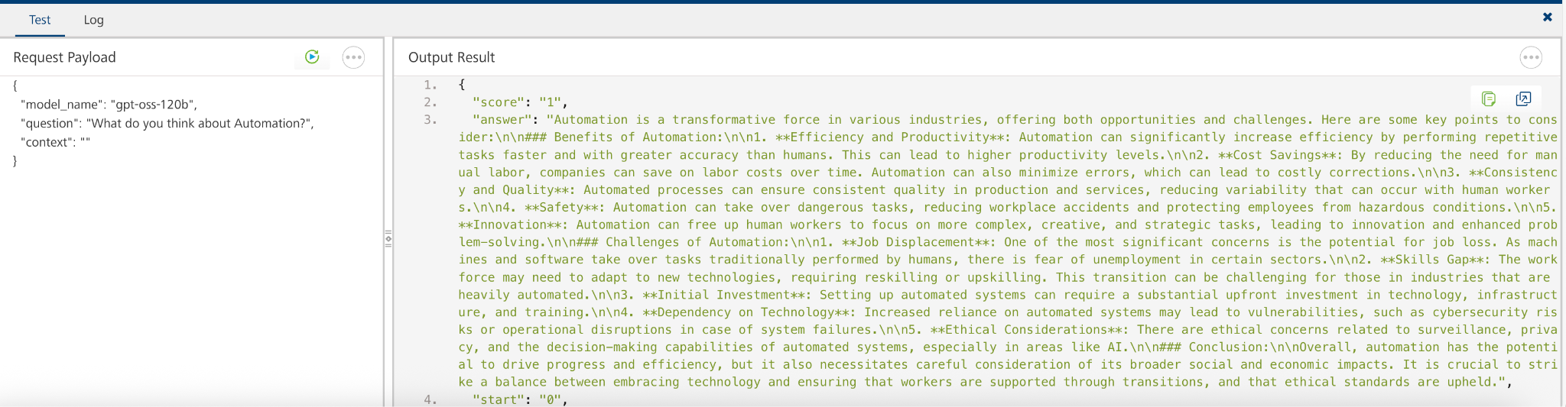
- Click the icon to go back to Volt MX Iris.

Publish the HCL Volt MX Foundry App
After you set the Operation Security Level, you must publish the HCL Volt MX Foundry app. To publish the HCL Volt MX Foundry, follow these steps:
In Volt MX Iris, click DATA & SERVICES, and then click Publish Project Services to Publish to your foundry app.
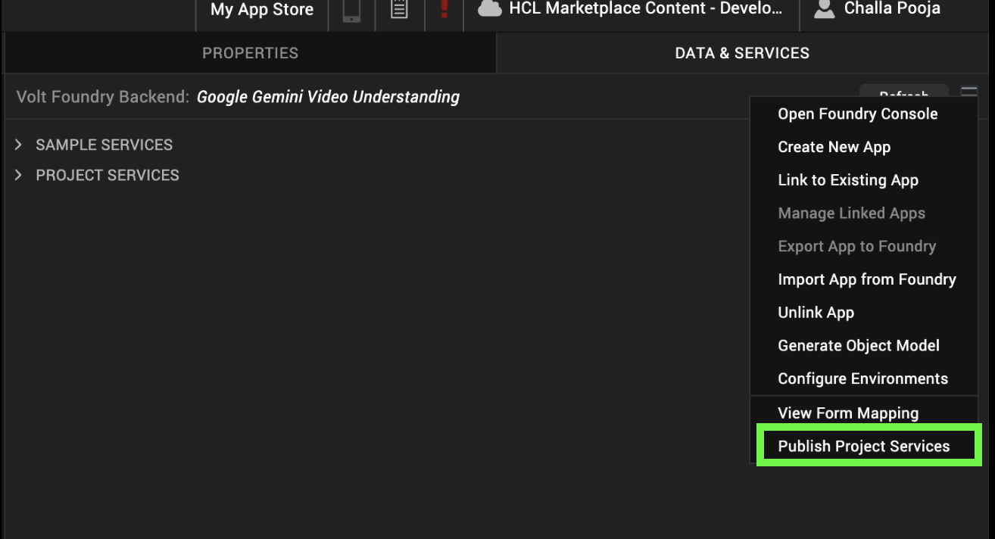
Select the environment to which you want to publish your app, and then click Publish.
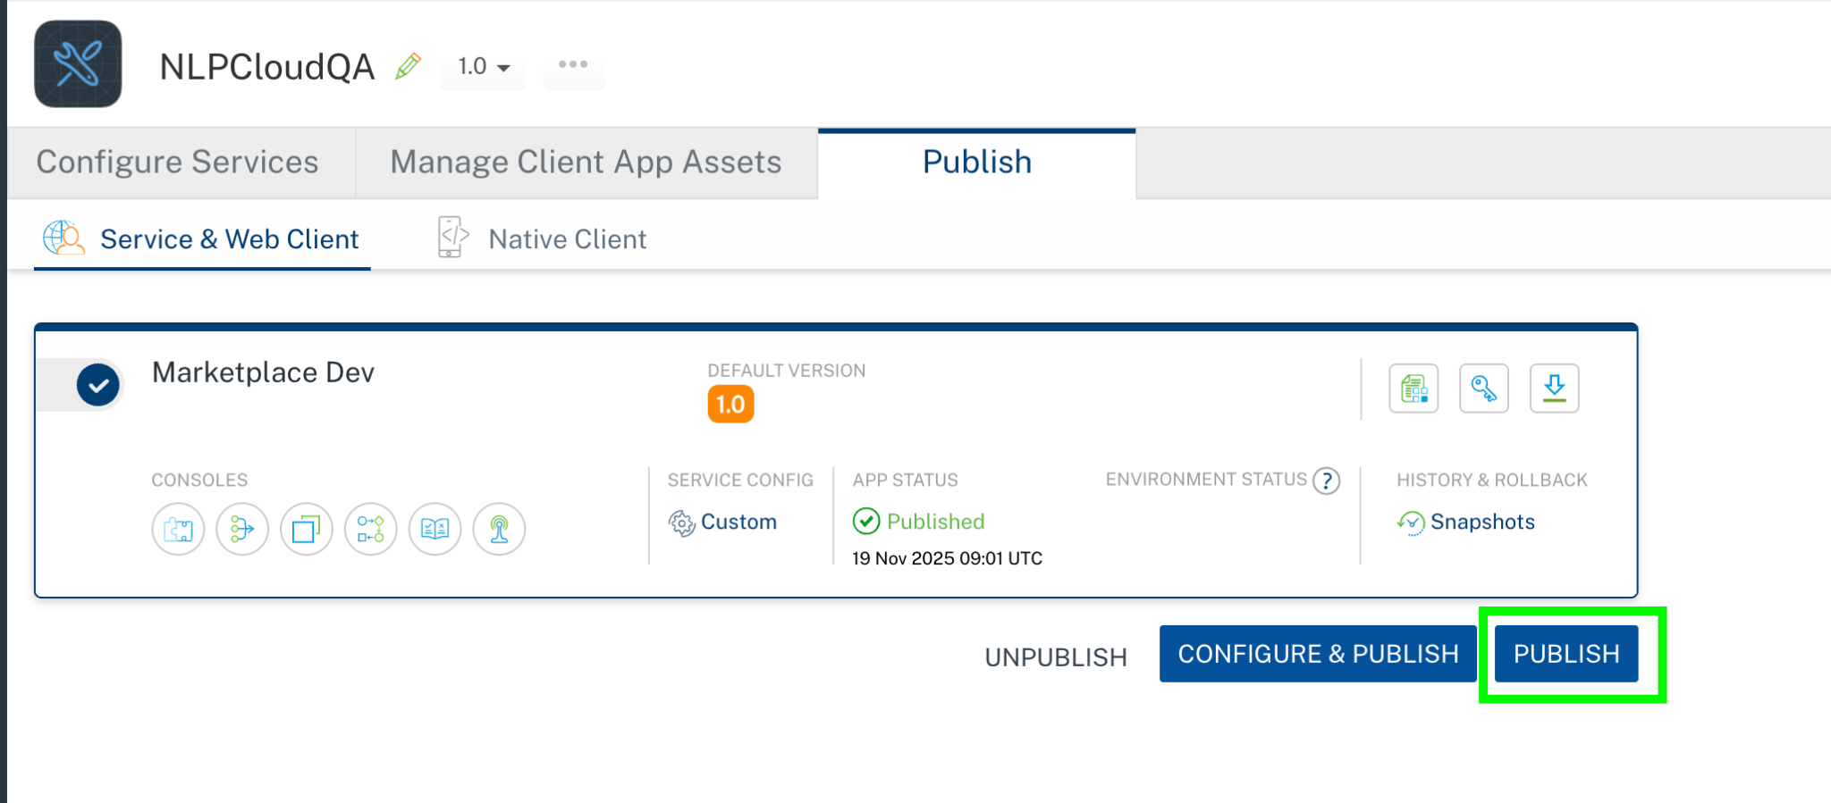
After the app is published to your environment, the following window appears confirming the publish.
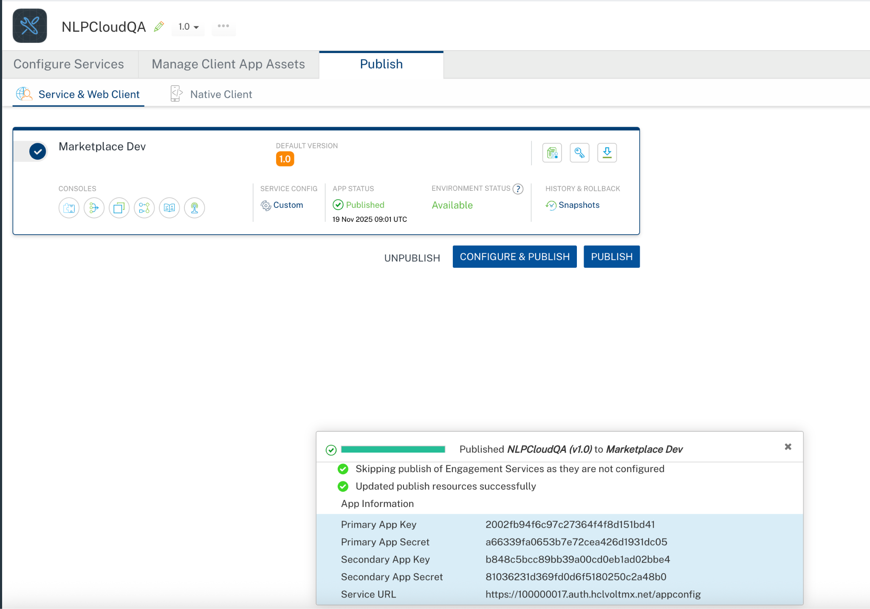

Building and previewing the app
After performing all the above steps, you can build your app and run it on your device. For more information, you can refer to the Building and Viewing an Application section of the Volt MX User Guide.
You can then run your app to see the NLP Cloud Question Answering Component work in real time.

REFERENCES

Dynamic Usage
You can also add a NLP Cloud Question Answering Component component dynamically. To do so,
1. In the Project Explorer, on the Projects tab, click Controllers section to access the respective Form Controller. Create a method and implement the code snippet similar to the sample code mentioned below.

/* Creating NLP Cloud Question Answering Component Component instance */

createComponent: function()
{
/* Creating the component's object */
var NLPCloudQuestionAnswering = new com.voltmx.NLPCloudQuestionAnswering(
{
"clipBounds": true,
"height": "10%",
"id": "NLPCloudQuestionAnswering",
"isVisible": true,
"left": "0dp",
"top": "90%",
"width": "100%",
"zIndex": 1
}, {}, {});
//General properties
NLPCloudQuestionAnswering.ModelName = "gpt-oss-120b";
this.view..add(NLPCloudQuestionAnswering);
}
In the code snippet, you can edit the properties of the component as per your requirement. For more information, see Setting Properties.
2. Save the file.

- Properties:

General Properties

- ModelName

Description: | Specifies which model to use (e.g., “gpt-oss-120b”).
Syntax: | ModelName
Type: | String
Read/Write: | Read + Write
Example: | this.view.NLPCloudQuestionAnswering.ModelName = "gpt-oss-120b";
- Question

Description: | Specifies the question you’re asking the model.
Syntax: | Question
Type: | Integer
Read/Write: | Read + Write
Example: | this.view.NLPCloudQuestionAnswering.Question = "";

APIs

No APIs

Events

getInput

Description: | Invoked after the input/Question is entered. This getInput should be invoked in the onNavigate function.
Syntax: | getInput
Parameters: | text: The given question or input text
Remarks: | Need to invoke this event to get the input text
Example: | onNavigate: function() {  this.view.NLPCloudQuestionAnswering.getInputText = function(text){  try{  if(text){  alert("Question= "+text);  }  else{  alert("Input is empty");  }  }.bind(this);  }

getGeneratedContent

Description: | Invoked after the component generates the content. This getGeneratedContent should be invoked in the onNavigate function.
Syntax: | getGeneratedContent
Parameters: | response[JSON] : The generated JSON object from the NLP Cloud Question Answering
Remarks: | Need to invoke this event to get the generated content result.
Example: | onNavigate: function() {  this.view.NLPCloudQuestionAnswering.getGeneratedContent = function(generatedContent){  try{  if(generatedContent){  alert("Generated content= "+JSON.stringify(generatedContent));  }  }  catch(err){  voltmx.ui.Alert({  message: "err in getGeneratedContent= "+err.message,  alertType: constants.ALERT_TYPE_INFO,  yesLabel: "OK"  }, {} );  }  }.bind(this);  }

onErrorCallback

Description : Invoked when error occurs.

Syntax : onErrorCallback

Parameters : args [Array of JSON] : Contains information about the error.

Example : this.view.NLPCloudQuestionAnswering.onErrorCallback= function(args)
{
alert("Error: "+JSON.stringify(args));
}.bind(this);

Reference API documentation: https://docs.nlpcloud.com/#question-answering

REVISION HISTORY
Adapter version 1.0.0:

Known Issues
None

Limitations
None

