Date : 22-June-26

NEBIUS APPLICATION

VERSION: 1.0.0

OVERVIEW
Nebius Token Factory API is a single AI platform that lets you use different AI models through one simple REST API. Instead of connecting separately to each provider, you can access text generation, chat, embeddings, reranking, and image generation using one unified system.
It supports OpenAI-style API formats, so it is easy to integrate into existing applications without major changes. You can use endpoints like chat completions, text completions, embeddings, and image generation depending on your needs.
Nebius helps developers build AI applications like chatbots, search tools, content generators, and image-based apps. It also provides basic controls like usage tracking and project-level management to help monitor and manage API usage easily.

Use case:
- Multi-model AI apps – Build chatbots and assistants using models like Llama, Mistral, and others through one API.
- Text generation & summarization – Create emails, blogs, and summaries using a single OpenAI-style interface.
- Smart routing – Automatically choose the best or cheapest model based on speed, cost, or task.
- Request tracking – Log all API calls to help with debugging and monitoring.
- Cost tracking – See token usage and spending across models in one place.
- Caching support – Reuse previous responses to reduce cost and improve speed.
- Failover support – Switch to another model if one fails to keep apps running smoothly.
- Prompt testing – Try different prompts across models and compare results easily.
- Multimodal support – Work with both text and images using a single API gateway.
- Observability tools – Monitor latency, errors, and performance using analytics.
- Easy integration – Connect AI to web or mobile apps using simple REST APIs without managing multiple SDKs.

Features:
- Multiple Model Access: Access models from OpenAI, Anthropic, Google, and open-source models like Llama and Mistral through one unified API.
- Unified Text Generation & Chat:Generate text, chat responses, summaries, and conversational AI using a single OpenAI-compatible API.
- Smart Model Routing:Automatically select the best model based on cost, speed, or performance needs.
- AI Request Logging & Observability:Track all API requests and responses for debugging, monitoring, and performance analysis.
- Cost Tracking & Usage Analytics:Monitor token usage and costs across all models to manage and optimize spending.
- Caching & Performance Optimization:Reuse repeated responses to reduce latency and lower API costs.
- Failover & Reliability Handling:Automatically retry or switch models if a request fails to ensure reliability.
- OpenAI-Compatible REST API:Integrates easily using standard HTTP requests and JSON formats without major code changes.
- Prompt Testing & Experimentation:Compare prompts across different models to improve output quality.
- Scalable & Developer-Friendly:Build and scale AI applications easily without managing multiple provider APIs separately.

Percentage of re-use:
80%

GETTING STARTED

Prerequisites
Before you start using the Nebius Adapter, ensure you have the following:

- HCL Foundry
- Nebius API Key Account - Get a Nebius API key
Step 1: Create a Nebius Account
- Navigate to the Nebius website.
- Sign up using your email, Google.
- Log in to access the Nebius Dashboard.

Step 2: Generate a Nebius API Key
- Go to the Nebius Token Factory Dashboard.
- Navigate to the API Keys section
- Click on “Get API key” (top-right blue button).
Step 3: Create the API Key
A popup will appear. Fill in the details:
- Name: Example → testNebius or dev-key
- (Optional) Select the project scope if required
Click on Create / Generate API Key
Step 4: Copy the API Key
- You will see a key like: v1.xxx-xxxxxxxxxxxx
- Copy it immediately and store it securely.❌ You will NOT be able to view it again later.
.

Devices
- Mobile

Platforms
- Android emulator
- IOS Simulator

Importing the App
To import the NebiusApp to Volt MX Iris, do the following:

To import the NebiusApp, do the following:
- Launch Volt MX Iris.
- Click project, and then select Import. The Import dialog box appears.
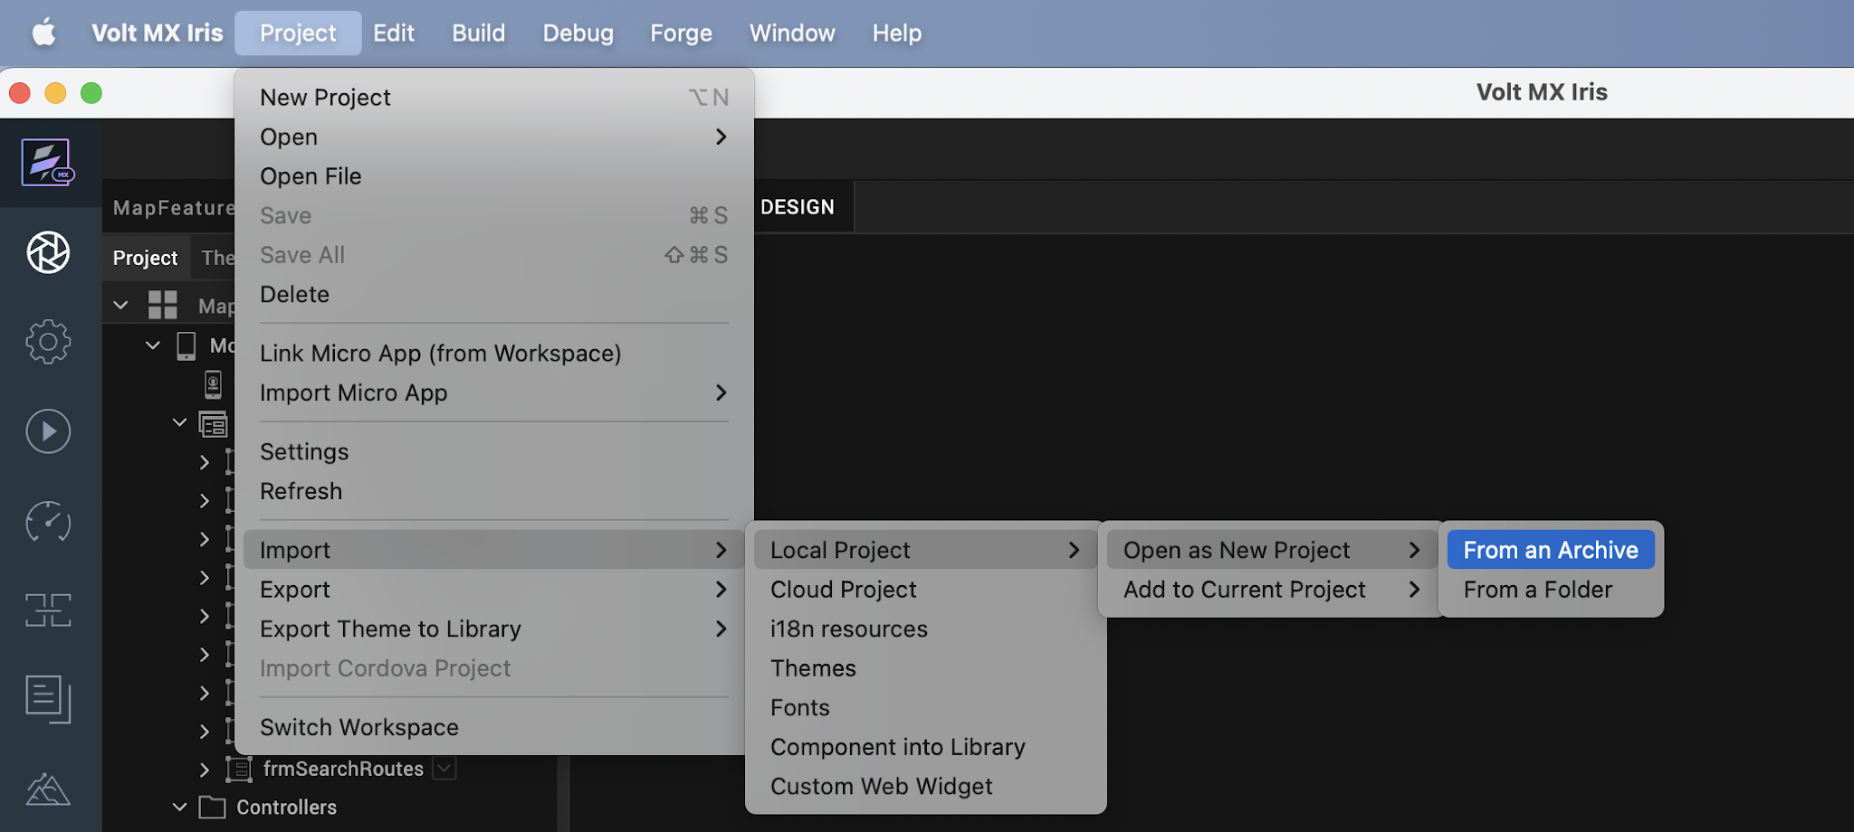

- Click From an Archive to navigate to the location of the project, select the files, and then click Import.
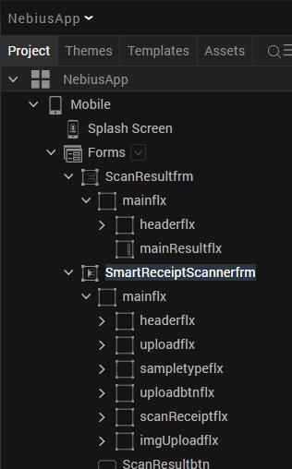
After you import the application, you can view the associated Foundry app connected at the in Data & Services section.
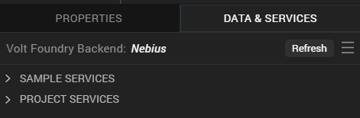

Nebius Volt MX Foundry Services:
When you import the application to your Volt MX Iris project, the HCL Volt MX Foundry services of the Nebius are added to the HCL Volt MX Foundry app, which is associated with the Volt MX Iris project. While importing the NebiusApp to your Volt MX Iris project, if there is no HCL Volt MX Foundry app associated with the existing Volt MX Iris project, a new HCL Volt MX Foundry app is automatically added to your HCL Volt MX Foundry environment and is associated with your Volt MX Iris.
To set up the Foundry app, follow these steps:

1. Click the HCL Volt MX Foundry app associated with your Volt MX Iris project from the Project Explorer. Click on DATA & SERVICES.

2. Under the Configure Services tab, click Integration and can see the Nebius Integration service. Click on that Integration service to add the keys.

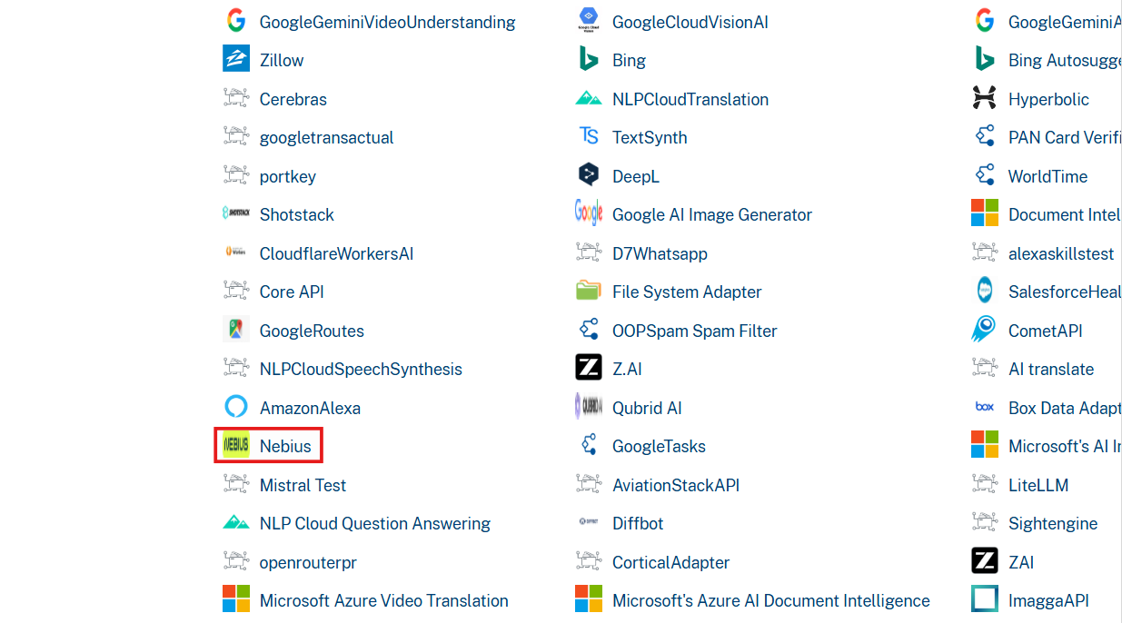

3. Click the Operations List tab. The Operations List tab opens with the list of operations available.
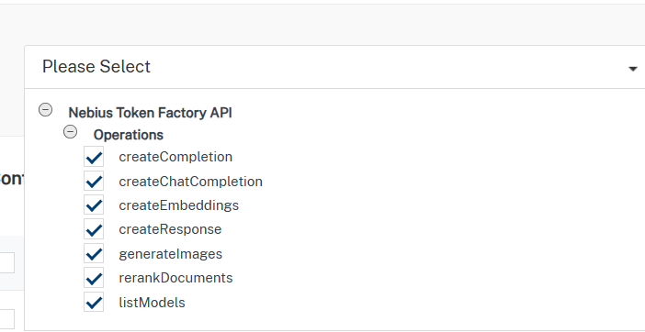
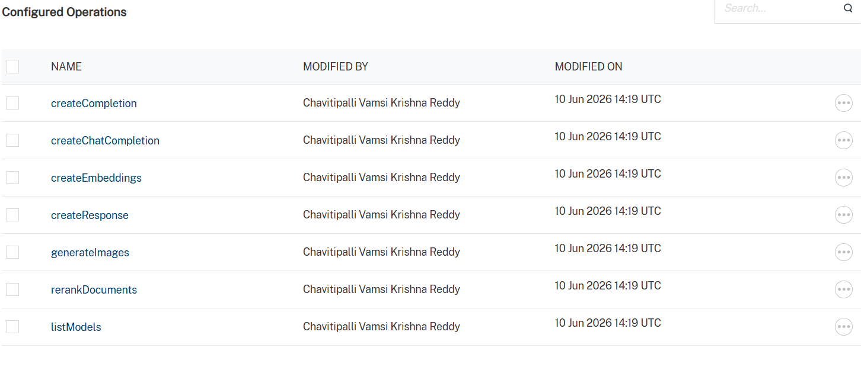

4. Executing an operation
A) Under the Configured Operations section, click the operation. The Request Input sub-tab opened by default. Provide Body and Headers.
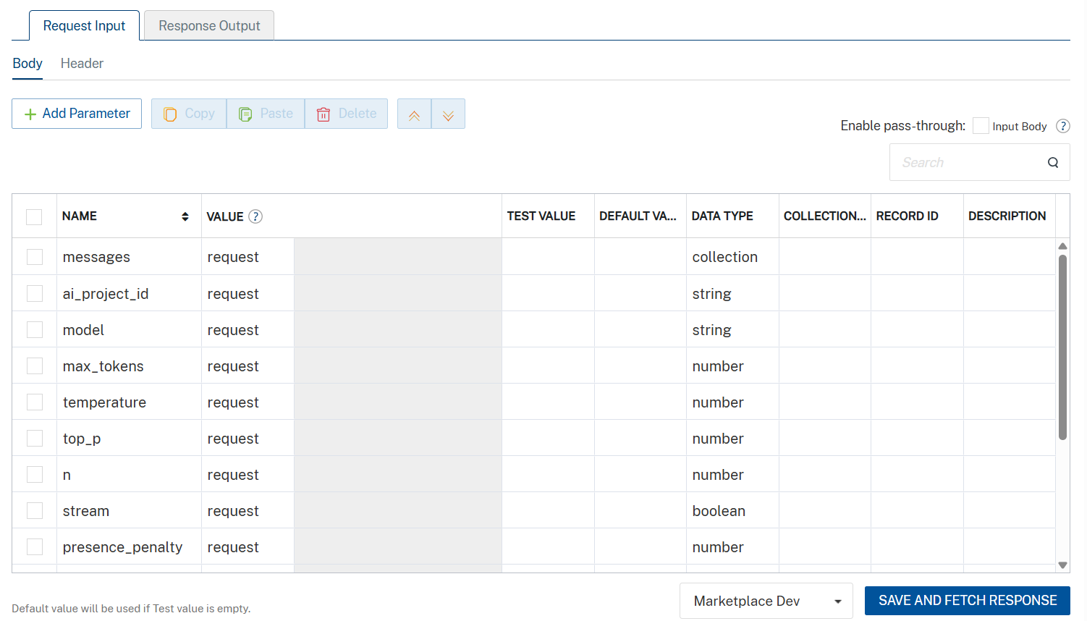
Parameter | Description | Syntax Example
model (Required) | Specifies which AI model to use for the request. Available models depend on your Scaleway configuration. | "model": "gemini-2.5-flash"
messages (Required) | Array of conversation messages. Each message must include a role (system, user, or assistant) and content. | "messages": [  { "role": "system", "content": "You are a helpful assistant." },  { "role": "user", "content": "Say hello in one sentence." }  ]
temperature (Optional) | Controls randomness of output. Lower values produce deterministic responses; higher values increase creativity. | "temperature": 0.7
max_completion_tokens  (Optional) | Maximum number of tokens the model can generate in the response. | -9007199254740991 <= x <= 9007199254740991
top_p (Optional) | Nucleus sampling parameter that controls diversity by limiting token selection to a probability mass. | "top_p": 1
stream (Optional) | Enables real-time streaming response when set to true. | "stream": true
stop (Optional) | Specifies sequences where the API will stop generating further tokens. | "stop": ["\n", "###"]
presence_penalty (Optional) | Penalizes new tokens based on whether they appear in the text so far, encouraging new topics. | "presence_penalty": 0.6
frequency_penalty (Optional) | Penalizes repeated tokens based on their frequency in the text so far. | "frequency_penalty": 0.5
Additionally, the messages parameter (array of objects) must be passed completely within the messages value as a properly structured JSON array.
Set the API key value to the default key generated in the Prerequisites section.

Nebius accepts the API key in the format: Bearer YOUR_API_KEY in the Headers
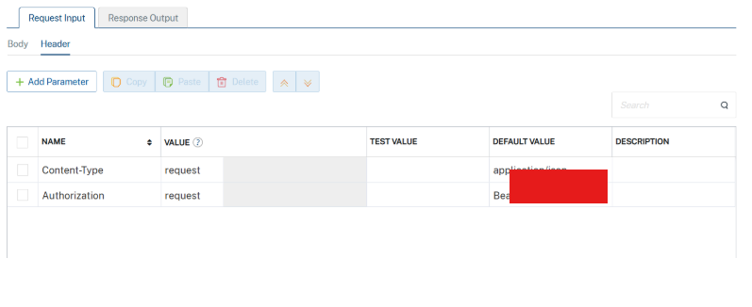

B) Click SAVE AND FETCH RESPONSE. The Output Result dialog appears with the response. Otherwise, the Output Result shows an error.
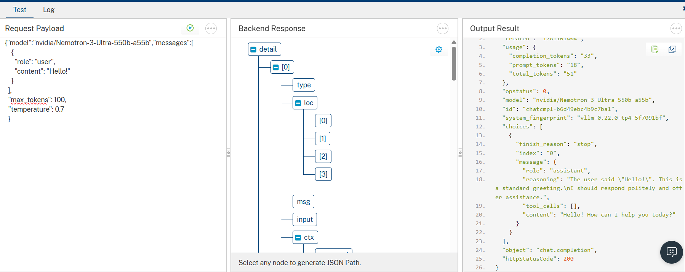

5.Publishing your application
After you set the Operation Security Level, you must publish the HCL Volt MX Foundry app. To publish the HCL Volt MX Foundry, follow these steps:

In Volt MX Iris, click DATA & SERVICES, and then click Publish Project Services to Publish to your foundry app.

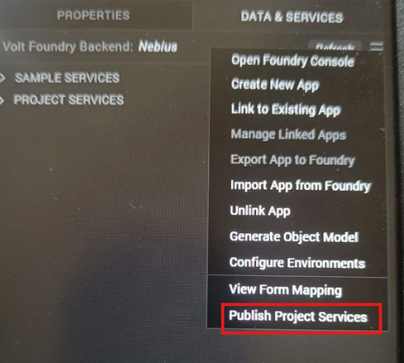

Select the environment to which you want to publish your app, and then click Publish. After the app is published to your environment, the following window appears confirming the publish.

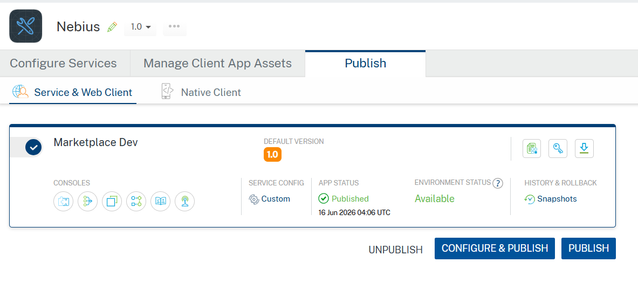

G. Configure Native Settings
1. While building the app for Android in Debug and Release mode, in order to open the camera and gallery. You need to add CAMERA and WRITE_EXTERNAL_STORAGE permissions in project settings.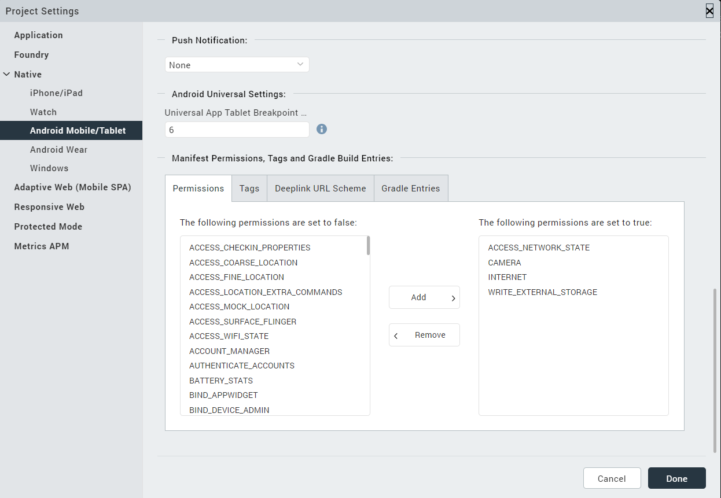
2. Enter the given snippet in Child tag entries under <manifest > tag
For Android below permissions are required in IRIS project setting > Native> Android Mobile/Tablet -> Tags (Child tag entries under tag) depending on the target version.
If target version is 33 and above below media permission must be added.
- <uses-permission android:name="android.permission.READ_MEDIA_IMAGES"/>
If target version is 34 and above below permission must be added along with other media permissions.
- <uses-permission android:name="android.permission.READ_MEDIA_VISUAL_USER_SELECTED"/>

Configuring Native Settings (iOS)
Follow the given steps to enable the permissions.
1. From the Project explorer, navigate to the Assets tab.
2. Right click Media and select Resource Location to open the project resources folder.
3. In the browser window that opens, navigate to the common folder.
4. Open the infoplist_configuration.json file with a text or code editor.
5. Add the given code at the end of the file. You can replace the values with your own descriptions.

{
/*
"NSAppTransportSecurity" :
{
"NSAllowsArbitraryLoads" : true ,
"NSExceptionDomains" :
{
"example.com" :
{
"NSIncludesSubdomains" : true ,
"NSExceptionAllowsInsecureHTTPLoads" : true
}
}
} ,

"NSCameraUsageDescription" : "This is a dummy description"
*/
"NSCameraUsageDescription": " This app uses Camera ",

"NSPhotoLibraryUsageDescription": "This app uses photo library"
}

6. Save the file.

Building the app
From the menu bar, go to Build and then select Build Native Local.

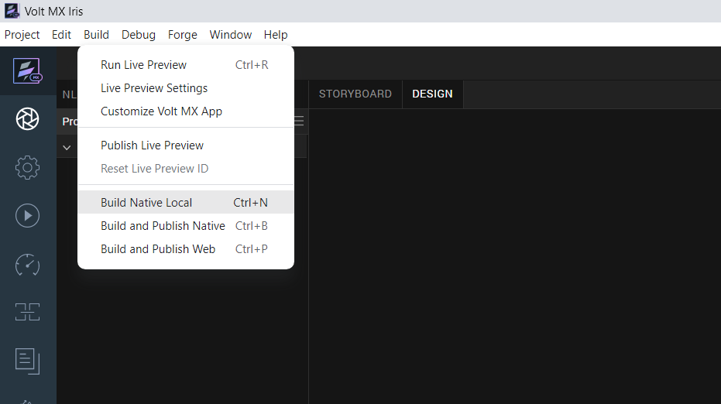

For Mobile, select Android and iOS. Click Build.
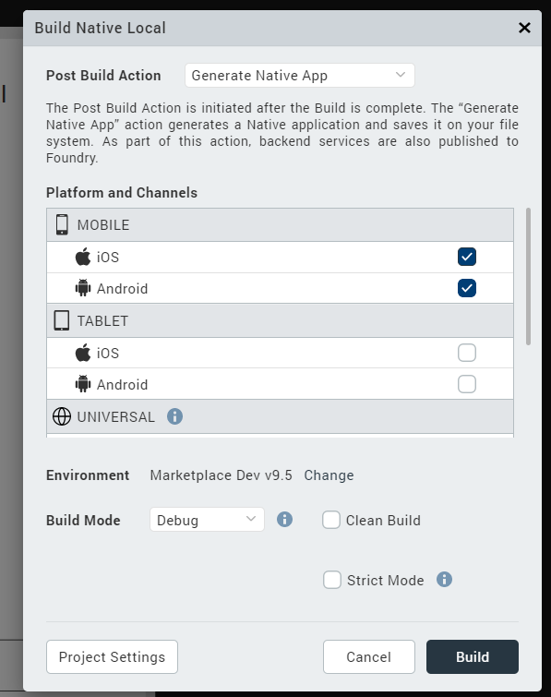

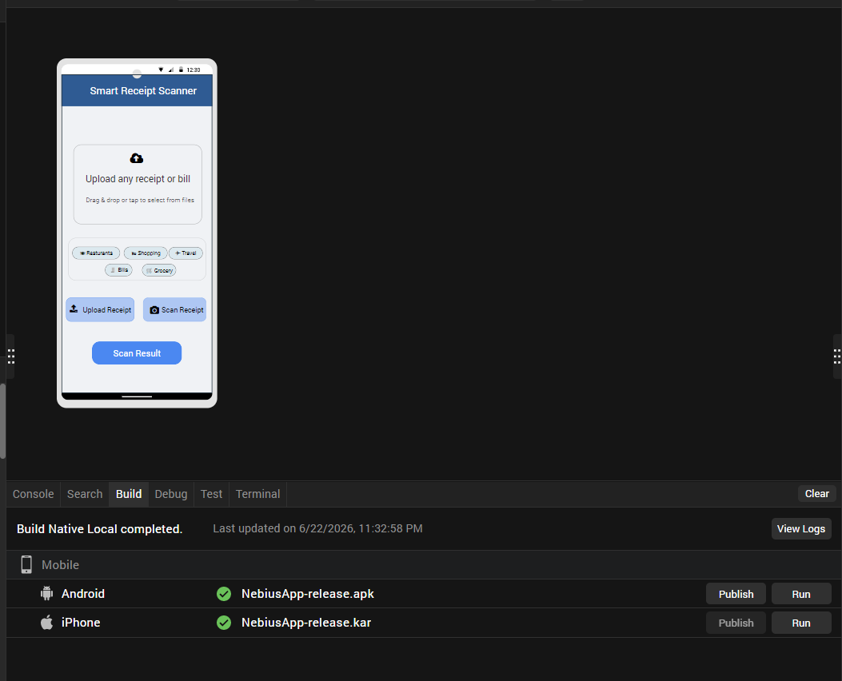
After the build is successful, run the app on your mobile device(emulator or simulator).

H. Application Flow
Scan or upload an image, then click the Scan Result button to extract the data.

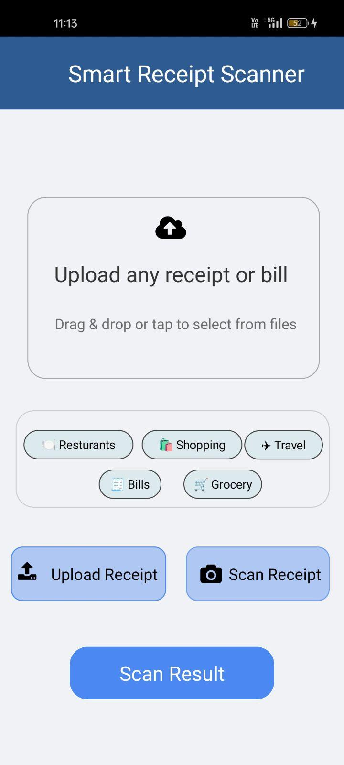
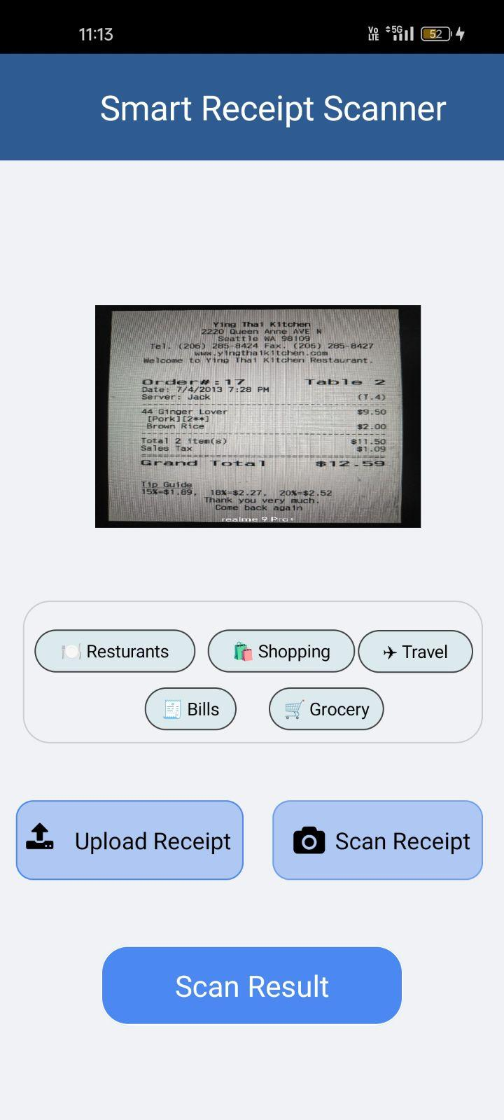

Upon clicking the Scan Result button, the system displays the extracted data in the correct order.
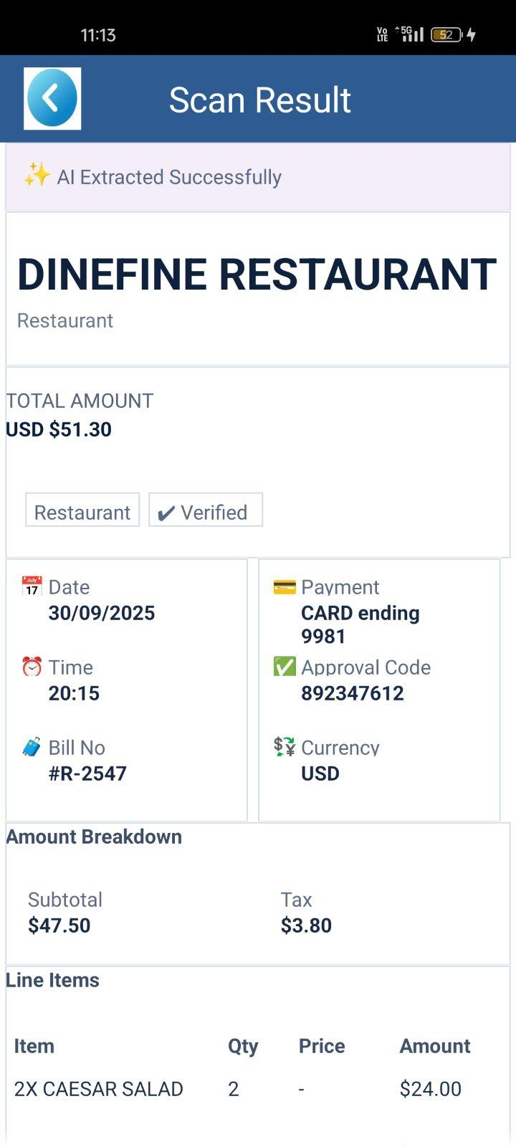
Note: Nebius Adapter is present in the Marketplace page.
Marketplace link:

4.REFERENCES

Endpoint Documentation
Nebius Account

5.REVISION HISTORY
App version 1.0.0:
  - Known Issues
None
  - Limitations
None

