Date : 14-Apr-26

NEBIUS

VERSION: 1.0.0

OVERVIEW
Nebius Token Factory API is a single AI platform that lets you use different AI models through one simple REST API. Instead of connecting separately to each provider, you can access text generation, chat, embeddings, reranking, and image generation using one unified system.
It supports OpenAI-style API formats, so it is easy to integrate into existing applications without major changes. You can use endpoints like chat completions, text completions, embeddings, and image generation depending on your needs.
Nebius helps developers build AI applications like chatbots, search tools, content generators, and image-based apps. It also provides basic controls like usage tracking and project-level management to help monitor and manage API usage easily.

Use case:
- Multi-model AI apps – Build chatbots and assistants using models like Llama, Mistral, and others through one API.
- Text generation & summarization – Create emails, blogs, and summaries using a single OpenAI-style interface.
- Smart routing – Automatically choose the best or cheapest model based on speed, cost, or task.
- Request tracking – Log all API calls to help with debugging and monitoring.
- Cost tracking – See token usage and spending across models in one place.
- Caching support – Reuse previous responses to reduce cost and improve speed.
- Failover support – Switch to another model if one fails to keep apps running smoothly.
- Prompt testing – Try different prompts across models and compare results easily.
- Multimodal support – Work with both text and images using a single API gateway.
- Observability tools – Monitor latency, errors, and performance using analytics.
- Easy integration – Connect AI to web or mobile apps using simple REST APIs without managing multiple SDKs.

Features:
- Multiple Model Access: Access models from OpenAI, Anthropic, Google, and open-source models like Llama and Mistral through one unified API.
- Unified Text Generation & Chat:Generate text, chat responses, summaries, and conversational AI using a single OpenAI-compatible API.
- Smart Model Routing:Automatically select the best model based on cost, speed, or performance needs.
- AI Request Logging & Observability:Track all API requests and responses for debugging, monitoring, and performance analysis.
- Cost Tracking & Usage Analytics:Monitor token usage and costs across all models to manage and optimize spending.
- Caching & Performance Optimization:Reuse repeated responses to reduce latency and lower API costs.
- Failover & Reliability Handling:Automatically retry or switch models if a request fails to ensure reliability.
- OpenAI-Compatible REST API:Integrates easily using standard HTTP requests and JSON formats without major code changes.
- Prompt Testing & Experimentation:Compare prompts across different models to improve output quality.
- Scalable & Developer-Friendly:Build and scale AI applications easily without managing multiple provider APIs separately.

GETTING STARTED

Prerequisites
Before you start using the Nebius Adapter, ensure you have the following:

- HCL Foundry
- Nebius API Key Account - Get a Nebius API key
Step 1: Create a Nebius Account
- Navigate to the Nebius website.
- Sign up using your email, Google.
- Log in to access the Nebius Dashboard.

Step 2: Generate a Nebius API Key
- Go to the Nebius Token Factory Dashboard.
- Navigate to the API Keys section
- Click on “Get API key” (top-right blue button).
Step 3: Create the API Key
A popup will appear. Fill in the details:
- Name: Example → testNebius or dev-key
- (Optional) Select the project scope if required
Click on Create / Generate API Key
Step 4: Copy the API Key
- You will see a key like: v1.xxx-xxxxxxxxxxxx
- Copy it immediately and store it securely.❌ You will NOT be able to view it again later.

B. Importing the Data Adapter

You can import the Nebius Data Adapter into HCL Foundry directly from the Volt MX Forge website or by importing the data adapter zip file.

To import Data Adapter to Volt Foundry, do the following:
- Sign in to the HCL Foundry.
- From the left navigation menu, select API Management.
- In API Management, select Custom Data Adapters.

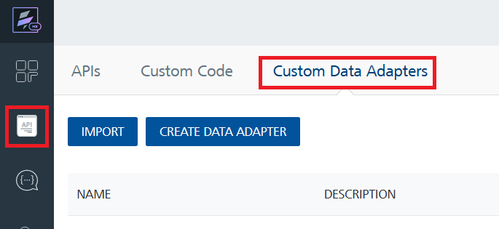

4. Click IMPORT to import a custom data adapter.
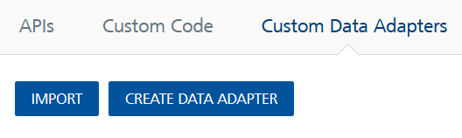
5. On the Import Data Adapter dialog box, click browser to import.

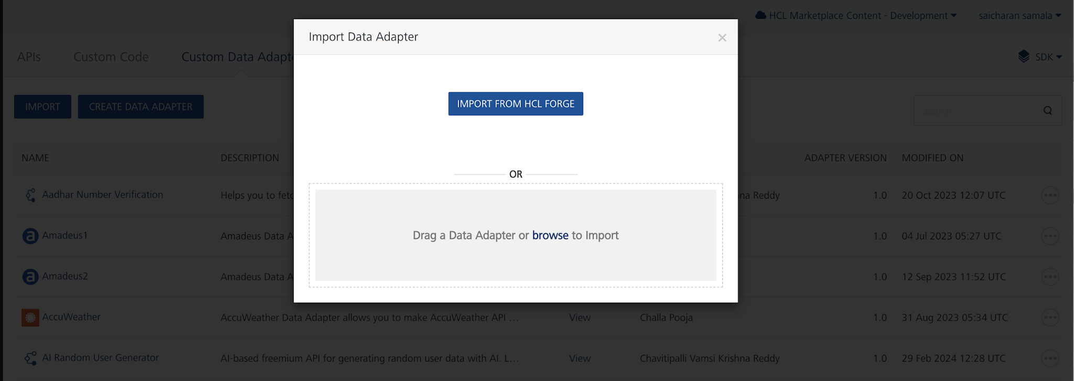
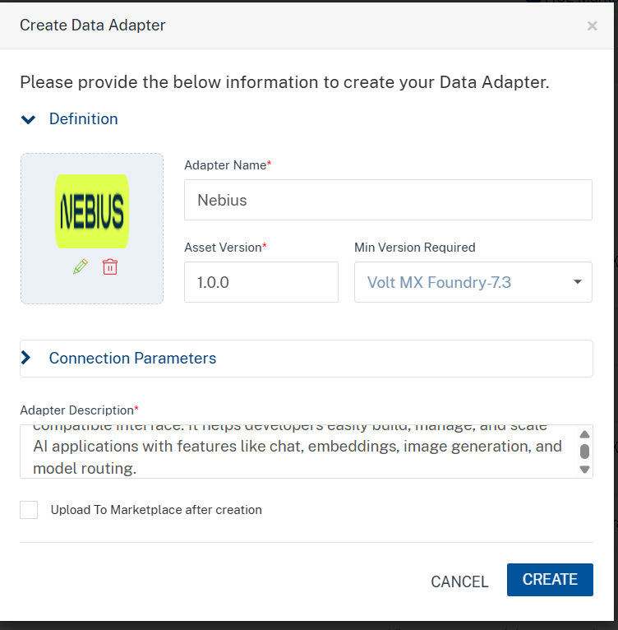

6. Click IMPORT FROM HCL FORGE. The Import Data Adapter from HCL Forge dialog appears with a list of available data adapters.
Click Import.Nebius Data adapter is listed on the Custom Data Adapters page.
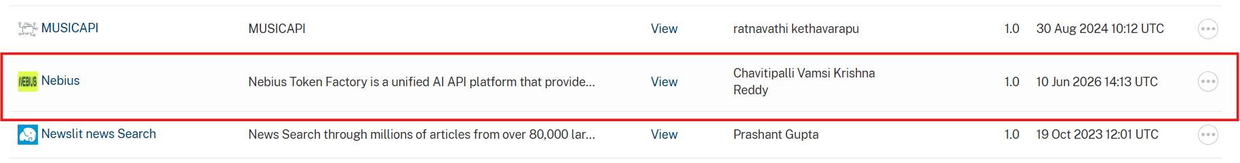
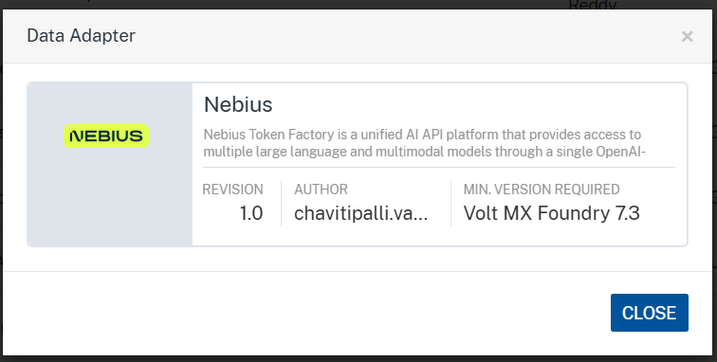
To import the data adapter zip file, do the following:
- Perform steps 1 to 4 in the above procedure
- Drag the data adapter zip file into the Drag a Data Adapter box.
Or
Click browse. The Open dialog appears.
Navigate to the location where you downloaded the data adapter (zip file) on your computer, select the data adapter, and click Open. The Import Data Adapter dialog shows the selected data adapter.
Note: Click Remove if the selected data adapter is not the one that you want to import.

C. Creating an Integration Service with Nebius:
After you import Nebius Data Adapter into Foundry, you must create an integration service with service type Nebius.
To create an integration service with Nebius, do the following:
- Log on to your HCL Foundry. The Dashboard page appears by default.
- In the left pane, click the API Management menu. The APIs tab opens by default.
- Click the Integration tab. The Integration tab opens with a list of existing integration services.
- Click CONFIGURE NEW. The Service Definition tab opens.
- In the Name box, type a unique name for your service.
- From the Service Type list, Nebius.
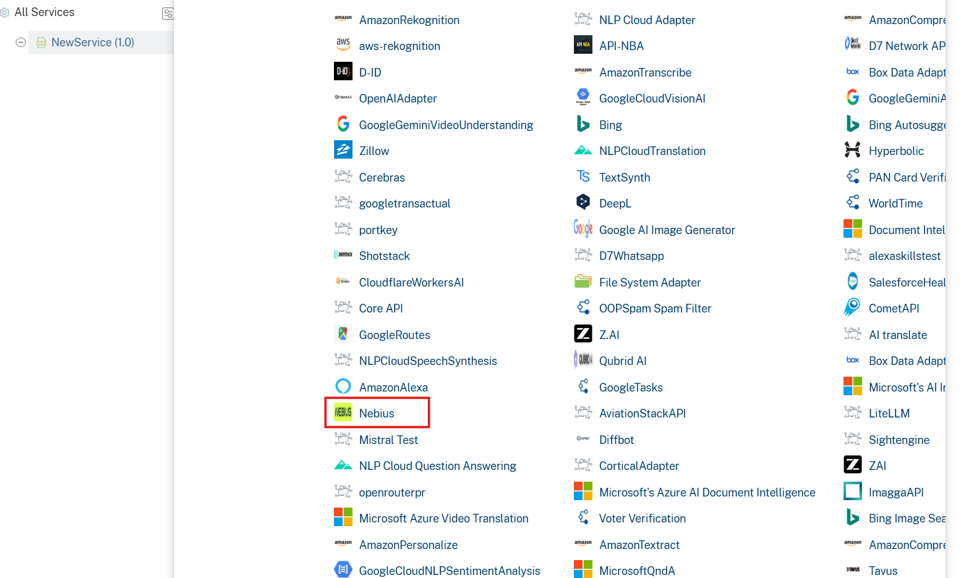
- Click Save

D. Creating an Operation
To make any API call in the HCL Foundry console, you must create an operation for the respective API and then execute the operation. Executing an operation involves making the API call and displaying the response.
This section provides steps to create an operation for the Nebius.
Steps to create an operation for the Nebius:
- Log on to your HCL Foundry. The Dashboard page appears by default.
- In the left pane, click the API Management menu. The APIs tab opens by default.
- Click the Integration tab. The Integration page appears with a list of existing integration services.
- From the list of integration services, select the integration service that you have created with the service type Nebius. The Service Definition tab of the selected integration service opens by default.
- Click the Operations List tab. The Operations List tab opens.
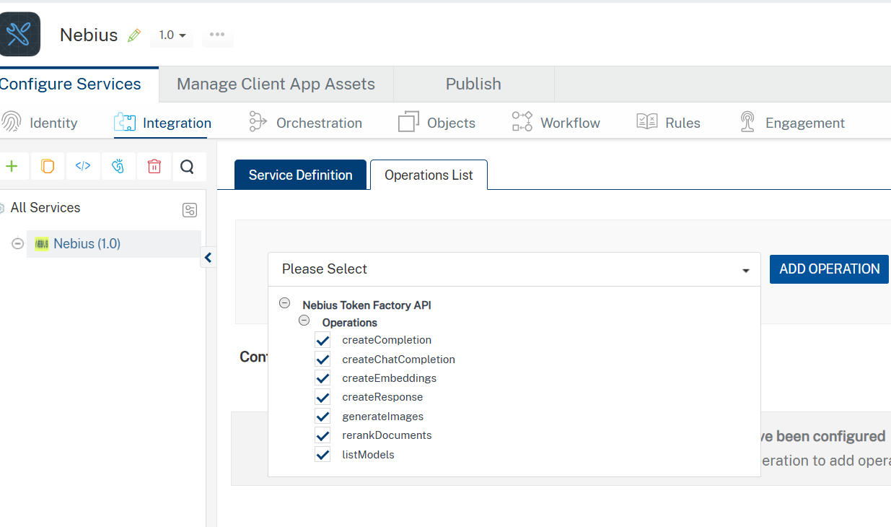
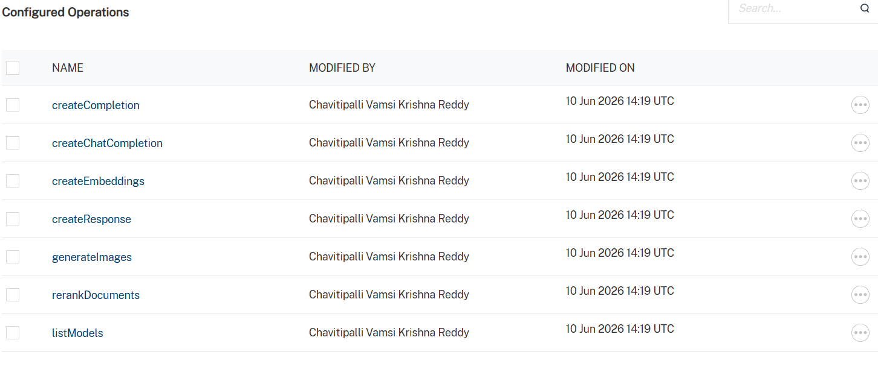
- Select All the operations. Click Add Operations.

E. Executing Operation
Executing an operation involves making the API call by setting the necessary parameters and displaying the response. The procedure to execute any operation is the same, but the request parameters of the APIs vary. This section provides steps to execute the createChatCompletion(explained in Creating an Operation).
Steps to execute the createChatCompletion operation:
- Log on to your Hcl Foundry. The Dashboard page appears by default.
- In the left pane, click the API Management menu. The APIs tab opens by default.
- Click the Integration tab. The Integration tab opens with a list of existing integration services.
- From the list of integration services, select the integration service that you have created with service type Nebius. The Service Definition tab of the selected integration service opens by default.
- Click the Operations List tab.
- In the Name box, the name of the operation is displayed by default. If you want, you can change the name.
- On the Request Input tab, in the Body section, for the following parameters, specify the values in the respective boxes under the Test Value column.
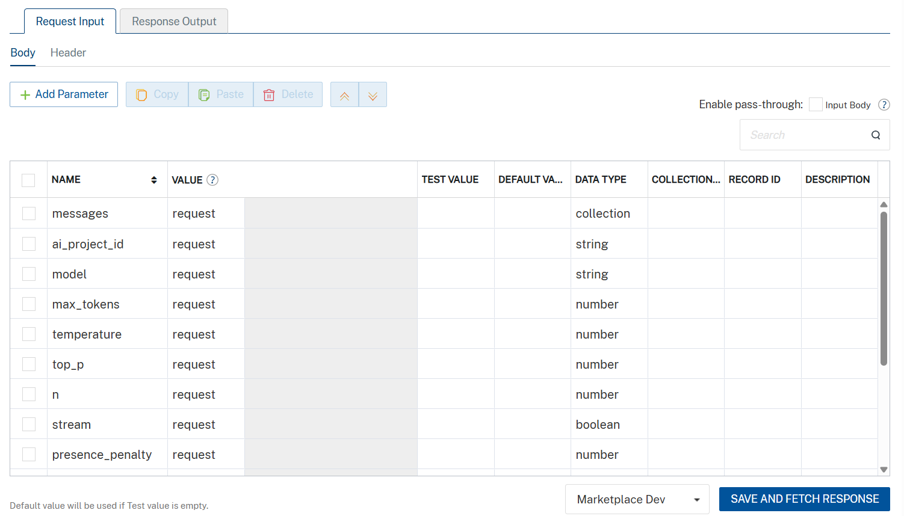
Parameter | Description | Syntax Example
model (Required) | Specifies which AI model to use for the request. Available models depend on your Scaleway configuration. | "model": "gemini-2.5-flash"
messages (Required) | Array of conversation messages. Each message must include a role (system, user, or assistant) and content. | "messages": [  { "role": "system", "content": "You are a helpful assistant." },  { "role": "user", "content": "Say hello in one sentence." }  ]
temperature (Optional) | Controls randomness of output. Lower values produce deterministic responses; higher values increase creativity. | "temperature": 0.7
max_completion_tokens  (Optional) | Maximum number of tokens the model can generate in the response. | -9007199254740991 <= x <= 9007199254740991
top_p (Optional) | Nucleus sampling parameter that controls diversity by limiting token selection to a probability mass. | "top_p": 1
stream (Optional) | Enables real-time streaming response when set to true. | "stream": true
stop (Optional) | Specifies sequences where the API will stop generating further tokens. | "stop": ["\n", "###"]
presence_penalty (Optional) | Penalizes new tokens based on whether they appear in the text so far, encouraging new topics. | "presence_penalty": 0.6
frequency_penalty (Optional) | Penalizes repeated tokens based on their frequency in the text so far. | "frequency_penalty": 0.5
Additionally, the messages parameter (array of objects) must be passed completely within the messages value as a properly structured JSON array.
- Click Header sub-tab. The Header section opens.
- For Authorization, In the box under the DEFAULT VALUE column, type the API Key generated from prerequisites section
- Syntax: Authorization: Bearer <YOUR_API_KEY>
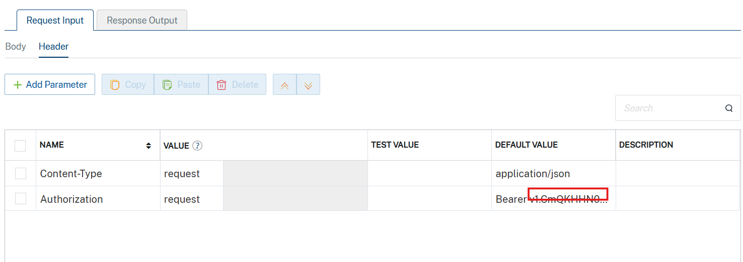

- Click SAVE AND FETCH RESPONSE. The Output Result dialog appears with the response. Otherwise, the Output Result shows an error.
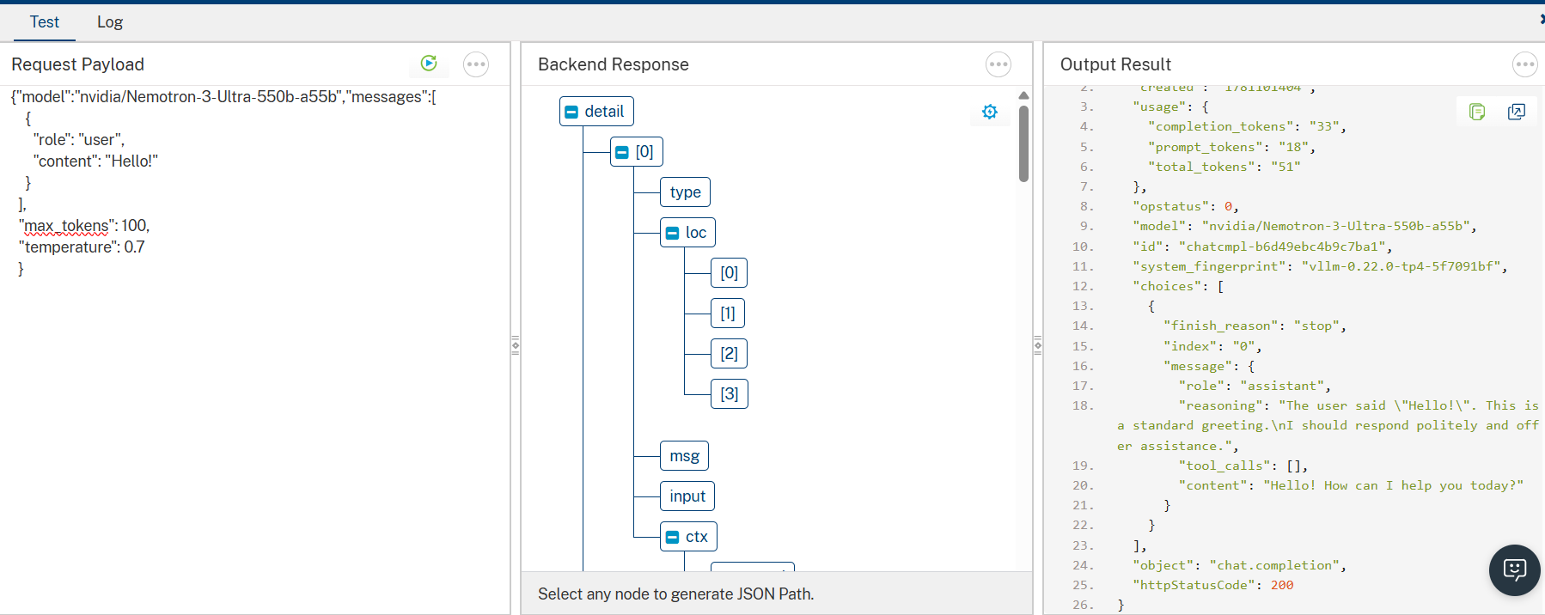

3. Publishing the App in VoltMX FOUNDRY:
After adding the Nebius Data Adapter to your app and configuring the necessary configurations, you must publish the app to HCL Foundry. For more information, refer to Publish a foundry app.
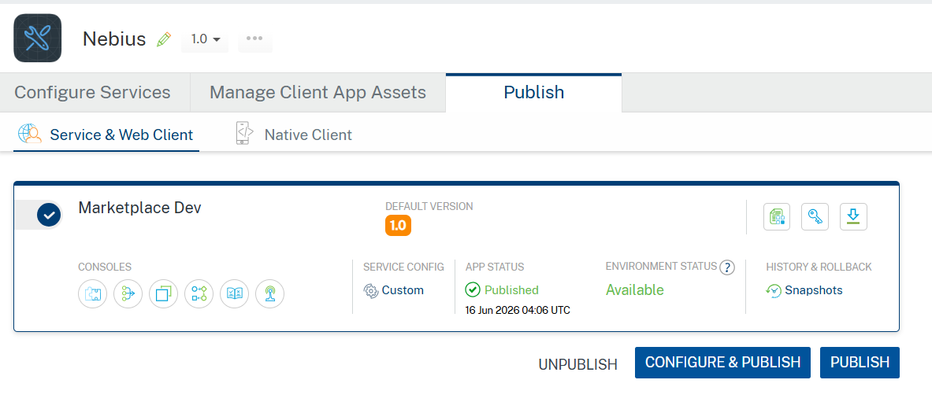

4. REFERENCES

Endpoint documentation
Nebius Account

5. REVISION HISTORY
Adapter version 1.0.0:

Known Issues
In VoltMX Foundry, always provide values for required parameters. Optional parameters should only be included when you have valid values. Avoid sending empty strings, empty objects, or empty arrays for optional fields, as this may lead to validation errors. The request example includes all available parameters only for reference.

Limitations
None

