Date : 22-02-2024

NAGER DATE

VERSION: 1.0.0

Overview

The Nager Date api provides a simple way to query the holidays of over 100 countries, also it is possible to query long weekends. For IoT devices there is an endpoint to check if today is a holiday.

Getting Started

A. Prerequisites

Volt Foundry
- Reference: https://date.nager.at/
- No API key required.

B. Importing the adapter:
To import the Data Adapter to Volt Foundry, do the following:
- Sign in to the HCL Foundry.
- From the left navigation menu, select API Management.
- In API Management, select Custom Data Adapters.
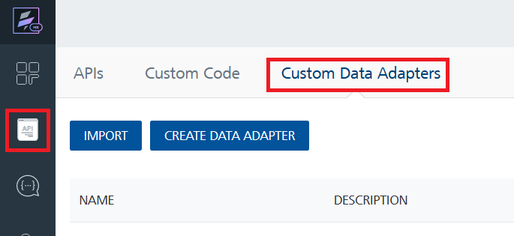
- Click IMPORT to import a custom data adapter.
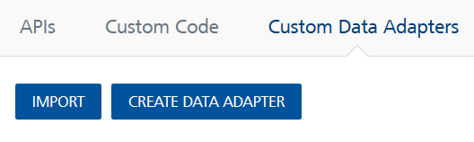
- On the Import Data Adapter dialog box, click browser to import.
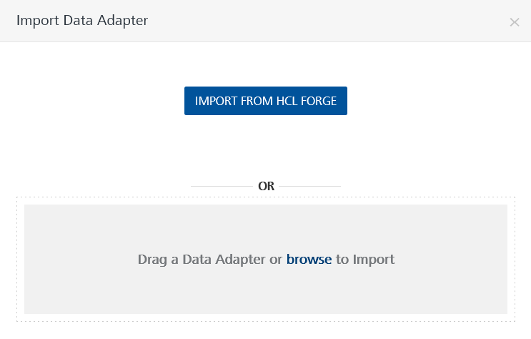
- Select Nager Date zip file and click IMPORT.
After you import the data adapter, Volt Foundry opens a window that shows the metadata of the data adapter.
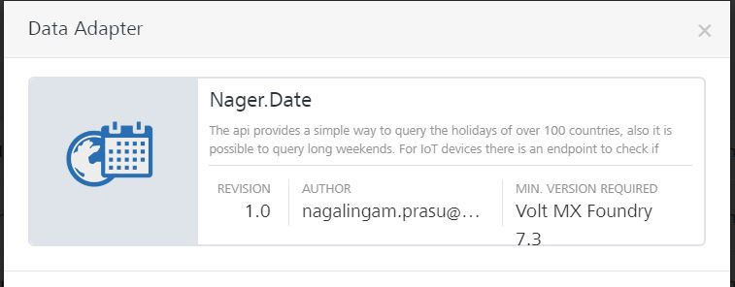

After you import the data adapter, you can view it on the Custom Data Adapters page and use it to create services on Volt Foundry.
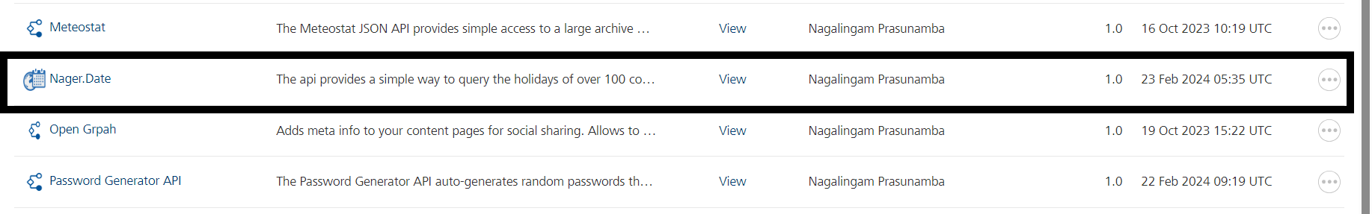

C. Creating an Integration service
After you import the data adapter into Volt Foundry, you can use it to create an Integration Service.
Follow the given steps to create an Integration service using the Nager Date Adapter.
- Sign in to the HCL Foundry.
- From the left navigation menu, select API Management.
- In API Management, select Integration.
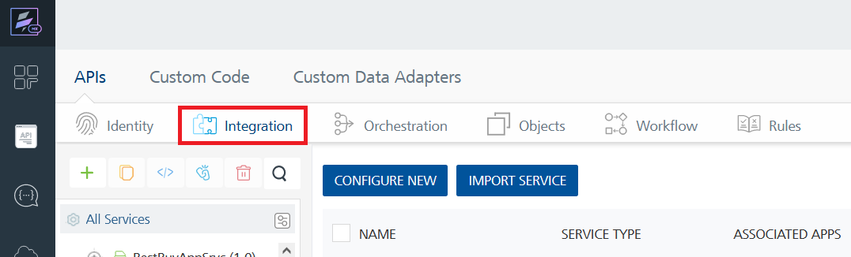
- To create a new service, click the + button or the CONFIGURE NEW button.
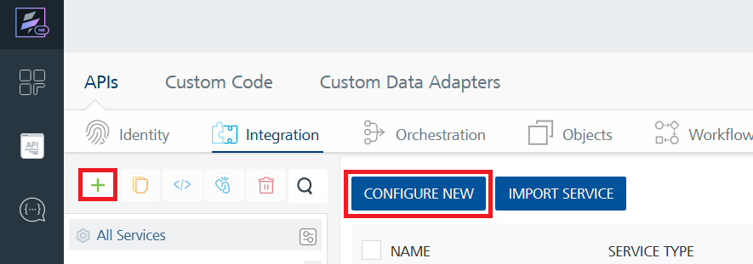
- On the Service Definition tab, select the service type as Nager Date, and click SAVE.
- 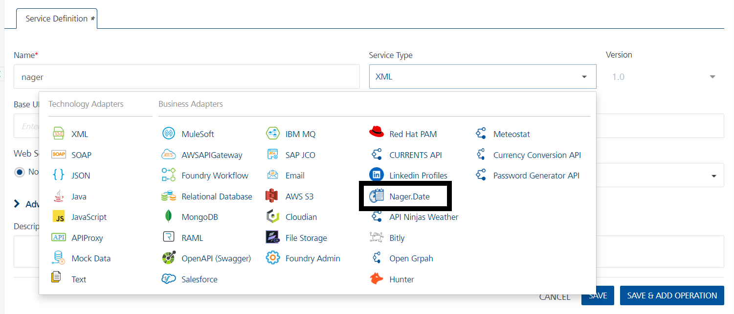
Alternatively, you can also create a Foundry app and create an Integration service inside it.
D. Creating and Executing operations
After you create an integration service, you can create and execute operations using the service.

Creating an operation
- In API Management/Foundry app you created, in the Integration section, select the service that you created.
- After you select the service, navigate to the Operation List tab.
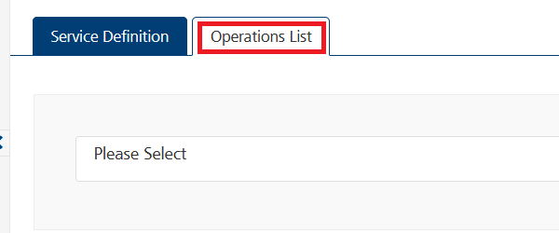
- From the drop-down list, select an operation that you want to execute, and click ADD OPERATION.
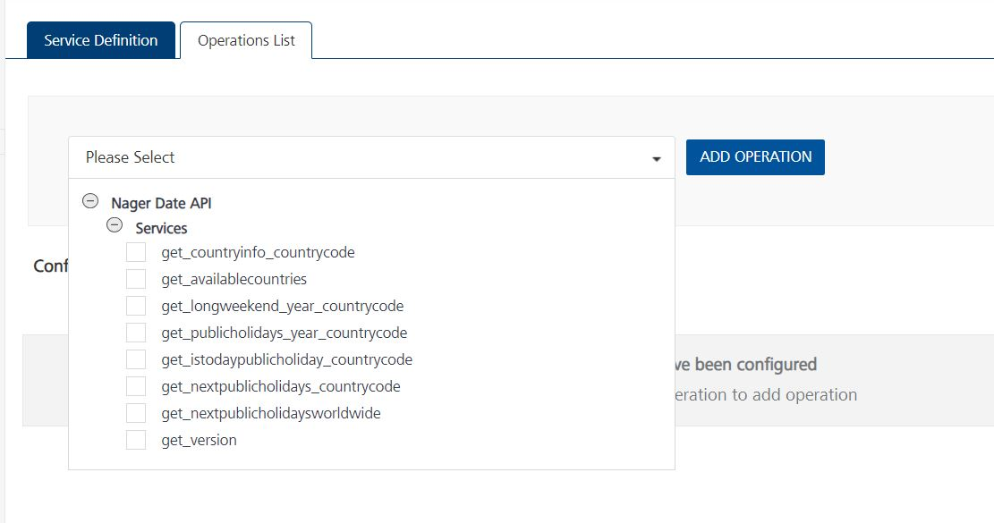

Executing an operation
- From the Operations List tab, in the Configured Operations section, select the operation you want to execute.

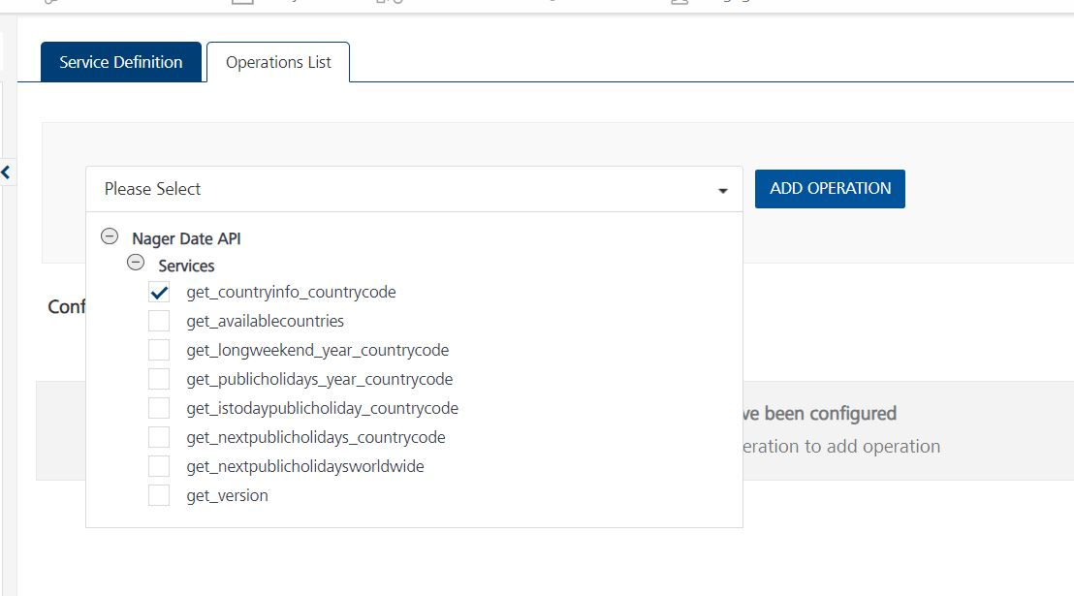
- On the Operation Page, in the Request Input tab, enter a TEST VALUE for all the fields.
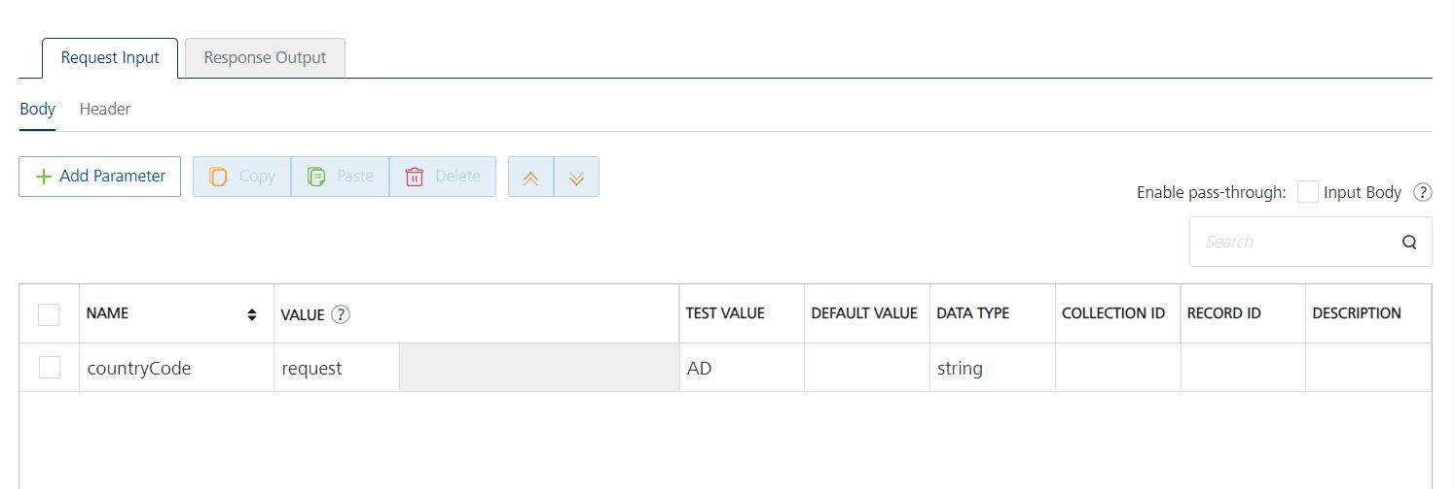
- Select a run-time environment and click Save and Fetch Response to get a response based on your inputs.
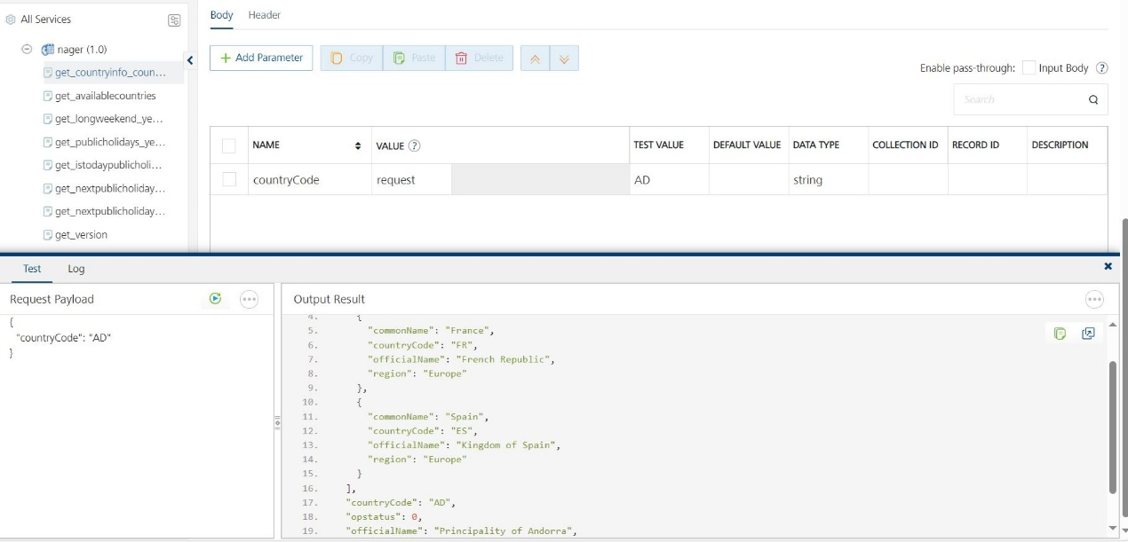

E. Publishing your application
If you want to use the services in client applications, you need to publish an app to a run-time environment. You can create the service (as described above) in an application or import the service into an application and publish the application.

3. References

Endpoint Documentation

No Header parameters(api-key) required.

/v3/CountryInfo/{countryCode}

GET

https://date.nager.at/api/v3/CountryInfo/AD

Get information about a country-by-country code.

Parameters
Name | Description
countryCode | Country code (e.g., AD)
 | string

/v3/AvailableCountries

Get a list of available countries.

GET

https://date.nager.at/api/v3/AvailableCountries
No parameters

/v3/LongWeekend/{year}/{countryCode}

Get information about long weekends in a specific year and country.

GET

https://date.nager.at/api/v3/LongWeekend/2022/AD year
Name | Description
year | Year for long weekends
 | integer
countryCode | Country code (e.g., AD)
 | string

/v3/PublicHolidays/{year}/{countryCode}

Get information about public holidays in a specific year and country.

GET
Parameter Name | Type | Description
year | integer | Year for public holidays
countryCode | string | Country code (e.g., "AD")

https://date.nager.at/api/v3/PublicHolidays/2024/AD

/v3/IsTodayPublicHoliday/{countryCode}

Check if today is a public holiday in a specific country.

GET

https://date.nager.at/api/v3/IsTodayPublicHoliday/AD?countyCode=AD&offset=0

Parameter Name | Type | Location | Description
countryCode * | string | path | Country code (e.g., "AD")
countryCode | string | query | Federal State Code
countyCode | string | query | County Code
offset | integer | query | UTC timezone offset

/v3/NextPublicHolidays/{countryCode}

Get information about the next public holidays in a specific country.

GET

https://date.nager.at/api/v3/NextPublicHolidays/AD
Parameter Name | Type | Location | Description
countryCode * | string | path | Country code (e.g., "AD")

/v3/NextPublicHolidaysWorldwide

Get information about the next public holidays worldwide.

GET

https://date.nager.at/api/v3/NextPublicHolidaysWorldwide

No parameters

Reference Document: Refer this document for more information.
https://date.nager.at/swagger/index.html

4. Revision History
Adapter version 1.0.0

Known Issues
-

Limitations
-

