Date :  01-03-2024

MUSIC API

version: 1.0.0

# **Overview**

This API will provide Spotify, Apple Music, YouTube, Amazon, Tidal, and Moreover 19 services supported. It Fetches metadata for the tracks, albums, playlists from multiple streaming services via URL.

2. **Getting Started**

## **A. Prerequisites**

## Volt Foundry

## **B. Importing the adapter:**

**To import the Data Adapter to Volt Foundry, do the following:**

1. Sign in to the  [HCL Foundry](https://manage.hclvoltmx.com/).
2. From the left navigation menu, select **API Management**.
3. In **API Management**, select **Custom Data Adapters**.  
   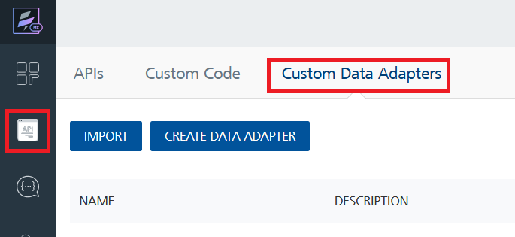
4. Click **IMPORT** to import a custom data adapter.  
   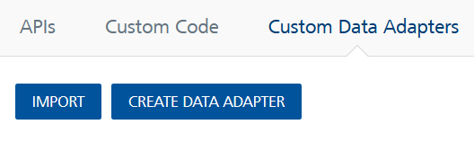
5. On the Import Data Adapter dialog box, click browser to import.  
   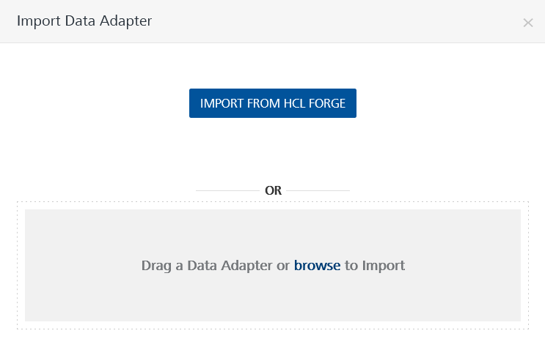
6. Select MusicAPI.zip file and click **IMPORT**.

After you import the data adapter, Volt Foundry opens a window that shows the metadata of the data adapter.

After you import the data adapter, you can view it on the Custom Data Adapters page and use it to create services on Volt Foundry.



## **[Creating an Integration service](javascript:void(0);)**

After you import the data adapter into Volt Foundry, you can use it to create an Integration Service.

Follow the given steps to create an Integration service using the Music API Data Adapter

1. Sign in to the [HCL Foundry](https://manage.hclvoltmx.com/).
2. From the left navigation menu, select **API Management**.
3. In **API Management**, select **Integration**.  
   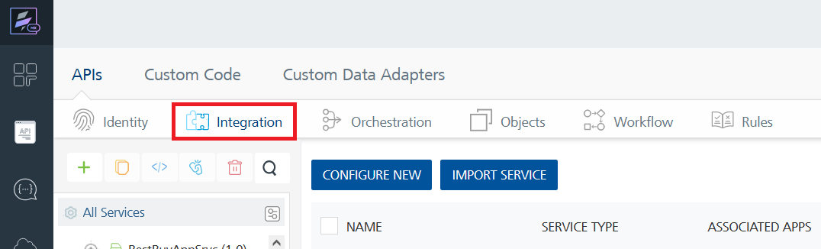
4. To create a new service, click the **+** button or the **CONFIGURE NEW** button.  
   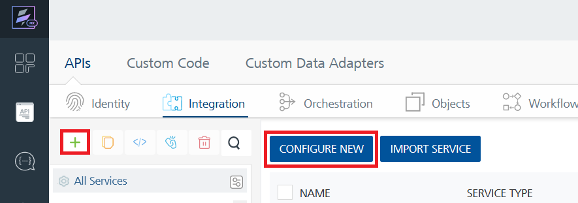
5. On the Service Definition tab, select the service type as MusicAPI, and click **SAVE**.

6. Alternatively, you can also create a Foundry app and create an Integration service inside it.

* **[Creating and Executing operations](javascript:void(0);)**

After you create an integration service, you can create and execute operations using the service.

#### **Creating an operation**

* In **API Management/Foundry app you created**, in the **Integration** section, select the service that you created.
* After you select the service, navigate to the **Operation List** tab.  
  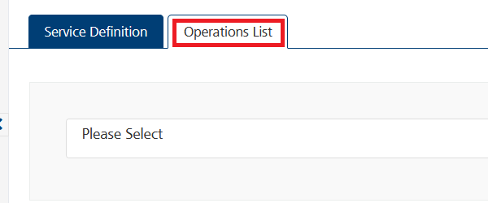
* From the drop-down list, select an operation that you want to execute, and click **ADD OPERATION**.

#### **Executing an operation**

* From the **Operations List** tab, in the **Configured Operations** section, select the operation you want to execute.

* On the Operation Page, in the Request Input tab, enter a TEST VALUE for all the fields.

* Select a run-time environment and click **Save and Fetch Response** to get a response based on your inputs.  
  A screenshot of a computer

  Description automatically generated

## [**Publishing your application**](javascript:void(0);)

If you want to use the services in client applications, you need to publish an app to a run-time environment. You can create the service (as described above) in an application or import the service into an application and publish the application.

# **C. References**

## **Endpoint Documentation**

## **Get /public/search/introspection**

## GET <https://musicapi13.p.rapidapi.com/public/search/introspection&api_key=YOUR_APIKEY>

## This endpoint provides to fetch all different enums needed for sending API requests.

|  |  |
| --- | --- |
| api_key  Required | Your secret API key. You can generate it in your dashboard. |

## **Get /public/search**

## GET [https://musicapi13.p.rapidapi.com/public/search?data={}&api_key=YOUR_APIKEY](https://musicapi13.p.rapidapi.com/public/search?data=%7b%7d&api_key=YOUR_APIKEY)

This endpoint provides a search for

* tracks
* albums
* playlists

in any of the music service (it supports).

|  |  |
| --- | --- |
| track  *Required | track name |
| artist  *Required | Name of the artist |
| Type  *Required | Type |
| api_key  Required | Your secret API key. You can generate it in your dashboard. |

## **Get /public/inspect/url**

## GET <https://musicapi13.p.rapidapi.com/public/inspect/url&api_key=YOUR_APIKEY>

## This endpoint provides you fetch the metadata of music service URL. You can pass any URL from music service (eg. https://tidal.com/browse/track/131696293) and the API will return you information about what it points at.

|  |  |
| --- | --- |
| URL  *Required | Track URL from any supported platforms for this API |
| api_key  Required | Your secret API key. You can generate it in your dashboard. |

# **D. Revision History**

Adapter version 1.0.0

## **Known Issues**

**-**

## **Limitations**

**-**