06 JAN 2026

MULTILINGUAL VIDEO PLAYER

version:1.0.0

- OVERVIEW:
The Multilingual Video Player delivers an interactive, seamless viewing experience by allowing users to select their preferred audio language and subtitle track — without interrupting playback.
When a viewer switches languages, the video continues from the current timestamp, while subtitles update instantly to match the new selection. This ensures smooth transitions, precise synchronisation, and a cohesive user experience.
The player achieves this through:
- Accurate playback time tracking
- Dynamic language switching
- Real-time subtitle updates
- Tight coordination with native media components
With these capabilities, users can explore content comfortably in the language and format that best suits their needs.
Requirements:
- Volt MX Iris is installed and configured
- MP4 video file (single file) that includes:
  - Multiple embedded audio tracks
  - Embedded subtitle tracks (for each supported language)
- Devices:
- Mobile

- Platforms:
- Android
- iOS

- GETTING STARTED

- Prerequisites
Before previewing the Multilingual Video Player, ensure you have:
- A Volt MX account
- Volt MX Iris installed
- The required video file is placed in the location below, with supported audio and subtitle languages:
Location:
workspace\project\resources\mobile\common\videos
The video must include the required audio tracks and subtitle files.
Supported Video Format: MP4
- Create a sample app and import the Component
To import the Multilingual video player into your workspace, follow these steps:
- Open Volt MX Iris.
- Click on project ->New Project
- Select the Native app and click on next.
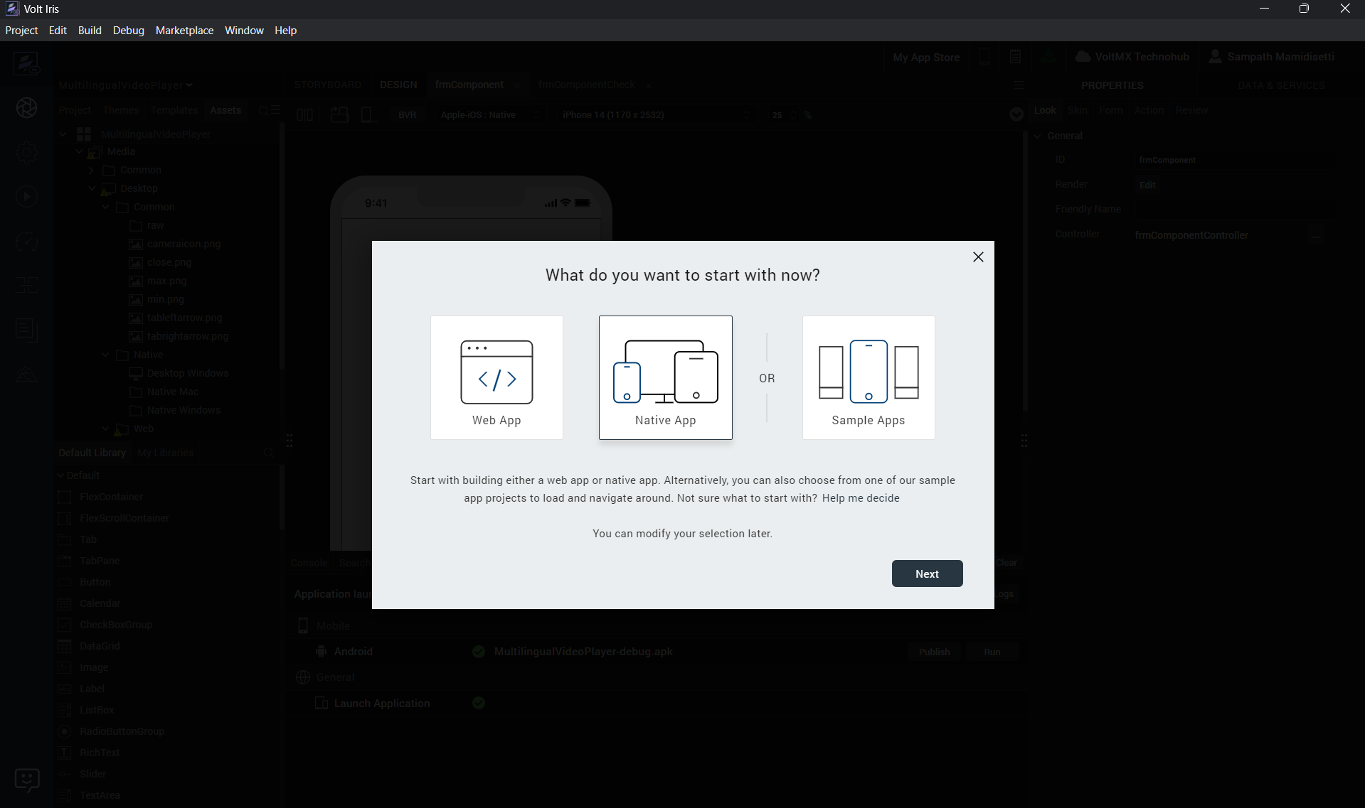
- Select Mobile and click on next.
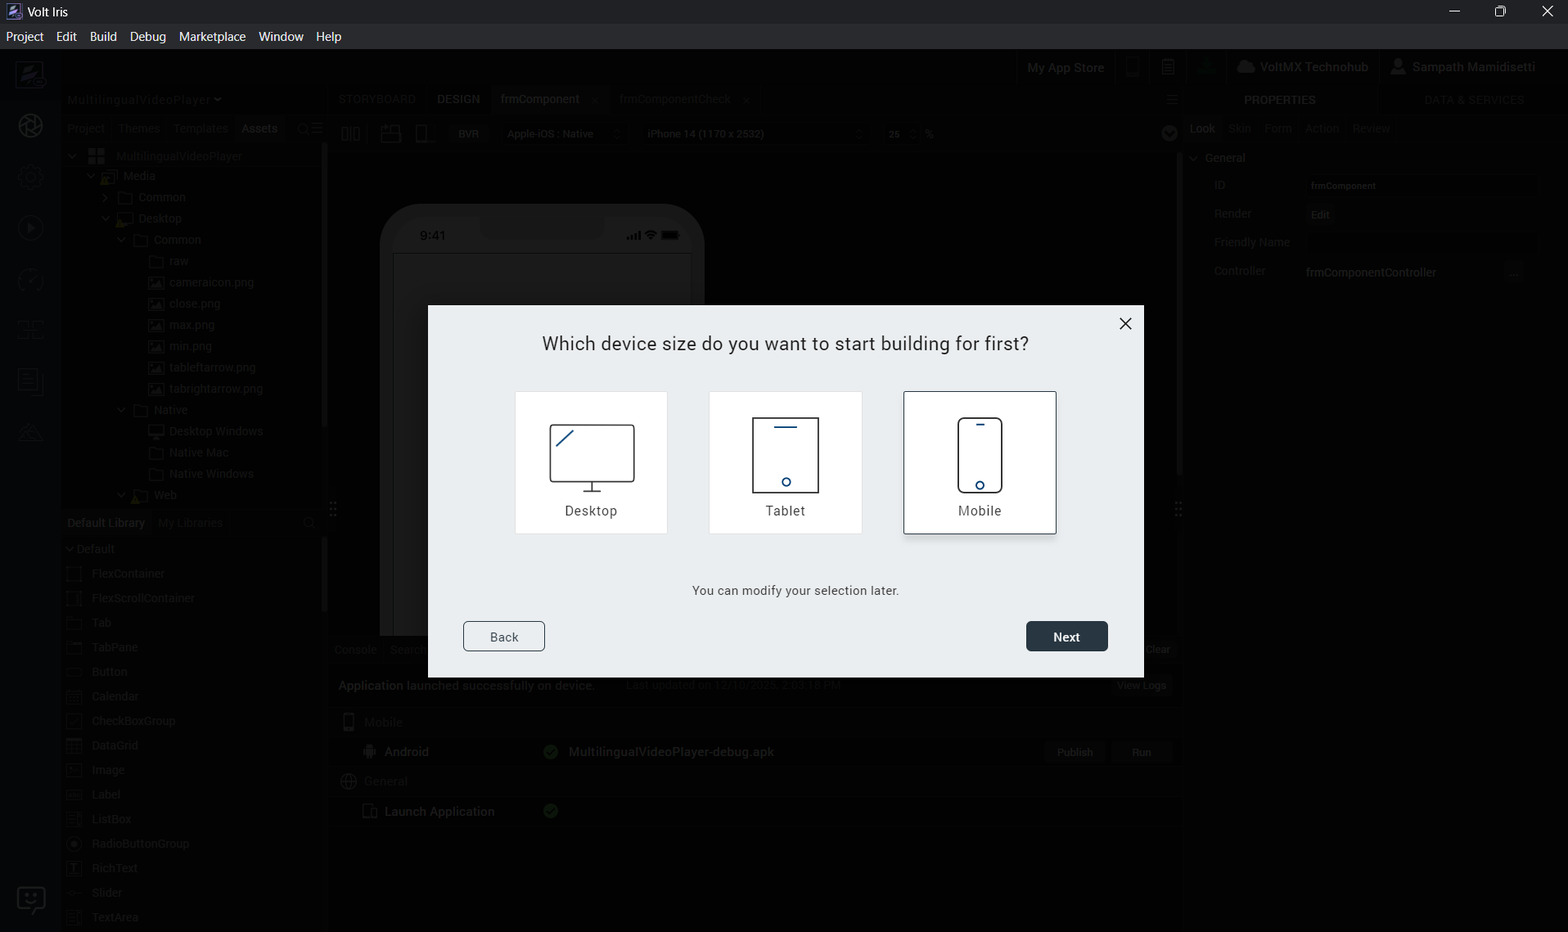
- Provide the name of the project and click on create.
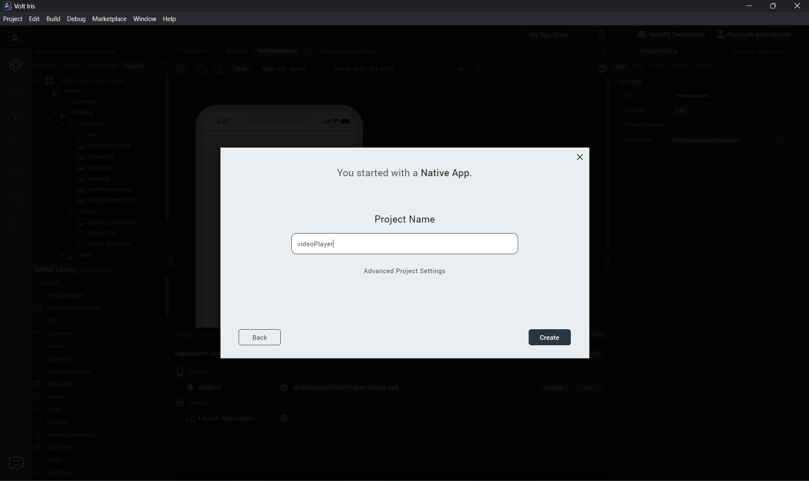
- Go to the project filter and enable the mobile option, and save.
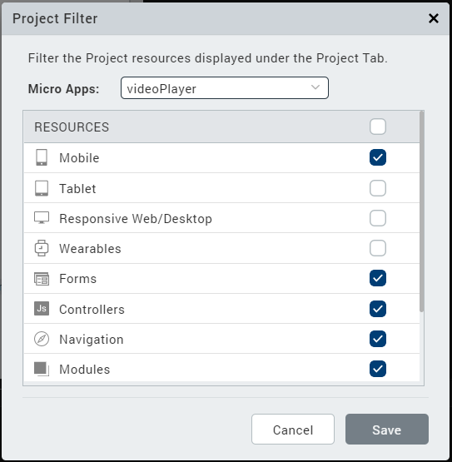

- Create forms in Mobile. example: frmHome
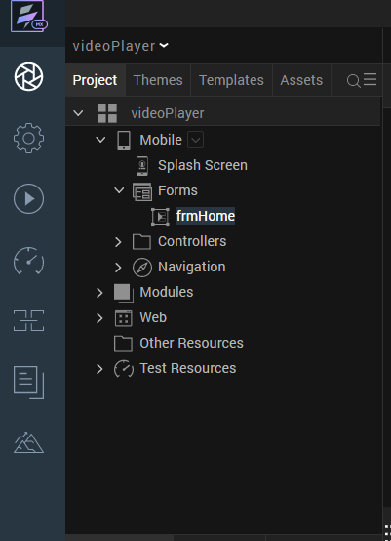

- Go to templates, components, Import Component.
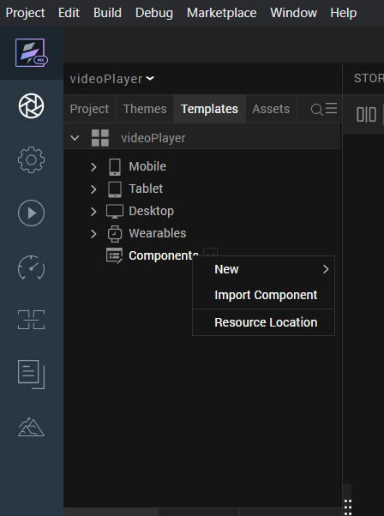

- Browse, select the component and Import.
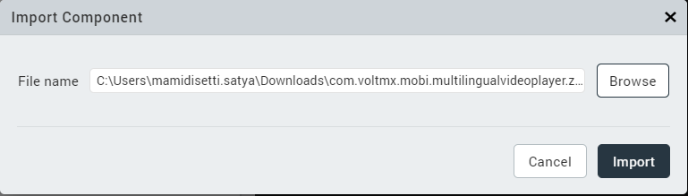

- In the components section, multilingualvideoplayer will be available and ready to use.
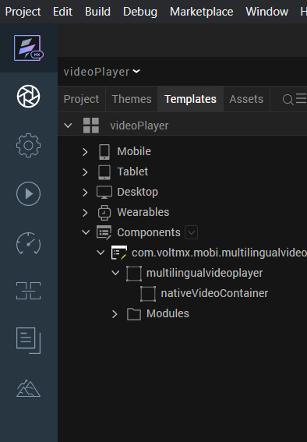

- Insert the component in to Mobile form respectively. For more information, refer Add a Component to a Form
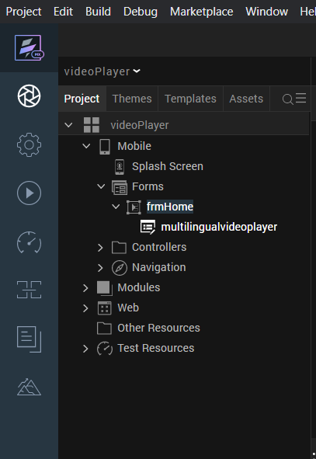

- Add below Gradle entries in project settings for Android.
Paste the below in following location
dependencies.implementation 'androidx.media3:media3-exoplayer:1.8.0'
dependencies.implementation 'androidx.media3:media3-ui:1.8.0'
Open project settings -> Native -> Android Mobile/Tablet -> Scroll to the bottom -> Gradle Entries -> build.gradle entries to the Suffix
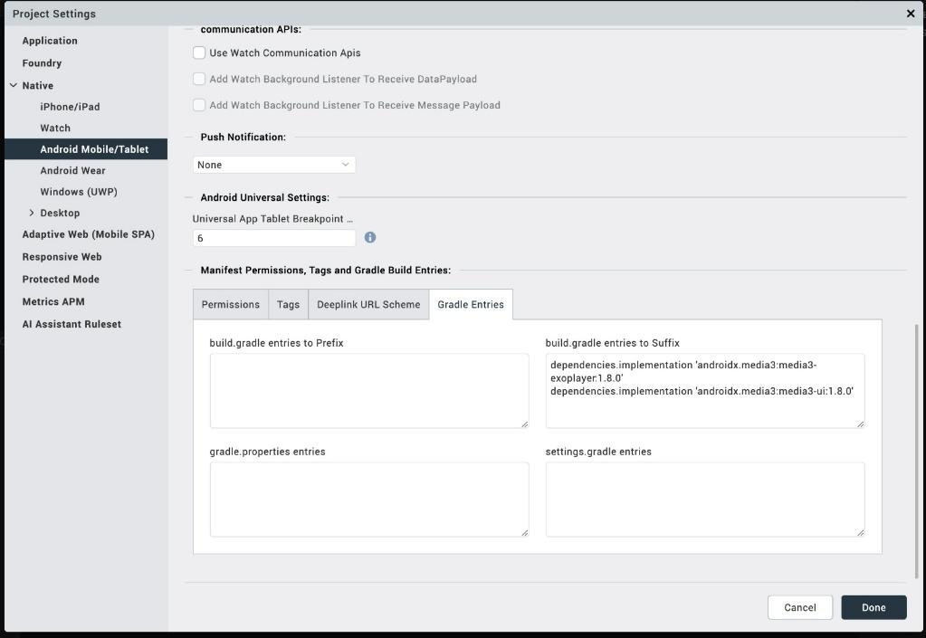

- After successful import of component check for the iOS NFI
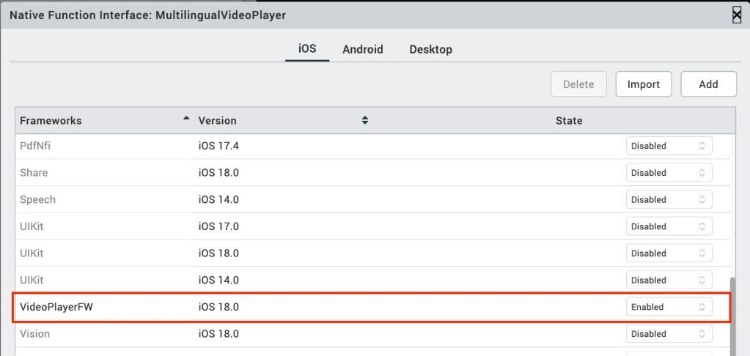
if not please add them manually
- The required video file is placed in the location below, with supported audio and subtitle languages:
Location:
workspace\project\resources\mobile\common\videos

- Properties.
- Video File Name - String - Provide the video file name without an extension.
- Return the Audio Track List - Boolean - This will automatically fetch the list of audio tracks during initialisation; the callback function needs to be defined.
- Default Language - String - This sets the default audio or subtitle language to be played.

- Events.
- getAudioTracksCallback – Retrieves and returns all audio tracks that are embedded within the specified video file during initialisation.
Example usage:
this.view.multilingualvideoplayer.getAudioTracksCallback = function(res){
if(res && res.length > 0){
const dataList = res.map(item => [item.langCode, item.language]);
this.view.lstBxLangauges.masterData = dataList;
this.view.lstBxLangauges.selectedKey = res[0].langCode;
}
}.bind(this);

- Methods.
- switchAudioTracks – Enables switching between any of the available embedded audio tracks and subtitles during playback.
Example usage:
this.view.lstBxLangauges.onSelection = function(){
let selectedKey = this.view.lstBxLangauges.selectedKey;
this.view.multilingualvideoplayer.switchAudioTracks(selectedKey);
}.bind(this);

- Building and previewing the app.
After performing all the above steps, you can build your app and run it on your device. For more information, you can refer to the Building and Viewing an Application section of the Volt MX User Guide.

- Application Flow.
  - Mobile Device
The landing page for the mobile app is as follows.
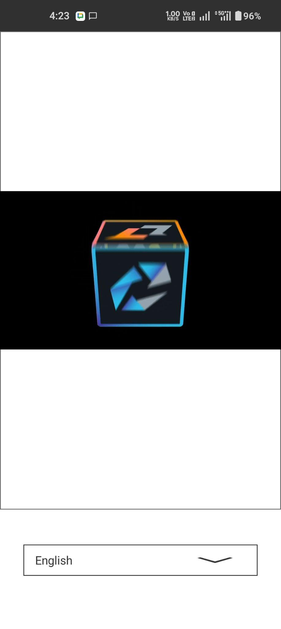
Click on the language list box and explore.
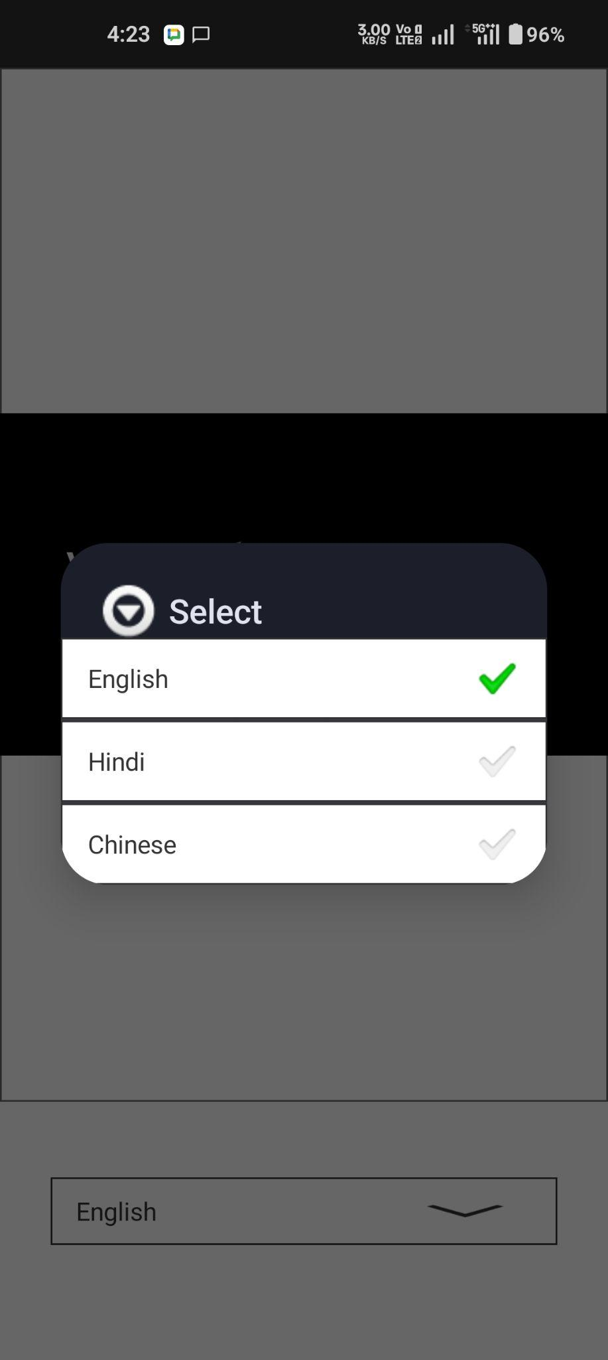

Click on the language button to switch the audio track and subtitle.

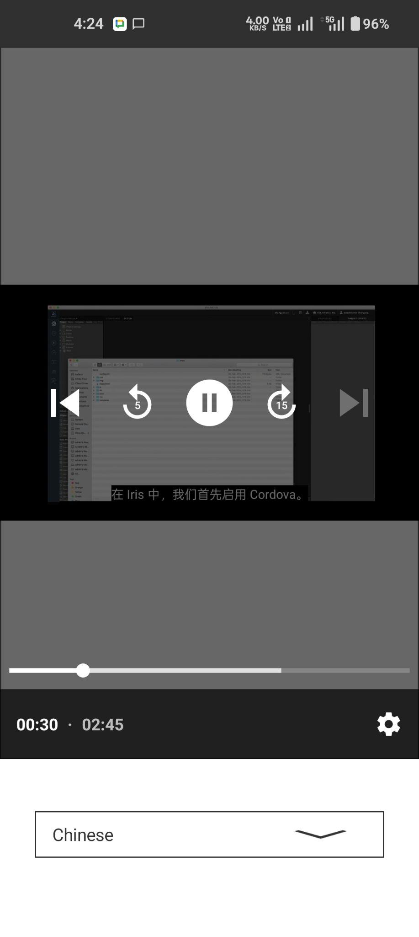

Buttons are provided to play/pause.

3. REVISION HISTORY
App version 1.0.0

A. Limitations:
None
B. Known issues:
None

