Date :  30-09-24

**Monday.com Data Adapter**

**VERSION: 1.0.0**

# **Overview**

Monday.com is a cloud-based work operating system that allows teams to create their own workflows and project management solutions. It’s highly customizable, enabling users to manage tasks, projects, processes, and team collaborations using a simple, visual interface.

**A. Use case:**

* Task Management and Tracking.
* Automation of Workflow Processes.
* Team Collaboration and Communication.

**B. Features**

* Ready-to-use adapter and simple to import.
* Easy to make API calls through simple interaction directly from Foundry.
* Secure and authentic.

# **Getting Started**

## **Prerequisites**

Before you start using the Monday.com data adapter, ensure you have the following:

* [HCL Foundry](https://manage.hclvoltmx.com/)
* Volt MX Iris
* An account with [Monday.com](https://monday.com/).
* Access token issued by Monday.com when you created an account in Monday.com

## **Platforms Supported**

### Mobile

#### iOS

#### Android

## **Importing the adapter**

**To import the Data Adapter to Volt Foundry, do the following:**

1. Sign in to the  [HCL Foundry](https://manage.hclvoltmx.com/).
2. From the left navigation menu, select **API Management**.
3. In **API Management**, select **Custom Data Adapters**.  
   A screenshot of a computer

   Description automatically generated
4. Click **IMPORT** to import a custom data adapter.  
   A blue and white box with text

   Description automatically generated
5. On the Import Data Adapter dialog box, click browse to import.  
   A screen shot of a computer

   Description automatically generated
6. Select data adapter zip file and click **IMPORT**.
7. After importing the Monday.com data adapter, Volt Foundry opens a window that shows the metadata of the data adapter.
8. After you import the data adapter, you can view it on the Custom Data Adapters page and use it to create services on VoltMX Foundry.

[**Creating an Integration service**](javascript:void(0);)

Follow the given steps to create an Integration service using the Monday.com Data Adapter.

1. Sign in to the [HCL Foundry](https://manage.hclvoltmx.com/).
2. From the left navigation menu, select **API Management**.
3. In **API Management**, select **Integration**.

1. To create a new service, click the **+** button or the **CONFIGURE NEW** button.

1. On the Service Definition tab, select the service type as Monday.com, and click **SAVE**.  
   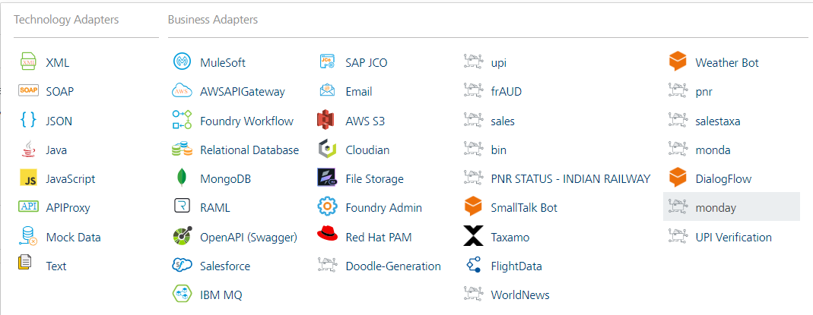

[**Creating and Executing operations**](javascript:void(0);)



After you create an integration service, you can create and execute operations using the service.

#### **Creating an operation**

* In **the API Management/Foundry app you created**, in the **Integration** section, select the service that you created.
* After you select the service, navigate to the **Operation List** tab.  
  A screenshot of a computer

  Description automatically generated
* From the drop-down list, select an operation that you want to execute, and click **ADD OPERATION**.

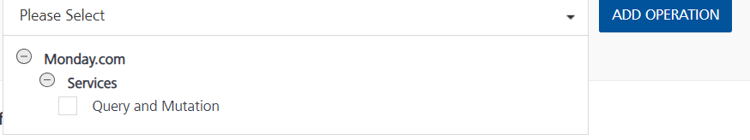

#### **Executing an Operation**

* From the **Operations List** tab, in the **Configured Operations** section, select the operation you want to execute and click on ADD OPERATION button.

* On the Operation Page, in the Request Input tab, enter a TEST VALUE for all the fields.

* On the Header Page, in the Request Input tab, enter the access token from Monday.com.

* Select a run-time environment and click **Save and Fetch Response** to get a response based on your inputs.

## [**Publishing your application**](javascript:void(0);)

If you want to use the services in client applications, you need to publish an app to a run-time environment. You can create the service (as described above) in an application or import the service into an application and publish the application.

# **References**Top of Form

## Refer [the link](https://developer.monday.com/api-reference/reference/about-the-api-reference) for more information about API endpoints.

# **Revision History**

Adapter version 1.0.0