Date: 07 May 2025

MLKIT BARCODE/QR SCANNER APP

VERSION: 1.0.4

Overview
The MLKit Barcode/QR Code Scanner app can scan and decode barcodes. Under the hood, the component contains NFIs that use the Google MLKit Barcode API. The component also supports continuous scanning.

Requirements:

- Volt MX Iris

Devices:
- Mobile
- Tablet

Platforms:
- Android
- IOS

Features:
1. The component utilizes Google MLKit Barcode SDK for decoding barcodes and QR codes.
2. It supports the following Barcode types: Android:(https://developers.google.com/ml-kit/vision/barcode-scanning/android) iOS:( https://developers.google.com/ml-kit/reference/ios/mlkitbarcodescanning/api/reference/Enums/MLKBarcodeFormat)

A. App Functionality:
- When you build and run the app using, you can scan and decode barcodes.
- You can zoom in, zoom out the camera by clicking on the respective z+ and z- buttons.

B. Importing the app:
To import the MLkit Barcode/QR scanner app into your workspace, follow these steps:
- Open Volt MX Iris
- On the main menu select Forge → Browse.
- Search for the MLkitBarcode app, and then click Import to Workspace. The app is imported to your workspace. A dialog box appears, confirming that the app has been imported. Click OK.
4. Switch to your project containing the MLkitBarcode app. To switch to your project, click File → Open → Reference Architecture → <project name>
C. Building the app:
After performing all the above steps, you can build your app and run it on your device. For more information, you can refer to the Building and Viewing an Application section of the Volt MX User Guide.
You can then run your app to see the Barcode/QR code Scanner work in real time.

D. Configure the UI and settings of the MLkitBarcode App
The MLkitBarcode app consists of the following component:
- The MLKitBCScanner component is used to scan the barcodes and QR codes.
- Take one form and add the buttons which you need like Restart, z+, z- and flash.

Restart:

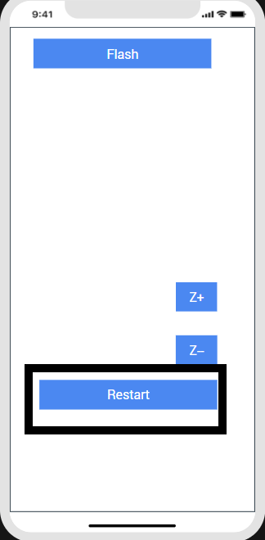

this.view.btnRestart.onClick=function(){
this.view.MLKitBCScanner.restartSession();
}.bind(this);

ZoomIn:

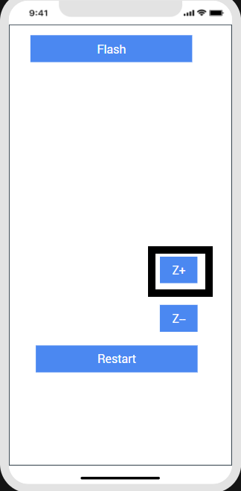

this.view.btnZoomIn.onClick=function(){
this.view.MLKitBCScanner.zoomIn();
}.bind(this);

ZoomOut:

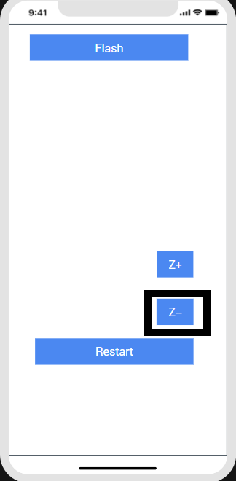
this.view.btnZoomOut.onClick=function(){
this.view.MLKitBCScanner.zoomOut();
}.bind(this);

Flash:

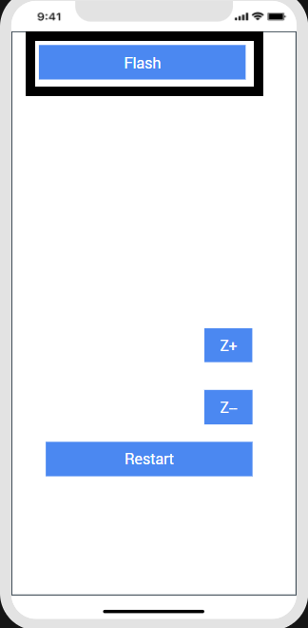

Configuring Native Settings (iOS):
To configure the native settings for iOS, follow these steps:
1. From the Project explorer, go to Assets and expand Media.
2. Right-click Common, and then select Resource Location. Volt MX Iris opens the common resources folder in a file explorer.
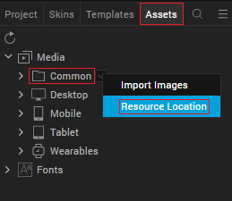
3. Open the infoplist_configuration.json file with a text or code editor.
4. At the end of the file, type the following code. You can change the description based on your preference.
"NSCameraUsageDescription”: "Your Description"
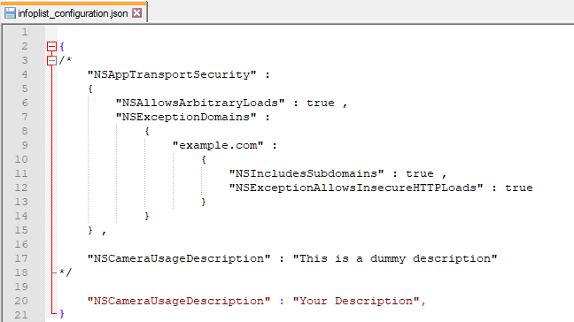
5. Save the file.

Configuring Deployment Target
1. From the left navigation menu, click Project Settings.
2. In the Project Settings window, go to Native → iPhone/iPad.
3. Under Target Versions, from the iOS Version list, select 11.0 or higher.
4. Set the application launch mode to Both and select both Portrait and Landscape for supported orientations.
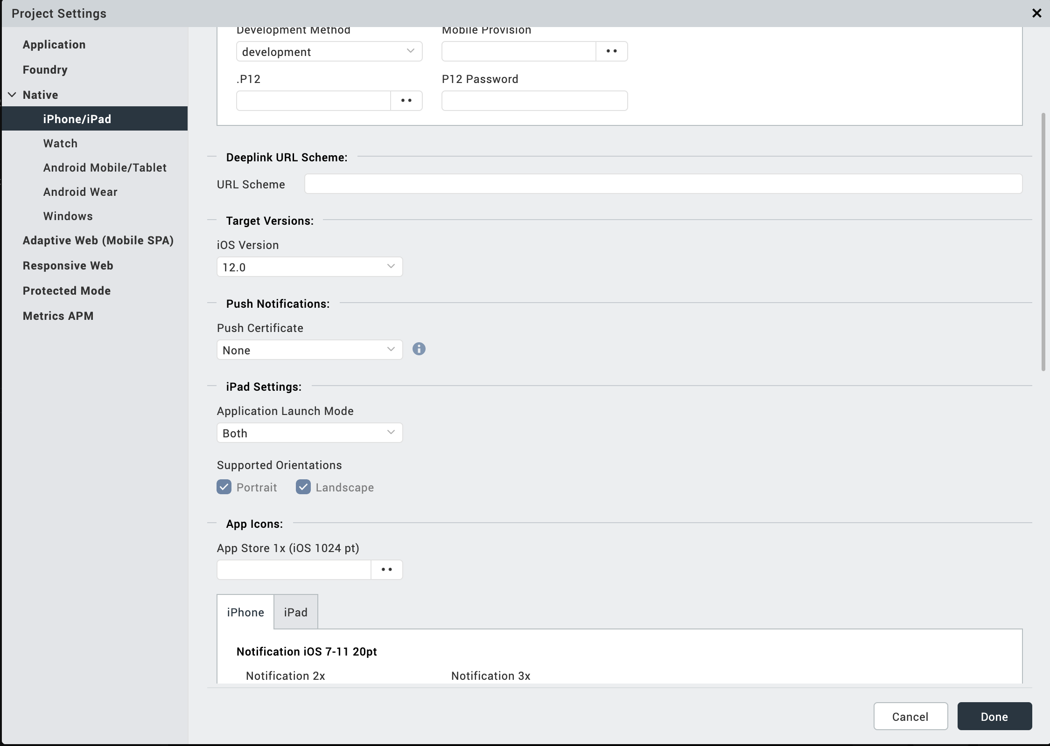
After you configure the native settings, you can Build and Run your app to see the Google MLKit Barcode/QR Code Scanner component work in real time.

Configuring Native Settings (Android)
To configure the native settings for Android, follow these steps:
1. From the left navigation menu, click Project Settings.
2. In the Project Settings window, go to Native → Android Mobile/Tablet.
3. Set the CAMERA permission to true.
To set a permission to true, select the permission from the left panel, and then click Add.
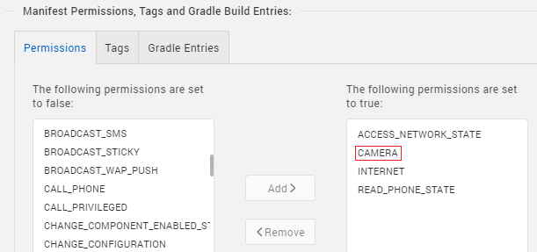
4. Switch to the Gradle Entries tab.
5. Add below Camera permission flag at Project Settings/Android Mobile/Tablet/Manifest Permissions, Tags and Gradle Build Entries/Tags/Child tag entries under <manifest> tag/
<uses-feature android:name="android.hardware.camera.any" />

6. In the build.gradle entries to Suffix box, type the given code based on the version of the component.
dependencies {
// CameraX
implementation "androidx.camera:camera-camera2:1.0.0-beta11"
implementation "androidx.camera:camera-lifecycle:1.0.0-beta11"
implementation "androidx.camera:camera-view:1.0.0-alpha18"

// MLKit
implementation 'com.google.mlkit:barcode-scanning:17.3.0'
implementation 'org.jetbrains:annotations:15.0'

// used for 32 bit support
android { defaultConfig { renderscriptSupportModeEnabled false}}}

NOTE:
· If you do not add the gradle entries to your project, the app crashes.
· You can update the Play Services version in the later builds of your app.
After you configure the native settings, you can Build and Run your app to see the Barcode/QR Code Scanner component work in real time.

MLKitBarcode app:

The following is the screen shots of the app:
- The iPhone will ask for permission like this.

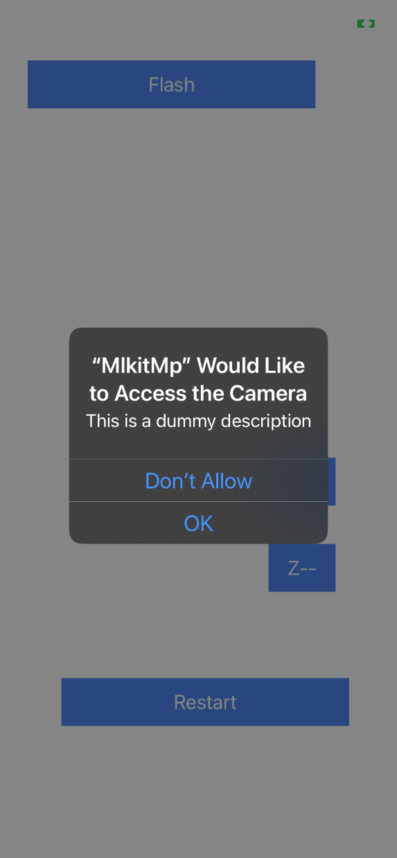

2. After that we can see this screen
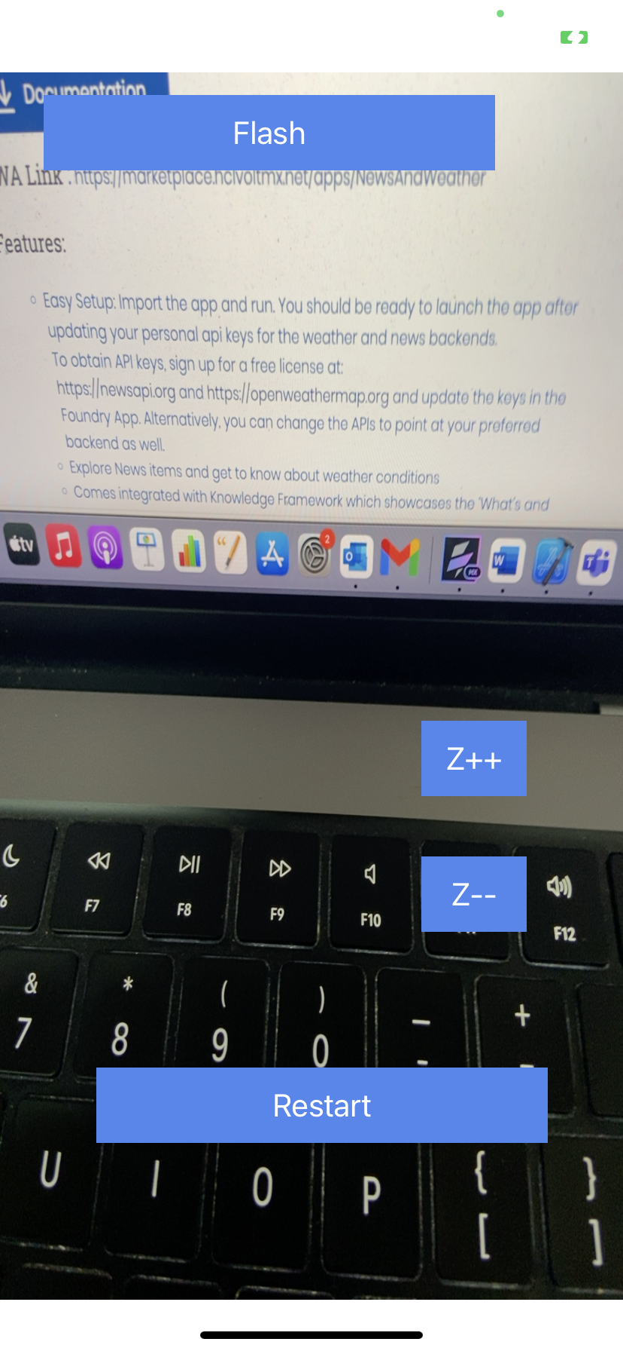

3. Try to scan any QR code, will scan like this
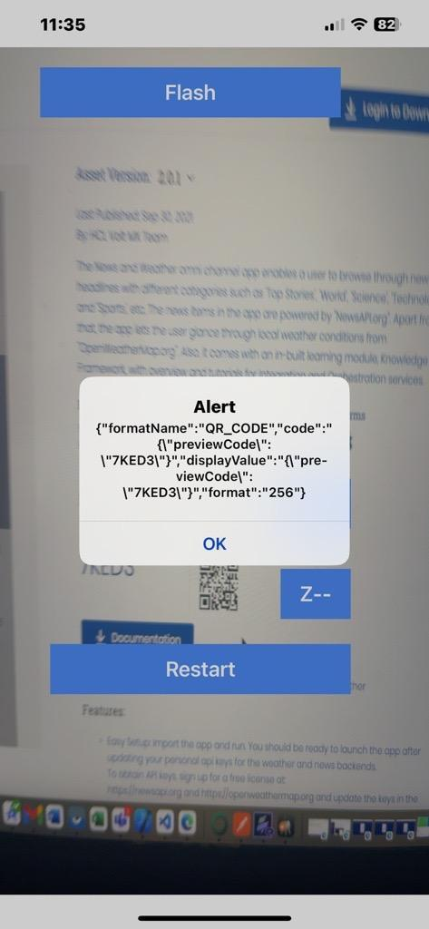

4. After click on Restart button the screen will be
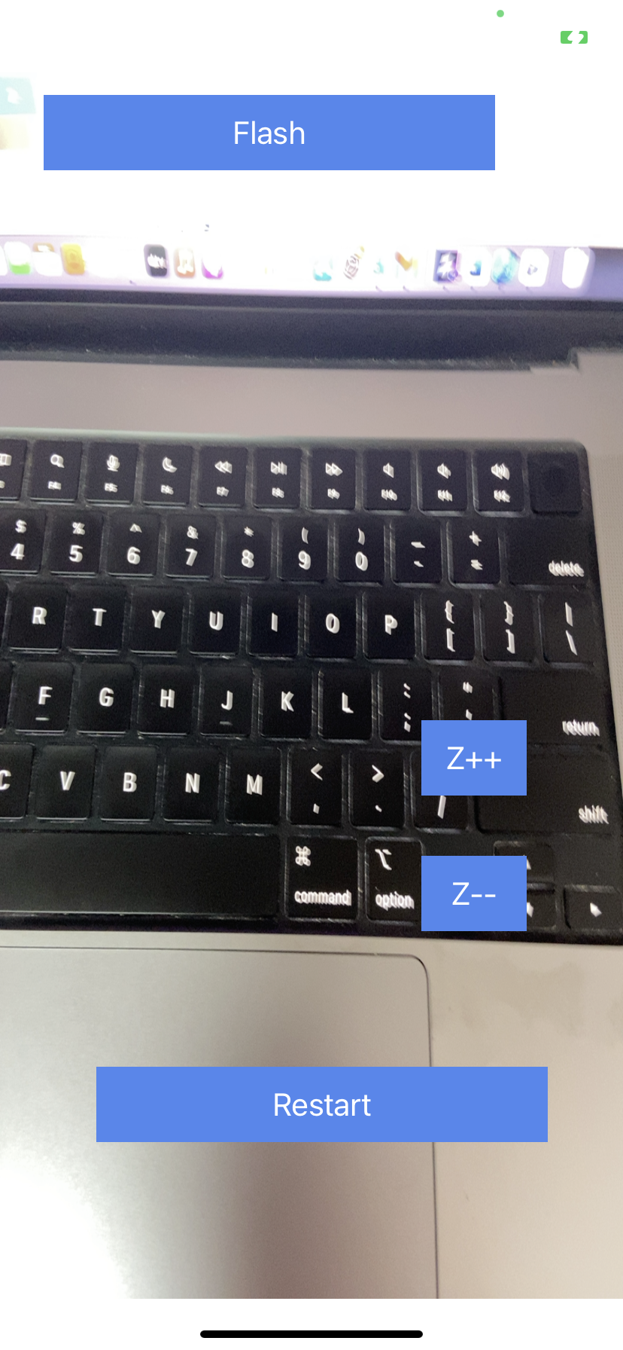

5. By clicking on z++ button
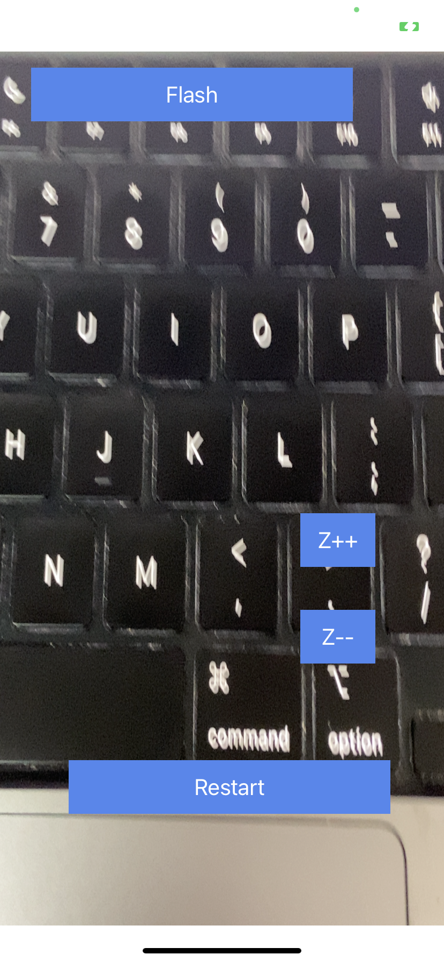

6. By clicking on z-- button
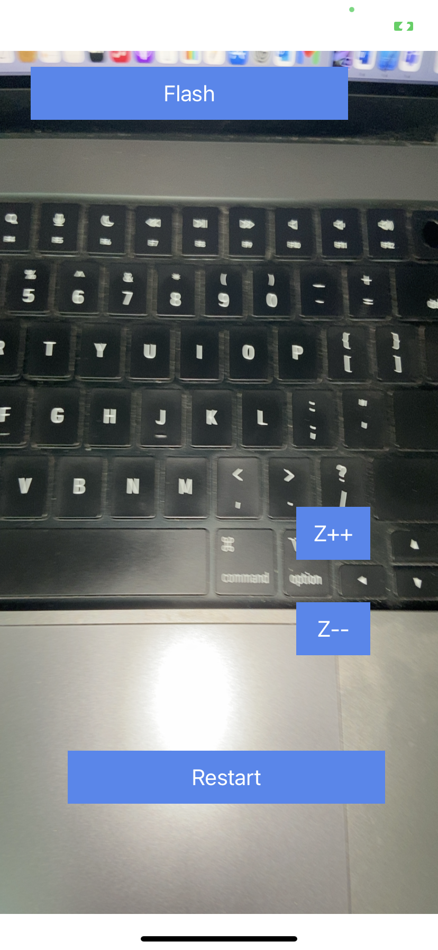

Limitations:
1. This component supports only 64-bit devices
Known issues:
-N.A.-

