Date: 13-Nov-24

MICROSOFT’S AI IMAGE GENERATOR APPLICATION

VERSION: 1.0.0

OVERVIEW
Help users to create any image you can dream up with Microsoft's AI image generator. Describe your ideas and then watch them transform from text to images. Whether you want to create ai generated art for your next presentation or poster, or generate the perfect photo, Image Creator in Microsoft Designer can effortlessly handle any style or format.
Microsoft's AI Image Generator is a tool powered by artificial intelligence that can create images based on text descriptions provided by the user. It's designed to help users generate visual content quickly and easily without needing advanced design skills.It will get vivid, high-resolution images with stunning detail.

Use case:
- Automates the generation of high-quality images for marketing, social media, and blog posts, saving time and effort.
- Helps artists and creative professionals brainstorm or enhance artwork by generating unique, AI-driven visuals.

Features:
- Easy Setup: Import the app and run, you should be ready to launch the app after updating your api keys for the Microsoft’s AI Image Generator backend. To obtain API keys, sign up for a free license at Microsoft account and update the keys in the Foundry and Iris App. Alternatively, you can change the APIs to point at your preferred backend as well.
- Users can generate highly detailed images from text descriptions using AI-powered models like DALL-E.
- Allows users to adjust image parameters such as style, colors, and resolution to match their needs.
- Generates high-resolution, realistic images suited for both professional and casual use.

Percentage of re-use:
80% (Data can be customizable and customers need to implement UI by themselves).

GETTING STARTED

Prerequisites
Before you start using the Microsoft’s AI Image Generator, ensure you have the following:

- HCL Foundry
- Volt MX Iris
- Microsoft account
- Endpoint, deployment-id and api-key to use the Microsoft’s AI Image Generator API issued by Microsoft.
Reference document: https://learn.microsoft.com/en-us/azure/ai-services/openai/how-to/dall-e?tabs=dalle3

Devices
- Mobile

Platforms
- Android
- IOS

Importing the App
To import the Microsoft’s AI Image Generator App to Volt MX Iris, do the following:

To import the Microsoft’s AI Image Generator App, do the following:
- Launch Volt MX Iris.
- Click project, and then select Import. The Import dialog box appears.
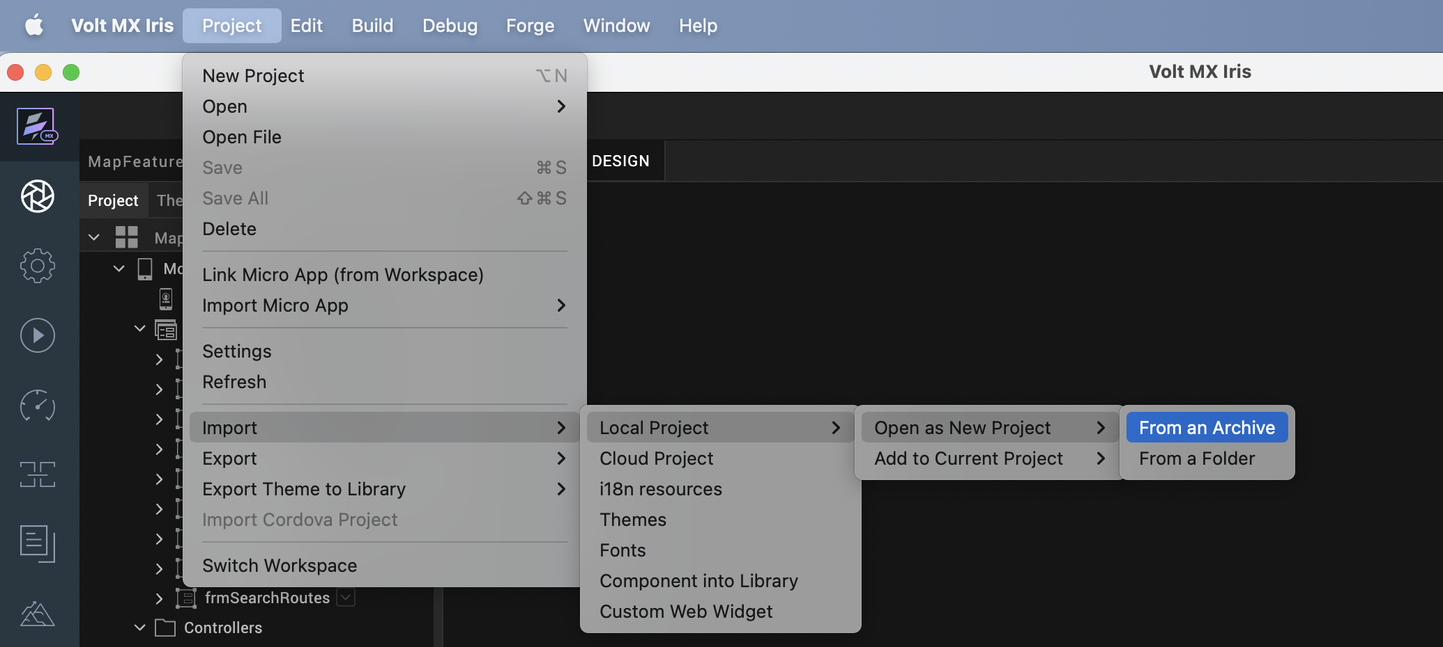

- Click From an Archive to navigate to the location of the project, select the files, and then click Import.
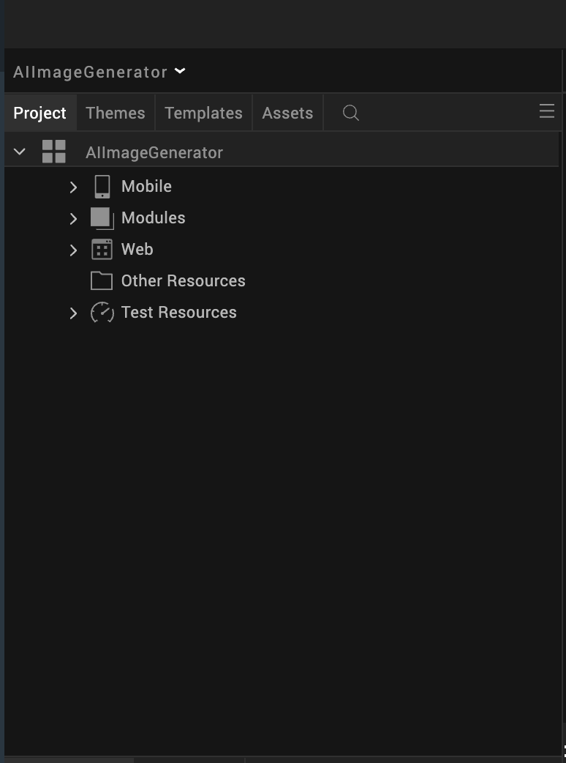
After you import the application, you can view the associated Foundry app connected at the Data & Services section.
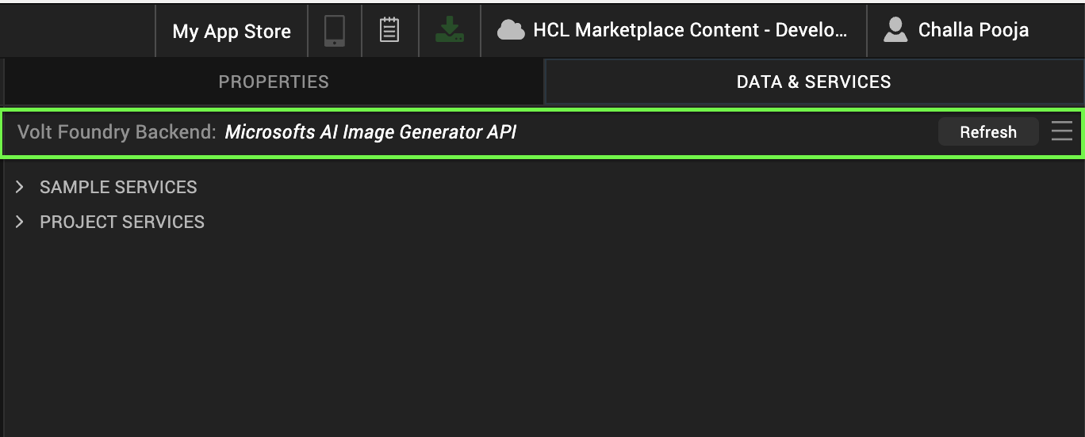

Microsoft’s AI Image Generator Volt MX Foundry Services:
The Microsoft’s AI Image Generator app contains an Integration Service :
ImageGeneration Service: This service is used for generating a batch of images from a text caption on a given DALLE model deployment
Operations :
i. generateImages - Used to generate a batch of images from a text caption

Configure Native Settings

Android:
To configure the native settings for Android, follow these steps:
1. From the left navigation menu, click Project Settings.
2. In the Project Settings window, go to Native → Android Mobile/Tablet.
3. We need to give the below permissions for Android Mobile.
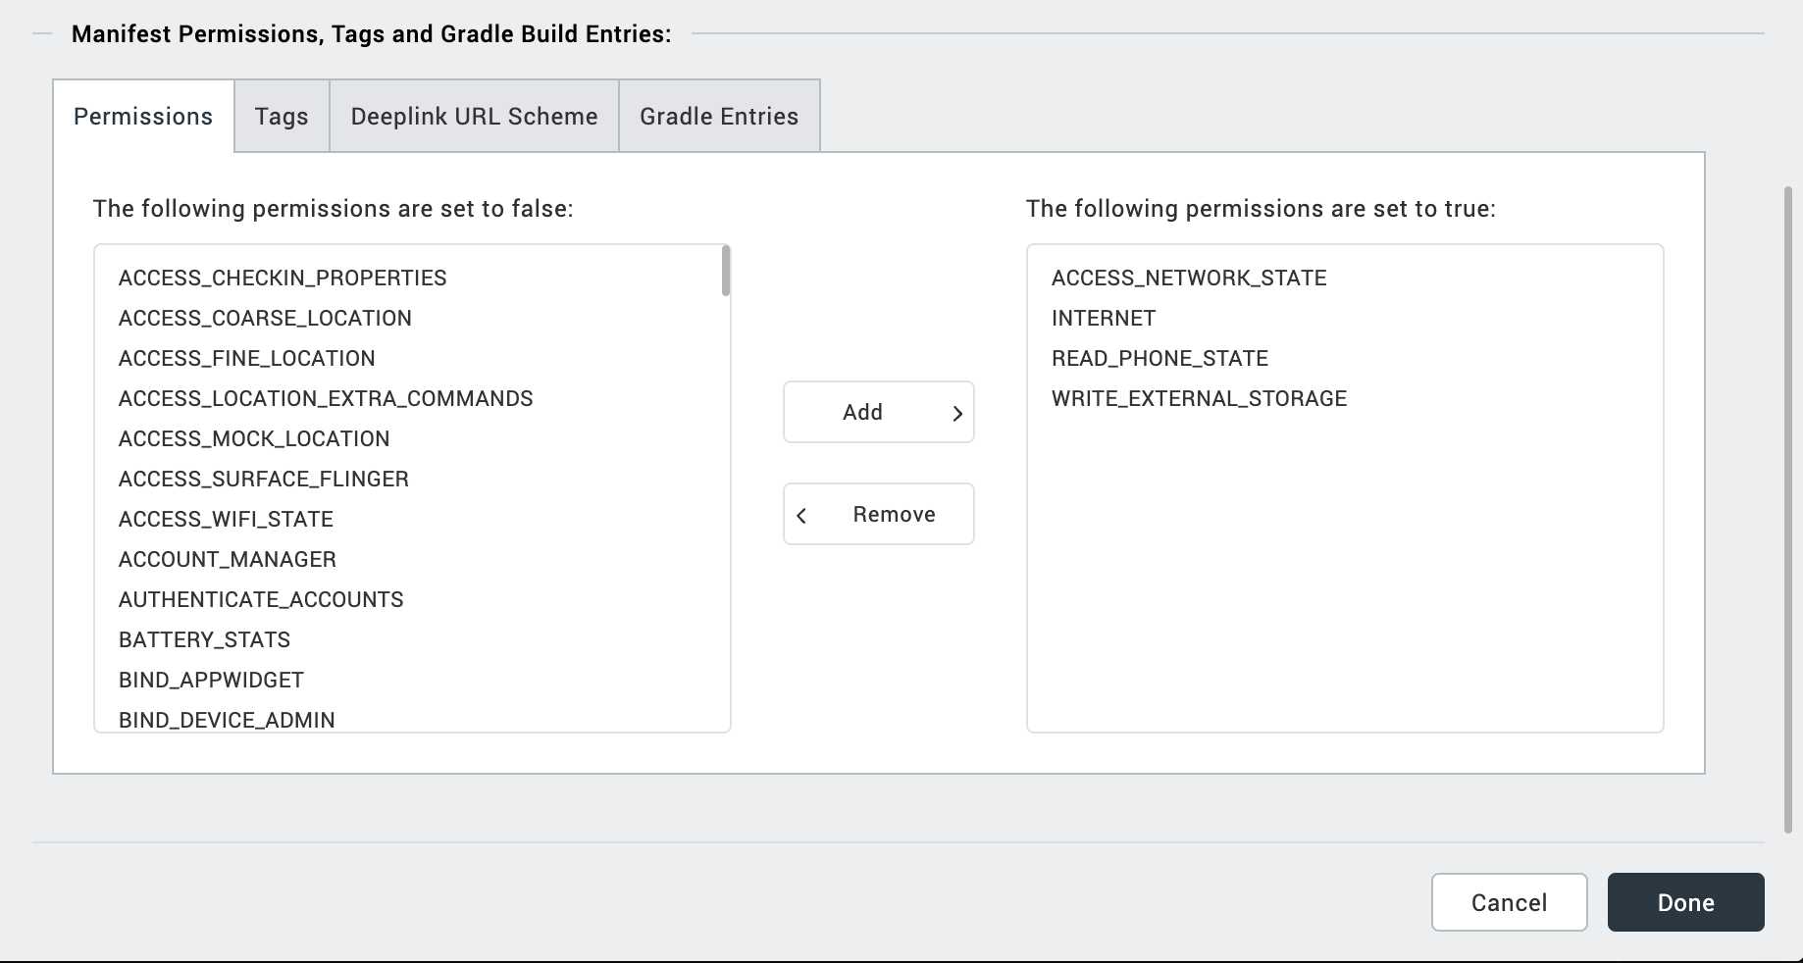
4. Enter the given snippet in Child tag entries under <manifest > tag

<uses-permission android:name="android.permission.READ_MEDIA_IMAGES" />
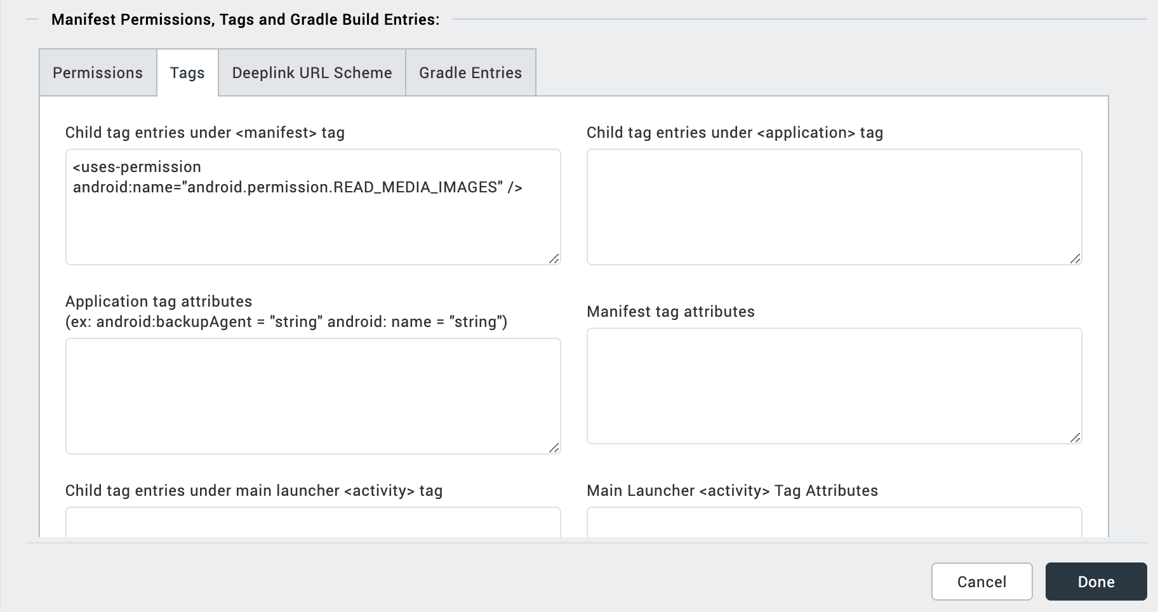

IOS:
Follow the steps given to enable the permissions.
1. From the Project explorer, navigate to the Assets tab.
2. Right click Media and select Resource Location to open the project resources folder.
3. In the browser window that opens, navigate to the common folder.
4. Open the infoplist_configuration.json file with a text or code editor.
5. Add the given code at the end of the file. You can replace the values with your own descriptions.
{
"NSPhotoLibraryUsageDescription": "This uses for Photo Library"
}

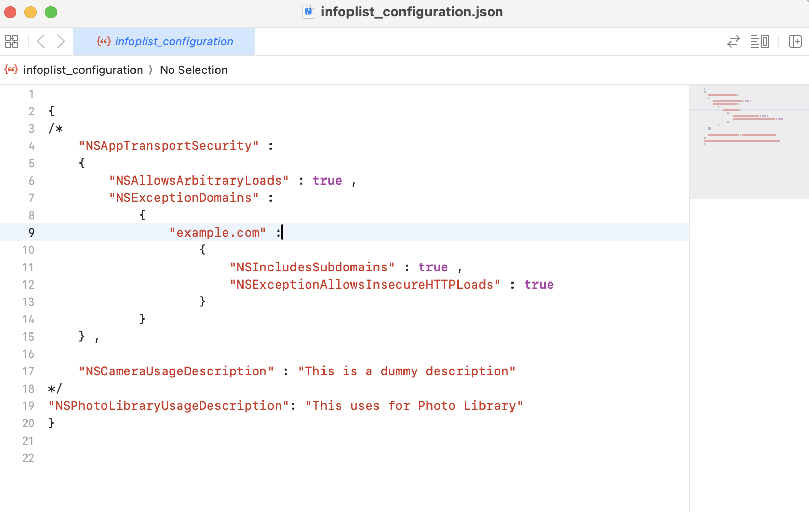

Building the app
From the menu bar, go to Build and then select Build Native Local.
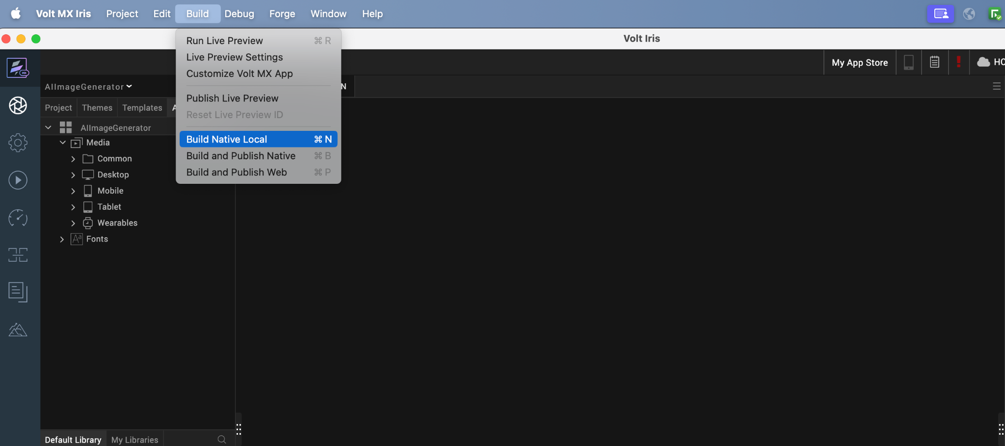

For Mobile, select Android and iOS. Click Build.
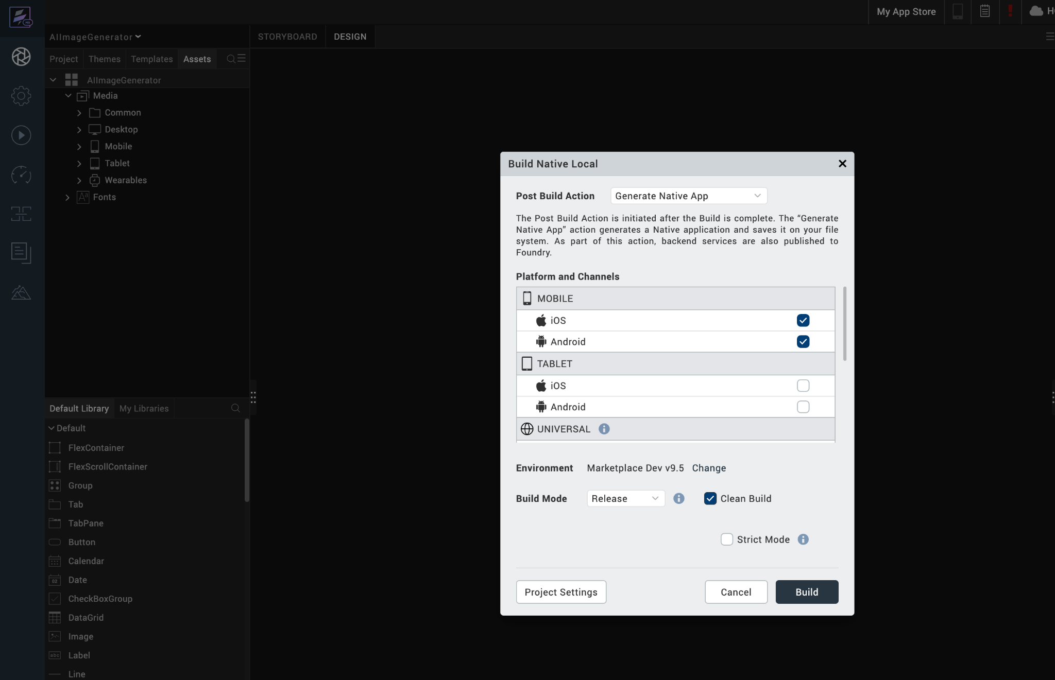

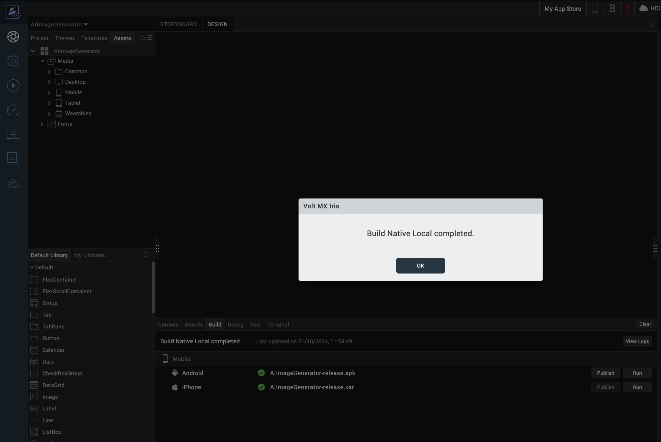

After the build is successful, run the app on your mobile device.

Application Flow
The landing page for the app is as follows:
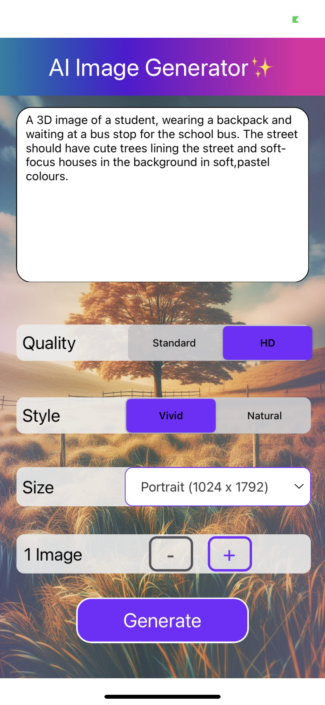
Click on Generate after providing all the required inputs. Now an AI Image will be generated.
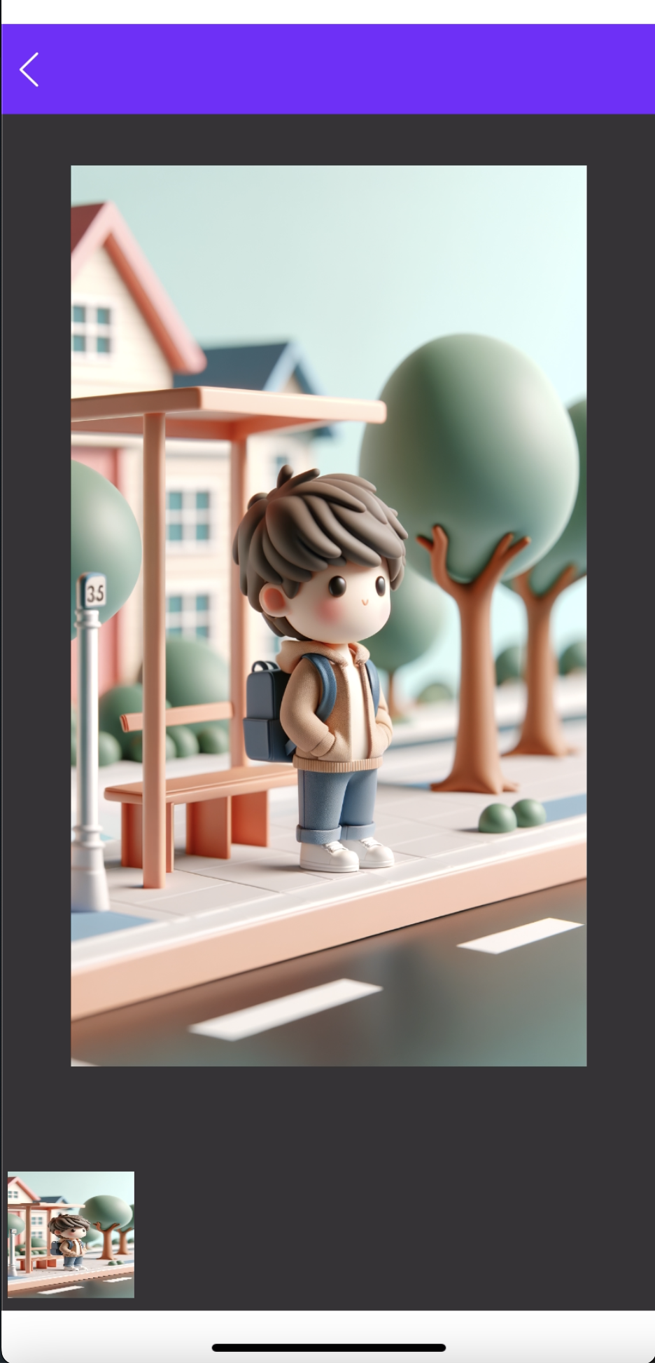
The generated images will be displayed in the image gallery view. You can download the image by swiping on it. The text used to generate the image will be displayed, with an option to copy the text.
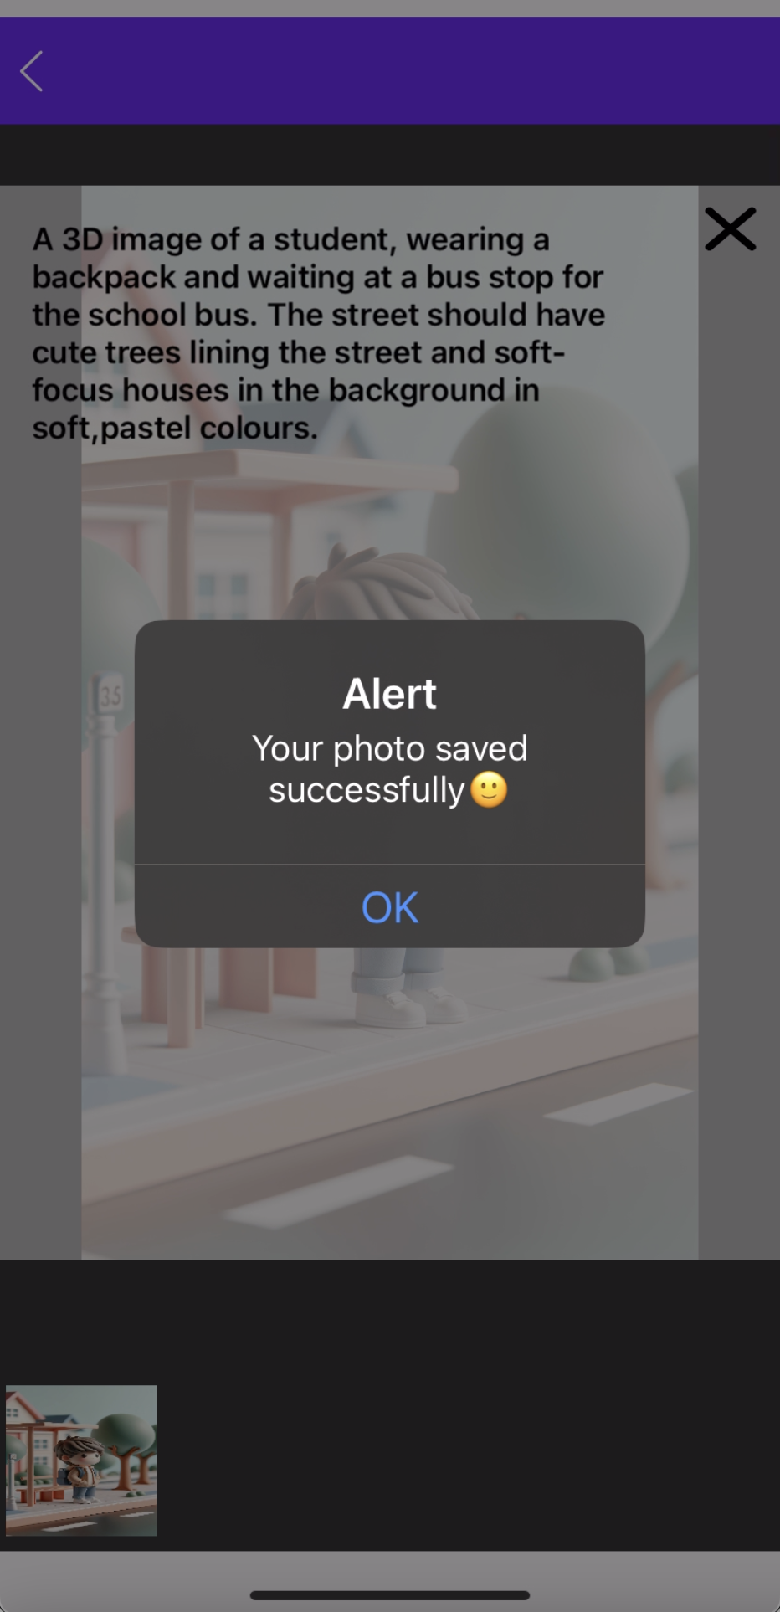

After downloading the image, you can view the image in the device gallery.
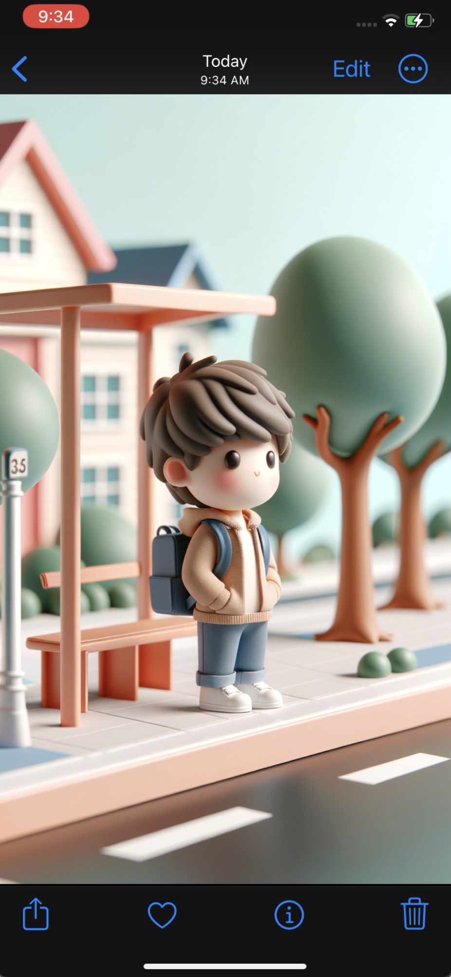

NOTE:
A Microsoft AI Image Generator data adapter is present in the Marketplace page.
Marketplace link: https://marketplace.hclvoltmx.com/items/microsofts-ai-image-generator

REVISION HISTORY
App version 1.0.0:

A. Limitations
1. Do not have support for Landscape mode.

B. Known Issue
- NA

