Date :  26-Aug-25

**MICROSOFT AZURE DOCUMENT TRANSLATION APPLICATION**

**VERSION: 1.0.0**

# **OVERVIEW**

Document translation is a cloud-based machine translation feature of the **Azure AI Translator** service. You can translate multiple and complex documents across all supported languages and dialects while preserving original document structure and data format. Instead of manually copying and pasting text into translation tools, this service allows seamless translation of files in multiple formats such as Word, PowerPoint, Excel, PDF, HTML, plain text, and more.

Document Translation is designed to help enterprises, content creators, educators, and organizations quickly localize content at scale for global audiences. By leveraging Azure’s Neural Machine Translation models, it ensures accurate, fluent, and context-aware translations while maintaining tables, layouts, fonts, and embedded objects.

# **Requirements:**

1. [HCL Foundry](https://manage.hclvoltmx.com/)
2. Volt MX Iris
3. [Microsoft account](https://portal.azure.com/)

* An Azure subscription. If you don't have an Azure subscription, create an account before you begin.
* Once you have your Azure subscription, create an [Azure AI Translator resource](https://portal.azure.com/#create/Microsoft.CognitiveServicesTextTranslation) in the Azure portal.
* An [Azure Blob Storage](https://learn.microsoft.com/en-us/azure/storage/blobs/storage-blobs-overview) account.
* You also need to [create containers](https://learn.microsoft.com/en-us/azure/ai-services/translator/document-translation/how-to-guides/use-rest-api-programmatically?tabs=csharp#create-azure-blob-storage-containers) in your Azure Blob Storage account for your source and target files:
  + Source container. This container is where you upload your files for translation (required).
  + Target container. This container is where your translated files are stored (required).

**Reference document:** <https://learn.microsoft.com/en-us/azure/ai-services/translator/document-translation/overview>

# **Devices:**

* Mobile

# **Platforms:**

* Android
* IOS

# **Features**

* **User-Selectable Target Language**: Users can choose their desired translation language from a dropdown of supported locales, ensuring flexibility for multilingual needs.
* **Multi-format Support** – Translate documents in formats like Word, PowerPoint, Excel, PDF, HTML, plain text, and more.
* **Batch Translation** – Process multiple documents or entire folders in one request, improving scalability.

# **App Functionality**

When you build and run the app, you can translate an Azure-hosted .txt file into your chosen language

1. **Home Screen (frmHome)**
   * User enters Azure Blob Storage SAS file URL and selects the target language from the dropdown list.
   * “**Translate Document**” button triggers validation and starts the translation process.
2. **Authentication**
   * The app authenticates the user through MicrosoftAzureAIService from foundry before making translation requests.
3. **Translation Process**
   * Sends a BatchTranslation request to Azure.
   * Polls translation status until it completes successfully.
4. **Result Retrieval & Display**
   * Display the original document content..
   * Displays transcript text.
5. **Back Navigation**

* Return to Home Screen to process a new Document.

# **Importing the app**

To import the **Microsoft Azure Document Translation Application** into your workspace, follow these steps:

1. Open Volt MX Iris
2. On the main menu select Forge → Browse.
3. Search for the **Microsoft Azure Document Translation Application**, and then click Import to Workspace. The app is imported to your workspace. A dialog box appears, confirming that the app has been imported. Click OK.
4. Switch to your project containing the **Microsoft Azure Document Translation Application**. To switch to your project, click File → Open → Reference Architecture → <project name>

# **Building the app**

After performing all the above steps, you can build your app and run it on your device. For more information, you can refer to the [Building and Viewing an Application](https://opensource.hcltechsw.com/volt-mx-docs/docs/documentation/Iris/iris_user_guide/Content/Cloud_Build_in_VoltMX_Iris.html#cloud)  section of the Volt MX User Guide.

You can then run your app to see the **Microsoft Azure Document Translation Application** work in real time.

# **Configure the UI and settings of the Microsoft Azure Document Translation Application**

The **Microsoft Document Translation Application** consists of the following key components:

* **Document Translation Component** – Used to translate Azure Blob Storage SAS file into a selected target language with transcripts.

**UI Configuration**

1. **Create the Home Screen**
   * Add a **TextBox** for entering the Azure Blob Storage SAS file URL.
   * Add a **ListBox** to select the target translation language.
   * Add a **Button** to start the translation process.  
     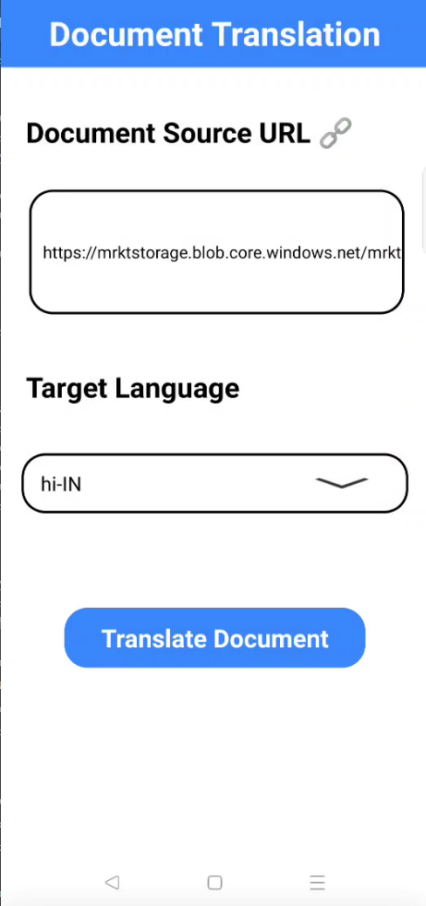
2. **Create the Translation Result Screen** 
   * Add a **Text Area Widget** inside a flex container to display the original text.
   * Add a **Text Area Widget** widget to display the translated text.

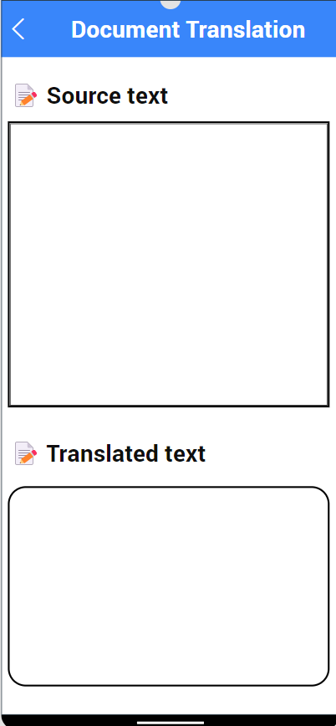

# **Foundry APP Setup**

When you import the application to your Volt MX Iris project, the HCL Volt MX Foundry services of the **Microsoft Document Translation** are added to the HCL Volt MX Foundry app, which is associated with the Volt MX Iris project. While importing the **Microsoft Azure Document Translation Application** to your Volt MX Iris project, if there is no HCL Volt MX Foundry app associated with the existing Volt MX Iris project, a new HCL Volt MX Foundry app is automatically added to your HCL Volt MX Foundry environment and is associated with your Volt MX Iris.

To set the Foundry app, follow these steps:

1. Click the HCL Volt MX Foundry app associated with your Volt MX Iris project from the Project Explorer. Click **DATA & SERVICES.**

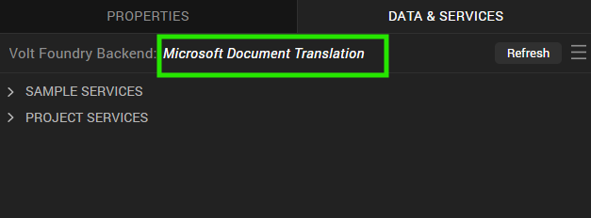

1. Under Configure Services, on the Identity tab, select the **MicrosoftAzureAIService** identity service. 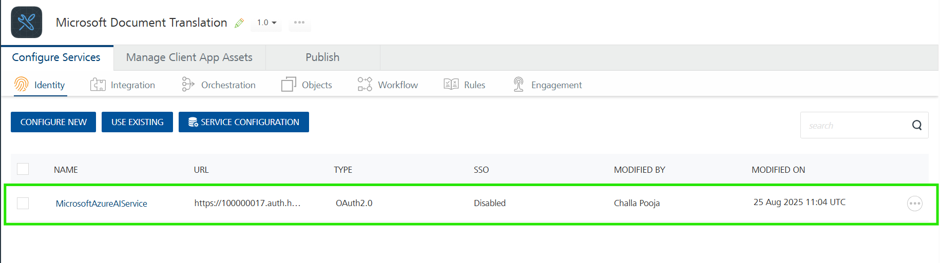
2. Under **Client Details**, type the Client ID and Client Secret that you received from [Microsoft identity platform](https://learn.microsoft.com/en-us/entra/identity-platform/quickstart-register-app?tabs=certificate#register-an-application).
3. To obtain Client ID and Client Secret from Microsoft refer the below documentations

**Links:**

* <https://learn.microsoft.com/en-us/entra/identity-platform/quickstart-register-app?tabs=certificate>
* <https://learn.microsoft.com/en-us/entra/identity-platform/access-tokens>

**Note:**  
If you want to verify the details, click **TEST LOGIN** and sign in by using your Microsoft account credentials.

1. Under the **Configure Services** tab, click **Integration** and can see the **TranslatedDocument**. Click on the Integration service to add the keys.   
   For the Host URL, replace the value of your-resource-name with your Microsoft’s Azure Translator resource endpoint URL obtained from [Microsoft Azure](https://portal.azure.com/#create/Microsoft.CognitiveServicesSpeechServices). Refer [Microsoft's Azure Document Translation Service](https://learn.microsoft.com/en-us/azure/ai-services/translator/document-translation/quickstarts/rest-api#prerequisites).  
   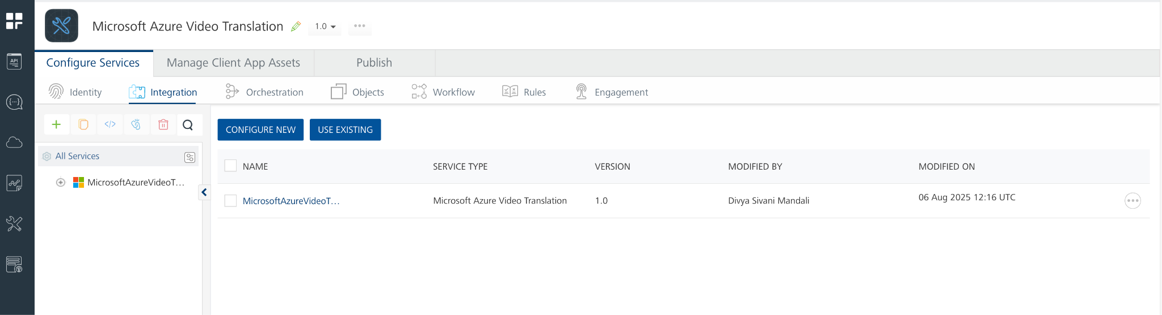
2. Click on the **TranslatedDocument**  integration service to expand the operations.  
     
   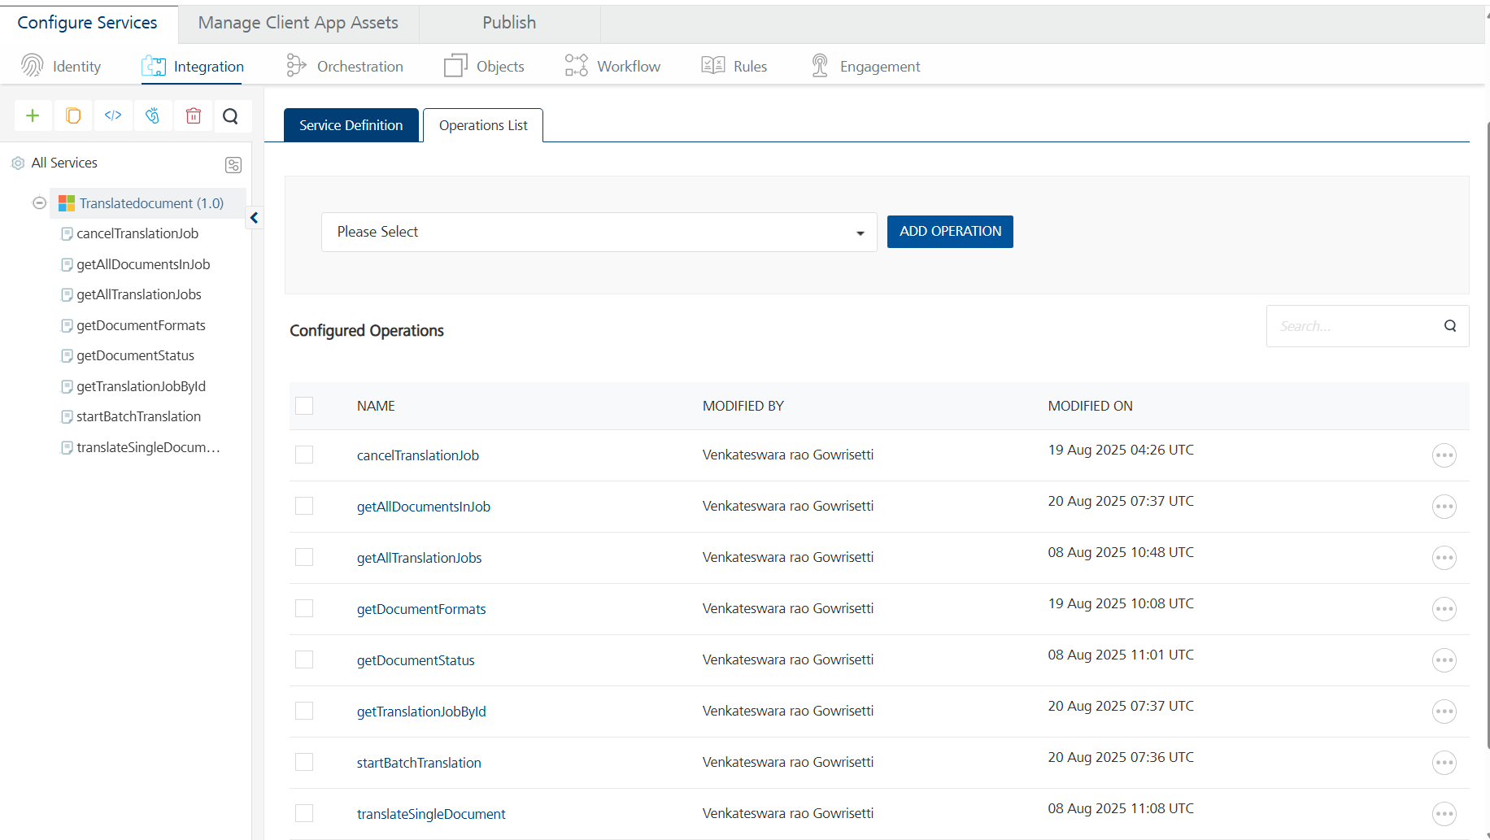
3. Select each operation, On the **Request Input** tab, in the **Body** section, specify the values in the respective boxes under the **Test Value** column.
4. Click **Header** sub-tab. The **Header** section opens.

* Specify the required values in the respective boxes under the **Test Value** column.
* For **Ocp-Apim-Subscription-Key**, In the box under the **TEST VALUE** and **DEFAULT VALUE** columns, type the API Key generated from [Microsoft Azure](https://learn.microsoft.com/en-us/azure/ai-services/translator/document-translation/how-to-guides/use-rest-api-programmatically?tabs=csharp#retrieve-your-key-and-custom-domain-endpoint).  
    
  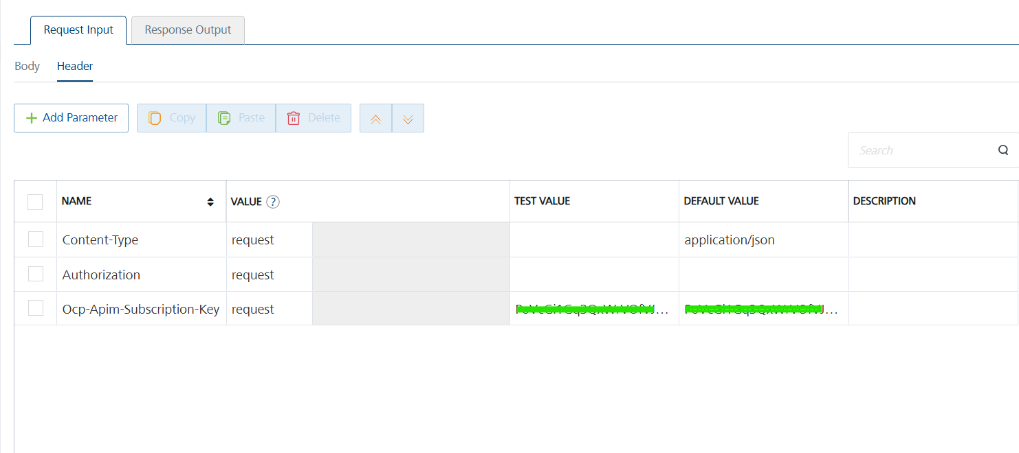

1. Click **SAVE OPERATION**.
2. Click **SAVE AND FETCH RESPONSE**. The **Output Result** dialog appears with the response. Otherwise, the **Output Result** shows an error.  
   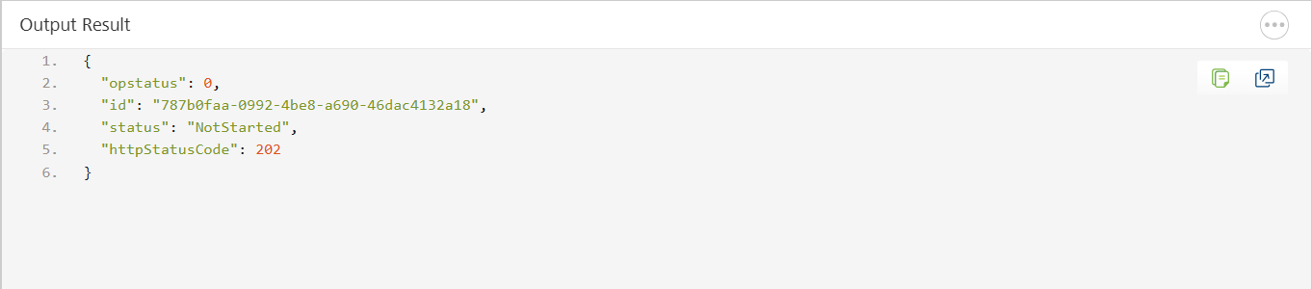

# **Publish the HCL Volt MX Foundry App**

After you set the Operation Security Level, you must publish the HCL Volt MX Foundry app. To publish the HCL Volt MX Foundry, follow these steps:

In Volt MX Iris, click **DATA & SERVICES**, and then click **Publish Project Services** to **Publish** to your foundry app.  
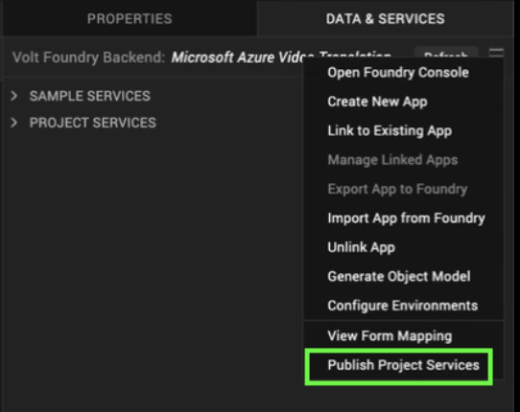

Select the environment to which you want to publish your app, and then click **Publish**.  
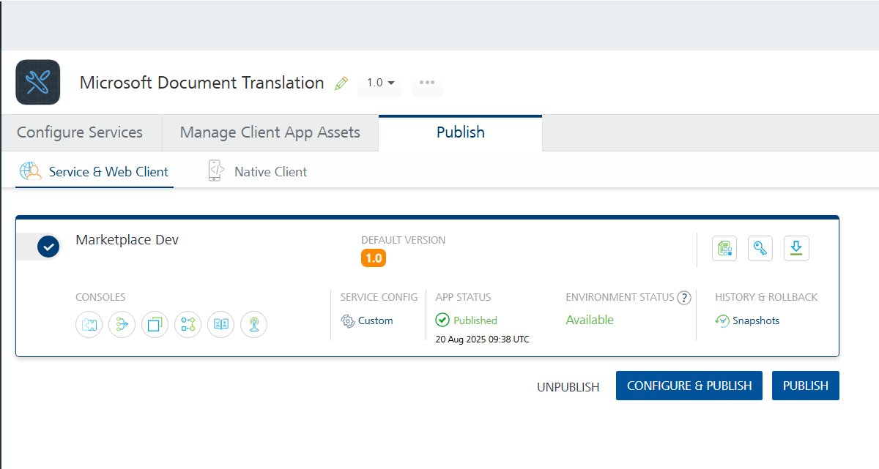After the app is published to your environment, the following window appears confirming the publish.  
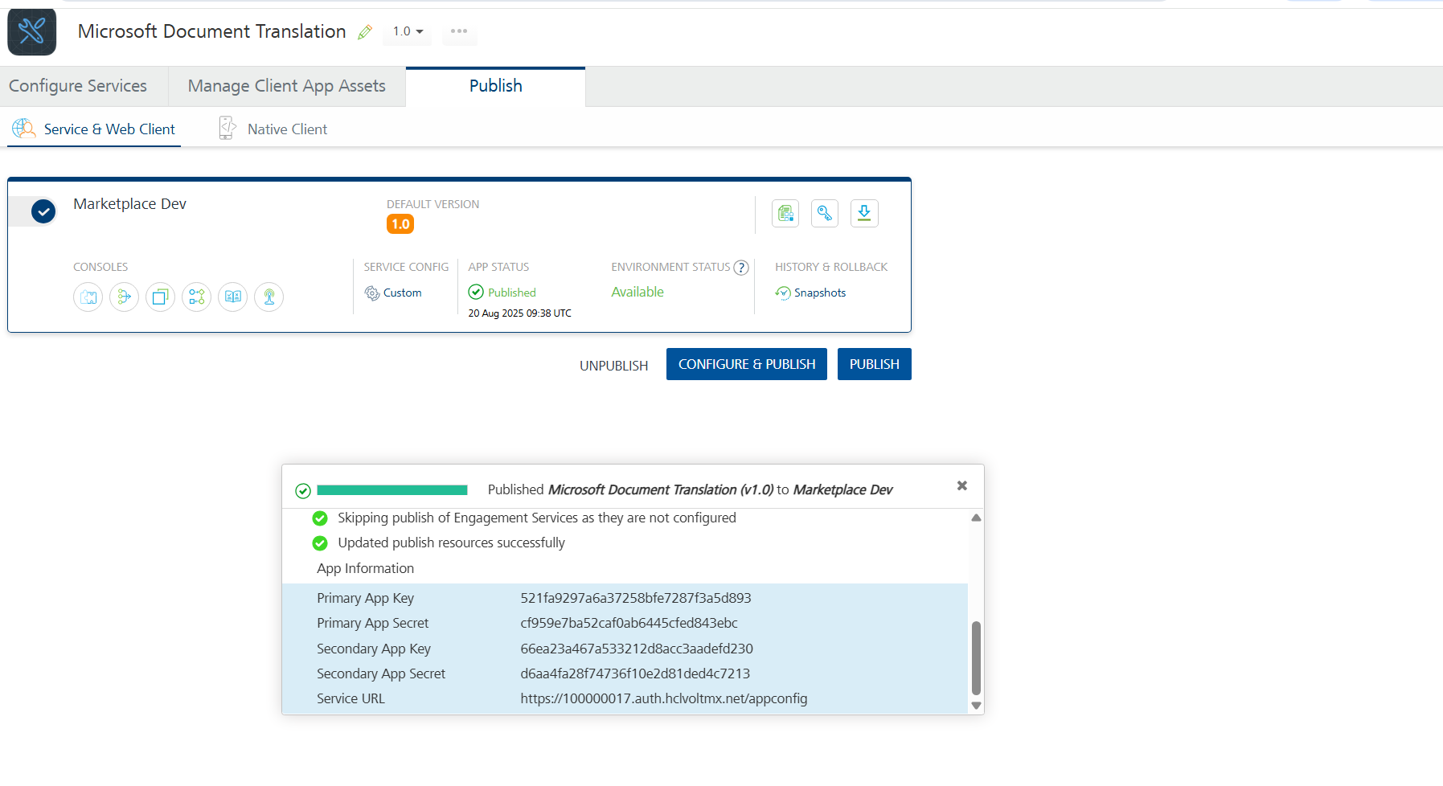

# **Building and previewing the app**

After performing all the above steps, you can build your app and run it on your device. For more information, you can refer to the [Building and Viewing an Application](https://opensource.hcltechsw.com/volt-mx-docs/docs/documentation/Iris/iris_user_guide/Content/Cloud_Build_in_VoltMX_Iris.html#cloud) section of the Volt MX User Guide.

You can then run your app to see the Microsoft Azure Document Translation work in real time.

**Reference Documents:**

* <https://learn.microsoft.com/en-us/azure/ai-services/translator/document-translation/overview>
* <https://learn.microsoft.com/en-us/azure/ai-services/translator/document-translation/reference/rest-api-guide>

# **REVISION HISTORY**

App version 1.0.0:

## **Known Issues**

None

## **Limitations**

None