Date :  18/10/2023

Message Bird Adapter (1.0.0)

# Overview

Message Bird Adapter uses <https://dashboard.messagebird.com/> to adopt SMS or Voice or WhatsApp services.

WhatsApp app which uses this service to send or receive different types of messages.

## Prerequisites

* Volt Foundry
* To use MessageBirds APIs, you need to first sign up for free at [**www.messagebird.com**](https://dashboard.messagebird.com/en/sign-up/).
* After successful Sign Up, you can login to your account and redirect to <https://dashboard.messagebird.com/>
* You can find 2 kids of APIKeys i.e. Production and Test.
* We should use Test APIKey to utilize services.

## Signup instructions for the service: Go to this link [www.messagebird.com](http://www.messagebird.com) and fill the following fields:

## Work Email

## What’s your goal Today

## Click Select and account is created.

## After submitting, you can see the APIKeys on the Dashboard of <https://dashboard.messagebird.com>.

## Importing the adapter

**To import the Data Adapter to Volt Foundry, do the following:**

1. Sign in to the  [HCL Foundry](https://manage.hclvoltmx.com/).
2. From the left navigation menu, select **API Management**.
3. In **API Management**, select **Custom Data Adapters**.  
   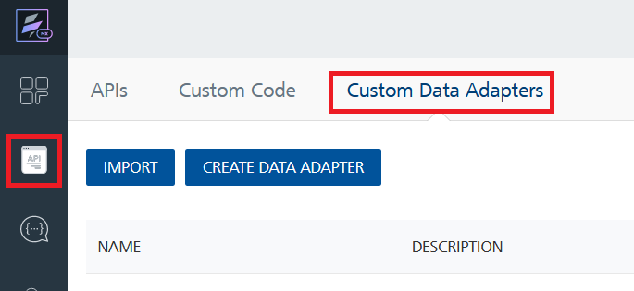
4. Click **IMPORT** to import a custom data adapter.  
   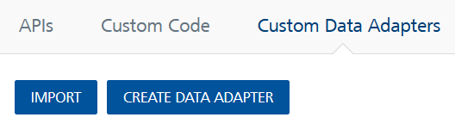
5. On the Import Data Adapter dialog box, click browser to import.  
   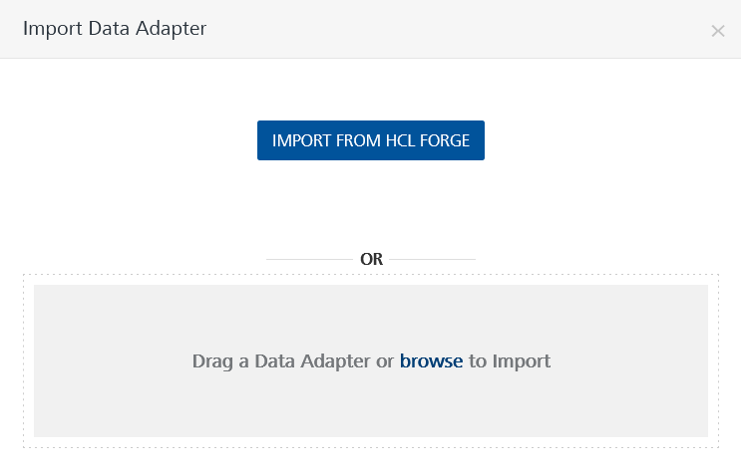
6. Select MessageBirdAdapter zip file and click **IMPORT**.

After you import the data adapter, Volt Foundry opens a window that shows the metadata of the data adapter.

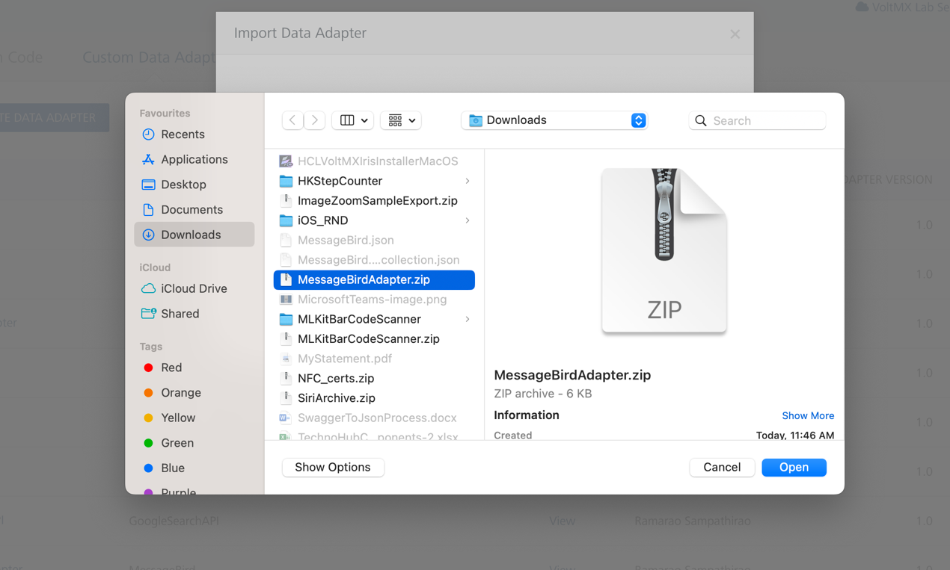

After you import the data adapter, you can view it on the Custom Data Adapters page and use it to create services on Volt Foundry.

## [Creating an Integration service](javascript:void(0);)

After you import the data adapter into Volt Foundry, you can use it to create an Integration Service.

Follow the given steps to create an Integration service using the News API Adapter.

1. Sign in to the [HCL Foundry](https://manage.hclvoltmx.com/).
2. From the left navigation menu, select **API Management**.
3. In **API Management**, select **Integration**.  
   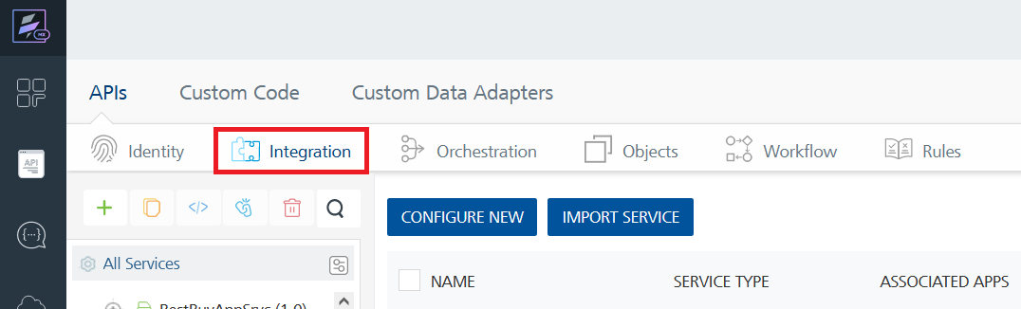
4. To create a new service, click the **+** button or the **CONFIGURE NEW** button.  
   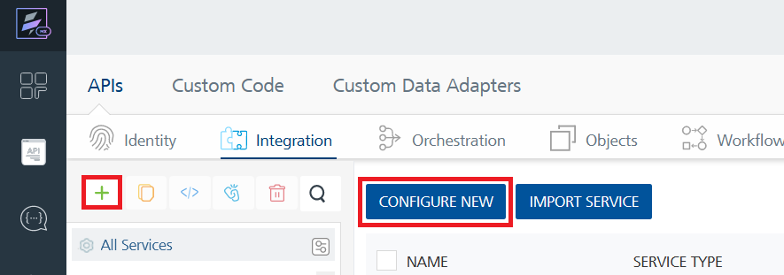
5. On the Service Definition tab, select the service type as MessageBirdAdapter and click **SAVE**.  
   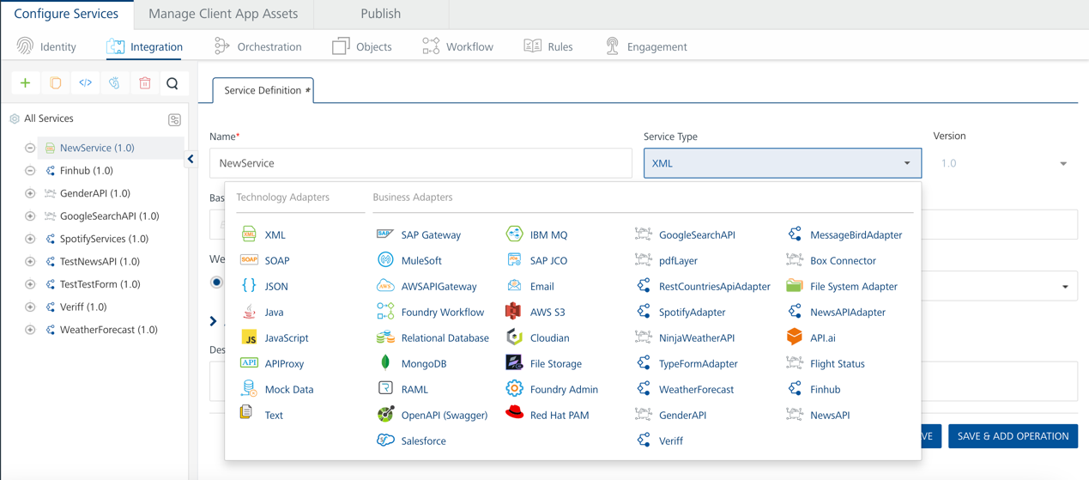

Alternatively, you can also create a Foundry app and create an Integration service inside it.

E. [Creating and Executing operations](javascript:void(0);)



After you create an integration service, you can create and execute operations using the service.

#### Creating an Operation

* In **API Management/Foundry app you created**, in the **Integration** section, select the service that you created.
* After you select the service, navigate to the **Operation List** tab.  
  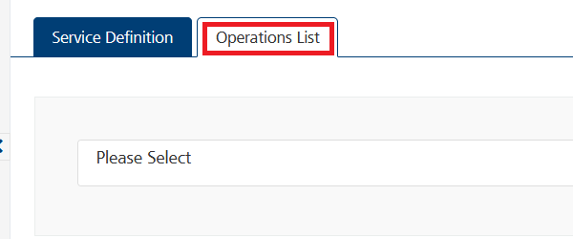
* From the drop down list, select an operation that you want to execute, and click **ADD OPERATION**.  
  A screenshot of a computer

  Description automatically generated

#### Executing an Operation

* From the **Operations List** tab, in the **Configured Operations** section, select the operation you want to execute.  
  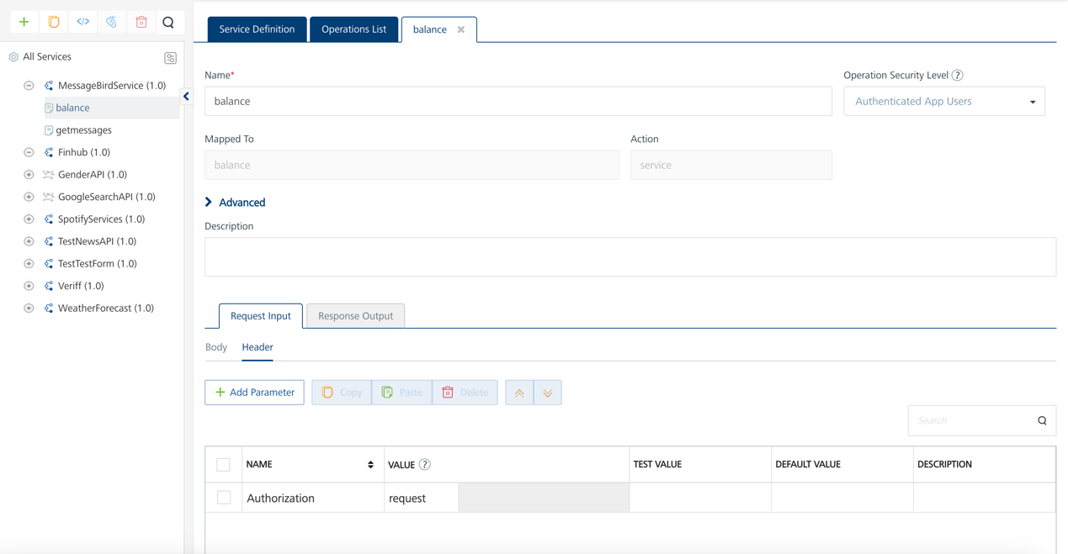
* On the Operation Page, in the Request Input tab, enter a TEST VALUE for all the fields.  
  A screenshot of a computer

  Description automatically generated
* Select a run-time environment and click **Save and Fetch Response** to get a response based on your inputs.  
  A screenshot of a computer

  Description automatically generated

## [Publishing your application](javascript:void(0);)

If you want to use the services in client applications, you need to publish an app to a run-time environment. You can create the service (as described above) in an application or import the service into an application and publish the application.

# References

## Endpoint Documentation

|  |  |  |
| --- | --- | --- |
| **Endpoint API** | **Requests** | **Description of API** |
| balance | Authorization | Gets the account balance to send or receive SMS |
| getMessages | Authorization | Gets all messages till date and you get limit also. |

# Revision History

Adapter version 1.0.0:

## Known Issues

N/A

## Limitations

* You must upgrade your account and pay accordingly.
* You must verify your number to send or receive SMS.
* You can only send messages to your verified numbers..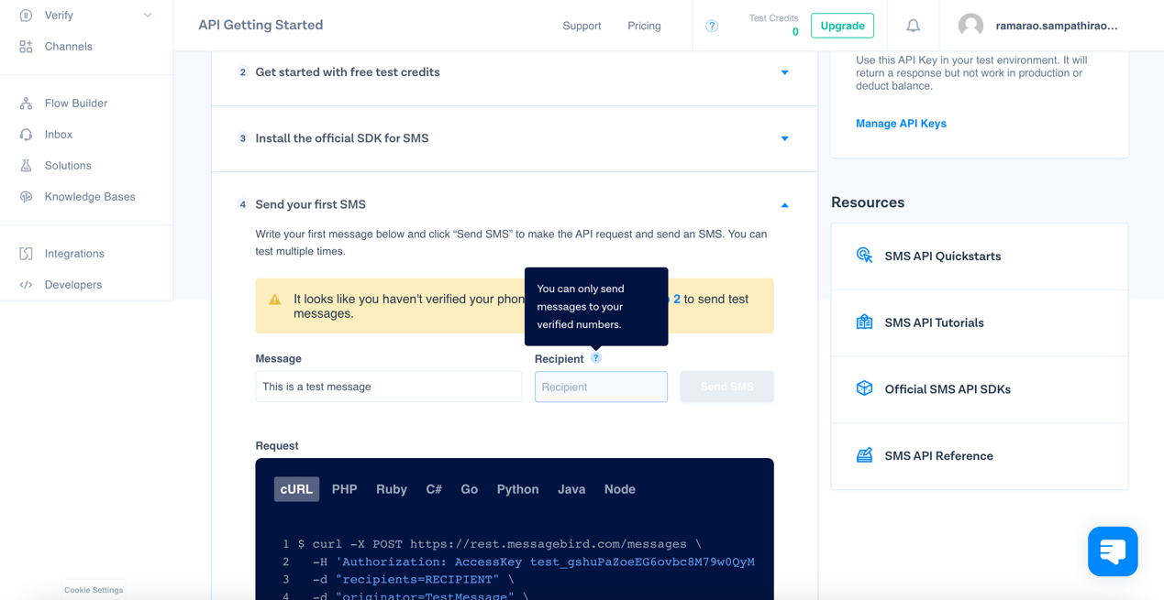A screenshot of a computer

  Description automatically generated