Date : 17-Sep-24

VOLT MX MAP FEATURE APP

VERSION: 1.1.1

OVERVIEW
Volt MX App Platform offers a Map Widget as well as has Map API in the frameworks. This feature app demonstrates the various capabilities of Map Widget such as adding circles and polygons to the map, drop single and multiple pins to the map, showing callouts on the map, etc. Similar Map API capabilities using a search route functionality is also demonstrated.

Use case:
Volt MX Iris Map Feature app highlights the usage and capabilities of the Map Widget and the Map APIs in the Volt MX Iris App Platform. The app provides an option to drop pins and add a closed shape such as a circle or polygon at a specific location on map, and also find all possible routes between the selected source and destination. For more information, refer Map Widget and Map API .

Features :

The app highlights the following features of Volt MX App Platform:
Map Widget
  - addCircle
  - addPolygon
  - addPin
  - addPins
  - Callouts
Map API
  - searchRoutes

Percentage of re-use:

Approximate 85% of reuse.

GETTING STARTED

Prerequisites
Before you start using the Map Feature App, ensure you have the following:
- HCL Foundry
- Volt MX Iris

Platforms Supported
- Mobile
- iOS
- Android

Importing the App
You can import the Forge components only into the apps that are of the Reference Architecture type.

To import the Map Feature App, do the following:
- Launch Volt MX Iris.
- Click project, and then select Import. The Import dialog box appears.
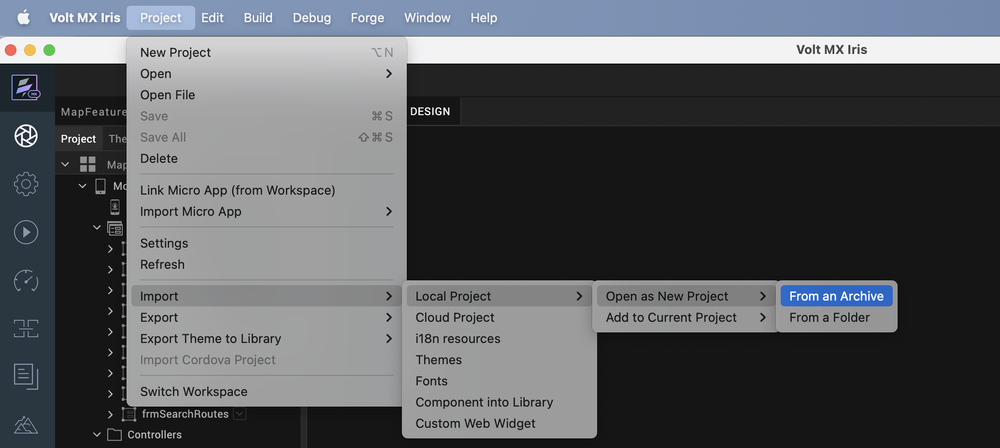
- Click From an Archive to navigate to the location of the project, select the files, and then click Import.
- Then the project and its associated components are imported.
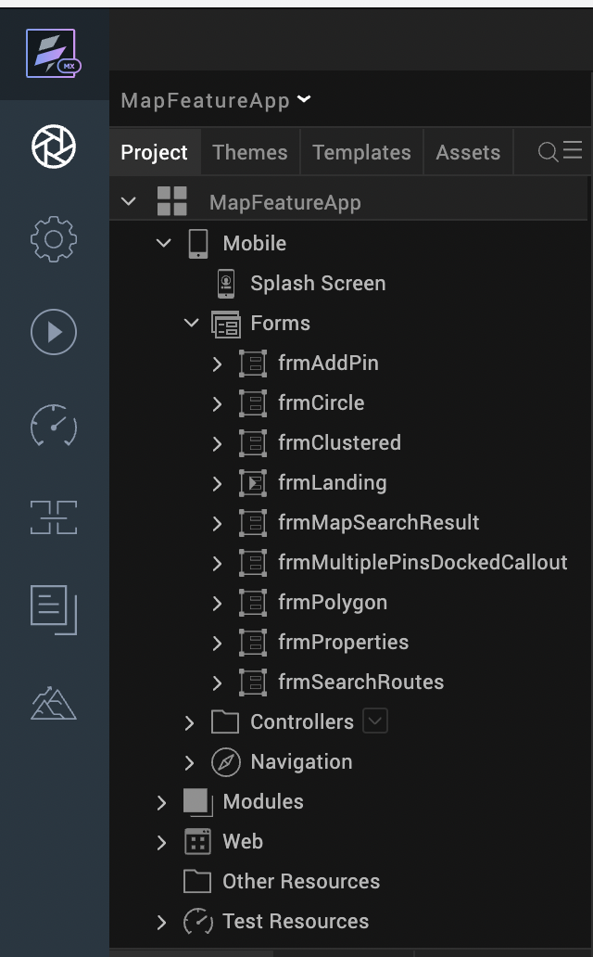

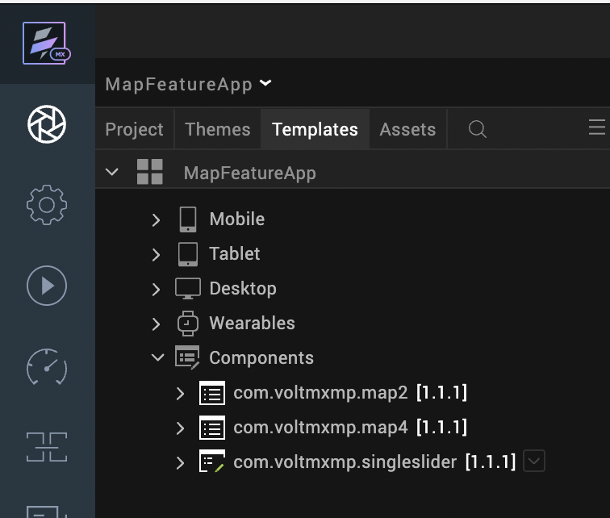

Building and previewing the app
After performing all the above steps, you can build your app and run it on your device. For more information, you can refer to the Building and Viewing an Application section of the Volt MX Iris User Guide.
You can then run your app to see the Map Feature App work in real time.

App Functionality
Volt MX Iris Map Feature app consists of the following screens:
- Landing Page
- Widgets Home
  - Details Page
- APIs Home
  - Details Page

Landing Page
The Landing page is simply a launch pad into the Volt MX Iris Map Feature app. The page contains two buttons namely Widget Properties and APIs. On tapping a button, the corresponding home screen is displayed.
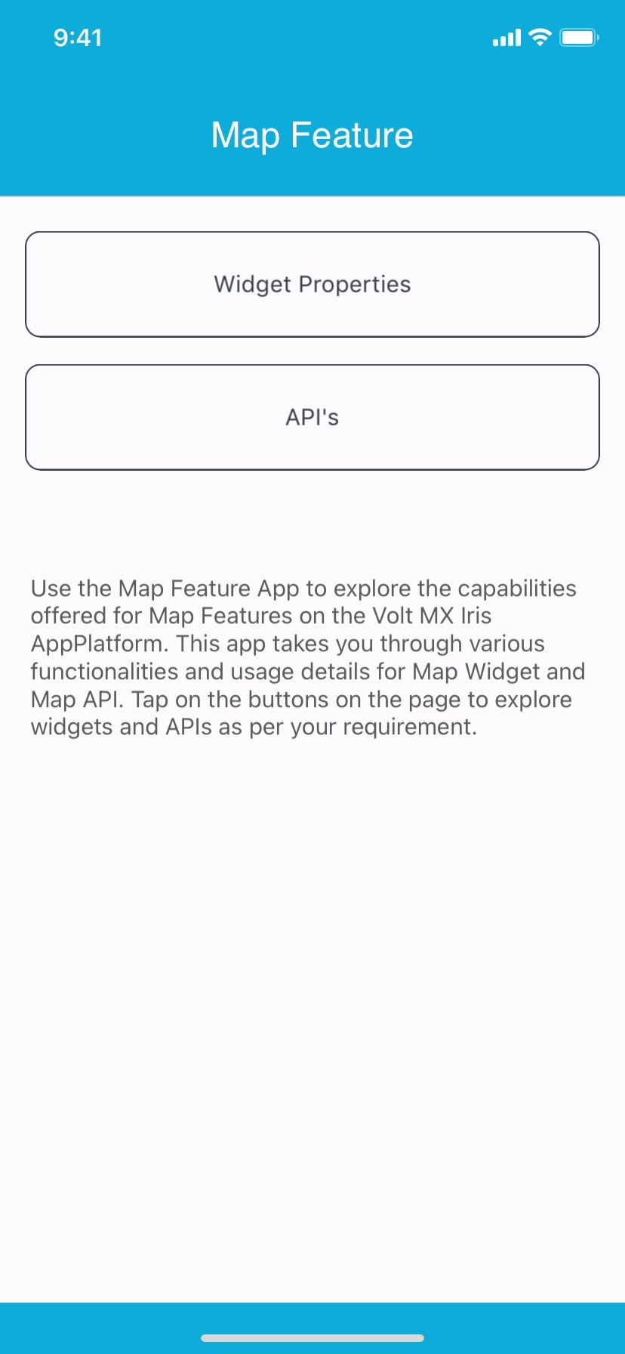

Widgets Home and Details Page
On tapping the Widget Properties button in the landing page, the Widget Home screen is displayed, where a few widget properties are listed. On tapping individual items on the page, the details page for the corresponding feature is displayed.

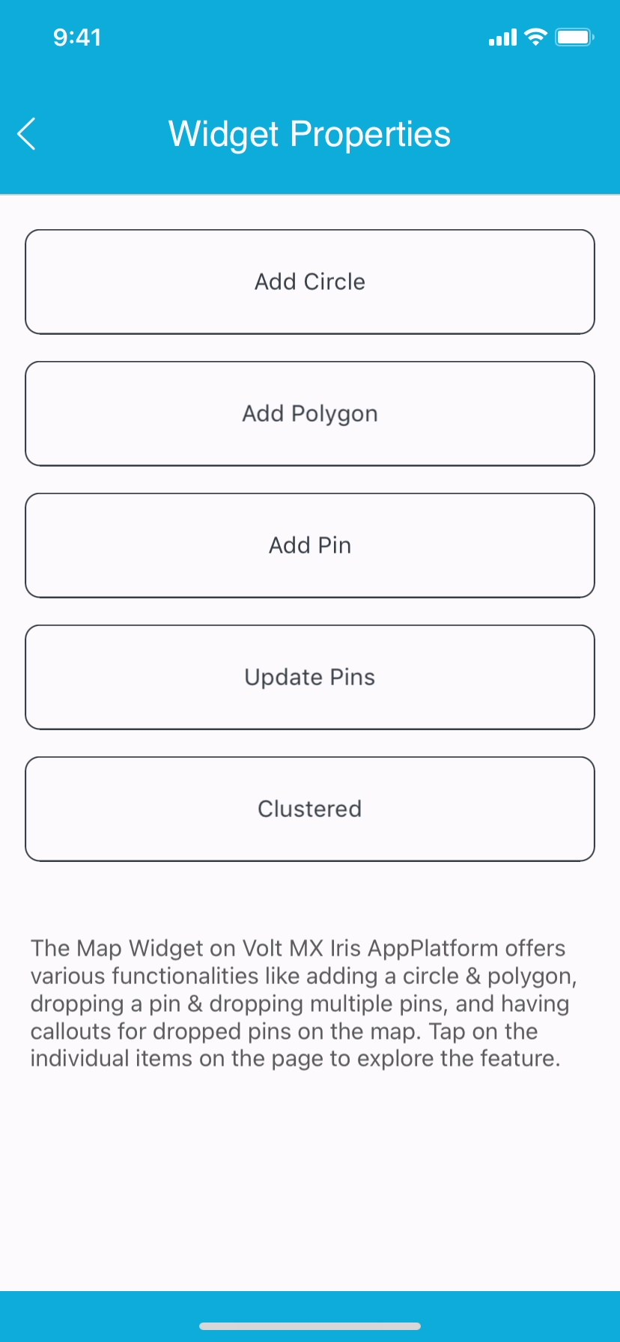
The following is a list of widget properties and their respective detail screens which are demonstrated under the widgets category:

Add Circle:
This functionality uses the addCircle method of Map Widget. This method is used to draw a circle around a specified point (latitude and longitude) on a map.
You can pass the center location, circle radius, circle line, fill color and the circle line width to this method to customize the circle.

addCircletoMapLoc: function(latValue, lonValue, rad) {
try {
var testdata = {
id: "circleId",
centerLocation: {
lat: latValue,
lon: lonValue
},
navigatetoZoom: true,
radius: rad,
circleConfig: {
lineColor: "00A0DDFF",
lineWidth: 3
},
showCenterPin: true
};
this.view.mapAddCircle.addCircle(testdata);
} catch (error) {
voltmx.print("frmCircle Controller" + JSON.stringify(error));
}
},
/*** @function selectPlace* @description adds circle for the selected place*/
selectPlace() {
try {
this.view.mapAddCircle.removeCircle("circleId");
var getRadiobtnKey = this.view.rbgDisplayPlace.selectedKey;
var selectedSliderValue = parseInt(this.view.singleslider.getSelectedValues());
if (getRadiobtnKey === "ny") {
this.addCircletoMapLoc("40.7127753", "-74.0059728", selectedSliderValue);
} else {
this.addCircletoMapLoc("38.9071923", "-77.0368707", selectedSliderValue);
}
} catch (error) {
voltmx.print("frmCircle Controller" + JSON.stringify(error));
}
}
The following screen shows two preselected options (city names) around which circle is drawn. You can also edit the radius of the circle using the range slider provided at the bottom.
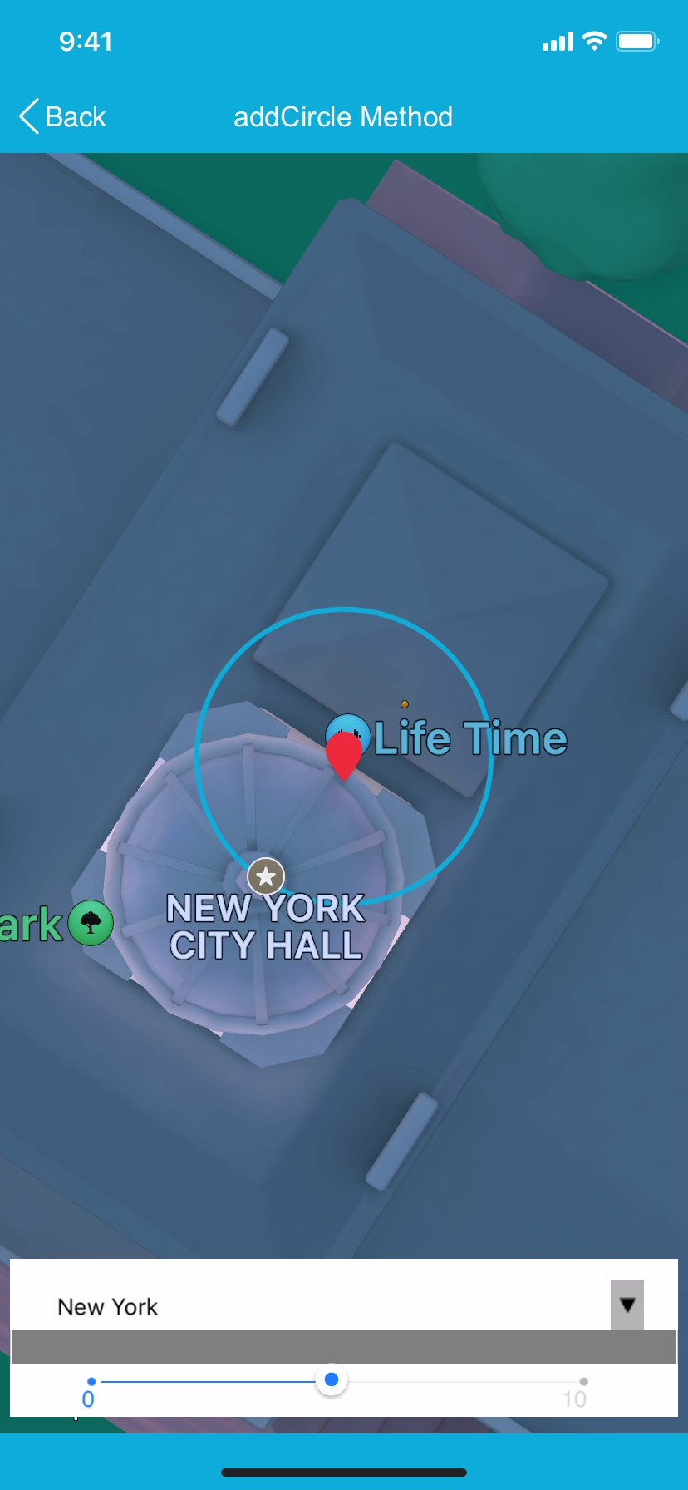

Add Polygon:
This functionality uses the addPolygon method of Map Widget. This method is used to draw a polygon against the provided location data on a map.
In this case, you have to provide the location data (latitude and longitude) of several points. These points construct the vertices of the polygon. The first and last points in the array are connected by default, to make the polygon closed one. You can pass the array of locations, polygon line, fill color and the polygon line width to this method to customize the polygon.
addPolygonTomap: function() {
try {
this.polyData = {
id: "polyId1",
locations: [{
lat: "41.9761852",
lon: "-80.5194486"
}, {
lat: "41.9903855",
lon: "-75.3377141"
}, {
lat: "41.3537697",
lon: "-74.6950917"
}, {
lat: "40.7639107",
lon: "-75.1715017"
}, {
lat: "40.1536600",
lon: "-74.7230434"
}, {
lat: "39.7215696",
lon: "-75.7740764"
}, {
lat: "39.7212829",
lon: "-80.5189779"
}],
navigateAndZoom: true,
polygonConfig: {
lineColor: "00A0DDFF",
lineWidth: 5
}
};
if (this.view.rbtn.selectedKey === "pen") {
this.polyData.locations = [{
lat: "41.9761852",
lon: "-80.5194486"
}, {
lat: "41.9903855",
lon: "-75.3377141"
}, {
lat: "41.3537697",
lon: "-74.6950917"
}, {
lat: "40.7639107",
lon: "-75.1715017"
}, {
lat: "40.1536600",
lon: "-74.7230434"
}, {
lat: "39.7215696",
lon: "-75.7740764"
}, {
lat: "39.7212829",
lon: "-80.5189779"
}]
} else {
this.polyData.locations = [{
lat: "41.7549062",
lon: "-87.5216476"
}, {
lat: "41.7600353",
lon: "-84.8049675"
}, {
lat: "38.7874035",
lon: "-84.8142087"
}, {
lat: "37.9594226",
lon: "-86.0395347"
}, {
lat: "37.8200046",
lon: "-88.0979943"
}, {
lat: "38.7347453",
lon: "-87.5120516"
}]
}
this.view.mapaddPolygon.addPolygon(this.polyData);
this.view.mapaddPolygon.zoomLevel = 5;
} catch (error) {
voltmx.print("frmPolygon Controller" + JSON.stringify(error));
}
}

The following screen shows two preselected options (state names) around which the Polygon is drawn.

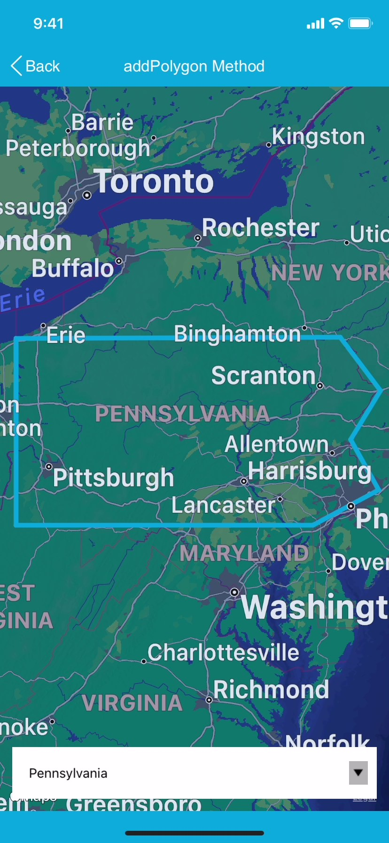

AddPin:
This functionality uses the addPin method of Map Widget. This method is used to add or append a single pin to the map.
In this case, the pin data that is passed to the method contains the pin Id, latitude, longitude, name, description, image and focus image key value pairs. Additionally, it also accepts a Boolean named showCallout in the same dictionary.

addDataToMap: function() {
this.view.mapView.enableMultipleCallouts = true;
this.view.mapView.locationData = [{
id: "pin1",
lat: "40.748817",
lon: "-73.985428",
showCallout: true,
calloutData: {
lblHeading: "Bikermann Davis",
lblDistance: "1.2 miles",
lblReviews: "12 Reviews",
lblDescription: "428 Cristopher Stravenue Apt.795",
}
}];
}
The following screen shows a default pin at a particular location on the map. The callout for the same is shown which contains the name, description and additional information about the location.
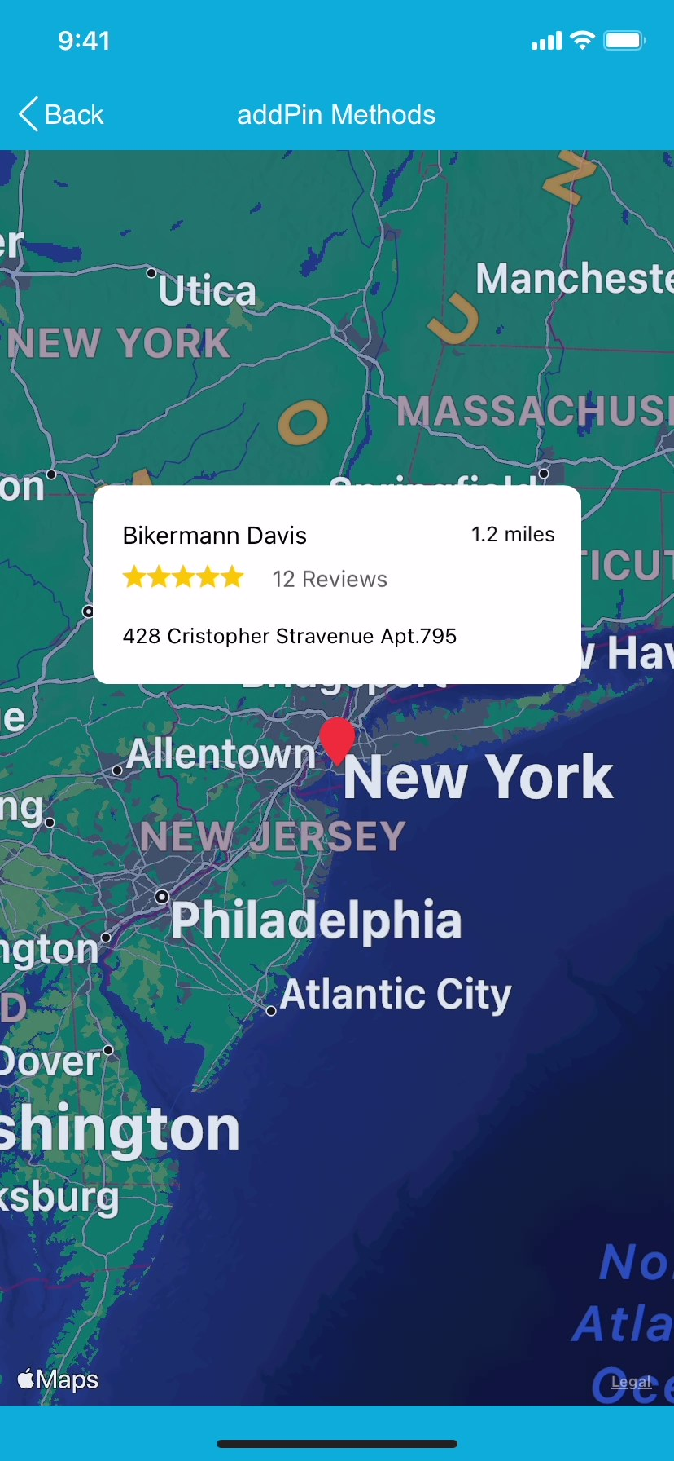

updatePins:
This functionality uses the updatePins method of Map Widget. You can drop multiple pins on the map using two methods: addPins and updatePins. addPins method drops all the pins on the map, while the updatePins method provides the user with the scope of interactability. In both the cases, the pin data is passed to the method as an array of pins. Each pin data contains the pin Id, latitude, longitude, name, description, image, focus image and showCallout (boolean) key value pairs.
addDataToMap: function() {
this.previous = "1";
this.locationData = [{
id: "1",
name: "pin1",
lat: "40.748817",
lon: "-73.985428",
image: "voltmx_mp_map04_blue_pin.png",
lblheading: "Bikermann Davis",
lbldistance: "1.2 Miles",
dec: "428 Cristopher Stravenue Apt. 495",
showcallout: false
}, {
id: "2",
name: "pin2",
lat: "42.361145",
lon: "-71.057083",
image: "voltmx_mp_map04_red_pin.png",
lblheading: "The Westin",
lbldistance: "10 Miles",
dec: "International Business Park",
showcallout: false
}, {
id: "3",
name: "pin3",
lat: "39.952583",
lon: "-75.165222",
image: "voltmx_mp_map04_red_pin.png",
lblheading: "JW Marriott",
lbldistance: "11 Miles",
dec: "160 Central Park S",
showcallout: false
}, ];
this.view.mapView.locationData = this.locationData;
},
pinClicked: function(location) {
this.view.mapView.updatePins([{
id: this.previous,
image: "voltmx_mp_map04_red_pin.png"
}, {
id: location.id,
image: "voltmx_mp_map04_blue_pin.png"
}, ]);
this.previous = location.id;
this.view.lblHeading.text = location.lblheading;
this.view.lblDistance.text = location.lbldistance;
this.view.lblDescription.text = location.dec;
}
};

The following screen shows default pins at three locations on the map. The callout for the selected pin is shown which contains the name, description and additional information about the location. On tapping the pins, the call out content changes to display the details of the selected pin.

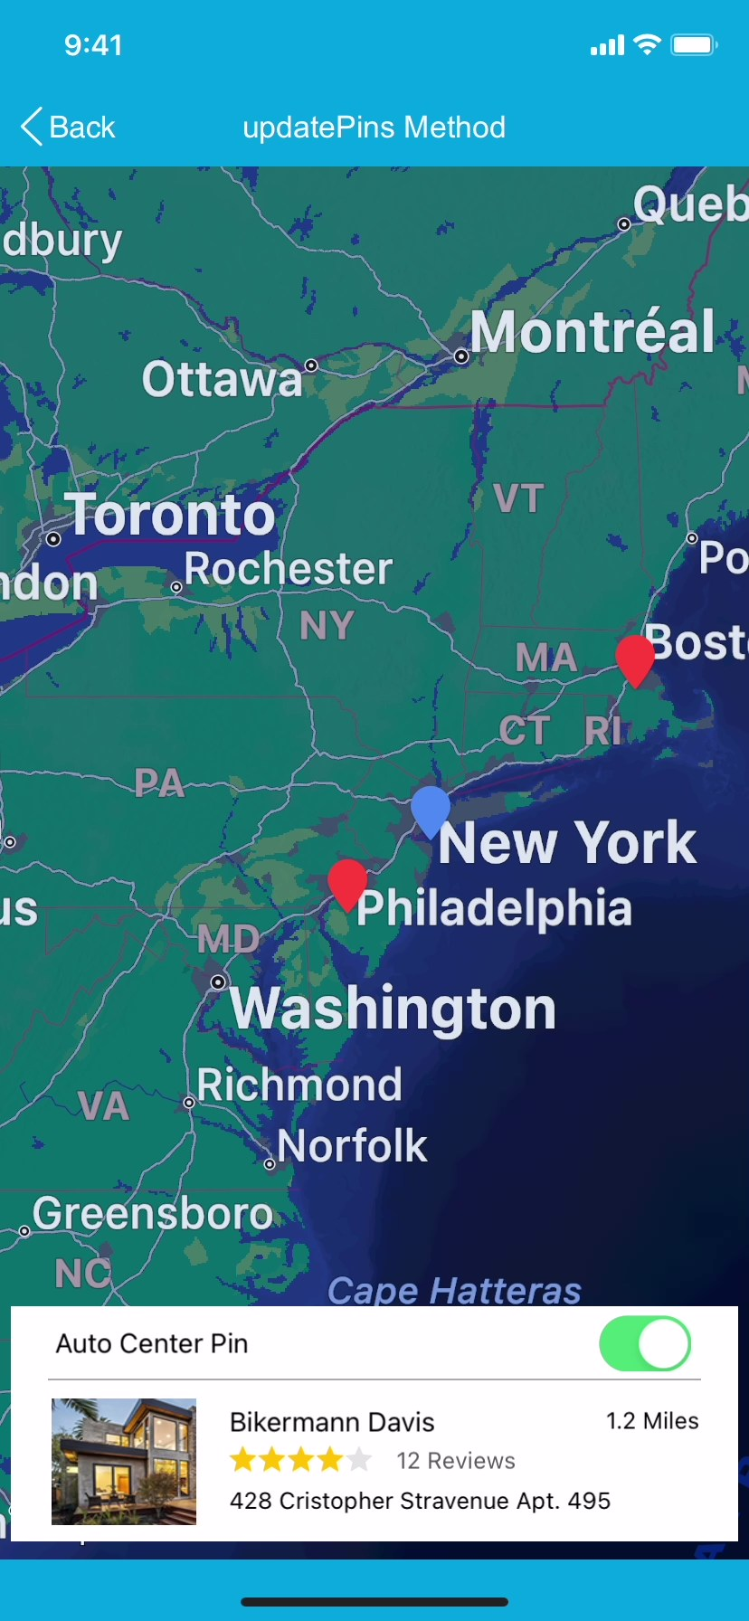

Clustered:

Clusters are a way to group multiple markers or pins that are close together on the map. Instead of displaying all the markers individually, clusters show a single marker icon that represents the group of markers.
Clusters created based on the proximity of the markers to each other. You can set the cluster radius and minimum cluster size in the app configuration to define how close the markers need to be to form a cluster.
When a user zooms in on the map, the cluster expands and shows the individual markers. This helps to reduce clutter on the map and makes it easier for users to view and interact with the markers.

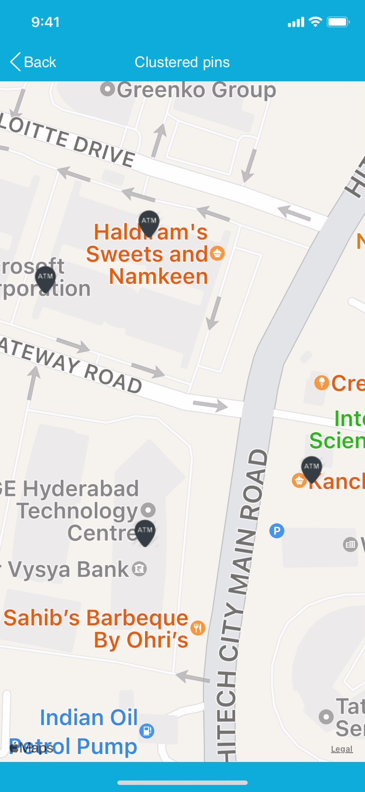
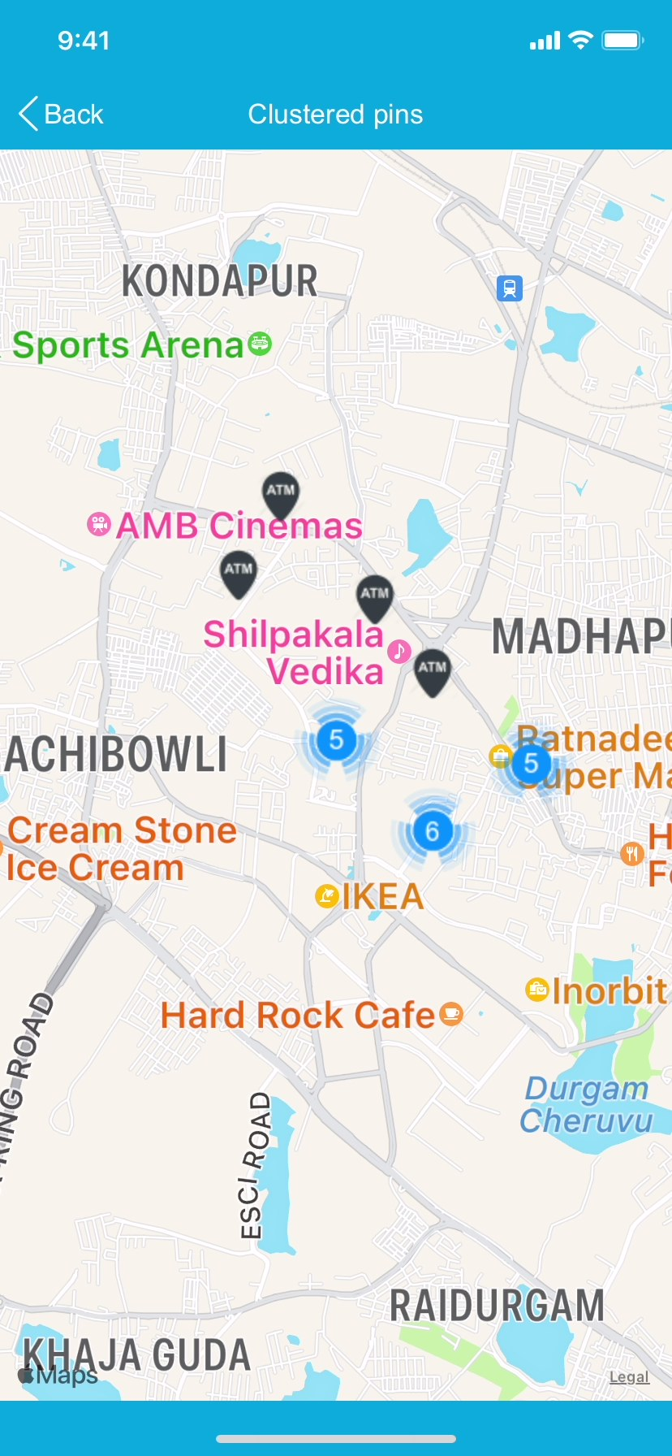

APIs Home and Details Page
On tapping the APIs button in the landing page, the APIs Home screen is displayed. The Map API on Volt MX Iris platform offers route searching service on the map. You can select a source and a destination to find all the routing options along with the travel time and distance for each route. The following screen shows one preset source and three preset destinations.
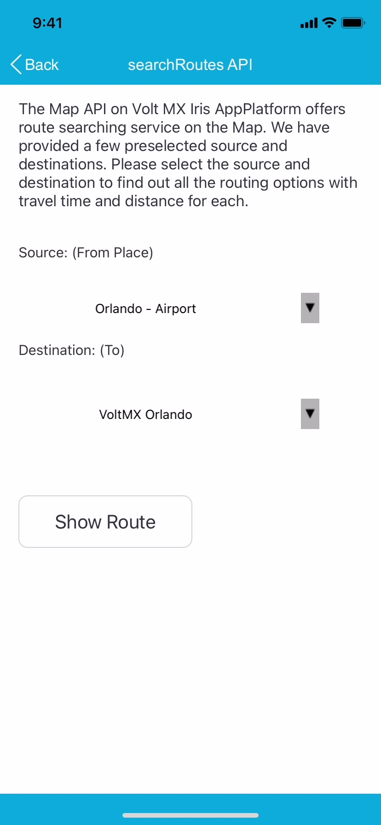
You can select one of the destinations and click on Show Route button to navigate to the next page and discover the possible routes. The next screen highlights the fastest route on the map by drawing a blue polyline on the map. In case there are multiple routing options available, the flex at the bottom of the screen shows other routing options along with distance and travel time for each route. The route with the shortest travel time is selected by default. Only the selected travel route is shown using blue color polylines whereas the other routing options are shown using grey color polylines.
Search Route
The search route functionality makes use of voltmx.map.searchRoutes function in Volt MX Iris Map API. The searchRoutes function accepts the following parameters:
origin | Source location
destination | Destination location
transportMode | Mode of transport, e.g. car, bus, train, etc.
directionServiceUrl | Google Direction API URL that Android uses to fetch the direction details. This is mandatory.
waypoints | Waypoints for the resultant routes to follow.
alternatives | Whether to search for alternative routes.
avoid | Indicates that the calculated route(s) should avoid the indicated features.
departureTime | Desired time of departure.
arrivalTime | Desired time of arrival.
language | Language in which the results should be returned.
region | Region code for region biasing.
transitMode | Preferred mode of transit.
transitRoutingPreference | Preference for transit routes.
apiKey | Android V2 client api key
clientID | Client ID required when Google maps for work is used.
signature | Generated signature for Google maps for work.
Note:
- For Android devices, you must mention the apiKey or [clientID + signature], otherwise, the request will fail. apiKey and clientID are mutually exclusive and using both in the same request causes the route search to fail.
- To show the Map Widget in real devices, need to add an API key in Project Settings.

Path to add API Key: Project Settings → Application → Map Widget → Android Map Widget Key 2 → add generated API key.
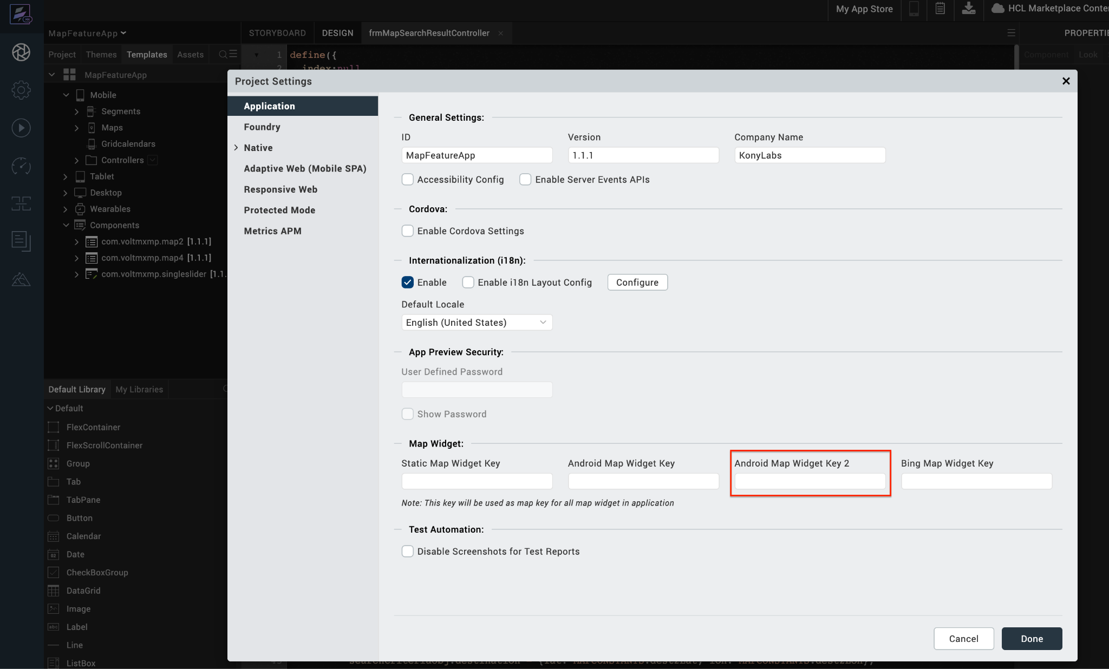

To obtain API Key, refer to this Generate Map API.

REVISION HISTORY
App version 1.1.1

Known Issues

No issues

Limitations

No Limitations

