Date: 29-Oct-2021

List and details - wordpress version: 1.0.2

1. OVERVIEW
A list of items coupled with a details page per item, is a popular UX pattern. The component offers a configurable list and detail view, with a preconfigured integration to WordPress.

Use case:
Consider a case that you are developing an app that provides information about WordPress Blogs. You can use the List and Details WordPress component in the app and configure the component in such a manner that the app displays the information of the WordPress Blog.

Percentage of re-use:
80%

Getting Started

Prerequisites
Before you start using the List and Details - WordPress component, ensure you have the following:
- HCL Foundry
- Volt MX Iris

Platforms Supported

Mobile

iOS

Android

Tablets

PWA

Importing the List and Details - WordPress Component
The List and Details - WordPress component consists of two views:

List View
The List View consists of a header and a set of rows that contain details about various articles based on your back-end source.
The details include the article's headlines, thumbnail image, date, and the author name. When you select any row, the component opens the Details View for the selected article.

Details View
The Details View consists of a header and the complete information about the article.
Under the hood, the component uses the WordPress Data Adapter to fetch data from the URL.
Before you start importing the component to Volt MX Iris, you must download the component from the HCL Volt MX website.
You can import the Forge components only into the apps that are of the Reference Architecture type.
To import the List and Details WordPress component, do the following:
- Open your app project in Volt MX Iris.
- On the File menu, point to Import, and click Component. The Open dialog appears.
- Navigate to the location where you downloaded the component (zip file) on your computer, select the component, and click Open. The Import Item dialog appears.
- In the Library Name box, type a name if you want to create a new library. Otherwise, you can select the existing library name.
- In the Collection Name box, type a name if you want to create a new collection. Otherwise, you can select the existing collection name.
- In the Component Name box, the com.voltmx.listdetailswebcontent name is displayed by default.
When you import a component, the component is imported to Iris's workspace, but not directly into your app. Thus, after you import a component, you must add the component to your app.

Adding a List and Details - WordPress Component to your App
You can add the List and Details WordPress component to the FlexForms, FlexContainer, and FlexScrollContainer widgets.
To add the List and Details - WordPress component, do the following:
- Open your app, and then open the form to which you want to add the component.
- On the My Libraries tab, select the defined Forge library from the drop-down list in which the component exists.
- From the Collections sub-tab, drag the component onto the form on the Iris canvas. The component is added to the form. You can also see new element, com.voltmx.listanddetailswebcontent in the Components section on the Templates tab.
After adding a component to a form, you can configure the component the way you want it using the Look, Skin, and Action tabs on the Properties pane. Configuring the properties on the Properties pane is similar to configuring the properties of any widget in Volt MX Iris.
You can also see that a new tab, Component, is added on the Properties pane. The Component tab contains assorted properties relevant to the component that allow you to customize the component as required. The properties on the Component tab are categorized as General and Skin properties.

Building and previewing the app
After performing all the above steps, you can build your app and run it on your device. For more information, you can refer to the Building and Viewing an Application section of the Volt MX Iris User Guide.
You can then run your app to see the List and Details WordPress work in real time.

References

Dynamic Usage
If you want to use the List and Details WordPress component dynamically, you will need to import the component into your project Templates. Follow the given steps to do so

Download the component from HCL VoltMX Marketplace as a zip file.

Go to the Templates tab in your project explorer.

Right click on Components and select Import Component.

Navigate to where you downloaded your zip file and import it into Iris.

After you import the component into your project templates, you can add it to your app dynamically. To do so, follow the given steps.

Access the FormController of the form you want to add the component into.

Create a function called createComponent(); and write the code inside it to create and configure the component.

You can call this function in preshow, postShow, onNavigate (Wherever you want).

You can refer to the given sample code for more information.

/* creating a component's Object */

createComponent: function(){
/* Creating the component's object */
var ListDetailsWebContent = new com.voltmx.listdetailswebcontent(
{
"clipBounds": true,
"height": "100%",
"id": "ListDetailsWebContentID",
"isVisible": true,
"left": "0dp",
"skin": "slFbox",
"top": "0dp",
"width": "100%",
"zIndex": 1
}, {}, {});
/* Setting the component's properties */
ListDetailsWebContent.isListVisible = true;
ListDetailsWebContent.text = "Latest Articles";
ListDetailsWebContent.siteUrl = "northrenlotusblog.wordpress.com";
ListDetailsWebContent.enableScrolling=true;
/*Adding the component to a Form*/
this.view.add(ListDetailsWebContent);
}

You can use a component's Properties to customize and configure the elements. These elements can be UI elements, service parameters, and so on. You can set the properties from the Iris's Properties panel on the right-hand side. You can also configure these properties using a JavaScript code.

Properties
The properties provided on the Component tab allow you to customize the UI elements in the List and Details WordPress component. You can set the properties directly on the Component tab or by writing a JavaScript. This section provides information about how to set the properties by writing a JavaScript.

General

1. Switch to List View from Details View
Description: | Enables or disables the visibility of the list view.
Syntax: | isListVisible
Type: | Boolean
Read/Write: | Read + Write
Default Value: | true

2. Site URL
Description: | Specifies the URL of the website to populate the data.
Syntax: | siteURL
Type: | String
Read/Write: | Read + Write
Default Value: | "northrenlotusblog.wordpress.com "

3. List View: Header Text
Description: | Specifies the text that you want to set on the header.
Syntax: | listHeaderText
Type: | String
Read/Write: | Read + Write
Default Value: | "User"
Example: | this.view.componentID.listHeaderText = "Latest Articles";

Events
None of the events are exposed.

APIs

None of the APIs are used.

List and Details - WordPress VoltMX Foundry SERVICES:
The List and Details - WordPress contains an Integration Service that uses the WordPress Data Adapter. To obtain the data, the service connects to the specified Site URL.
To configure the VoltMX - Foundry services of the List and Details - WordPress component, follow the given steps:
- From the left navigation bar of Iris, click VoltMX - Foundry to open the VoltMX - Foundry app that is associated with your project.
- Navigate to Configure Services → Integration. From the list of available Integration Services, open WordPressIntgService.
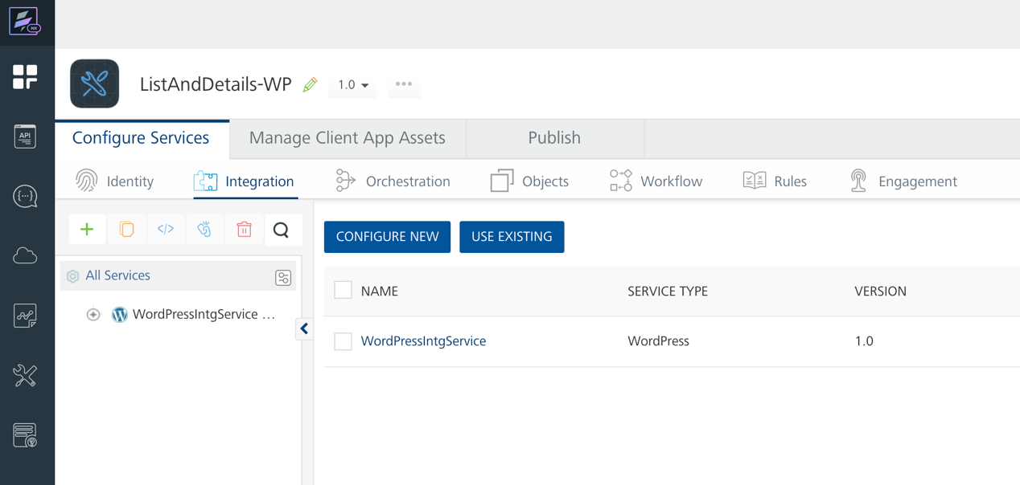
- Click Operations List and from the drop-down list, navigate to WordPressApis → Services.
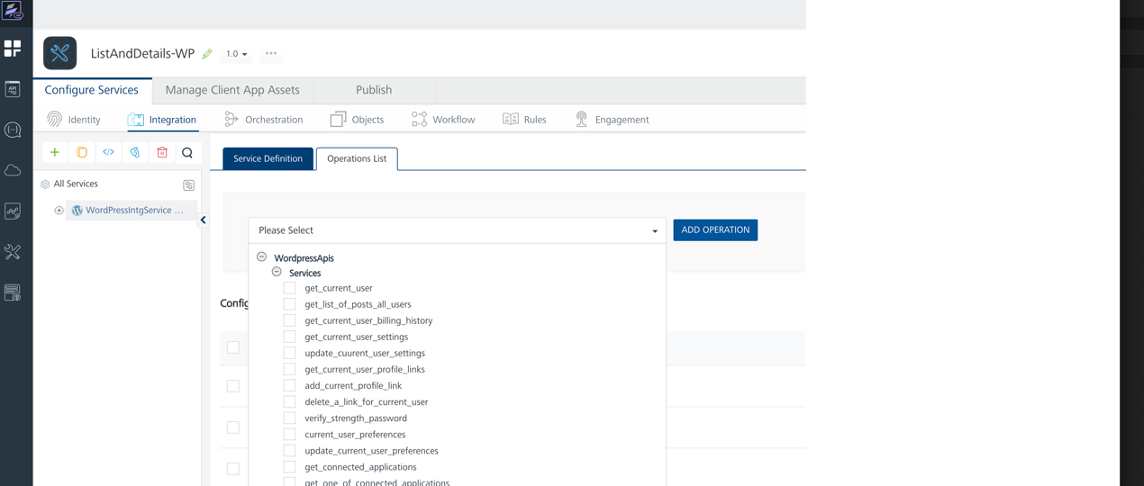

- Select any of the available Wordpress service operations based on your requirement and click Add Operation.
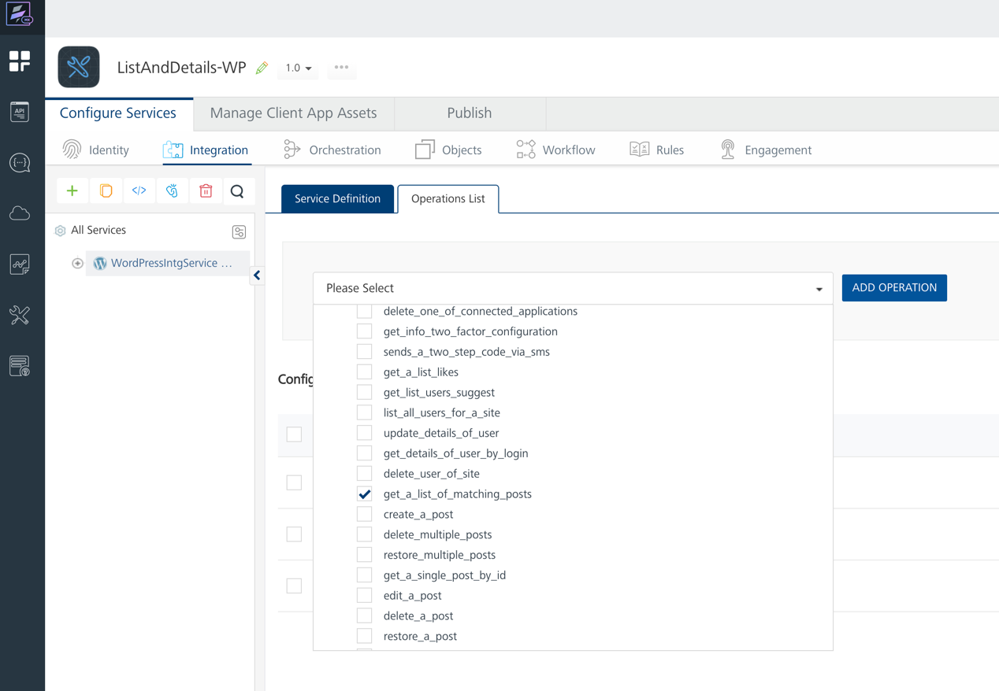
VoltMX - Foundry adds the operation to the Integration Service.
- You can select an operation to change it based on your requirement. You can also test the operation.
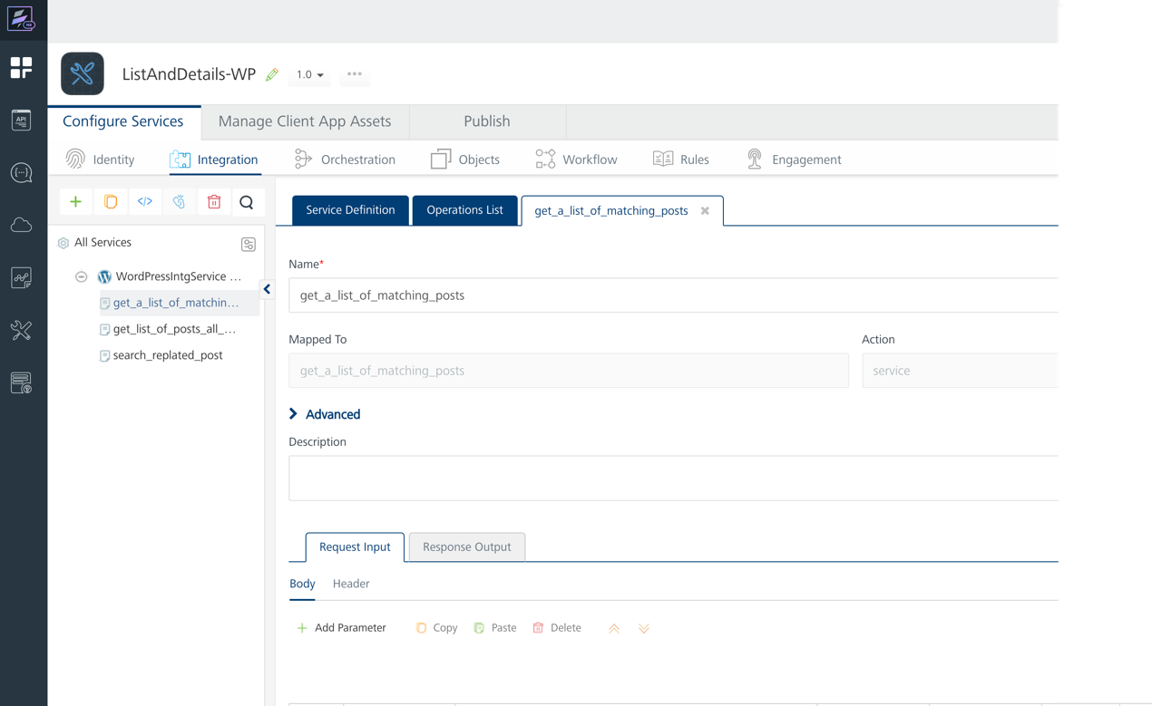

Revision History
App version: 1.0.2

Known Issues
- If browser height is minimized, then UI got distorted.
- If the article has Internal Script Execution the article will not render properly due to security restrictions.

