Date: 27 Sep 2023

LinkedIn Login

VERSION:1.0.2

Overview
LinkedIn login is a fast and convenient way for users to create account and login to your app. Drag and drop the component in your app, configure few properties and you are ready to go.
A. Features
- Ready to use LinkedIn login
- Configure UI properties and service parameters directly from Iris properties panel
B. Percentage of re-use:
70-80%

Getting Started

This is a getting started section for the LinkedIn Login component. It contains information about setting up and running your component in an application.
Before you start using the LinkedIn Login component, make sure that you meet all the prerequisites.

Prerequisites
• HCL Foundry
• Volt MX Iris

Platforms Supported

Mobile

iOS

Android

Importing the Component

Make sure that you are logged into Volt MX Iris

You can import the Forge components only into the apps that are of the Reference Architecture type.

To import the LinkedIn Login component, do the following:

Open your app project in Volt MX Iris.
2. In the Project Explorer, click the Templates tab.
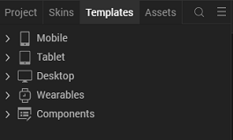
3.Right-click Components, and then select Import Component. The Import Component dialog box appears.
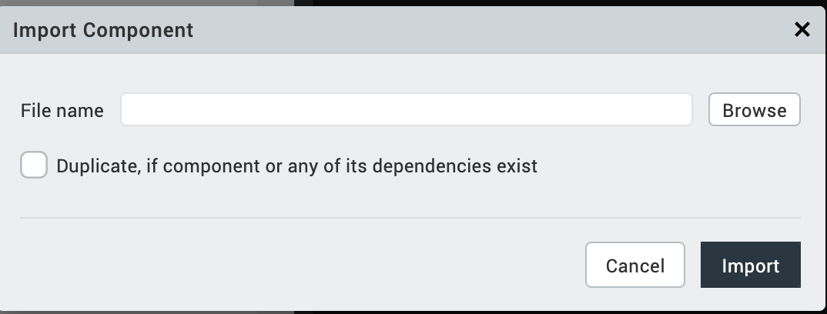
4.Click Browse to navigate to the location of the component, select the component, and then click Import. The component and its associated widgets and modules are added to your project.
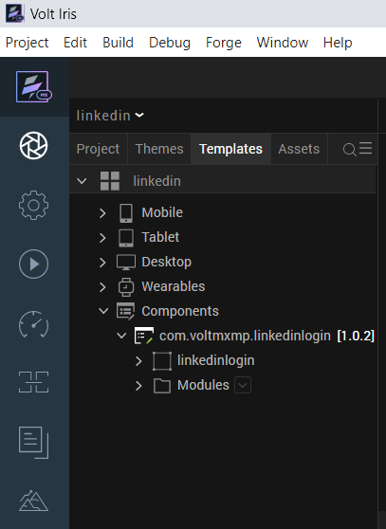

Once you have imported a component to your project, you can easily add the component to a form. For more information, refer Add a Component to a Form

Building and previewing the app
After performing all the above steps, you can build your app and run it on your device. For more information, you can refer to the Building and Viewing an Application section of the Volt MX User Guide.
You can then run your app to see the LinkedIn Login work in real time.

References

Dynamic Usage
After you import the component into your project templates, you can add it to your app dynamically. To do so, follow the given steps.
- Access the FormController of the form you want to add the component into.
- Create a function called createComponent(); and write the code inside it to create and configure the component.
You can refer to the given sample code for more information.
define({
onNavigate: function() {
this.createComponent();
},
createComponent: function(){
var Linkedinlogin = new com.voltmxmp.linkedinlogin(

{

"autogrowMode": voltmx.flex.AUTOGROW_NONE,

"clipBounds": true,

"height": "50dp",

"id": "Linkedinlogin",

"isVisible": true,

"layoutType": voltmx.flex.FREE_FORM,

"left": "45%",

"masterType": constants.MASTER_TYPE_USERWIDGET,

"skin": "slFbox",

"top": "45%",

"width": "50dp"

}, {}, {});

/*Setting the component's properties*/

Linkedinlogin.iconSource = "reusablelogin_linkedin.png";

Linkedinlogin.logoScaleMode = constants.IMAGE_SCALE_MODE_FIT_TO_DIMENSIONS;

Linkedinlogin.onLoginSuccess = function(response)

{

alert( "Login Success" );

}.bind(this);

Linkedinlogin.onLoginFailure = function(response)

{

alert( "Login Failure" );

}.bind(this);

/*Adding the component to a form*/

this.view.add(Linkedinlogin);
}
}
);

Note:
VoltMX Foundry services (Created app) must be published only after the app is imported into the form. The app must be published by an existing user only facilitating the authentication of credentials.
While importing the components, if the services associated with components match with the services in your Cloud, you need to choose to replace the services or to skip.
- If you click on Skip, the properties under service parameters do not work (even if you click the import changes option) and the component will use existing service client ID and client secret.
- If you click on replace, you will have full access on the service parameter properties.
To delete the linkedinlogin component, do the following:
- In VoltMX Iris, open your app and then open the form to which you added the component.
- Click the context menu of the linkedinlogin component, and then click Delete. A confirmation dialog appears.
- Click OK.

Creating an app in LinkedIn Developer Console
- Create an app in the developer console.
- Add the callback URL of the VoltMX Foundry Identity Service in the developer app.
- Get the Client ID and Client Secret from the developer app and paste it in the Identity Service on VoltMX Foundry.
For more information, refer to the Service Parameters section.
For more information, refer to the LinkedIn Developer documentation.
Note: You only need to follow the first step in the LinkedIn Developer documentation, that is, Configuring Your LinkedIn Application.
If the LinkedIn Console requires a target platform, select the option as Web.

Properties
The properties provided on the Component tab allow you to customize the UI elements and set constraints for the fields in the LinkedIn Login component. You can set the properties directly on the Component tab or by writing a JavaScript. This section provides information on how to set the properties by writing a JavaScript.
General Properties:
1. iconSource
Description:
  This property enables the consumer to change the icon source in the component..
Syntax: | iconSource
Type:
  string
Read/Write: | Read + Write
Remarks: | The default value for this property is "icon.png".
Example: | this.view.componentID.iconSource = "icon.png";

2. Icon Scale Mode
Description:
  This property enables the consumer to set the scale mode of the icon source.
Syntax: | logoScaleMode
Type:
  Constant
Read/Write: | Read + Write
Remarks: | Please click here for more information about the scaling properties of the image widget.
Example: | this.view.componentID.logoScaleMode = constants.IMAGE_SCALE_MODE_FIT_TO_DIMENSIONS;

Service Properties:
Properties under the service parameters can be seen only as component perspective but not at project level. Copy the client ID and client secret and paste under the below properties. For more information on obtaining the Client ID and Client Secret, refer to the Creating an app in LinkedIn Developer Console section.
1.Client Id
Description:
  This property enables the consumer to set the client id of the respective identity service in VoltMX Foundry from Iris.
Remarks: | - If you change the client id, ensure to click on import changes.  - This property can’t be changed at the run time. (Only at design time).
2. Client Secret
Description:
  This property enables the consumer to set the client secret of the respective identity service in VoltMX Foundry from Iris.
Remarks: | • If you change the client secret, ensure to click on import changes.  • This property can’t be changed at the run time. (Only at design time).

C. Events
You can define events to be executed when an action is performed. You can configure the events directly on the Actions tab or by writing a JavaScript. To configure the events on the Actions tab, click the Edit button against each event.0020
This section provides details about each event that help you define the actions by writing a JavaScript.
1. onLoginSuccess
Description:
  An event call back is invoked when LinkedIn oauth login is a success..
Syntax: | onLoginSuccess(response)
Example:
  this.view.componentID.onLoginSuccess = function(response)
  {
  alert("Login Successful");
  }.bind(this);
2. onLoginFailure
Description: | An event call back is invoked when LinkedIn oauth login fails.
Syntax: | onLoginFailure(response)
Example:
  this.view.componentID.onLoginFailure = function(response)
  {
  alert("Login Failed");
  }.bind(this);
D. Publishing the App in VoltMX Foundry
After adding the linkedinlogin component to your app and configuring the necessary configurations, you must publish the app to VoltMX Foundry. For more information, refer to Publish a Project to VoltMX Foundry.

Revision History
App version 1.0.2

