Date : 03-June-24

Line CHART WITH Area

version: 1.1.2

Overview
Line Chart with Area (also known as Area Chart) is a Volt MX Iris component that creates an area chart, based on the data that you provide. You can use the component in your mobile app to represent the comparison between distinct items or data in the form of area chart. For examples, sales growth on monthly basis.
In the Area Chart component, the intervals are defined on y-axis and the labels are defined on the x-axis.
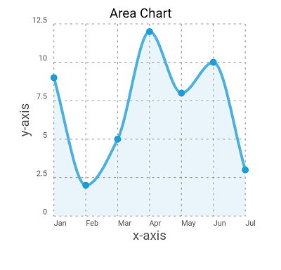

Use case:

Consider a scenario that you want to provide the stock market information in a use case in your application. In the app, you want to build a feature to represent variation in the stock values of companies on monthly basis in the area chart. You can use the Area Chart component to represent the variations of stock values in the form of area chart.

You can also use the Area Chart component to represent the variations of monthly incomes.

Percentage of re-use:
85%-90% (Data can be customizable and skins are customized and can be changed manually).

Getting Started

Prerequisites
Before you start using the Area Chart component, ensure you have the following:

- HCL Foundry
- Volt MX Iris

Platforms Supported

Mobile

iOS

Android

Tablets

PWA

Importing the app
You can import the Forge components only into the apps that are of the Reference Architecture type.

To import the Area Chart component, do the following:

- Open your app project in Volt MX Iris.
- In the Project Explorer, click the Templates tab.

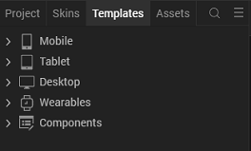

- Right-click Components, and then select Import Component. The Import Component dialog box appears.
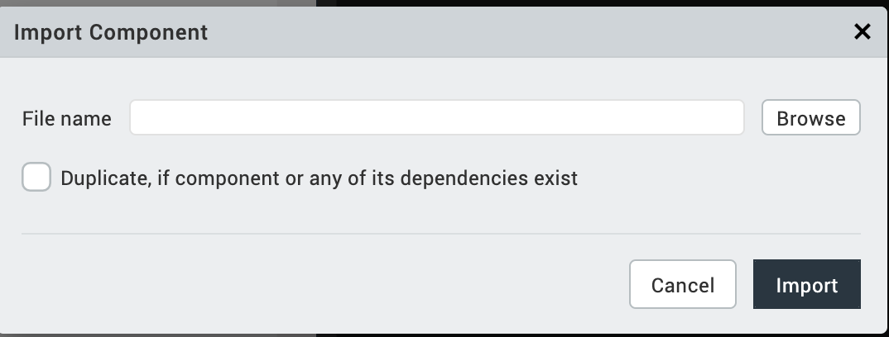

- Click Browse to navigate to the location of the component, select the component, and then click Import. The component and its associated widgets and modules are added to your project.

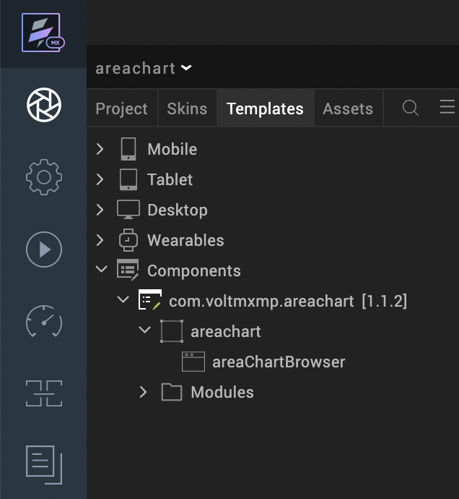

Once you have imported a component to your project, you can easily add the component to a form. For more information, refer Add a Component to a Form.
After adding a component to a form, you can configure the component the way you want it using the Look, Skin, and Action tabs on the Properties pane. Configuring the properties on the Properties pane is like configuring the properties of any widget in VoltMX Iris.
You can also see that a new tab, Component, is added on the Properties pane. The Component tab contains assorted properties relevant to the component that allow you to customize the component as required. The properties on the Component tab are categorized as General, Axis Titles, Grid and Title properties. The General properties are the default properties of individual widgets in the component.

References

Dynamic Usage
You can also add an Area Up Chart component dynamically. To do so:

In the Project Explorer, on the Projects tab, click Controllers section to access the respective formController. Create a method and implement the code snippet like the sample code mentioned below.
/* Creating the component s object */

var areachart = new com.voltmxmp.areachart(
{
"autogrowMode": voltmx.flex.AUTOGROW_NONE,
"clipBounds": true,
"id": "areachart",
"height": "100%",
"width": "100%",
"top": "0%",
"left": "0%",
"isVisible": true,
"zIndex": 1,
"layoutType": voltmx.flex.FREE_FORM,
"skin": "slFbox",
"masterType": constants.MASTER_TYPE_USERWIDGET
}, {}, {});

/* Setting the component s properties */

areachart.graphColor = "#1B9ED9";
areachart.bgColor = "#FFFFFF";
areachart.lowValue = "0";
areachart.highValue = "40";
areachart.enableStaticPreview = true;
areachart.enableChartAnimation = true;
areachart.xAxisTitle = "x-axis";
areachart.yAxisTitle = "y-axis";
areachart.enableGrid = true;
areachart.enableGridAnimation = true;
areachart.chartTitle = "Area Chart";
areachart.titleFontColor = "#000000";
areachart.titleFontSize = "12";
areachart.chartData =
{
"data":
[
{"dataVal": 9, "lblName": "data1"},
{"dataVal": 2, "lblName": "data2"},
{"dataVal": 5, "lblName": "data3"},
{"dataVal": 12, "lblName": "data4"}
]
};

/* Adding the component to the form */

this.view.add(areachart);
In the code snippet, you can edit the properties of the component as per your requirement.
- Save the file.

Properties
The properties provided on the Component tab allow you to customize the UI elements in the Area Chart component. You can set the properties directly on the Component tab or dynamically through code. This section provides information on how to set the properties dynamically through code.

General
Background Color

Description: | Specifies background color of the chart.
Syntax: | bgColor
Type: | String
Read/Write: | Write
Example: | this.view.componentID.bgColor= "#FFFFFF";

Graph Color

Description: | Specifies the color of the graph generated on the chart.
Syntax: | graphColor
Type: | String
Read/Write: | Write
Example: | this.view.componentID.graphColor= "#1B9ED9";

Enable Chart Animation

Description: | Controls whether or not to enable the chart animation.
Syntax: | enableChartAnimation
Type: | Boolean
Read/Write: | Write
Remarks: | Disabling the chart animation will also disable the grid animation.
Example: | this.view.componentID.enableChartAnimation= true;

Low Value
Description: | Specifies the starting value on the vertical axis where the reading starts.
Syntax: | lowValue
Type: | String
Read/Write: | Write
Remarks: | Low and High values must be passed according to the data passed to the charts.
Example: | this.view.componentID.lowValue = "0";

High Value

Description: | Specifies the end value on the vertical axis where the reading starts.
Syntax: | highValue
Type: | String
Read/Write: | Write
Remarks: | Low and High values must be passed according to the data passed to the charts.
Example: | this.view.componentID.highValue = "40";

Enable Chart with Static Data

Description: | Specifies whether or not the chart should render in the data grids, with the given data.
Syntax: | enableStaticPreview
Type: | Boolean
Read/Write: | Write
Example: | this.view.componentID.enableStaticPreview = true;

Chart Data

Description: | Enables a user to provide the data to generate the chart.
Syntax: | chartData
Type: | Data Grid
Read/Write: | Write
Remarks: | The property is static and cannot be assigned dynamically.

Axis Titles
X-axis Title
Description: | Specifies the text to be displayed as the X-axis (horizontal axis) title.
Syntax: | xAxisTitle
Type: | String
Read/Write: | Write
Example: | this.view.componentID.xAxisTitle= "x-axis";

Y-axis Title

Description: | Specifies the text to be displayed as the Y-axis (vertical axis) title.
Syntax: | yAxisTitle
Type: | String
Read/Write: | Write
Example: | this.view.componentID.yAxisTitle= "y-axis";

Grid
Enable Grid

Description: | Controls whether or not to enable the chart grid.
Syntax: | enableGrid
Type: | Boolean
Read/Write: | Write
Example: | this.view.componentID.enableGrid= true;

Enable Grid Animation

Description: | Controls whether or not to enable the grid animation.
Syntax: | enableGridAnimation
Type: | Boolean
Read/Write: | Write
Example: | this.view.componentID.enableGridAnimation= true;

Title
Chart Title

Description: | Specifies the text to be displayed as the Chart title.
Syntax: | chartTitle
Type: | String
Read/Write: | Write
Example: | this.view.componentID.chartTitle = "Area Chart";

Title Font Size

Description: | Specifies the font size of the Chart title.
Syntax: | titleFontSize
Type: | String
Read/Write: | Write
Example: | this.view.componentID.titleFontSize= "12";

Title Font Color

Description: | Specifies the font color of the Chart title.
Syntax: | titleFontColor
Type: | String
Read/Write: | Write
Remarks: | The property expects an Hex color code preceded by a number sign (#).
Example: | this.view.componentID.titleFontColor = "#000000";

Events
-- None of the events are exposed.

API’s
The following API pertains to the Area Chart component.
createChart
The API creates an Area Chart.
Syntax
createChart(data)
Parameters
data:
JSON array contains the data based on which the Area Chart is generated. The JSON array should contain data of column names and the corresponding values to generate lines, in the key-value pair format. Here is the JSON array format:
var data = [{lblName: "col1", dataVal: "val1"},
{lblName: "col2", dataVal: "val2"}, ..];
In the above format, lblName and dataVal are keys and they are case sensitive.
- lblName: The key accepts values for the label names on the Horizontal (x) axis. You can specify upto Four characters as a row name. For example, "Jan". Specifying more than four characters results distortion in the component UI.
- dataVal: The key accepts the values corresponding to the label name on the Vertical (y) axis.
The component can conveniently handle a maximum of 07 key-value pairs in the JSON array. Defining more than seven key-value pairs results distortion in the component UI.
Return Value
None
Example
var chartData = [{lblName: "Jan", dataVal: "12"},
{lblName: "Feb", dataVal: "5"},
{lblName: "Mar", dataVal: "8"}];
this.view.componentID.chartData={data: chartData};
this.view.componentID.createChart(chartData);

Revision History
App version 1.1.2:

Known Issues
Following are the known issues in the Area Chart component:
- On Android, when adding the component dynamically, the layout of the component does not show up as expected.
- Cannot handle layout properties of the component as per the device orientation. You must handle the properties at the form level.

Limitations
The following are the limitations with the Area Chart component:
- Label names on the horizontal axis and vertical axis must not exceed three characters. Exceeding the character limit leads to overlap of characters.
- The maximum length of data that can be passed to the chart is seven. Exceeding the limit leads to UI distortions.

