Date: 05-Feb-24

line chart

version: 1.1.2

Overview
Line Chart is a component that creates a Line Chart, based on the data that you provide. You can use the component in your mobile app to represent the comparison between distinct items or data in the form of a line graph. For examples, sales growth on monthly basis.
In the Line Chart component, the intervals are defined on y-axis and the labels are defined on the x-axis.
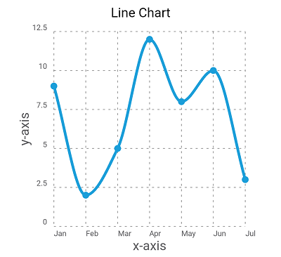

Use case:

You can use the component in your mobile app to represent the comparison between distinct items or data in the form of a line graph. For examples, sales growth on monthly basis.

Features

Easily to update the chart with Iris properties or by API.

Percentage of re-use:
80-90% (Data can be customizable and skins are not customized but can be changed manually)

Getting Started

Prerequisites
Before you start using the component, ensure you have the following:
- HCL Foundry
- Volt MX Iris

Platforms Supported

Mobile

iOS

Android

Tablets

iOS

Android

PWA

Importing the app

You can import the Forge components only into the apps that are of the Reference Architecture type.

To import the component, do the following:

Open your app project in Volt MX Iris.

In the Project Explorer, click the Templates tab.
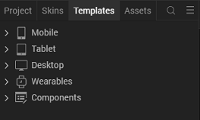

- Right-click Components, and then select Import Component. The Import Component dialog box appears.
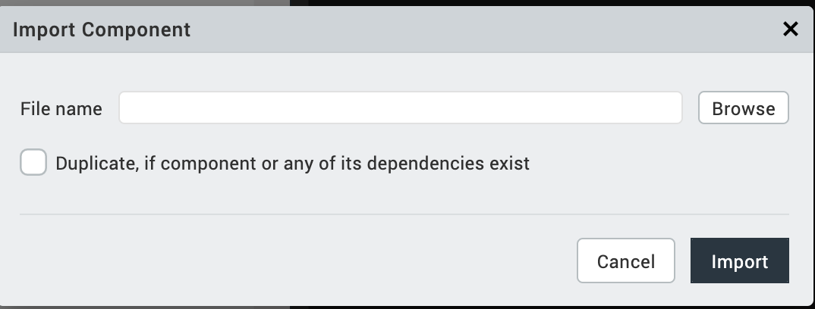
- Click Browse to navigate to the location of the component, select the component, and then click Import. The component and its associated widgets and modules are added to your project.
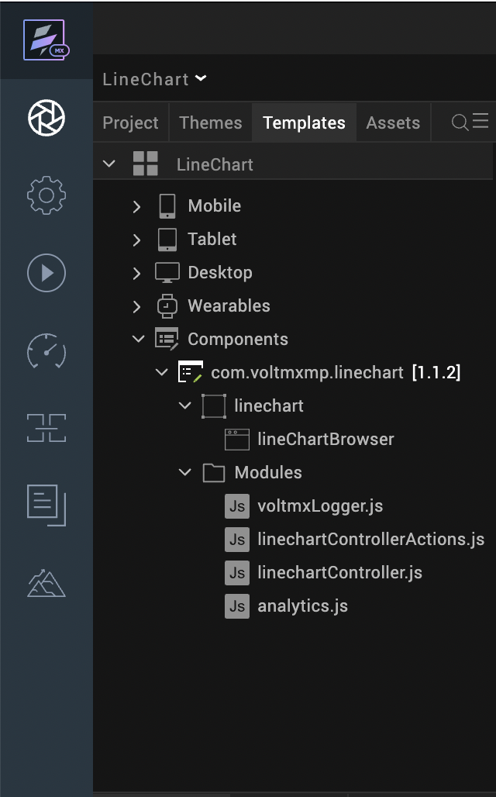

Once you have imported a component to your project, you can easily add the component to a form. For more information, refer Add a Component to a Form.

Building and previewing the app

Refer to below links:

Build & Generate Native Apps

Publish Apps to Enterprise App Store

References

Dynamic Usage
- You can add a Line Chart component dynamically. To do so,
In the Project Explorer, on the Projects tab, click Controllers section to access the respective formController. Create a method and implement the code snippet like the sample code mentioned below.
In the code snippet, you can edit the properties of the component as per your requirement. For more information, see Setting Properties.
var linechart = new com.voltmxmp.linechart(

{

"autogrowMode": voltmx.flex.AUTOGROW_NONE,

"clipBounds": true,

"id": "linechart",

"height": "90%",

"width": "100%",

"top": "10%",

"left": "0%",

"isVisible": true,

"zIndex": 1,

"layoutType": voltmx.flex.FREE_FORM,

"skin": "slFbox",

"masterType": constants.MASTER_TYPE_USERWIDGET

}, {}, {});

/* Setting the component s properties */

linechart.lineColor = "#1B9ED9";

linechart.bgColor = "#FFFFFF";

linechart.lowValue = "0";

linechart.highValue = "12.5";

linechart.enableChartAnimation = true;

linechart.xAxisTitle = "Month";

linechart.yAxisTitle = "Sales";

linechart.enableGrid = true;

linechart.enableGridAnimation = true;

linechart.chartTitle = "Line Chart";

linechart.titleFontColor = "#000000";

linechart.titleFontSize = "12";

linechart.enableStaticPreview = true;

linechart.chartData =

{

"data":

[

{"dataVal": "9", "lblName": "Jan"},

{"dataVal": "2", "lblName": "Feb"},

{"dataVal": "5", "lblName": "Mar"},

{"dataVal": "12", "lblName": "Apr"}

]

};

/* Adding the component to the form */

this.view.add(linechart);

- Save the file.

Properties

General
Background Color
Description: | Specifies background color of the chart.
Syntax: | bgColor
Type: | String
Read/Write: | Write
Example: | this.view.componentID.bgColor= "#FFFFFF";

Low Value
Description: | Specifies the starting value on the vertical axis where the reading starts.
Syntax: | lowValue
Type: | String
Read/Write: | Write
Remarks: | Low and High values must be passed according to the data passed to the chart.
Example: | this.view.componentID.lowValue = "0";

High Value
Description: | Specifies the end value on the vertical axis where the reading starts.
Syntax: | highValue
Type: | String
Read/Write: | Write
Remarks: | Low and High values must be passed according to the data passed to the chart.
Example: | this.view.componentID.highValue = "40";

Line Color
Description: | Specifies the color of the line generated on the chart.
Syntax: | lineColor
Type: | String
Read/Write: | Write
Example: | this.view.componentID.lineColor= "#1B9ED9";

Enable Chart Animation
Description: | Controls whether or not to enable the chart animation.
Syntax: | enableChartAnimation
Type: | Boolean
Read/Write: | Write
Remarks: | Disabling the chart animation will also disable the grid animation.
Example: | this.view.componentID.enableChartAnimation= true;

Enable Chart with Static Data
Description: | Specifies whether or not the chart should render in the data grids, with the given data.
Syntax: | enableStaticPreview
Type: | Boolean
Read/Write: | Write
Example: | this.view.componentID.enableStaticPreview = true;

Chart Data
Description: | Enables a user to provide the data to generate the chart.
Syntax: | chartData
Type: | Data Grid
Read/Write: | Write
Remarks: | The property is static and cannot be assigned dynamically.

Axis Titles

X-axis Title
Description: | Specifies the text to be displayed as the X-axis (horizontal axis) title.
Syntax: | xAxisTitle
Type: | String
Read/Write: | Write
Example: | this.view.componentID.xAxisTitle= "x-axis";

Y-axis Title
Description: | Specifies the text to be displayed as the y-axis (vertical axis) title.
Syntax: | yAxisTitle
Type: | String
Read/Write: | Write
Example: | this.view.componentID.yAxisTitle= "y-axis";

Grid

Enable Grid
Description: | Controls whether or not to enable the chart grid.
Syntax: | enableGrid
Type: | Boolean
Read/Write: | Write
Example: | this.view.componentID.enableGrid= true;

Enable Grid Animation
Description: | Controls whether or not to enable the grid animation.
Syntax: | enableGridAnimation
Type: | Boolean
Read/Write: | Write
Example: | this.view.componentID.enableGridAnimation= true;

Title

Chart Title
Description: | Specifies the text to be displayed as the Chart title.
Syntax: | chartTitle
Type: | String
Read/Write: | Write
Example: | this.view.componentID.chartTitle = "Line Chart";

Title Font Size
Description: | Specifies the font size of the Chart title.
Syntax: | titleFontSize
Type: | String
Read/Write: | Write
Example: | this.view.componentID.titleFontSize= "12";

Title Font Color
Description: | Specifies the font color of the Chart title.
Syntax: | titleFontColor
Type: | String
Read/Write: | Write
Example: | this.view.componentID.titleFontColor = "#000000";

Events
No Events

API’s

createChart
The API creates a Line Chart.
Syntax
createChart(data)
Parameters
data:
JSON array contains the data based on which the Area Chart is generated. The JSON array should contain data of column names and the corresponding values to generate line, in the key-value pair format. Here is the JSON array format:
var chartData =
[
{lblName: "Jan", dataVal: "12"},

{lblName: "Feb", dataVal: "5"},

{lblName: "Mar", dataVal: "8"}

];
In the above format, lblName and dataVal are keys and they are case sensitive.
- lblName: The key accepts values for the label names on the Horizontal (x) axis. You can specify upto Four characters as a row name. For example, "Jan". Specifying more than 04 characters results distortion in the component UI.
- dataVal: The key accepts the values corresponding to the label name on the Vertical (y) axis.
The component can conveniently handle a maximum of 07 key-value pairs in the JSON array. Defining more than 07 key-value pairs results distortion in the component UI.
Return Value
None
Example

var chartData =
[
{lblName: "Jan", dataVal: "12"},

{lblName: "Feb", dataVal: "5"},

{lblName: "Mar", dataVal: "8"}

];
this.view.linechart.lineColor = "#F26B29";
this.view.componentID.chartData = {data: chartData};
this.view.componentID.createChart(chartData);

Note:
- The createChart API must be invoked to reflect the dynamic change of any property after adding the chart to a form either by drag and drop method or dynamic creation.
- The data must be passed in a proper format (without any missing values).

Revision History
App version 1.1.2:

Known Issues
Following are the known issues in the Line Chart component:
- Cannot handle layout properties of the component as per the device orientation. You must handle the properties at the form level.
- You cannot invoke createChart() API on forms preShow and postShow.

Limitations
The following are the limitations with the Line Chart component:
- The label names on the horizontal axis and vertical axis must not contain more than three characters. Providing more characters will cause an overlap.
- The maximum length of the data that can be passed to the chart is seven. Exceeding the limit leads to UI distortions.

