Date : 12 Mar 2023
LauNch GooGLE MAPS
Version:1.0.3

1.OVERVIEW
The component allows you to display an address/ location on Google Maps/ Apple Maps- just drag and drop the component, customize few properties and you are ready to go!
- Use case:
Provide location to your app users using Google Maps/ Apple Maps
B. Features:
- Configure location, map view type etc. properties directly from Iris property panel.
- Customize the look and feel as per your company's branding guidelines.
- The component uses URL schemes provided by Google Maps/ Apple Maps
C. Percentage of Re-use:
90%

2.Getting Started

A. Prerequisites
Before you start using the TimeLine component, ensure you have the following:
- HCL Foundry
- Volt MX Iris

B. Platforms Supported

Mobile

iOS

Android

PWA

C. Importing the Component

You can import the Forge components only into the apps that are of the Reference Architecture type.

To import the TimeLine component, do the following:

Open your app project in Volt MX Iris.
- In the Project Explorer, click the Templates tab.
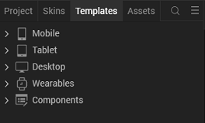

- Right-click Components, and then select Import Component. The Import Component dialog box appears.

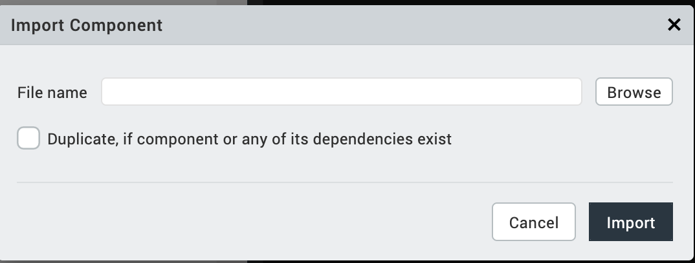

- Click Browse to navigate to the location of the component, select the component, and then click Import. The component and its associated widgets and modules are added to your project.

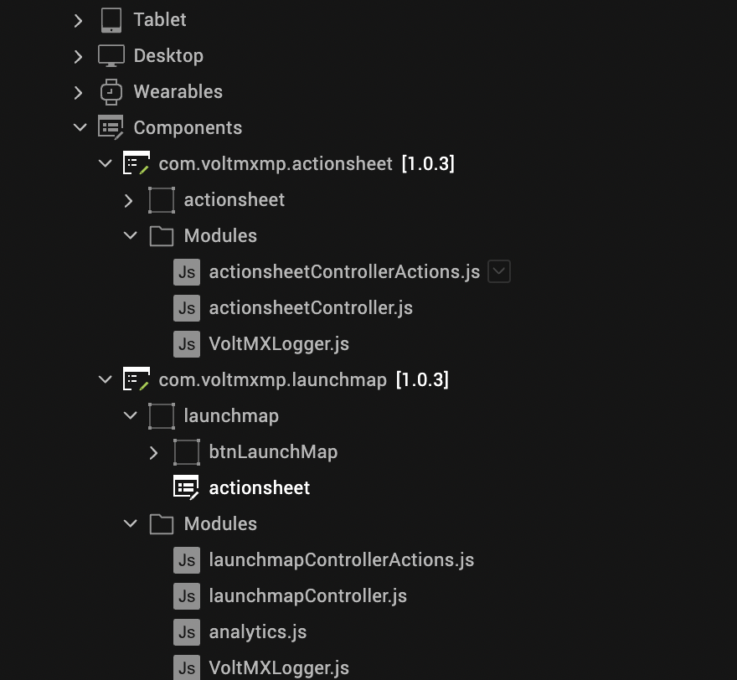

Once you have imported a component to your project, you can easily add the component to a form. For more information, refer Add a Component to a Form.
  - Building and previewing the app
After performing all the above steps, you can build your app and run it on your device. For more information, you can refer to the Building and Viewing an Application section of the Volt Mx Iris User Guide.
You can then run your app to see the Launch Google Maps work in real time.

as per your requirement. For more information, see Setting Properties.

3.References

A. Dynamic Usage
You can also add a Launch Google Maps component dynamically. To do so:
- In the Project Explorer, on the Projects tab, click Controllers section to access the respective Form Controller. Create a method and implement the code snippet like the sample code mentioned below.
In the code snippet, you can edit the properties of the component.
/* Creating a component s object*/

var launchmap = new com.voltmxmp.launchmap(

{

"autogrowMode": voltmx.flex.AUTOGROW_NONE,

"clipBounds": true,

"height": "80dp",

"id": "launchmap",

"isVisible": true,

"layoutType": voltmx.flex.FREE_FORM,

"left": "0dp",

"masterType": constants.MASTER_TYPE_USERWIDGET,

"skin": "slFbox",

"top": "0dp",

"width": "80dp"

}, {}, {});

/* Adding Properties to the component */

launchmap.mapTypeApple = "Standard";

launchmap.googlePlaceID = "";

launchmap.iOSMapOptions = "Both Maps";

launchmap.location = "Eiffel Tower";

launchmap.iconScaleMode = constants.IMAGE_SCALE_MODE_MAINTAIN_ASPECT_RATIO;

/* Adding Component to the form */

this.view.add(launchmap);

In the code snippet, you can edit the properties of the component as per your requirement. For more information, see Properties.
- Save the file.

B. Setting Properties
The Properties provided on the Component tab allow you to customize the UI elements and set constraints for fields in the launch map component. You can set the properties directly on the Component tab or by writing a JavaScript.

i. General Properties
1.Icon Source
Description: | Specifies the source of the component's icon.
Syntax: | iconSrc
Type: | String
Read/Write: | Read + Write
Remarks: | Make sure that the source file is present in the project resources.
Example: | this.view.componentID.iconSrc = voltmxmplmlaunchmapicon.png ;

2. Icon Scale Mode
Description: |  | Specifies the scale mode of the component's icon. For further information,  you can refer to the imageScaleMode property in the Quantum Widget  User Guide.
Syntax: |  | iconScaleMode
Type: |  | Constant
Read/Write: |  | Read + Write
Values: |  | - constants.IMAGE_SCALE_MODE_CROP  - constants.IMAGE_SCALE_MODE_FIT_TO_DIMENSIONS  - constants.IMAGE_SCALE_MODE_MAINTAIN_ASPECT_RATIO
Example: | this.view.componentID.iconScaleMode = constants.IMAGE_SCALE_MODE_MAINTAIN_ASPECT_RATIO;

3.Location

Description: | Specifies the Location to be searched in the visible map region.
Syntax: | location
Type: | String
Read/Write: | Read + Write
Remarks: | - This property is mandatory. The component throws an exception if the Location is not provided.  - This property refers to:  - The query parameter in Google Maps Directions URL scheme.  - The q parameter in Apple Maps URL scheme.  For more information, you can refer to the Google Maps documentation and Apple Maps reference.  - While providing the location as (lat,long), make sure there is no space before or after the comma.
Example: | this.view.componentID.location = paris ;  or  this.view.componentID.location = 48.858371,2.294481 ;

ii. iOS

1. Map Options
Description: |  | This property is used to ask the users which map they want to use.  This property invokes an Action Sheet pop-up that presents the choice of map to the user - Google Maps, or Apple Maps.  This property has the following options:  - Apple Maps  - Google Maps  - Both Maps
 | Syntax: |  | iOSMapOptions
 | Type: |  | String
 | Read/Write: |  | Read + Write
 | Default Value: |  | "Both Maps"
 | Remarks: |  | - The component throws an exception if the given value is not a valid string.  - The Action Sheet will not pop up if you enable only one map.
 | Example: |  | this.view.componentID.iOSMapOptions = "Both Maps";

2. Action Sheet Main Text
Description: | Specifies the text to be displayed as the main header of the Action Sheet. You can refer to the Map Options property for more information regarding Action Sheet.
Syntax: | headerMainText
Type: | String
Read/Write: | Read + Write
Remarks: | The Action Sheet will not display the Header if you do not provide any text.
Example: | this.view.componentID.headerMainText = "Launch Map";

3.Action Sheet Sub Text
 | Description: |  | Specifies the text to be displayed as the sub header of the Action Sheet. You can refer to the Map Options property for more information regarding Action Sheet.
 | Syntax: |  | headerSubText
 | Type: |  | String
 | Read/Write: |  | Read + Write
 | Remarks: |  | The Action Sheet will not display the Sub Header if you do not provide any text.
Example: |  | this.view.componentID.headerSubText = "Which map would you like to use?";

Action Sheet Skin Properties
An Action Sheet is a pop-up in iOS that presents the choice of map to the user - Google Maps, or Apple Maps.
You can change the exposed skins of the Action Sheet component in the Skins tab under the Properties panel of the Iris.
1.Sheet Background Skin
Description: | Specifies the skin that is applied to the background container of Header and Options of the Action Sheet.
Syntax: | sheetBackgroundSkin
Type: | String
Read/Write: | Read + Write
Example: | this.view.componentID.sheetBackgroundSkin = "sheetBGSkin";
2. Header Main Text Skin
Description: | Specifies the skin that is applied to the header's main text in the Action Sheet.
Syntax: | headerMainTextSkin
Type: | String
Read/Write: | Read + Write
Example: | this.view.componentID.headerMainTextSkin = "headerTextSkin";
3. Header Sub Text Skin
Description: | Specifies the skin that is applied to the header's sub text in the Action Sheet.
Syntax: | headerSubTextSkin
Type: | String
Read/Write: | Read + Write
Example: | this.view.componentID.headerSubTextSkin = "headerTextSkin2";
4. Separator Skin
Description: | Specifies the skin that is applied to the separator lines in the Action Sheet.
Syntax: | separatorSkin
Type: | String
Read/Write: | Read + Write
Example: | this.view.componentID.separatorSkin = "separatorSkin";
5. Options Skin
Description: | Specifies the skin to be applied to the options in the Action Sheet.
Syntax: | optionsSkin
Type: | String
Read/Write: | Read + Write
Example: | this.view.componentID.optionsSkin = "optSkin";
6. Options Focus Skin
Description: | Specifies the skin to be applied to the options in the Action Sheet when it is focused.
Syntax: | optionsFocusSkin
Type: | String
Read/Write: | Read + Write
Example: | this.view.componentID.optionsFocusSkin = "optFocusSkin";
7.Footer Background Skin
Description: | Specifies the skin to be applied to the background container of the Footer in the Action Sheet.
Syntax: | footerBackgroundSkin
Type: | String
Read/Write: | Read + Write
Example: | this.view.componentID.footerBackgroundSkin = "footBGSkin";
8. Footer Button Skin
Description: | Specifies the skin to be applied to the Footer button in the Action Sheet.
Syntax: | footerButtonSkin
Type: | String
Read/Write: | Read + Write
Example: | this.view.componentID.footerButtonSkin = "footBtnSkin";
9. Footer Button Focus Skin
Description: | Specifies the skin to be applied to the Footer button in the Action Sheet when it is focused.
Syntax: | footerButtonFocusSkin
Type: | String
Read/Write: | Read + Write
Example: | this.view.componentID.footerButtonFocusSkin = "footBtnFocusSkin";

iv. Google Maps Properties
1. Place ID
Description: | Specifies Google Maps Place ID. A Place ID is a unique identifier for a place in the Google Places database and Google Maps.
Syntax: | googlePlaceID
Type: | String
Read/Write: | Read + Write
Remarks: | - This property refers to the query_place_id parameter of Google Maps Directions URL scheme. For more details you can refer to Google Maps Documentation.  - The component throws an exception if the given value is not a String.
Example: | this.view.componentID.googlePlaceID = "frankfurt";

V. Apple Maps Properties
1. Map View Type
Description: | Specifies the map type. The options for Map Type are:  - Standard  - Satellite  - Hybrid  - Transit
Syntax: | mapTypeApple
Type: | String
Read/Write: | Read + Write
Remarks: | - If you don't provide any value for Map Type, the current map type is used.  - This property refers to the t parameter of Apple Maps URL scheme.  For more details you can refer to Apple Maps URL Scheme reference.  - The component throws an exception if the given value is not a String.
Example: | this.view.componentID.mapTypeApple = "Standard";

3. Revision History
App version 1.0.3
- component is malfunctioning in the adaptive web, and the action sheet fails to open when included in the thin client for (iPhone WEB ,Android WEB). So, ThinClient support only Google Maps .

