19 June 2025

KEY PHRASE EXTRACTION COMPONENT

VERSION: 1.0.0

Overview
The Key Phrase Extraction Component is designed to identify and extract meaningful words and phrases from input text using advanced natural language processing services. It integrates with Amazon Comprehend using the Detect Text operation, Azure AI Language for Key Phrase Extraction, and Google Natural Language API through its Analyze Entities feature. This component enables users to quickly understand the core ideas and important concepts in any given text, making it useful for summarization, content analysis, and enhancing user interactions.

- Use Case:
- Content Categorization: Automatically tag and organize content based on extracted key phrases to streamline taxonomy creation and improve content management systems.
- Search Enhancement: Boost search accuracy and relevance by using extracted key terms for better indexing, filtering, and query matching.
- Customer Feedback Analysis: Identify recurring issues, themes, or sentiments from reviews and support tickets to drive product and service improvements.
- Trend Detection: Track frequently mentioned phrases across platforms (news, social media) to uncover emerging trends, market demands, or public concerns.
- Compliance Monitoring: Extract important legal or regulatory terms from documents to assist in automated auditing and ensure compliance with industry standards.

- Percentage of re-use:
80-90%.

Getting Started

Prerequisites
Before you start using theKey Phrase Extraction Component, ensure you have the following:
- HCL Foundry
- Volt MX Iris
- Google Cloud Natural Language AI - ENTITY ANALYSIS - API KEY
- Go to the Google Cloud Console → Credentials
- Create an API Key (or use an existing one).
- Enable Cloud Natural Language API for your project.

- Azure AI Language - key phrase extraction
- Microsoft account
- Endpoint,and api-key to use the Microsoft’s AI Language API issued by Microsoft.
Reference document:
https://learn.microsoft.com/en-us/azure/ai-services/language-service/key-phrase-extraction/overview
https://learn.microsoft.com/en-us/azure/ai-services/language-service/key-phrase-extraction/quickstart?tabs=macos&pivots=rest-api
- Amazon Comprehend - DetectKeyphrases
- Aws account
Reference document:
https://docs.aws.amazon.com/comprehend/latest/APIReference/API_D etectKeyPhrases.html

Platforms Supported

Mobile

iOS

Android

Importing the Component

You can import the Forge components only into the apps that are of the Reference Architecture type.

To import the Key Phrase Extraction Component, do the following:

- Open your app project in Volt MX Iris.

In the Project Explorer, click the Templates tab.

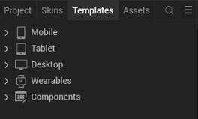

Right-click Components, and then select Import Component. The Import Component dialog box appears.
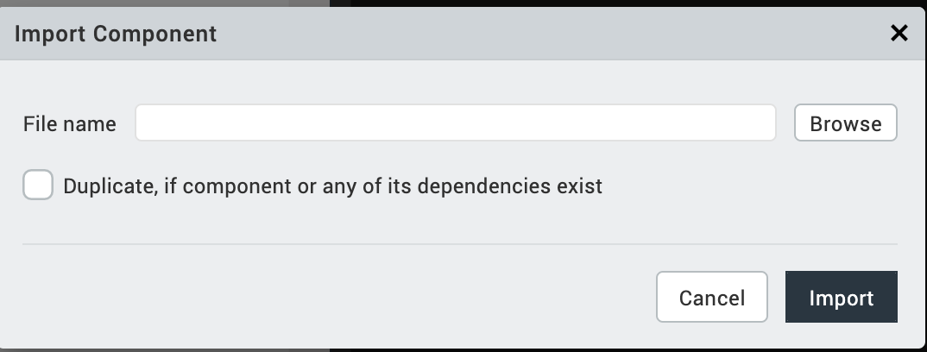

Click Browse to navigate to the location of the component, select the component and then click import. The component and its associated widgets and modules are added to your project.

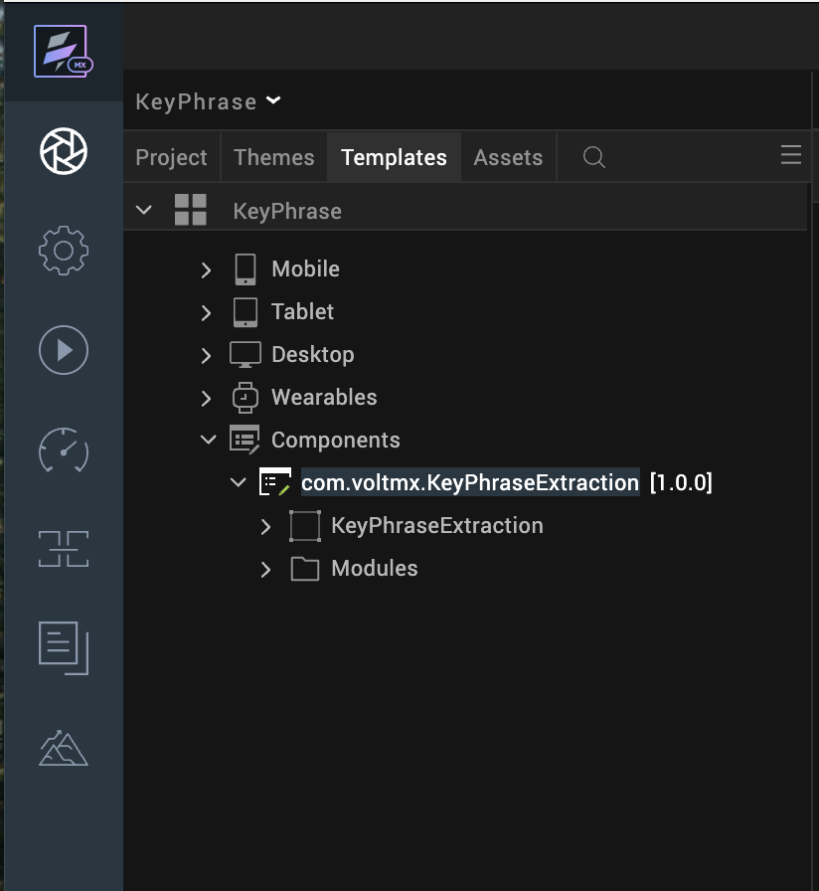
- Once you have imported a component to your project, you can easily add the component to a form. For more information, refer Add a Component to a Form

D. Building and previewing the app
After performing all the above steps, you can build your app and run it on your device. For more information, you can refer to the Building and Viewing an Application section of the Volt MX User Guide.
You can then run your app to see the Key Phrase Extraction Component work in real time.

3. References

Dynamic Usage
You can also add Key Phrase Extraction Component dynamically. To do so,
In Project Explorer, on the Projects tab, click Controllers section to access the respective Form Controller. Create a method and implement the code snippet like the sample code mentioned below.

var keyPhraseComponent = new com.voltmx.KeyPhraseExtraction({
id: "KeyPhraseExtraction",
isVisible: true,
width: "96%",
height: "30%",
left: "2%",
top: "15%",
skin: "slFbox",
zIndex: 1
}, {
paddingInPixel: false
}, {});
this.view.add(keyPhraseComponent);

In the code snippet, you can edit the properties of the component as per your requirement. For more information, see Setting Properties.
Save the file

4. Properties:
The properties provided on the Component tab allow you to customize the UI elements in the Key Phrase Extraction component. You can set the properties directly on the Component tab or by writing a JavaScript.

1. ServiceName

Category: | Custom
Description: | Specifies the service name in the adapter.
Syntax:
  ServiceName
Type: | String
Read/Write: | Write
Example: | this.view.componentID.ServiceName = "Service Name";

B. Events
You can define events to be executed when an action is performed. You can configure the events directly on the Actions tab or by writing a JavaScript. To configure the events on the Actions tab, click Edit against each event. For more information, refer Add Actions.
This section provides details about each event that help you define the actions by writing a JavaScript.

1. onKeyPhrasesSuccess
Description: | Triggered when key phrase extraction is completed successfully. Receives the key phrases extracted from the input text.
Syntax: | onKeyPhrasesSuccess
Parameters: | keyPhrases
Example: | this.view.componentID.onKeyPhrasesSuccess= function(keyPhrases){  alert("Key Phrase Extracted”);  }.bind(this);

2. onKeyPhrasesFailure

Description: | Triggered when key phrase extraction fails due to an error or service issue.Receives the error details.
Syntax: | onKeyPhrasesFailure
Parameters: | keyPhrases
Example: | this.view.componentID.onKeyPhrasesFailure= function(error){  alert("Key Phrase Extraction failed”);  }.bind(this);

5. References
A. Endpoint Documentation
- Amazon Comprehend Detect Key phrase
- Google Cloud Natuiral Language AI - Entity Analysis
- Azure AI Language Detect Key Phrases

6. Revision History
App version 1.0.0:

Known Issues
- No Known Issues

Limitations
- Azure AI Language's Detect Key Phrases API does not return a confidence score.

