Date: 13-Dec-21

Kendo pdf generator

version: 1.0.0

1. **OVERVIEW**

The Kendo PDF Generator component can generate a PDF file with content from HTML or a Responsive Web/ Desktop form in Volt MX Iris. Under the hood, the component uses the [kendo-ui library](https://www.telerik.com/kendo-ui), which is available under the [Commercial License](https://www.telerik.com/purchase/license-agreement/kendo-ui).

## **Features:**

The component provides 2 APIs:

1. generatePdfUsingDom() takes Volt MX Web FormName_FlexName as input and generates PDF
2. generatePdfUsingHtmlString() takes HTML string as input and generates PDF

## **Percentage of re-use:**

80-90% (PDF format, orientation, page margins and so on can be customized).

# **Getting Started**

## **Prerequisites**

Before you start using the Kendo PDF Generator component, ensure you have the following:

• [HCL Foundry](https://manage.hclvoltmx.com/)

• Volt MX Iris

## **Platforms Supported**

### Mobile

#### iOS

#### Android

### Tablets

### PWA

## **Importing the App**

## You can import the Forge Apps only into the apps that are of the Reference Architecture type.

## **To import the Kendo PDF Generator component, do the following:**

## Open your app project in Volt MX Iris.

1. In the Project Explorer, click the **Templates** tab.

1. Right-click **Components**, and then select **Import Component**. The **Import Component** dialog box appears.

1. Click **Browse** to navigate to the location of the component, select the component, and then click **Import**. The component and its associated widgets and modules are added to your project.

Once you have imported a component to your project, you can easily add the component to a form. For more information, refer [Add a Component to a Form](https://opensource.hcltechsw.com/volt-mx-docs/docs/documentation/Iris/iris_user_guide/Content/C_UsingComponents.html#add-a-component-to-a-form).

## **Configuring Native Settings**

#### **Android platform:**

#### The Kendo PDF Generator component requires the **READ_PHONE_STATE** and **WRITE_EXTERNAL_STORAGE** permissions on the Android platform.

1. From the left navigation panel of Volt MX Iris, select **Project Settings**.
2. Switch to the **Native** tab, and in **Native**, switch to the **Android** tab.
3. Ensure that the READ_PHONE_STATE and WRITE_EXTERNAL_STORAGE permissions are set to **true**.  
   To set a permission to **true**, select it from the left panel and click **Add >**.

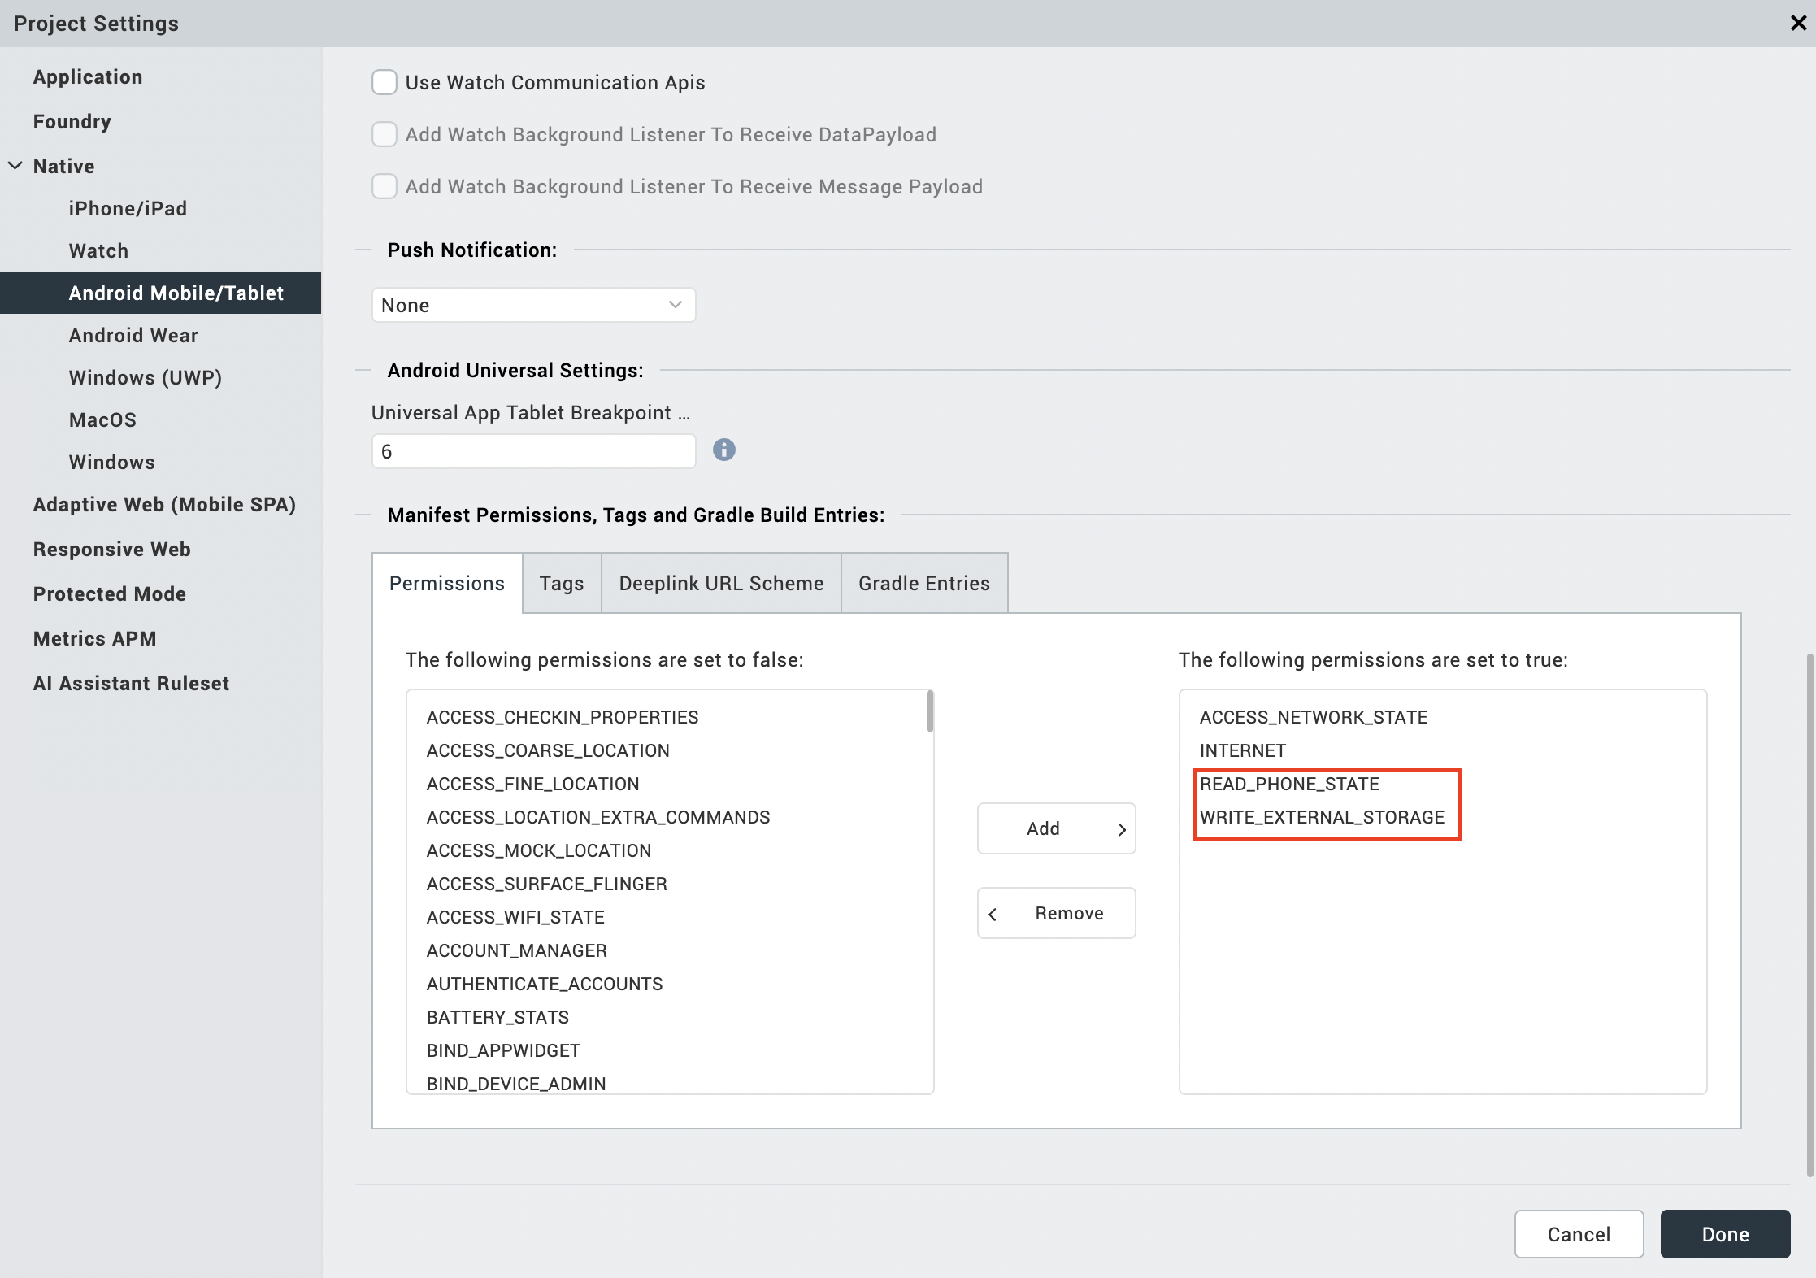

1. Select Tags tab and add the below permission under **child tag entries under <manifest> tag.**

**Permissions:**

|  |
| --- |
| <uses-permission android:name="android.permission.MANAGE_EXTERNAL_STORAGE" />  <uses-permission android:name="android.permission.READ_MEDIA_IMAGES" />  <uses-permission android:name="android.permission.READ_MEDIA_VIDEO" />  <uses-permission android:name="android.permission.READ_MEDIA_AUDIO" /> |

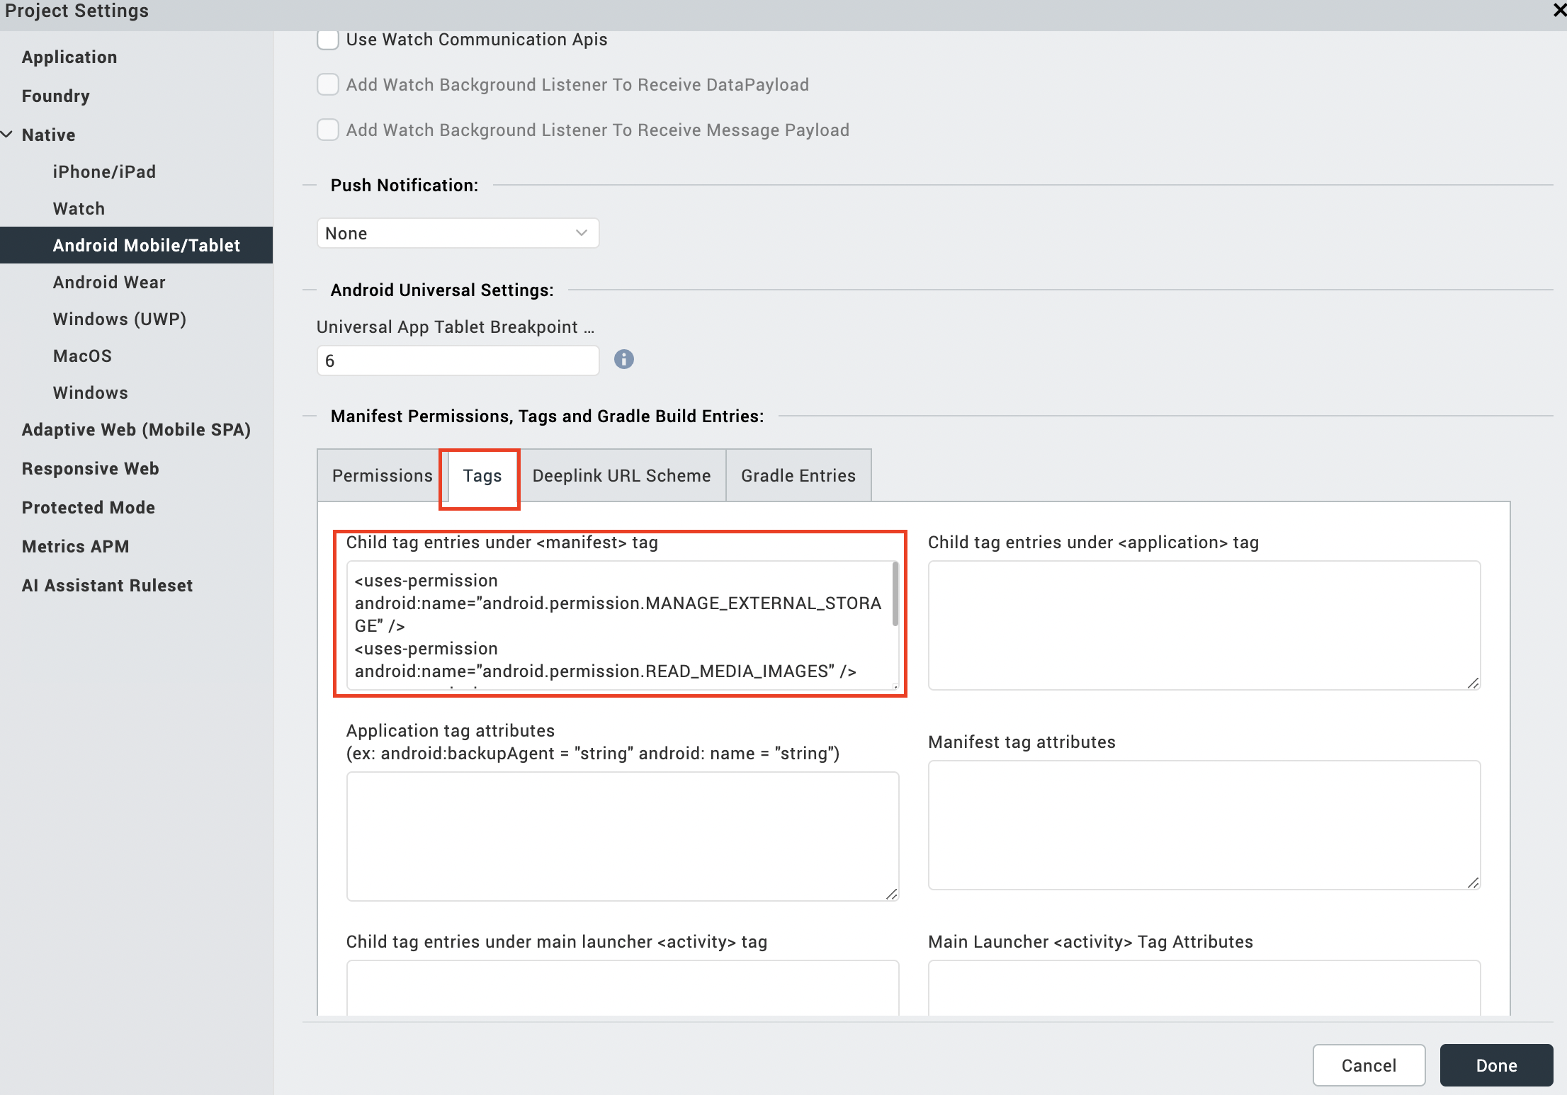

# **References**

## **Dynamic Usage**

You can also add a **Kendo PDF Generator** component dynamically. To do so:

1. In the **Project Explorer**, on the **Projects** tab, click **Controllers** section to access the respective **Form Controller**. Create a method and implement the code snippet like the sample code mentioned below.

In the code snippet, you can edit the properties of the component as per your requirement. For more information, see Setting Properties.

createComponent: function()

{

/* Creating the component's object */

const kendoPdfGenerator = new com.voltmxmp.kendopdfgenerator({

"clipBounds": true,

"height": "0dp",

"id": "kendoPdfGenerator",

"isVisible": true,

"left": "0dp",

"top": "0dp",

"width": "0dp",

"zIndex": 1

}, {}, {});

kendoPdfGenerator.fileName = "<pdf file name>";

kendoPdfGenerator.orientation = "<pdf file orientation>";

kendoPdfGenerator.format = "<pdf file format>";

kendoPdfGenerator.compress = <pdf file compress>;

kendoPdfGenerator.unit = "<the unit>";

kendoPdfGenerator.leftprop = <page margin for left>;

kendoPdfGenerator.topprop = <page margin for top>;

kendoPdfGenerator.rightprop = <page margin for right>;

kendoPdfGenerator.bottomprop = <page margin for bottom>;

return kendoPdfGenerator;

1. **Save** the file.

## **Properties**

You can use a component's **Properties** to customize and configure the elements. These elements can be UI elements, service parameters, and so on.

You can set the properties from the **Properties** panel on the right side of Volt MX Iris. You can also configure these properties using a JavaScript code.

#### **PDF File Name (fileName)**

|  |  |
| --- | --- |
| **Category:** | Custom |
| **Description:** | Specifies the name that you want to set for the generated PDF. |
| **Syntax:** | fileName |
| **Type:** | String |
| **Read/Write:** | Write |
| **Example:** | this.view.componentID.fileName = "SamplePdf"; |

#### **orientation (orientation)**

|  |  |
| --- | --- |
| **Category:** | Custom |
| **Description:** | Specifies the orientation that you want to set for the generated PDF. |
| **Syntax:** | orientation |
| **Type:** | * List Selector * String |
| **Read/Write:** | Write |
| **Values:** | * portrait (p) * landscape (l) |
| **Default Value:** | portrait |
| **Example:** | this.view.componentID.orientation = "portrait"; |

#### **format (format)**

|  |  |
| --- | --- |
| **Category:** | Custom |
| **Description:** | Specifies the format that you want to set for the pages of the generated PDF. |
| **Syntax:** | format |
| **Type:** | * List Selector * String |
| **Read/Write:** | Write |
| **Values:** | |  |  |  |  | | --- | --- | --- | --- | | * a0 * a1 * a2 * a3 * a4 * a5 * a6 * a7 * a8 * a9 * a10 | * b0 * b1 * b2 * b3 * b4 * b5 * b6 * b7 * b8 * b9 * b10 | * c0 * c1 * c2 * c3 * c4 * c5 * c6 * c7 * c8 * c9 * c10 | * dl * letter * government-letter * legal * junior-legal * ledger * tabloid * credit-card | |
| **Default Value:** | a4 |
| **Example:** | this.view.componentID.format = "a4"; |

#### **compress (compress)**

|  |  |
| --- | --- |
| **Category:** | Custom |
| **Description:** | Specifies whether you want to compress the generated PDF. |
| **Syntax:** | compress |
| **Type:** | boolean |
| **Read/Write:** | Write |
| **Default Value:** | false |
| **Example:** | this.view.componentID.compress = false; |

#### **unit (unit)**

|  |  |
| --- | --- |
| **Category:** | Custom |
| **Description:** | Specifies the measurement unit for the page margins. |
| **Syntax:** | unit |
| **Type:** | * List Selector * String |
| **Read/Write:** | Write |
| **Values:** | * pt * mm * cm * m * in * px |
| **Default Value:** | pt |
| **Remarks:** | The component uses the **unit** measurement for the following properties.   * [left](https://docs.kony.com/marketplace/PDFGenerator/Content/Reference.htm#left) * [top](https://docs.kony.com/marketplace/PDFGenerator/Content/Reference.htm#top) * right * [bottom](https://docs.kony.com/marketplace/PDFGenerator/Content/Reference.htm#bottom) |
| **Example:** | this.view.componentID.unit = "pt"; |

#### **left (leftprop)**

|  |  |
| --- | --- |
| **Category:** | Custom |
| **Description:** | Specifies the distance of the left edge of the content from the left edge of the page. |
| **Syntax:** | leftprop |
| **Type:** | Integer |
| **Read/Write:** | Write |
| **Example:** | this.view.componentID.leftprop = 10; |

#### **top (top)**

|  |  |
| --- | --- |
| **Category:** | Custom |
| **Description:** | Specifies the distance of the top edge of the content from the top edge of the page. |
| **Syntax:** | topprop |
| **Type:** | Integer |
| **Read/Write:** | Write |
| **Example:** | this.view.componentID.topprop = 10; |

#### **right(rightprop)**

|  |  |
| --- | --- |
| **Category:** | Custom |
| **Description:** | Specifies the right edge of the content from the right edge of the page. |
| **Syntax:** | rightprop |
| **Type:** | Integer |
| **Read/Write:** | Write |
| **Example:** | this.view.componentID.rightprop = 10; |

#### **bottom (bottom)**

|  |  |
| --- | --- |
| **Category:** | Custom |
| **Description:** | Specifies the distance of the bottom edge of the content from the bottom edge of the page. |
| **Syntax:** | bottomprop |
| **Type:** | Integer |
| **Read/Write:** | Write |
| **Example:** | this.view.componentID.bottomprop = 10; |

## **API’s**

Thefollowing APIs pertain to the Kendo PDF Generator component:

#### **generatePdfUsingHtmlString**

|  |  |
| --- | --- |
| **Category:** | Custom |
| **Description:** | Generates a PDF file from the specified HTML string. |
| **Syntax:** | generatePdfUsingHtmlString(htmlString) |
| **Parameters:** | *htmlString [String]* :  Contains the HTML content to generate the PDF. |
| **Return Value:** | None |
| **Platform Availability:** | * Android * iOS * Desktop Web |
| **Example:** | var htmlString = '<div style="position:absolute;  top:5;left:5;z-index:5;color:white">'+  'Sample Html'+  '</div>'+  ‘<img width=300 height=200  src="https://images.unsplash.com/photo-1620052583766-f61ee0336a7d?  ixid=MnwxMjA3fDB8MHxwaG90by1wYWdlfHx8fGVufDB8fHx8&ixlib=rb-1.2.1&auto=format&fit=crop&w=1867&q=80" />’;    this.view.componentID.generatePdfUsingHtmlString(htmlString); |

#### **generatePdfUsingDom**

|  |  |
| --- | --- |
| **Category:** | Custom |
| **Description:** | Generates a PDF file from the specified Volt MX element. |
| **Syntax:** | generatePdfUsingDom(formFlexName) |
| **Parameters:** | *formFlexName [String]*: The name of FlexContainer that you want to use to generate the PDF. |
| **Return Value:** | None |
| **Platform Availability:** | * Desktop Web |
| **Remarks:** | The name of the element is in the format **FormName_FlexName**.  Therefore, if the name of your form is **frmHome**, and the name of your FlexContainer is **flxContainer1**, then the Volt MX element name is **frmHome_flxContainer1**. |
| **Example:** | var formFlexName = "frmHome_flxContainer1";  this.view.componentID.generatePdfUsingDom(formFlexName); |

# **Revision History**

App version 1.0.0

## **Known Issues**

## No issues

## **Limitations**

* + [Limitations and Browser Support](https://docs.telerik.com/kendo-ui/framework/drawing/limitations-browser-support)
  + For ios, the pdf file is generated in the data directory of Volt MX App, so it cannot be downloaded directly.