Date :  20-10-2023

JSEARCH DATA ADAPTER(1.0.0)

# Overview

Fast and Simple searches for jobs posted on LinkedIn, indeed, Glassdoor, ZipRecruiter, Dice and others, all in a single API.

JSearch is the #1 Global Job Search API solution. As the most comprehensive and highly maintained option available, JSearch empowers you to seamlessly access most-up-to-date job postings and salary information from Google for Jobs and the web in real-time from Google for Jobs - the largest job board in the world.

**USAGE:**

* Highly comprehensive both in terms of data and capabilities:  
  1. Covering most of the major jobs’ sites.  
  2. More than 30 data points per job.  
   3. Extensive search, querying and filtering capabilities.

# Getting Started

## Prerequisites

* Volt Foundry

## Importing the adapter

**To import the Data Adapter to Volt Foundry, do the following:**

1. Sign in to the  [HCL Foundry](https://manage.hclvoltmx.com/).
2. From the left navigation menu, select **API Management**.
3. In **API Management**, select **Custom Data Adapters**.  
   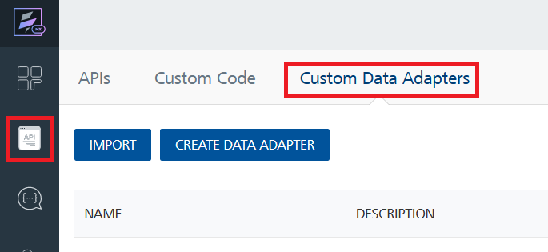
4. Click **IMPORT** to import a custom data adapter.  
   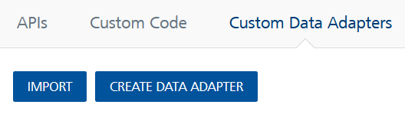
5. On the Import Data Adapter dialog box, click browser to import.  
   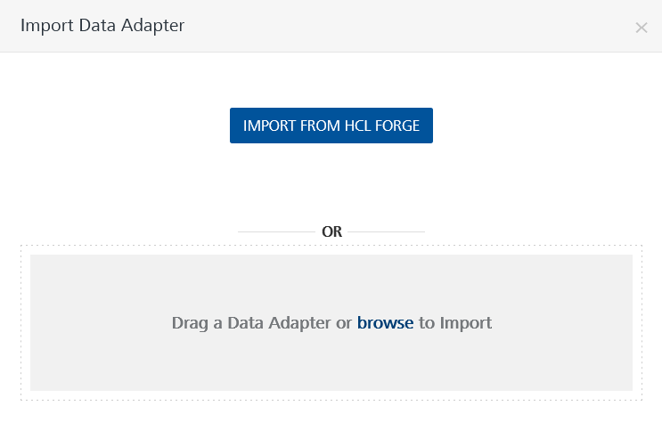
6. Select JSEARCH zip file and click **IMPORT**.

After you import the data adapter, Volt Foundry opens a window that shows the metadata of the data adapter. 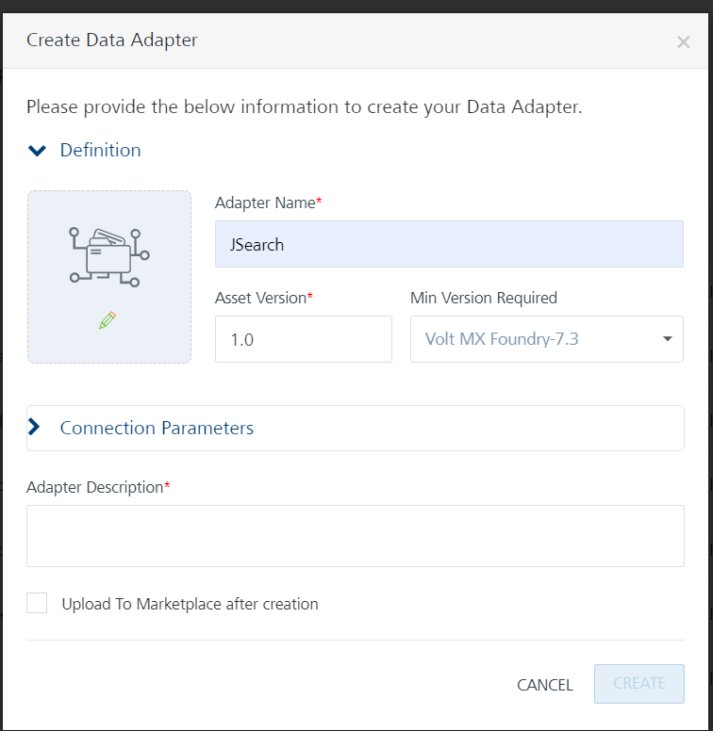

After you import the data adapter, you can view it on the Custom Data Adapters page and use it to create services on Volt Foundry



## [Creating an Integration service](javascript:void(0);)

After you import the data adapter into Volt Foundry, you can use it to create an Integration Service.

Follow the given steps to create an Integration service using the <Custom> Adapter.

1. Sign in to the [HCL Foundry](https://manage.hclvoltmx.com/).
2. From the left navigation menu, select **API Management**.
3. In **API Management**, select **Integration**.  
   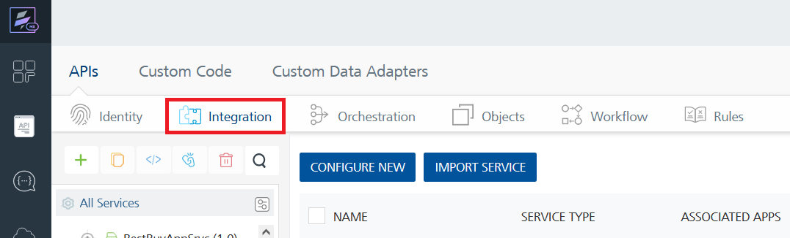
4. To create a new service, click the **+** button or the **CONFIGURE NEW** button.  
   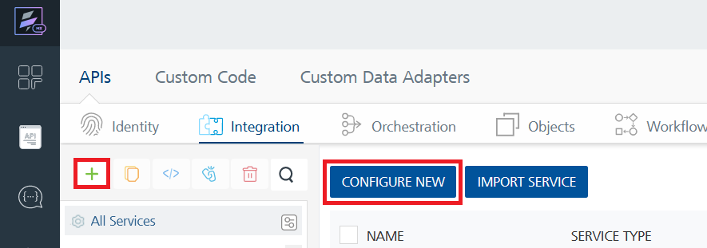
5. On the Service Definition tab, select the service type as JSEARCH and click **SAVE**.  
   A screenshot of a computer

   Description automatically generated

Alternatively, you can also create a Foundry app and create an Integration service inside it.

E. [Creating and Executing operations](javascript:void(0);)



After you create an integration service, you can create and execute operations using the service.

#### Creating an Operation

* In **API Management/Foundry app you created**, in the **Integration** section, select the service that you created.
* After you select the service, navigate to the **Operation List** tab.  
  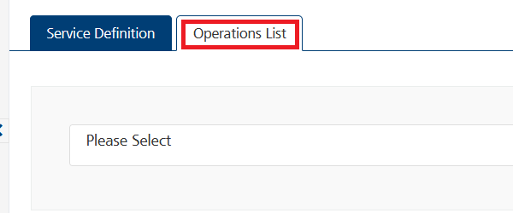
* From the drop down list, select an operation that you want to execute, and click **ADD OPERATION**.  
  A screenshot of a computer

  Description automatically generated

#### Executing an Operation

* From the **Operations List** tab, in the **Configured Operations** section, select the operation you want to execute.



* On the Operation Page, in the Request Input tab, enter a TEST VALUE for all the fields.  
  A screenshot of a computer

  Description automatically generated
* Select a run-time environment and click **Save and Fetch Response** to get a response based on your inputs.  
  A screenshot of a computer

  Description automatically generated

## [Publishing your application](javascript:void(0);)

If you want to use the services in client applications, you need to publish an app to a run-time environment. You can create the service (as described above) in an application or import the service into an application and publish the application.

# References

## Endpoint Documentation

|  |  |  |  |
| --- | --- | --- | --- |
| S.NO | ENDPOINT NAME | ENDPOINT | Description |
| 1 | Search | https://jsearch.p.rapidapi.com/search | Search for jobs posted on job sites across the web on the largest job aggregate in the world - Google for Jobs. Extensive filtering support and most options available on Google for Jobs. |
| 2 | Search Details | https://jsearch.p.rapidapi.com/search-filters | Accepts all **Search** endpoint parameters (except for page and num_pages) and returns the relevant filters and their estimated result counts for later use in search or for analytics. |
| 3 | Job Details | https://jsearch.p.rapidapi.com/job-details | Get all job details, including additional application options / links, employer reviews and estimated salaries for similar jobs. |
| 4 | Estimated Salary | https://jsearch.p.rapidapi.com/estimated-salary | Get estimated salaries for a jobs around a location. |

## For more information regarding endpoints,Jsearch data adapters goto [JSearch API Documentation](https://rapidapi.com/letscrape-6bRBa3QguO5/api/jsearch)

# Revision History

Adapter version 1.0.0: