Date :  28-02-2024

Jobs API

version: 1.0.0

# **Overview**

Access the global job listing by using Google Jobs webscraping. This API allows you to discover employment opportunities from various providers, including but not limited to LinkedIn, Indeed, Jooble, ZipRecruiter, Glassdoor, and many other sources.

Introducing our innovative API designed to revolutionize the job search experience on a global scale. Using the power of web scraping technology for accessing job opportunities worldwide. With this Google Jobs webscraping API, you can now effortlessly retrieve an extensive list of employment opportunities from a diverse array of renowned providers.

This API consolidates job listings from top-tier providers such as LinkedIn, Indeed, Jooble, ZipRecruiter, Glassdoor, and many more, streamlining your job search process and providing you with a one-stop-shop for employment opportunities.

# **Getting Started**

## **Prerequisites**

* Volt Foundry
* Api key from <https://rapidapi.com/Pat92/api/jobs-api14>

Note:Provide this Api-Key in header part.

## **Importing the adapter**

**To import the Data Adapter to Volt Foundry, do the following:**

1. Sign in to the  [HCL Foundry](https://manage.hclvoltmx.com/).
2. From the left navigation menu, select **API Management**.
3. In **API Management**, select **Custom Data Adapters**.  
   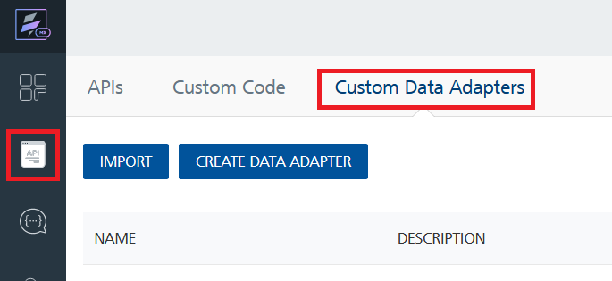
4. Click **IMPORT** to import a custom data adapter.  
   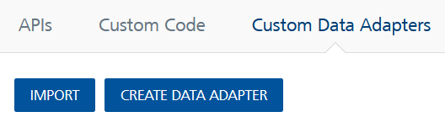
5. On the Import Data Adapter dialog box, click browser to import.  
   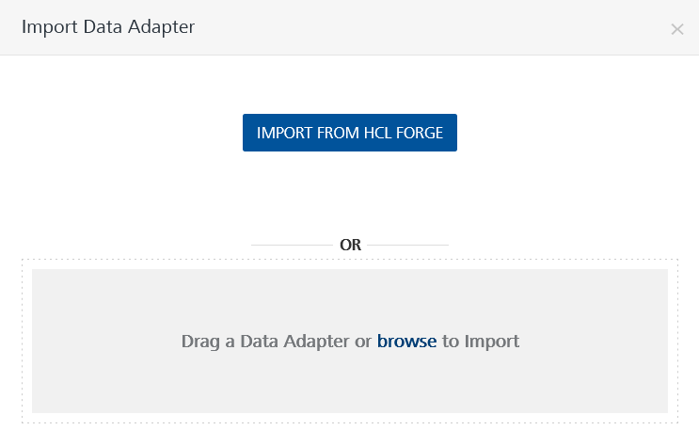
6. Select Jobs.zip file and click **IMPORT**.

After you import the data adapter, Volt Foundry opens a window that shows the metadata of the data adapter.

After you import the data adapter, you can view it on the Custom Data Adapters page and use it to create services on Volt Foundry.

## **[Creating an Integration service](javascript:void(0);)**

After you import the data adapter into Volt Foundry, you can use it to create an Integration Service.

Follow the given steps to create an Integration service using the jobs Adapter.

1. Sign in to the [HCL Foundry](https://manage.hclvoltmx.com/).
2. From the left navigation menu, select **API Management**.
3. In **API Management**, select **Integration**.  
   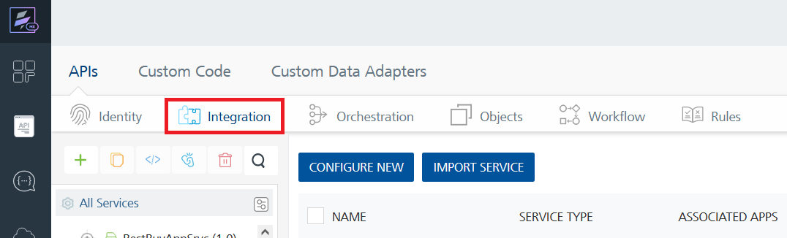
4. To create a new service, click the **+** button or the **CONFIGURE NEW** button.  
   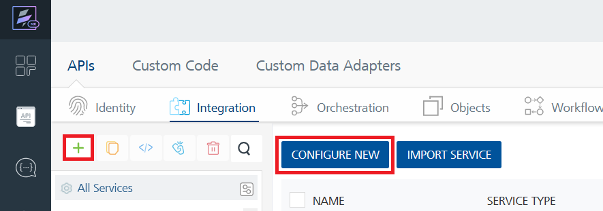
5. On the Service Definition tab, select the service type as jobs and click **SAVE**.

Alternatively, you can also create a Foundry app and create an Integration service inside it.

D. [**Creating and Executing operations**](javascript:void(0);)



After you create an integration service, you can create and execute operations using the service.

#### **Creating an Operation**

* In **API Management/Foundry app you created**, in the **Integration** section, select the service that you created.
* After you select the service, navigate to the **Operation List** tab.  
  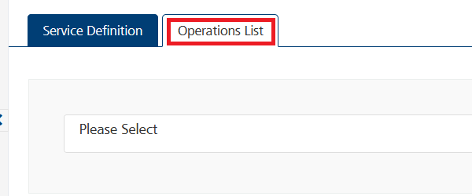
* From the drop down list, select an operation that you want to execute, and click **ADD OPERATION**.  
  A white rectangular object with a black border

  Description automatically generated

#### **Executing an Operation**

* From the **Operations List** tab, in the **Configured Operations** section, select the operation you want to execute.

* On the Operation Page, in the Request Input tab, enter a TEST VALUE for all the fields.

* Select a run-time environment and click **Save and Fetch Response** to get a response based on your inputs.

## [**Publishing your application**](javascript:void(0);)

If you want to use the services in client applications, you need to publish an app to a run-time environment. You can create the service (as described above) in an application or import the service into an application and publish the application.

# **References**

## Endpoint Documentation

# get job list

The API simplifies the job search process by offering an array of filter criteria in the URL parameters, to receive relevant results.

## The endpoint is available through this URL:

GET <https://jobs-api14.p.rapidapi.com/list>

## **Parameters**

When calling this endpoint, please refer to the following parameters.

|  |  |  |  |
| --- | --- | --- | --- |
| Parameter | Description | Types | Required |
| query | Keywords, Jobtitle, Company name or any other relevant search-query. | String | Yes |
| location | City, country, or any other locations. | String | Yes |
| distance | Distance to the location in kilometers | Number | No |
| language | Sets the language of the following return fields **(location, employmentType, datePosted and salaryRange)**, but does not filter by language. | String | No |
| remoteOnly | Filter by only remote job postings. | Boolean | No |
| datePosted | Only receive job postings that are newer than the date given, takes all job postings if not set.  **Allowed values** month, week, today, 3days | String | No |
| allowedJobProviders | Only receive job postings from specific job-providers. You can use multiple providers and separate them with semicolons (ziprecruiter;indeed;linkedin)  **Note:** It currently works only with bigger providers like indeed, linkedin, etc. | String | No |
| index | Index of the search, per request you will get a maximum of 10 jobs. If you have received a total of 10 jobs, you can increase the index by 1 to get the next results. | Number | No |
| employmentTypes | Only receive job postings with the specific employment types. You can use multiple types and separate them with semicolons (parttime;internship)  **Allowed values** contractor, fulltime, parttime, intern | String | No |

Refer to <https://rapidapi.com/Pat92/api/jobs-api14>

# **Revision History**

Adapter version 1.0.0:

## Known Issues

-

## Limitations -