Date : 06-Feb-2024

Input Prompt popup

version: 1.0.4

1. OVERVIEW

The Input Prompt Pop-up component is used when you need user's input before moving forward in app s flow. For example, you might want to capture user's comments about a task he / she just completed. Using this component, users can quickly set the input prompt message directly from the Iris.

Use case:
Consider a case that you want to develop an app for Milk tracker that helps users to track the Milk delivered daily. The App requests the user to provide inputs for various items such as Brand of Milk, Number of packets, Milk delivered (Yes or No) etc. Using the Input Prompt Pop-up component, you can achieve this feature in your app. To achieve the feature, do the following.
- Define an Input Prompt Pop Up component with Specific Input Prompt Message.
- Set the Input Placeholder Text as required with Characters Limit.
The following sections help you use the inputpromptpopup component in your app.

Features
- The Input Prompt Pop-up component is a ready-to-use component.
- You can import the component into your app (created in Volt MX Iris) and can achieve the features without developing it from scratch.
- The Input Prompt Pop-up component also facilitates a set of properties, events, and APIs that helps you customize the UI elements and functionality, if required.

Percentage of re-use
Approximate 80 % of reuse.

Getting Started

Prerequisites
Before you start using the Input Prompt Popup component, ensure the following:
• HCL Foundry
• Volt MX Iris

Platforms Supported
- Mobile
- iOS
- Android

- Tablet & iPad

- PWA & Responsive Web

Importing the app

You can import the Forge components only into the apps that are of the Reference Architecture type.

To import the Input Prompt Popup component, do the following:

Open your app project in Volt MX Iris.
2. In the Project Explorer, click the Templates tab.

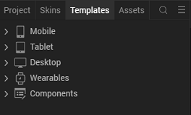

3. Right-click Components, and then select Import Component. The Import
Component dialog box appears.
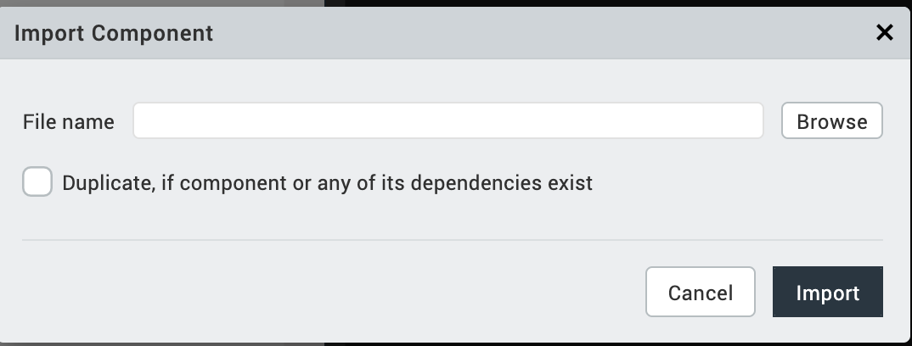
4. Click Browse to navigate to the location of the component, select the
component, and then click Import. The component and its associated widgets and
modules are added to your project.

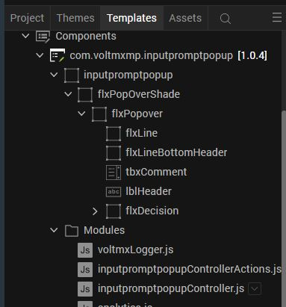
Once you have imported a component to your project, you can easily add the component to a form. For more information, refer Add a Component to a Form

Building and previewing the app
After performing all the above steps, you can build your app and run it on your device. For more information, you can refer to the Building and Viewing an Application section of the Volt MX User Guide.
You can then run your app to see the Input Prompt Popup work in real time.

References

Dynamic Usage
You can also add Input Prompt Popup component dynamically. To do so,
- In the Project Explorer, on the Projects tab, click Controllers section to access the respective Form Controller. Create a method and implement the code snippet similar to the sample code mentioned below.
/*Creating the component's object */
var inputpromptpopup = new com.voltmxmp.inputpromptpopup(

{

"clipBounds": true,
"height": "100%",
"id": "inputpromptpopup",

"isVisible": true,
"layoutType": voltmx.flex.FREE_FORM,
"left": "0dp",
"masterType": constants.MASTER_TYPE_USERWIDGET,
"skin": "slFbox",
"top": "0dp",
"width": "100%"

}, {}, {});

/*Setting the component's properties*/

inputpromptpopup.placeholderText = "Add comments (Max 70 chars)";

inputpromptpopup.leftButtonText = "Cancel";

inputpromptpopup.rightButtonText = "OK";

inputpromptpopup.messageText = "Your custom message here for the user seeking comment/input";

inputpromptpopup.maxTextLength = 70;
/* Adding the component to a Form */
this.view.add(inputpromptpopup);
},

In the code snippet, you can edit the properties of the component as per your requirement. For more information, see Setting Properties.
- Save the file.

Properties
The properties provided on the Component tab allows you to customize the elements in the Input Prompt Pop-up component. These elements can be UI elements, service parameters, and so on. You can set the properties from the Volt MX Iris Properties panel on the right-hand side. You can also configure these properties using a JavaScript code.

General Properties

1. Input Placeholder Text
Description: | Specifies the Placeholder text for comments.
Syntax: | placeholderText
Type: | String
Read/Write: | Read + Write
Example: | this. view. inputpromptpopup.placeholderText = "Add Comments";
Remarks: | The default value for the property is "Add Comments".

2. Left Button Text
Description: | Specifies the text for left button.
Syntax: | leftButtonText
Type: | String
Read/Write: | Read + Write
Example: | this. view. inputpromptpopup. leftButtonText = "No";
Remarks: | The default value for the property is “No”.

3. Right Button Text
Description: | Specifies the text for right button.
Syntax: | rightButtonText
Type: | String
Read/Write: | Read + Write
Example: | this. view. inputpromptpopup. rightButtonText = "No";
Remarks: | The default value for the property is “Yes”.

4. Message
Description: | Specifies the text for Display Message.
Syntax: | messageText
Type: | String
Read/Write: | Read + Write
Example: | this. view. inputpromptpopup. messageText = "Do you really want to reject this purchase Order” ;
Remarks: | The default value for the property is "Do you really want to reject this Purchase Order?".

5. Input Character Limit
Description: | Specifies the maximum length for input text in comment textbox.
Syntax: | maxTextlength
Type: | Number
Read/Write: | Read + Write
Example: | this. view. inputpromptpopup. maxTextlength = 5;
Remarks: | The default value for the property is "70".

Skins Section

6. Left Button Skin
Description: | This property enables the consumer to change the left button skin of the Input Prompt Pop Up component.
Syntax: | leftButtonSkin
Widget Type: | Button
Read/Write: | Read + Write
Example: | this. view. inputpromptpopup. leftButtonSkin = " voltmxmpip80s9btnSkin ";
Remarks: | Skin assigned to the property is accepted only by same widget type.

7. Right Button Skin
Description: | This property enables the consumer to change the right button skin of the Input Prompt Pop Up component.
Syntax: | rightButtonSkin
Widget Type: | Button
Read/Write: | Read + Write
Example: | this. view. inputpromptpopup. leftButtonSkin = " voltmxmpip80s9rightButtonSkin";
Remarks: | Skin assigned to the property is accepted only by same widget type.

8. Message Skin
Description: | This property enables the consumer to change the message skin of the Input Prompt Pop Up component.
Syntax: | messageSkin
Widget Type: | Label
Read/Write: | Read + Write
Example: | this. view. inputpromptpopup. leftButtonSkin = " voltmxmpip80s9headerSkin”;
Remarks: | Skin assigned to the property is accepted only by same widget type.

9. Background Overlay
Description: | This property enables the consumer to change the Background Overlay skin of the Input Prompt Pop Up component.
Syntax: | backgroundOverlaySkin
Widget Type: | FlexContainer
Read/Write: | Read + Write
Example: | this. view. inputpromptpopup. backgroundOverlaySkin = " voltmxmpip80s9backgroundShade ";
Remarks: | Skin assigned to the property is accepted only by same widget type.

10. Popover Flex Skin
Description: | This property enables the consumer to change the popover flex skin of the Input Prompt Pop Up component.
Syntax: | popoverSkin
Widget Type: | FlexContainer
Read/Write: | Read + Write
Example: | this. view. inputpromptpopup. popoverSkin = " voltmxmpip80s9popoverSkin ";
Remarks: | Skin assigned to the property is accepted only by same widget type.

11. Left Button Focus Skin
Description: | This property enables the consumer to change the left button s focus skin of the Input Prompt Pop Up component.
Syntax: | leftButtonFocusSkin
Widget Type: | Button
Read/Write: | Read + Write
Example: | this. view. inputpromptpopup. leftButtonFocusSkin = " voltmxmpip80s9leftButtonSkin";
Remarks: | Skin assigned to the property is accepted only by same widget type.

12. Right Button Focus Skin
Description: | This property enables the consumer to change the right button s focus skin of the Input Prompt Pop Up component.
Syntax: | rightButtonFocusSkin
Widget Type: | Button
Read/Write: | Read + Write
Example: | this. view. inputpromptpopup. rightButtonFocusSkin = " voltmxmpip80s9btnSkin";
Remarks: | Skin assigned to the property is accepted only by same widget type.

13. Input Box Skin
Description: | This property enables the consumer to change the input box skin of the Input Prompt Pop Up component.
Syntax: | inputBoxSkin
Widget Type: | TextBox
Read/Write: | Read + Write
Example: | this. view. inputpromptpopup. inputBoxSkin = " voltmxmpip80s9commentSkin";
Remarks: | Skin assigned to the property is accepted only by same widget type.

C. API’s
1. validateAndSetSkin
Description: | The API can be invoked at the form level if required.
Syntax: | validateAndSetSkin ()
Parameters: | None
Return Value: | None
Example: | this. view. inputpromptpopup. validateAndSetSkin ();

D. Events

1. onLeftButtonClick
Description: | This event is invoked when the user-touch is released from the left button on the Input Prompt Pop Up.
Syntax: | onLeftButtonClick (eventobject)
Type: | String
Read/Write: | Read + Write
Example | this.view.inputpromptpopup.onLeftButtonClick= function(eventobject){  alert(eventobject.comment);  };
Params | eventobject - JsonObject

2. onRightButtonClick
Description: | This event is invoked when the user-touch is released from the right button on the Input Prompt Pop Up.
Syntax: | onRightButtonClick (eventobject)
Type: | String
Read/Write: | Read + Write
Example | this.view.inputpromptpopup. onRightButtonClick = function(eventobject){  alert(eventobject.comment);  };
Params | eventobject - JsonObject

4. Revision History
App version 1.0.4

