24 Sep 2021

INFO CARDS (1.0.1)
- Overview
Info cards let you display basic details and past historical values for any entry in the database.

Use case

During Inspections/ workorders, technicians/engineers need to view past values for each measurement point.

Features:

Info cards display past values in simple horizontal scrollable thumbnail format, hence easing the navigation across the performance records.

Percentage of re-use:
Approximate % of reuse. It sets an expectation of how much can be used out of the box, and how much needs to be customized for a specific app.

Getting Started

Prerequisites
Before you start using the Info Cards component, ensure the following:
• HCL Foundry
• Volt MX Iris

Platforms Supported

Mobile

iOS

Android

Tablets

PWA

Importing the Component

You can import the Forge components only into the apps that are of the Reference Architecture type.

To import the Info Cards component, do the following:

Open your app project in Volt MX Iris.
2. In the Project Explorer, click the Templates tab.

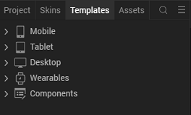
3.Right-click Components, and then select Import Component. The Import Component dialog box appears.
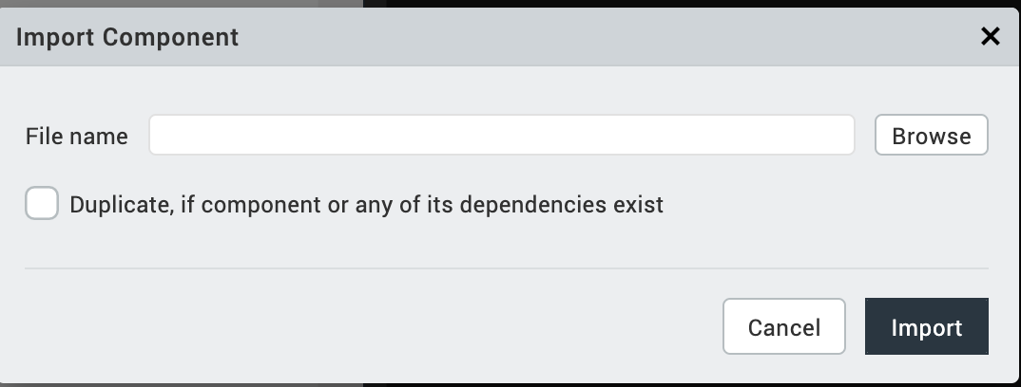
4.Click Browse to navigate to the location of the component, select the component, and then click Import. The component and its associated widgets and modules are added to your project.

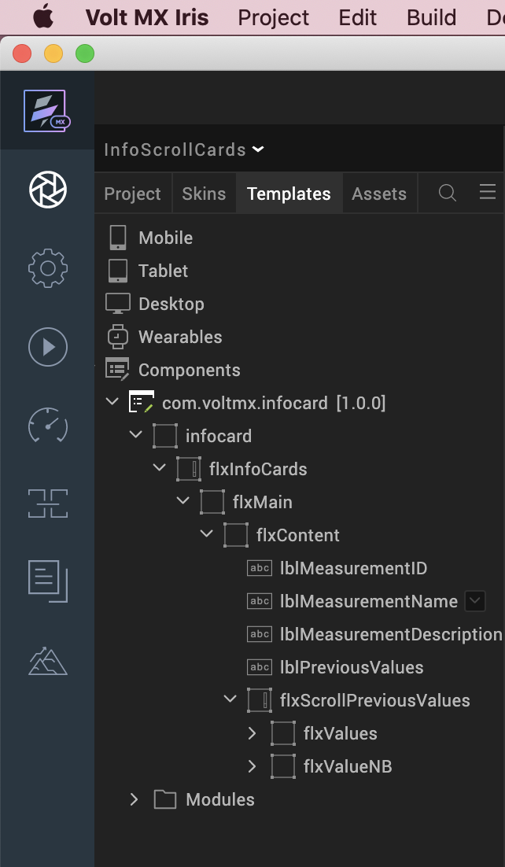
Once you have imported a component to your project, you can easily add the component to a form. For more information, refer Add a Component to a Form

Building and previewing the app
After performing all the above steps, you can build your app and run it on your device. For more information, you can refer to the Building and Viewing an Application section of the Volt MX User Guide.
You can then run your app to see the Info Cards work in real time.

References

Dynamic Usage
You can also add Info Cards component dynamically. To do so,
- In the Project Explorer, on the Projects tab, click Controllers section to access the respective Form Controller. Create a method and implement the code snippet similar to the sample code mentioned below.
/* Creating InfoCard component instance */

var infoCard= new com.voltmx.infocard(
{
id: "infocard",
isVisible: true,
height: "100%",
top: "0dp",
left: "0dp",
width: "100%",
layoutType: voltmx.flex.FREE_FORM,
autogrowMode: voltmx.flex.AUTOGROW_NONE,
skin: "voltmxqfsSknInfoCard",
clipBounds:true,
zIndex:1
}, {}, {});

/*Setting the component's properties*/

infoCard.cardTitle ="#amb557766";
infoCard.cardName = "Ambient Temperature";
infoCard.cardDescription = "Lorem Ipsum has been the industry's standard dummy text ever since the 1500s, when an unknown printer took a galley of type and scrambled it to make a type specimen book.
infoCard.recordSectionLabel = "Previous Value";
infoCard.hasValues = true;

/*Adding the Info Card component to a Form*/

this.view.add(infoCard);

/*Calling APIs from code */

/* Sample data object*/

data=[{time:"7:00 PM",

date: "19th Jun 2021",

value: "Validating the product",

responseType:"Null"

},{time:"8:00 PM",

date: "20th Jun 2021",

value: "Testing",

responseType:"Null"

}];

this.view.infocard.initialize(data);
In the code snippet, you can edit the properties of the component as per your requirement. For more information, see Setting Properties.
2. Save the file

Properties
The properties provided on the Component tab allows you to customize the elements in the Info Card component. These elements can be UI elements, service parameters, and so on. You can set the properties from the Volt MX Iris Properties panel on the right-hand side. You can also configure these properties using a JavaScript code.
General Properties
1. Card Title (cardTitle)
Description: | Specifies the title for the card.
Syntax: | cardTitle
Type: | String
Read/Write: | Read + Write
Example: | this. view. infocard.cardTitle= "#amb557766";
Remarks: | The default value for the property is “#amb557766”.

- Card Name(cardName)
Description: | Specifies the name of the card.
Syntax: | cardName
Type: | String
Read/Write: | Read + Write
Example: | this. view. infocard.cardName= "Ambient Temperature";
Remarks: | The default value for the property is “Ambient Temperature”.

3. Card Description(cardDescription)
Description: | Specifies the description of the card.
Syntax: | cardDescription
Type: | String
Read/Write: | Read + Write
Example: | this. view. infocard.cardDescription= "Lorem Ipsum has been the industry's standard dummy text ever since the 1500s, when an unknown printer took a galley of type and scrambled it to make a type specimen book.";
Remarks: | The default value for the property is "Lorem Ipsum has been the industry's standard dummy text ever since the 1500s, when an unknown printer took a galley of type and scrambled it to make a type specimen book.".

4.Record Section Label(recordSectionLabel)
Description: | Specifies the label value of the card.
Syntax: | recordSectionLabel
Type: | String
Read/Write: | Read + Write
Example: | this. view. infocard. recordSectionLabel = "Previous Values";
Remarks: | The default value for the property is "Previous Values".

5. Enable Scrolling(enableScrolling)
Description: | Specifies scroll bars are needed or not for main flex.
Syntax: | enableScrolling
Type: | Boolean
Read/Write: | Read + Write
Example: | this. view. infocard. enableScrolling = true;
Remarks: | The default value for the property is true.

6. Contains Values(hasValues)
Description: | Specifies if the values (date , time …) to be displayed on the card should be visible or not.
Syntax: | hasValues
Type: | Boolean
Read/Write: | Read + Write
Example: | this. view. infoCard.hasValues= true;
Remarks: | The default value for the property is true.

7. Record Values (recordValues)
Description: | Specifies the list of record values that you want to add.
Syntax: | recordValues
Type: | Datagrid, Array of JSON
Read/Write: | Read + Write
Example: | this. view. infoCard.recordValues= [{  time:"7:00 PM",  date: "19th Jun 2021",  value: "Validating the product",  responseType:"Null"  },  {  time:"8:00 PM",  date: "20th Jun 2021",  value: "Testing",  responseType:"Null"  }];
Remarks: | This property does not reflect on the preview canvas of Voltmx Iris.

Skins Section
8. InfoCard Skin(infoCardSkin)
Description: | Specifies the skin of the infocard flex.
Syntax: | infoCardSkin
Type: | String
Read/Write: | Read + Write
Example: | this. view. infocard. infoCardSkin= “voltmxqfsSknInfoCard”;
Remarks: | The default value for the property is “voltmxqfsSknInfoCard”.

9. MainFlex Skin (flxMainSkin)
Description: | Specifies the skin of the main flex.
Syntax: | flxMainSkin
Type: | String
Read/Write: | Read + Write
Example: | this. view. infocard. flxMainSkin= “voltmxqfsSknFlxMain”;
Remarks: | The default value for the property is “voltmxqfsSknFlxMain”.

10. MeasurementID Skin (mesaurementIdSkin)
Description: | Specifies the skin of the measurementID label.
Syntax: | mesaurementIdSkin
Type: | String
Read/Write: | Read + Write
Example: | this. view. infocard. mesaurementIdSkin = “voltmxqfsSknLblMeasurementID”;
Remarks: | The default value for the property is “voltmxqfsSknLblMeasurementID”.

11. MeasurementName Skin (measurementNameSkin)
Description: | Specifies the skin of the measurementName label.
Syntax: | measurementNameSkin
Type: | String
Read/Write: | Read + Write
Example: | this. view. infocard. infoCardSkin= “voltmxqfsSknLblMeasurementID”;
Remarks: | The default value for the property is “voltmxqfsSknLblMeasurementID”.

12. MeasurementDesc Skin (measurementDescSkin)
Description: | Specifies the skin of the measurementDesc label.
Syntax: | measurementDescSkin
Type: | String
Read/Write: | Read + Write
Example: | this. view. infocard. measurementDescSkin = “voltmxqfsSknLblMeasurementDescription”;
Remarks: | The default value for the property is “voltmxqfsSknLblMeasurementDescription”.

13. PreviousValues Skin (previousValuesSkin)
Description: | Specifies the skin of the previousValues label.
Syntax: | previousValuesSkin
Type: | String
Read/Write: | Read + Write
Example: | this. view. infocard. previousValuesSkin = “voltmxqfsSknLblMeasurementID”;
Remarks: | The default value for the property is “voltmxqfsSknLblMeasurementID”.

14. Flex Values (flxValuesSkin)
Description: | Specifies the skin of the Flex Values flexes.
Syntax: | flxValuesSkin
Type: | String
Read/Write: | Read + Write
Example: | this. view. infocard. flxValuesSkin= “voltmxqfsSknFlxValues”;
Remarks: | The default value for the property is “voltmxqfsSknFlxValues”.

15. Label Values (lblValuesSkin)
Description: | Specifies the skin of the Label Values.
Syntax: | lblValuesSkin
Type: | String
Read/Write: | Read + Write
Example: | this. view. infocard. lblValuesSkin= “voltmxqfsSknLblValuesNB”;
Remarks: | The default value for the property is “voltmxqfsSknLblValuesNB”.

16. Label Date Time (lblDateTimeSkin)
Description: | Specifies the skin of the Datetime label.
Syntax: | previousValuesSkin
Type: | String
Read/Write: | Read + Write
Example: | this. view. infocard. lblDateTimeSkin = “voltmxqfsSknLblDate”;
Remarks: | The default value for the property is “voltmxqfsSknLblDate”.

API’s

initialize
Description: | This method is used to create records for the component
Syntax: | initialize(data)
Parameters: | Data (type-json) [Optional]
Return Value: | None
Example: | this. view. infocard. initialize (data);
Remarks: | Keys in the json should always be same.

Revision History
App version 1.0.1:

Limitations
1.Landscape mode is not supported in all channels.
2. If browser height is minimized then UI gets distorted.

