05 June 2023

IN APP NOTIFICATION(1.0.0)

# Overview

Use this component to periodically check a data object for any updated data. If new data is discovered then display a message to the user which will be removed the next time the component checks for new changes.

## Use case

### To check and inform the user of backend data changes periodically. Use where device push notifications are not available.

## Percentage of re-use:

Approximately 95% reusable.

## Features.

Configure how often it is run.

Configure what service to check and the fields that will be used by the check.

Display the updated message to the user.

Message will automatically be removed when the check occurs again.

# Getting Started

## Prerequisites

Before you start using the In App Notification component, ensure the following:

• [HCL Foundry](https://manage.hclvoltmx.com/)

• Volt MX Iris

## Platforms Supported

### PWA & Responsive Web

### Native

## Importing the app

You can import the Forge components only into the apps that are of the Reference Architecture type.

**To import the InAppNotification component, do the following:**

#### Open your app project in Volt MX Iris..

#### In the Project Explorer, click the **Templates** tab.

#### Right-click **Components**, and then select **Import Component**. The **Import Component** dialog box appears.

#### Click **Browse** to navigate to the location of the component, select the component, and then click **Import**. The component and its associated widgets and modules are added to your project.

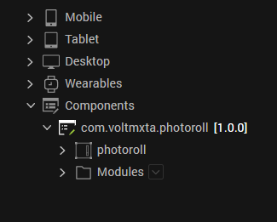

Once you have imported a component to your project, you can easily add the component to a form. For more information, refer [Add a Component to a Form](https://opensource.hcltechsw.com/volt-mx-docs/docs/documentation/Iris/iris_user_guide/Content/C_UsingComponents.html" \l "add-a-component-to-a-form)

## Building and previewing the app

After performing all the above steps, you can build your app and run .For more information, you can refer to the [Building and Viewing an Application](https://opensource.hcltechsw.com/volt-mx-docs/docs/documentation/Iris/iris_user_guide/Content/Cloud_Build_in_VoltMX_Iris.html#cloud) section of the Volt MX User Guide.

You can then run your app to see the PhotoRoll work in real time

# Configure the component

# The Component lets you configure what data object you are checking. You must specify the Object service name and the object. Then you need to specify the objects key field, the field which has the message we will be displaying to the user and a Boolean field so we can update the object that the message has been displayed to the user.

# Finally, there is an iteration field which allows you to set in seconds, how often the back end data source is checked. This same iteration value will determine how long the user message is displayed on the app.

# Revision History

App version 1.0.1:

## Known Issues

NA

## Limitations

NA