Date :  18-Oct-23

IMDB Search ADAPTER (1.0.0)

# Overview

This Foundry adapter uses the Open Movie Database APIs to return information about Movie and TV / Web Shows.

*Disclaimer: This adapter is built on using the OMDB APIs hosted by http://omdbapi.com. Any future change in how the APIs function may break the adapter and author of this adapter is not responsible for that.*

*OMDB Terms of Service:* [*https://www.omdbapi.com/apikey.aspx*](https://www.omdbapi.com/apikey.aspx)

*OMDB License:* [*https://creativecommons.org/licenses/by-nc/4.0/*](https://creativecommons.org/licenses/by-nc/4.0/)

# Getting Started

## Prerequisites

1. Volt Foundry
2. OMDB API key

## Account Registration and API Subscription process

### This API requires authorization, you can get a free key here: <https://www.omdbapi.com/apikey.aspx>

## Importing the adapter

**To import the Data Adapter to Volt Foundry, do the following:**

1. Sign in to the  [HCL Foundry](https://manage.demo-hclvoltmx.com/).
2. From the left navigation menu, select **API Management**.
3. In **API Management**, select **Custom Data Adapters**.  
   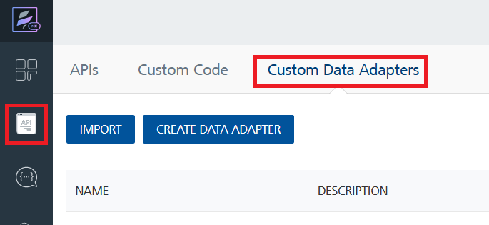
4. Click **IMPORT** to import a custom data adapter.  
   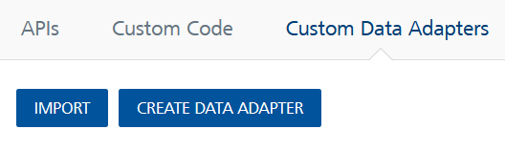
5. On the Import Data Adapter dialog box, click browser to import.  
   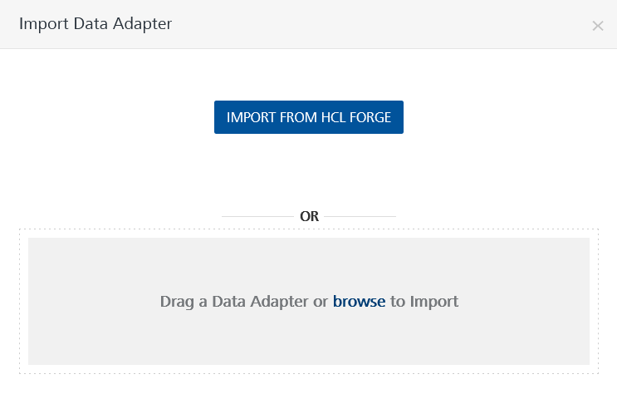
6. Select **IMDBSearch.zip** file and click **IMPORT**.

After you import the data adapter, Volt Foundry opens a window that shows the metadata of the data adapter.

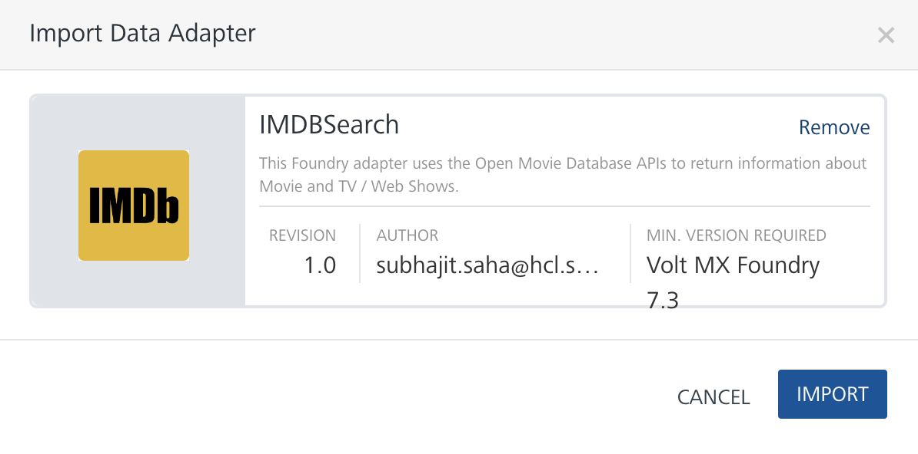

After you import the data adapter, you can view it on the Custom Data Adapters page and use it to create services on Volt Foundry.

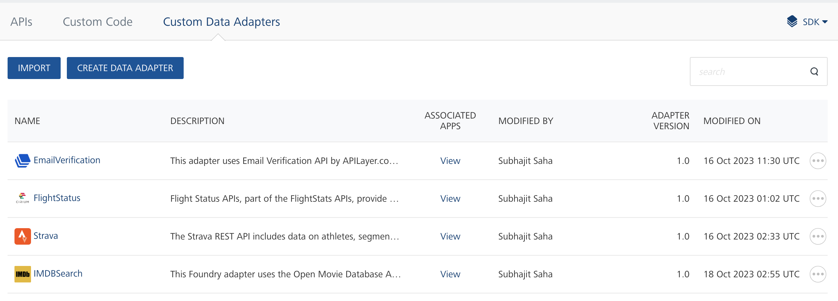

## [Creating an Integration service](javascript:void(0);)

After you import the data adapter into Volt Foundry, you can use it to create an Integration Service.

Follow the given steps to create an Integration service using the **IMDBSearch** Adapter.

1. Sign in to the [HCL Foundry](https://manage.hclvoltmx.com/).
2. From the left navigation menu, select **API Management**.
3. In **API Management**, select **Integration**.  
   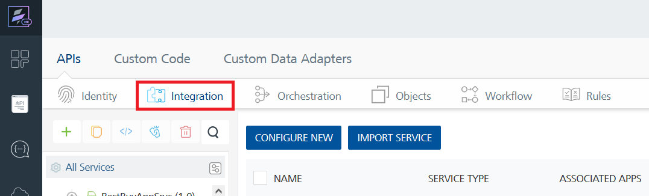
4. To create a new service, click the **+** button or the **CONFIGURE NEW** button.  
   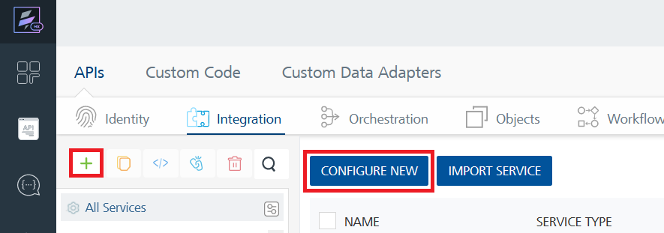
5. On the Service Definition tab, select the service type as **IMDBSearch** and click **SAVE**.  
   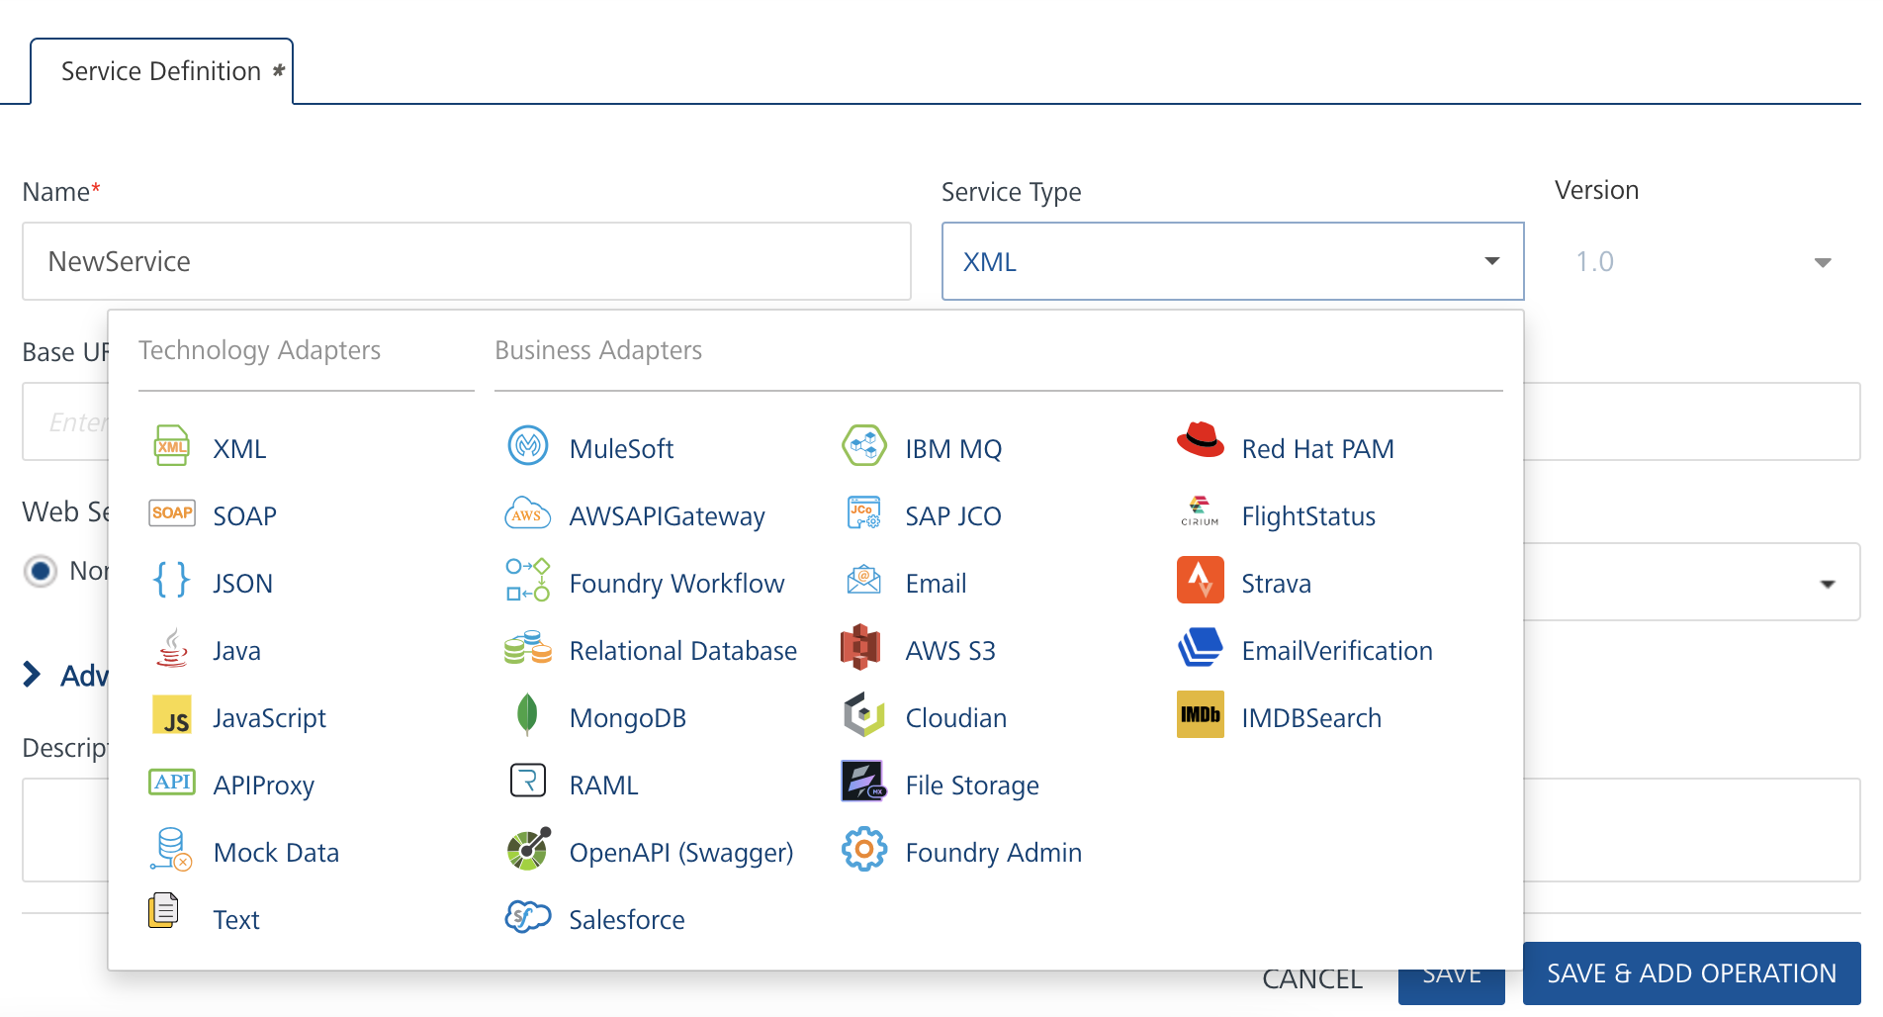

Alternatively, you can also create a Foundry app and create an Integration service inside it.

E. [Creating and Executing operations](javascript:void(0);)



After you create an integration service, you can create and execute operations using the service.

#### Creating an Operation

* In **API Management/Foundry app you created**, in the **Integration** section, select the service that you created.
* After you select the service, navigate to the **Operation List** tab.  
  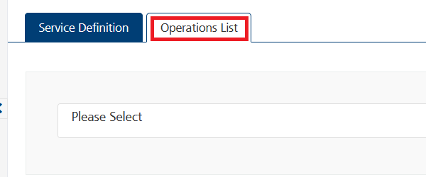
* From the drop-down list, select an operation that you want to execute, and click **ADD OPERATION**.  
  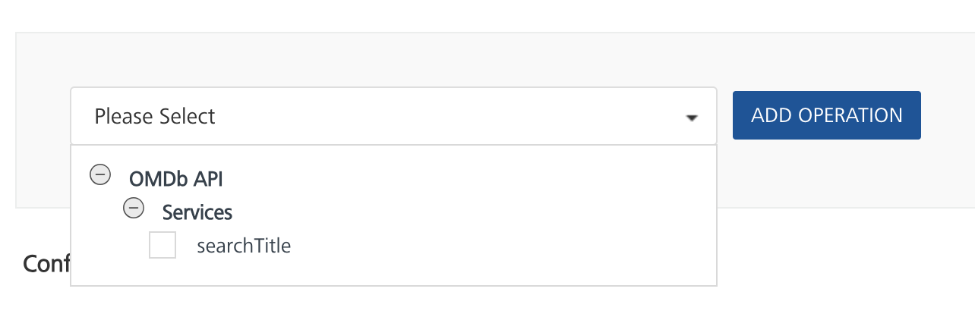

#### Executing an Operation

* From the **Operations List** tab, in the **Configured Operations** section, select the operation you want to execute.  
  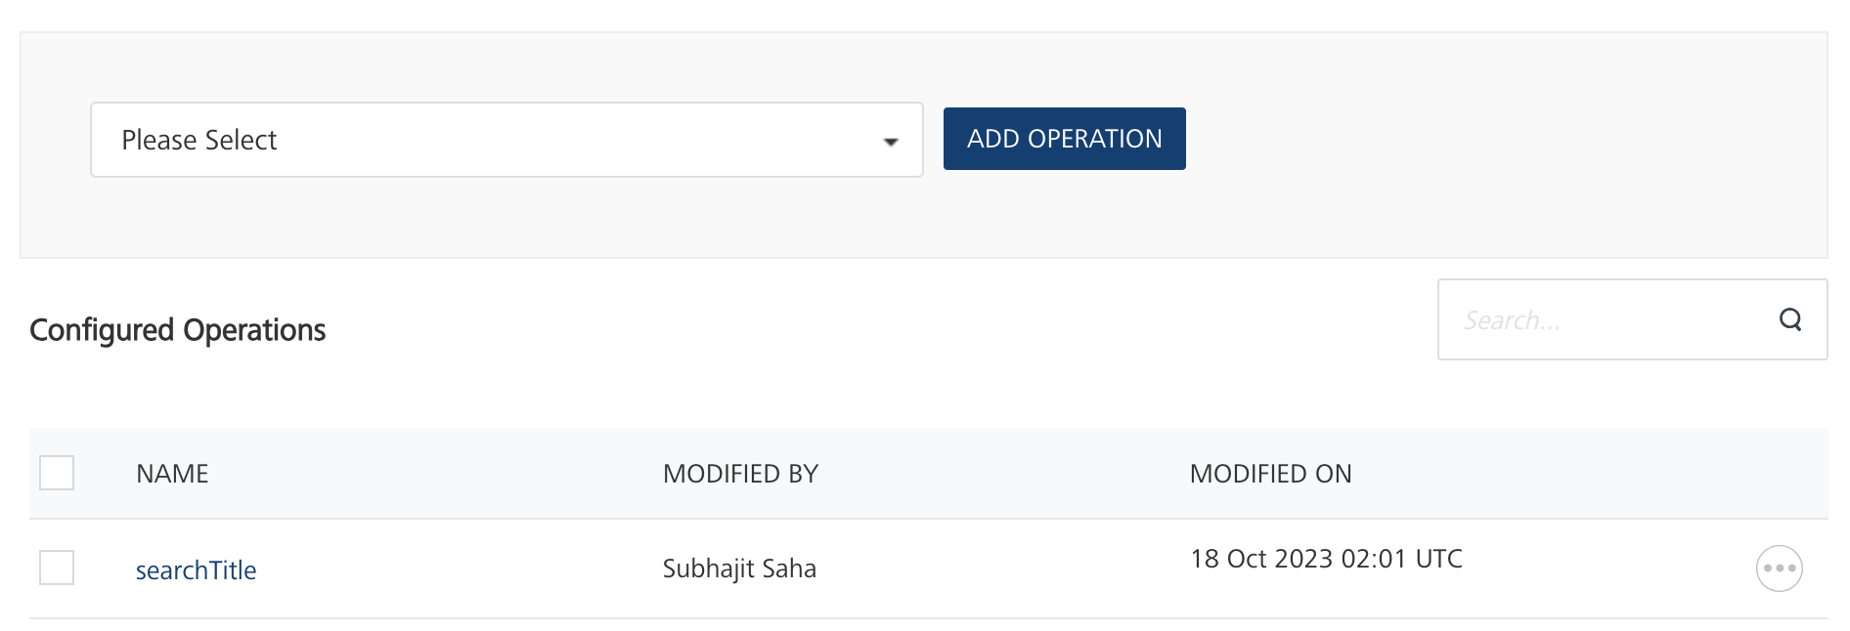On the Operation Page, in the Request Input tab, enter a TEST VALUE for the fields under Body as detailed in Reference section.

* Select a run-time environment and click **Save and Fetch Response** to get a response based on your inputs.  
  A blue rectangle with a black arrow

  Description automatically generated

## [Publishing your application](javascript:void(0);)

If you want to use the services in client applications, you need to publish an app to a run-time environment. You can create the service (as described above) in an application or import the service into an application and publish the application.

# References

## Request Parameters:

|  |  |  |  |  |
| --- | --- | --- | --- | --- |
| Parameter | Required | Valid Options | Default Value | Description |
| i | yes* |  | <empty> | A valid IMDb ID (e.g., tt1285016). Returns a single result based on the ID provided |
| t | yes* |  | <empty> | Movie or Show title to search for. Returns the most popular match for a given title |
| s | yes* |  | <empty> | Movie or Show title to search for. Returns an array of results for a given title |
| type | No | movie, series, episode | <empty> | Type of result to return. |
| y | No |  | <empty> | Year of release. |
| plot | No | short, full | short | Return short or full plot. Can be used only with “i” or “t”. |
| page | No | 1-100 | 1 | Page number to return. Can be used only with “s” |

## *\*Please note that at least “s” or "i" or "t" are required.*

# Revision History

|  |  |  |  |
| --- | --- | --- | --- |
| Version | Date Uploaded | Uploaded By | Known Issues |
| 1.0.0 | 18-Oct-23 | Subhajit Saha (HCL Software) | - |