Date :  23-02-2024

imdb top 100 movies

version:1.0.0

# **Overview**

Top 100 Greatest Movies and Series of All Time based on IMDb. Frequent Updates to The Movie List and Series List. Easy to use. Includes .The top 100 moves ever made, according to IMDb ratings. It is very easy to use. The API response includes, among others, the titles of the movies, their descriptions, cover images, and YouTube links to their trailers.

# **Getting Started**

## **Prerequisites**

* Volt Foundry
* Api key from <https://rapidapi.com/rapihub-rapihub-default/api/imdb-top-100-movies>

Note:Provide this Api-Key in header part.

## **Importing the adapter**

**To import the Data Adapter to Volt Foundry, do the following:**

1. Sign in to the  [HCL Foundry](https://manage.hclvoltmx.com/).
2. From the left navigation menu, select **API Management**.
3. In **API Management**, select **Custom Data Adapters**.  
   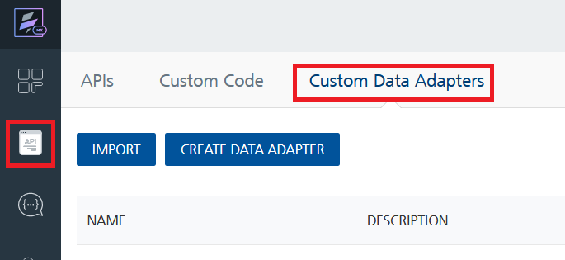
4. Click **IMPORT** to import a custom data adapter.  
   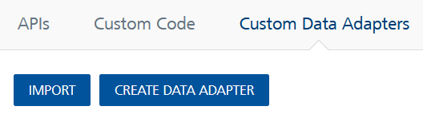
5. On the Import Data Adapter dialog box, click browser to import.  
   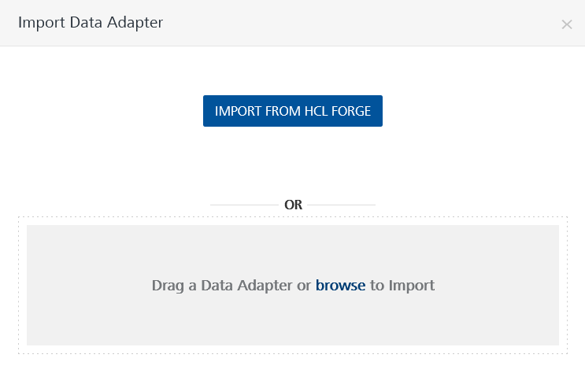
6. Select IMDB.zip file and click **IMPORT**.

After you import the data adapter, Volt Foundry opens a window that shows the metadata of the data adapter.

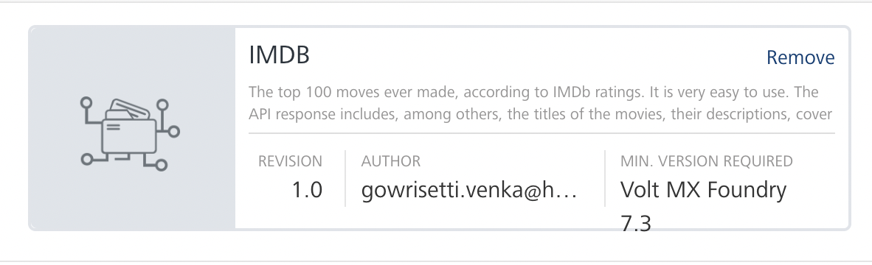

After you import the data adapter, you can view it on the Custom Data Adapters page and use it to create services on Volt Foundry.

## **[Creating an Integration service](javascript:void(0);)**

After you import the data adapter into Volt Foundry, you can use it to create an Integration Service.

Follow the given steps to create an Integration service using the IMDB 100 movies Adapter.

1. Sign in to the [HCL Foundry](https://manage.hclvoltmx.com/).
2. From the left navigation menu, select **API Management**.
3. In **API Management**, select **Integration**.  
   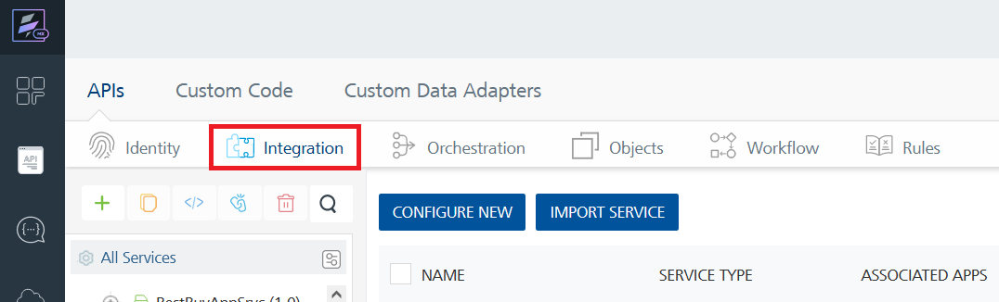
4. To create a new service, click the **+** button or the **CONFIGURE NEW** button.  
   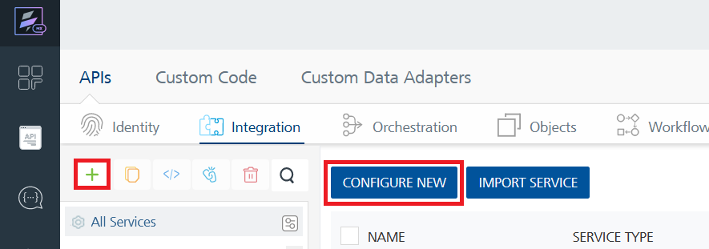
5. On the Service Definition tab, select the service type as Zipopotam and click **SAVE**.

Alternatively, you can also create a Foundry app and create an Integration service inside it.

**D.** [**Creating and Executing operations**](javascript:void(0);)



After you create an integration service, you can create and execute operations using the service.

### **Creating an Operation**

* In **API Management/Foundry app you created**, in the **Integration** section, select the service that you created.
* After you select the service, navigate to the **Operation List** tab.  
  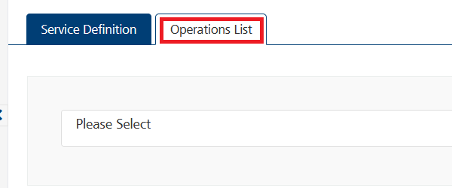
* From the drop down list, select an operation that you want to execute, and click **ADD OPERATION**.

#### **Executing an Operation**

**a)get Top 100 movies**

* From the **Operations List** tab, in the **Configured Operations** section, select the operation you want to execute.

* On the Operation Page, in the Request header tab , enter a TEST VALUE for all the fields.No input fields required.

* Select a run-time environment and click **Save and Fetch Response** to get a response based on your inputs.

**b)get movie by id**

* From the **Operations List** tab, in the **Configured Operations** section, select the operation you want to execute.

* On the Operation Page, in the Request Input tab, enter a TEST VALUE for all the fields.

* Select a run-time environment and click **Save and Fetch Response** to get a response based on your inputs.

**c)get Top 100 series**

* From the **Operations List** tab, in the **Configured Operations** section, select the operation you want to execute.

* On the Operation Page, in the Request header tab , enter a TEST VALUE for all the fields.No input fields required.

* Select a run-time environment and click **Save and Fetch Response** to get a response based on your inputs.  
  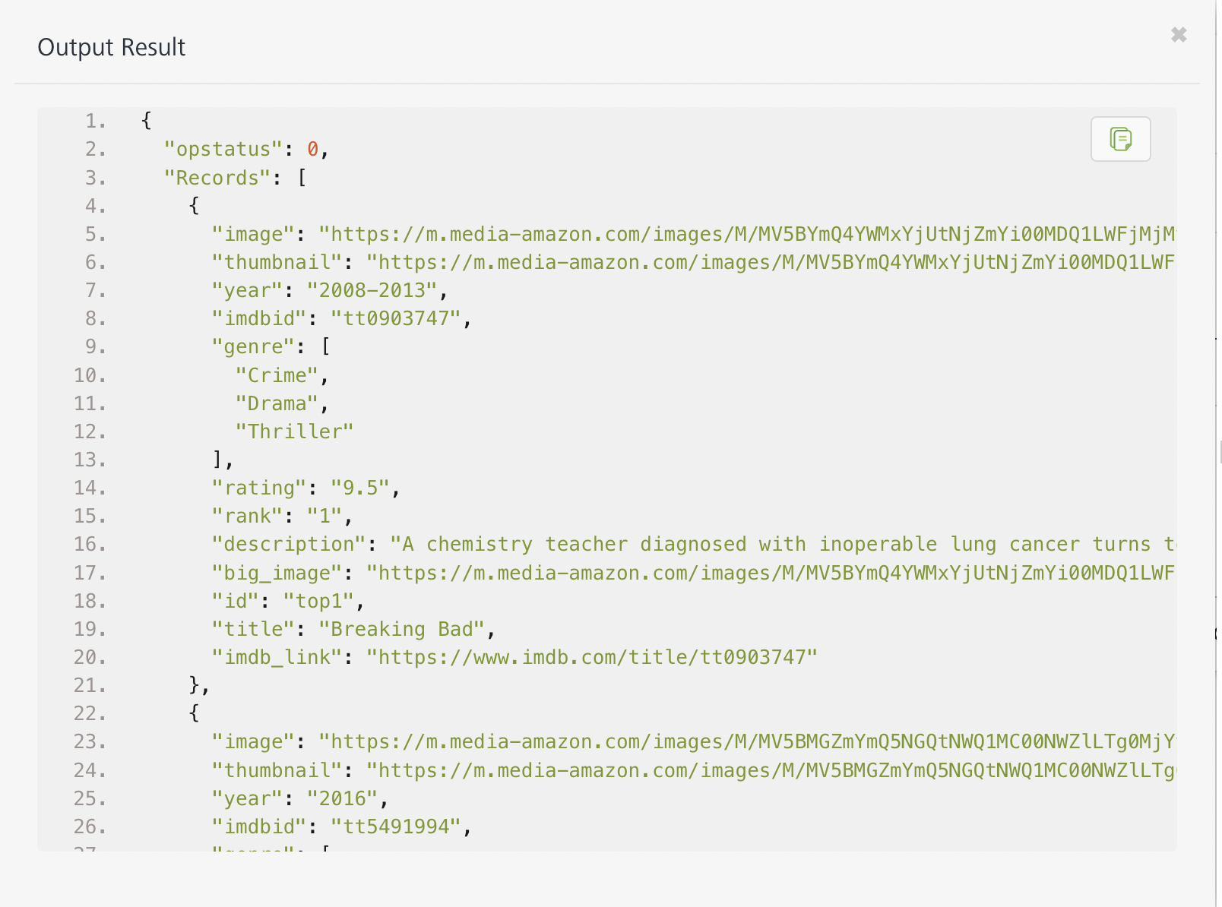

**b)get series by id**

* From the **Operations List** tab, in the **Configured Operations** section, select the operation you want to execute.

* On the Operation Page, in the Request Input tab, enter a TEST VALUE for all the fields.

* Select a run-time environment and click **Save and Fetch Response** to get a response based on your inputs.

## [**Publishing your application**](javascript:void(0);)

If you want to use the services in client applications, you need to publish an app to a run-time environment. You can create the service (as described above) in an application or import the service into an application and publish the application.

# **References**

## **Endpoint Documentation**

# **Get Top 100 movies**

## This endpoint enables users to get top IMDB 100 movies.

## The endpoint is available through this URL:

https://imdb-top-100-movies.p.rapidapi.com/

## **Parameters**

When calling this endpoint, please refer to the following parameters.

|  |  |  |  |
| --- | --- | --- | --- |
| **Parameter** | **Description** | **Types** | **Required** |
| X-Rapiapi-key(IN HEADER) | API key | String | Yes |

# **Get INFO of movie by id**

## This endpoint enables users to get info of movie by Id.

## The endpoint is available through this URL:

https://imdb-top-100-movies.p.rapidapi.com/{id}

## **Parameters**

When calling this endpoint, please refer to the following parameters.

|  |  |  |  |  |
| --- | --- | --- | --- | --- |
| **Parameter** | **Description** | **Types** | **Required** | **Default value** |
| Id | Id of movie | String | Yes | top10 |

# **Get Top 100 Series**

## This endpoint enables users to get top IMDB 100 series.

## The endpoint is available through this URL:

https://imdb-top-100-movies.p.rapidapi.com/series/

## **Parameters**

When calling this endpoint, please refer to the following parameters.

|  |  |  |  |
| --- | --- | --- | --- |
| **Parameter** | **Description** | **Types** | **Required** |
| X-Rapiapi-key(IN HEADER) | API key | String | Yes |

# **Get INFO of series by id**

## This endpoint enables users to get info of series by Id.

## The endpoint is available through this URL:

https://imdb-top-100-movies.p.rapidapi.com/series/{id}

## **Parameters**

When calling this endpoint, please refer to the following parameters.

|  |  |  |  |  |
| --- | --- | --- | --- | --- |
| **Parameter** | **Description** | **Types** | **Required** | **Default value** |
| Id | Id of series | String | Yes | top10 |

# Revision History

Adapter version 1.0.0:

## Known Issues

-

## Limitations

-It provides only INFO for only up to TOP IMDB 100 movies and series.