4 Oct 2023

Image Zoom component(1.0.0)

Overview
The Image Zoom component provides image zooming functionality. It takes remote URL as an input and caters pinch zoom in/out and double tap zoom in/out features.

Use case
1. a Photo viewing app requires to provide the Zoom in/out functionality to see the images into more details.
2. In E commerce apps, to view the product image to minute details this component helps in zoom in/out the image.
B .Percentage of re-use:
Approximate 90% of reuse. It sets an expectation of how much can be used out of the box, and how much needs to be customized for a specific app.

C. Features

- The component does not use any third party library, it is purely written in native.
- Uses NFI 3.0

2. Getting Started

A. Prerequisites
Before you start using the Image Zoom component, ensure the following:
• Volt MX Iris

Platforms Supported

Mobile

iOS

Android

Tablets

Importing the app

You can import the Forge components only into the apps that are of the Reference Architecture type.

To import the Image Zoom component, do the following:

Open your app project in Volt MX Iris.
2. In the Project Explorer, click the Templates tab.
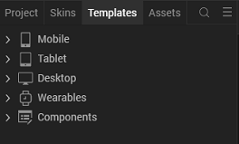
3.Right-click Components, and then select Import Component. The Import Component dialog box appears.
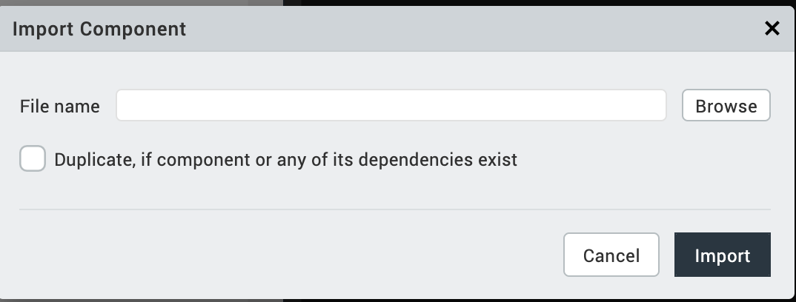
4.Click Browse to navigate to the location of the component, select the component, and then click Import. The component and its associated widgets and modules are added to your project.

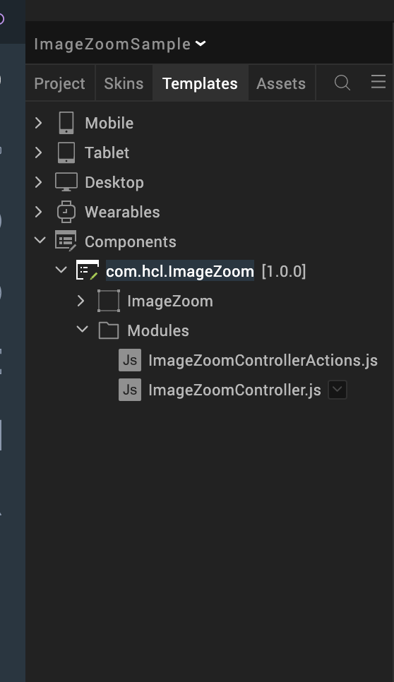

Once you have imported a component to your project, you can easily add the component to a form. For more information, refer Add a Component to a Form

Building and previewing the app
After performing all the above steps, you can build your app and run it on your device. For more information, you can refer to the Building and Viewing an Application section of the Volt MX User Guide.
You can then run your app to see the Image Zoom work in real time.

3. References

Dynamic Usage
You can also add Image Zoom component dynamically. To do so,

1. In the Project Explorer, on the Projects tab, click Controllers section to access the respective Form Controller. Create a method and implement the code snippet similar to the sample code mentioned below.

/* Creating Image Zoom component instance */

var ImageZoom = new com.hcl.ImageZoom ({
"height": "100%",
"id": "Image Zoom",
"isVisible": true,
"left": "0dp",
"masterType": constants.MASTER_TYPE_USERWIDGET,
"isModalContainer": false,
"skin": "slFbox",
"top": "0dp",
"width": "100%",
"zIndex": 1,
"overrides": {
"ImageZoom": {
"right": "viz.val_cleared",
"bottom": "viz.val_cleared",
"minWidth": "viz.val_cleared",
"minHeight": "viz.val_cleared",
"maxWidth": "viz.val_cleared",
"maxHeight": "viz.val_cleared",
"centerX": "viz.val_cleared",
"centerY": "viz.val_cleared"
}
}
}, {
"overrides": {}
}, {
"overrides": {}
});

/*Adding the Image Zoom component to a Form*/

this.view.add(ImageZoom);

In the code snippet, you can edit the properties of the component as per your requirement. For more information, see Setting Properties.
2. Save the file

4.Configuring Deployment Target - iOS
- From the left navigation menu, click Project Settings.
- In the Project Settings window, go to Native → iPhone/iPad.
- Under Target Versions, from the iOS Version list, select 11.0 or higher.

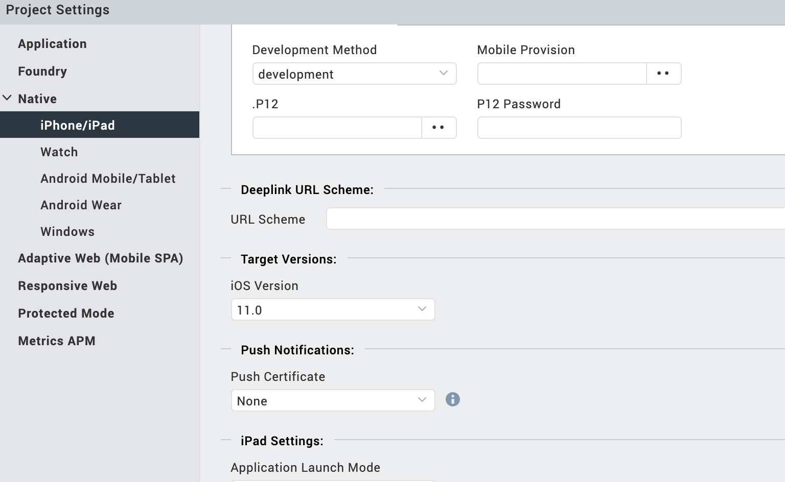

Configuring Deployment Target - Android

- From the left navigation menu, click Project Settings.
- In the Project Settings window, go to Native → Android Mobile/Tablet.
- Under SDK Versions, from the Minimum SDK list, select 21.0 or higher.

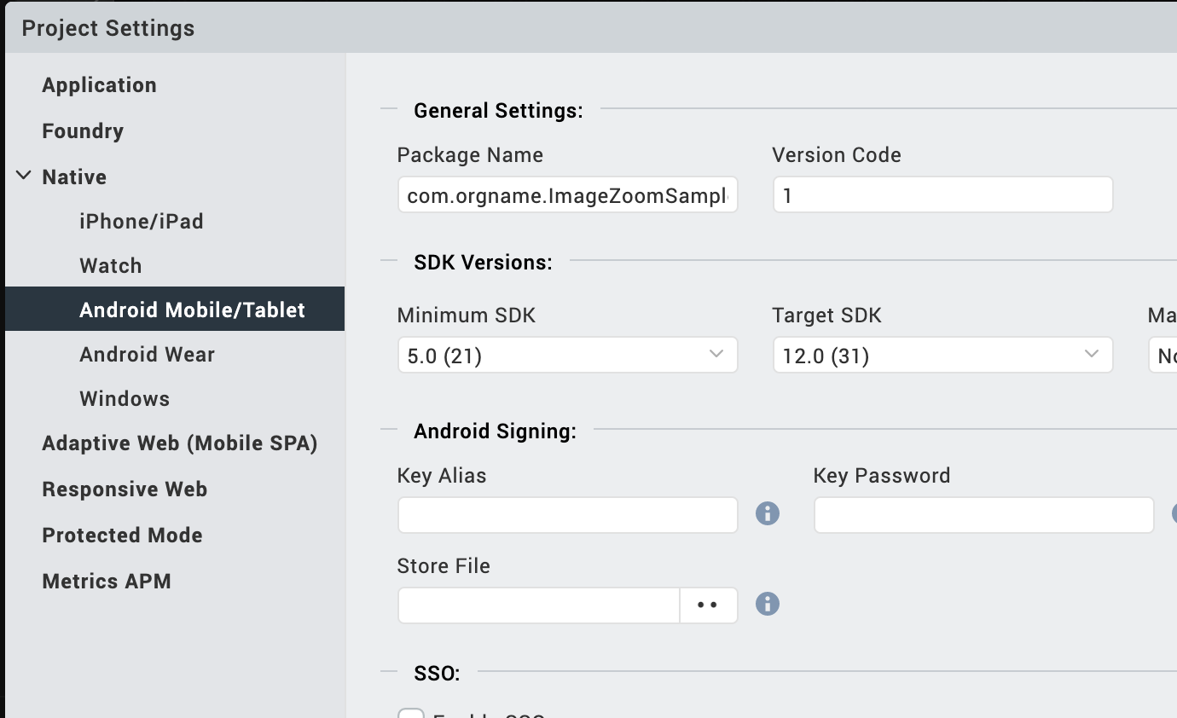

5. API’s

i. updatePlaceHolderImage

Description: | This API meant to set the place holder image. This image will be reflected when actual remote image fails to load. It accepts only local images as a placeholder.
Syntax: | updatePlaceHolderImage()
Parameters: | String - Image name(image must be placed at following locations  Android - /resources/mobile/native/android/drawable  iOS - /resources/mobile/native/iphone/mainbundle  )
Return Value: | None
Remarks: | Image name(parameter) must be passed without extensions like .png or .jpeg
Example: | this.view.ImageZoom.updatePlaceHolderImage(“placeholder”);

ii. registerCompletionCallback

Description: | Registers the callback to get an event when image loading is completed, this helps control the loading indicators. In this callback, it is preferred to remove the loading indicator.
Syntax: | registerCompletionCallback(function(status){})
Parameters: | Callback
Return Value: | None
Remarks: | It returns the status flag in the callback parameter, based on that it can determined the status of image loading into the component.
Example: | this.view.ImageZoom.registerCompletionCallback(function(status) {  });

iii. imageWithURL

Description: | This API accepts the remote Image URL, and loads that image into the component.  And loaded image can be performed zoom in/out operations.
Syntax: | imageWithURL(“https://image.com/imagename”)
Parameters: | String – Remote image address
Return Value: | None
Remarks: | None
Example: | this.view.Image.imageWithURL(“https://image.com/imagename”);

App version 1.0.1:

Limitations

B. Known Issue

