Date : 09-June-26

IMAGE GALLERY

VERSION:1.0.2

OVERVIEW
Image Gallery component lets you view all the captured images.

Use case:
Consider that you are developing any application in which we need to display images, in such cases this Image Gallery Component can be used.

Percentage of re-use:
Approximately 85% reusable.

Features:
- All the captured images displayed in a simple horizontally scrollable thumbnail format.
- Size of the thumbnail area dynamically decided based on number of images

GETTING STARTED

Prerequisites
Before you start using the Image Gallery component, ensure the following:
- HCL Foundry
- Volt MX Iris

Platforms Supported
      - Mobile

iOS

Android
      - Tablet & iPad
      - PWA & Responsive Web

Importing the app
You can import the Forge components only into the apps that are of the Reference Architecture type.
To import the Image Gallery component, do the following:
      - Open your app project in Volt MX Iris.
      - In the Project Explorer, click the Templates tab. 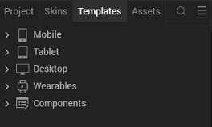
      - Right-click Components, and then select Import Component. The Import Component dialog box appears. 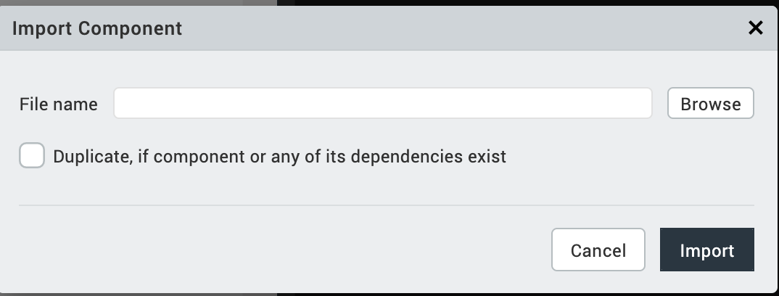

      - Click Browse to navigate to the location of the component, select the component, and then click Import. The component and its associated widgets and modules are added to your project.
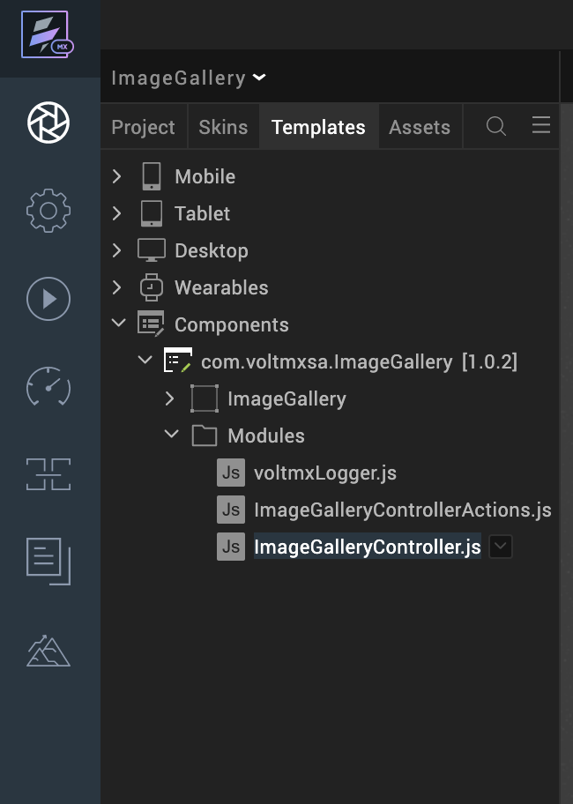
Once you have imported a component to your project, you can easily add the component to a form. For more information, refer Add a Component to a Form

Building and previewing the app
After performing all the above steps, you can build your app and run it on your device. For more information, you can refer to the Building and Viewing an Application section of the Volt MX User Guide.
You can then run your app to see the Image Gallery work in real time.

REFERENCES

Dynamic Usage

You can also add an Image Gallery component dynamically. To do so,
- In the Project Explorer, on the Projects tab, click Controllers section to access the respective Form Controller. Create a method and implement the code snippet like the sample code mentioned below.

/*Creating a Component Object*/

var imageGalleryInstance = new com.voltmxsa.ImageGallery ({
"clipBounds": true,
"height": "100%",
"id": "ImageGallery",
"isVisible": true,
"left": "0dp",
"top": "0dp",
"width": "100%",
"zIndex":"1"
}, {}, {
});
this.view.add(imageGalleryInstance);
this.view.ImageGallery.flxItemSkin="sknFlxThumbBGWhite";

In the code snippet, you can edit the properties of the component as per your requirement. For more information, see Setting Properties.
- Save the file.
Hidden Widgets
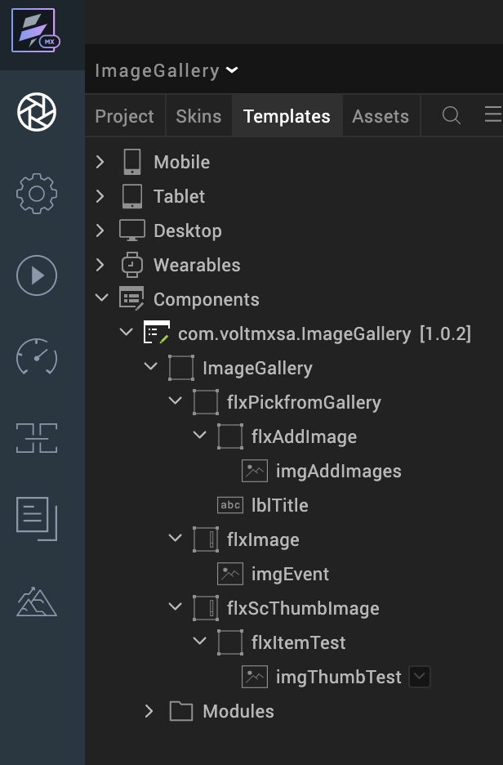

Configure UI and settings of the Image Gallery

Configuring Native Settings (iOS):
To configure the native settings for iOS, follow these steps:
1. From the Project explorer, go to Assets and expand Media.
2. Right-click Common, and then select Resource Location. Volt MX Iris opens the common resources folder in a file explorer.
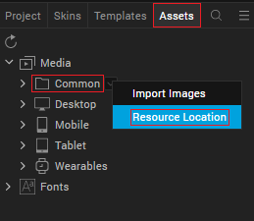
3. Open the infoplist_configuration.json file with a text or code editor.
4. Add the following code. You can change the description based on your preference.
{
"NSAppTransportSecurity" :
{
"NSAllowsArbitraryLoads" : true ,
"NSExceptionDomains" :
{
"example.com" :
{
"NSIncludesSubdomains" : true ,
"NSExceptionAllowsInsecureHTTPLoads" : true
}
}
} ,

"NSCameraUsageDescription" : "This is a dummy description",
"NSPhotoLibraryUsageDescription" : "This app uses photo library"
}

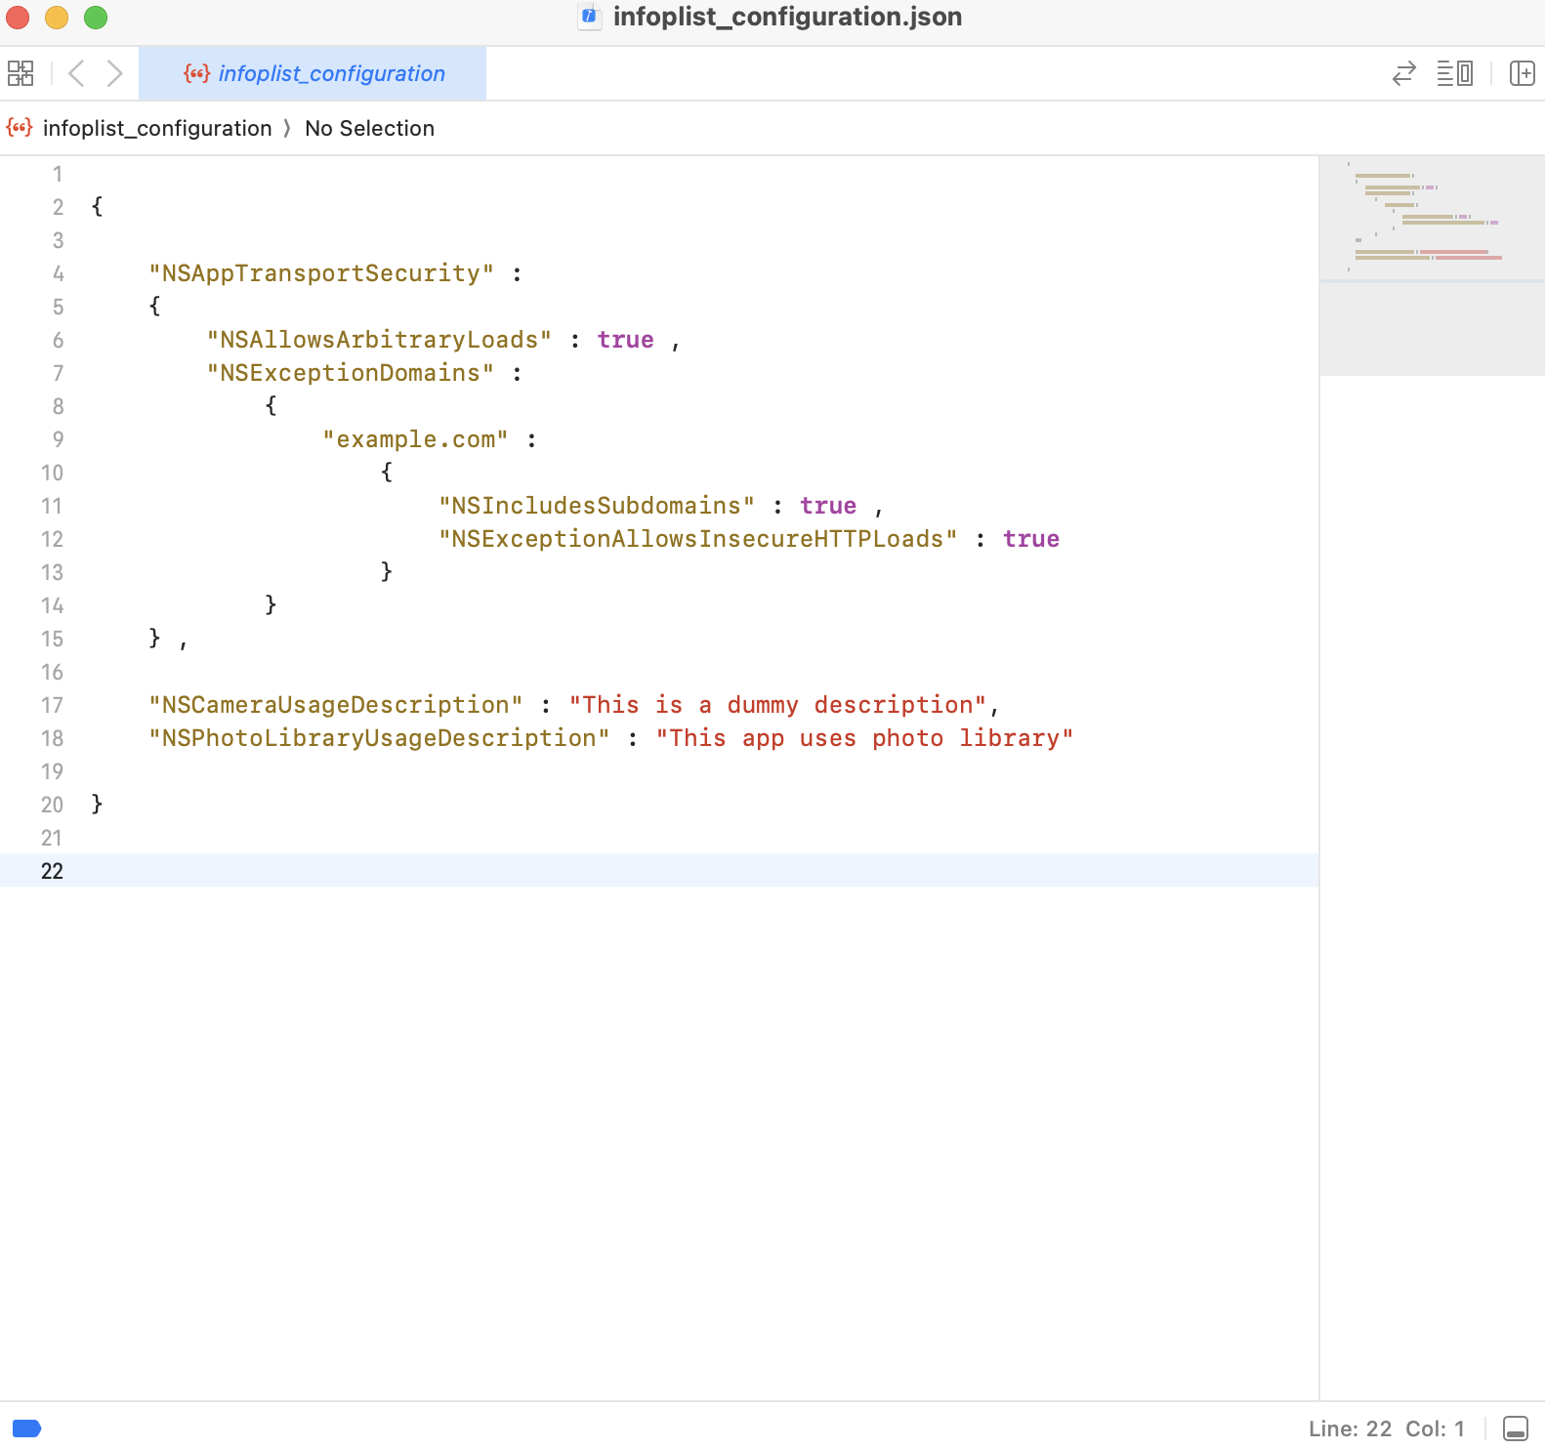

5. Save the file.

Configuring Native Settings (Android)
To configure the native settings for Android, follow these steps:
1. From the left navigation menu, click Project Settings.
2. In the Project Settings window, go to Native → Android Mobile/Tablet.
3. Set the CAMERA and WRITE_EXTERNAL_STORAGE permissions to true.
To set a permission to true, select the permission from the left panel, and then click Add.
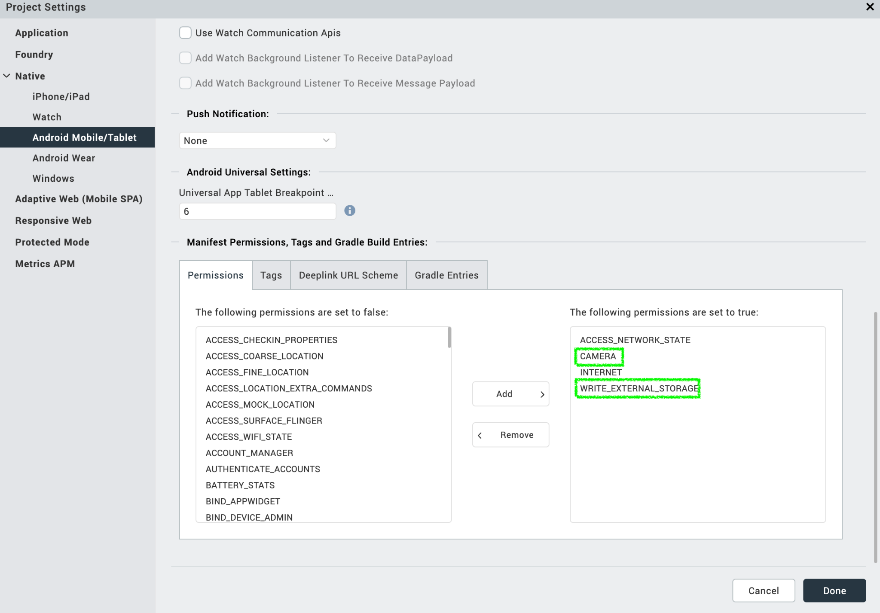
4. Click Done.

Configuring Native Settings (Responsive Web)
To configure the native settings for Responsive Web, follow these steps:
1. From the left navigation menu, click Project Settings.
2. In the Project Settings window, go to Native →Responsive Web.
3. Enable PWA
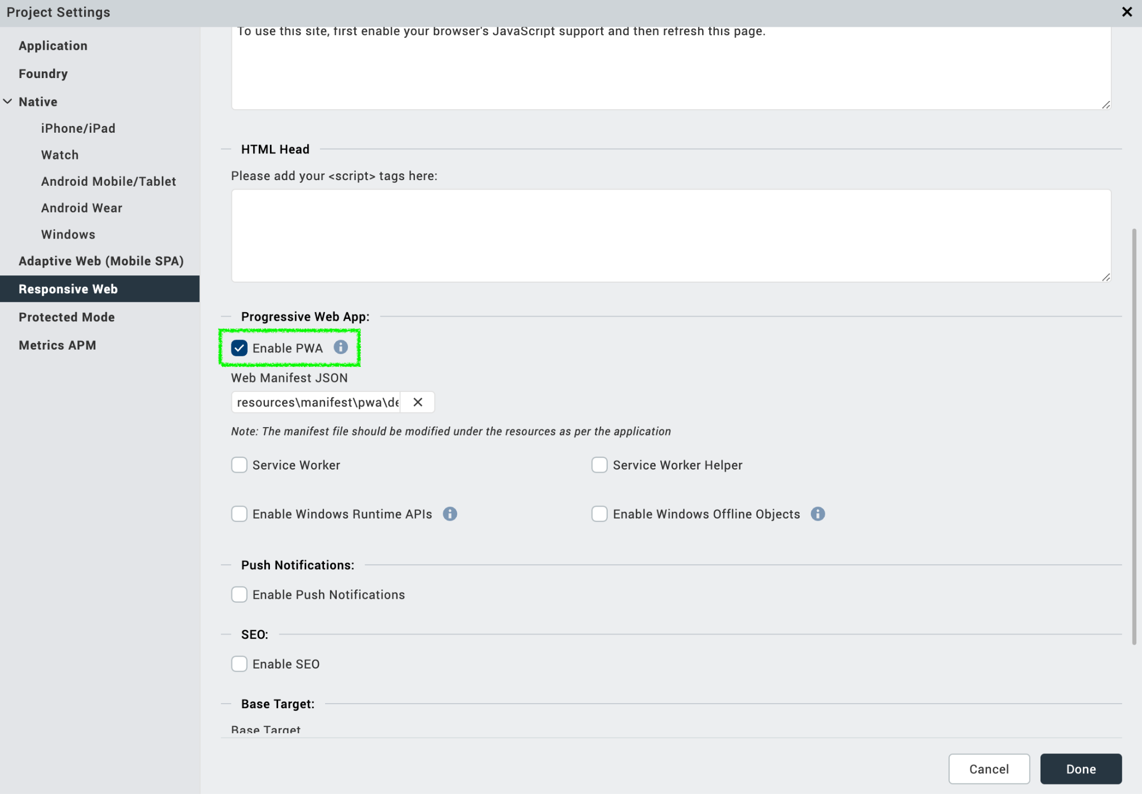

4. Click Done.

Properties
The properties provided on the Component tab allows you to customize the elements in the Image Gallery component. These elements can be UI elements, service parameters, and so on. You can set the properties from the Volt MX Iris Properties panel on the right-hand side. You can also configure these properties using a JavaScript code.
General Properties
- TextProperties
1. Title Text (lblTileText): This Property can be used when we use hidden widgets.
Description: | Specifies the skin to be applied to the Flex container.
Syntax: | lblTitleText
Type: | String
Read/Write: | Read + Write
Example: | this.view.ImageGallery.lblTitleText = "PICK FROM DEVICE GALLERY";
Remarks: | The default value for the property is “PICK FROM DEVICE GALLERY”.

2. Exposed Skins

1.flxpickfromGallerySkin: This Property can be used when we use hidden widgets
Description: | Specifies the skin to be applied to the Flex container.
Syntax: | flxpickfromGallerySkin
Type: | String
Read/Write: | Read + Write
Example: | this.view.ImageGallery.flxpickfromGallerySkin = "sknflx575ee7";
Remarks: | The default value for the property is “sknflx575ee7”.

2. flxAddImageSkin: This Property can be used when we use hidden widgets

Description: | Specifies the skin to be applied to the Flex container.
Syntax: | flxAddImageSkin
Type: | String
Read/Write: | Read + Write
Example: | this.view.ImageGallery.flxAddImageSkin = "sknFlxThumbBGWhite";
Remarks: | The default value for the property is “sknFlxThumbBGWhite”.

3. lblTitleSkin: This Property can be use when we use hidden widgets
Description: | Specifies the skin to be applied to the label title skin.
Syntax: | lblTitleSkin
Type: | String
Read/Write: | Read + Write
Example: | this.view.ImageGallery.lblTitleSkin = "sknLblWhite";
Remarks: | The default value for the property is “sknLblWhite”.

4. flxItemskin
Description: | Specifies the skin to be applied to the Flex container.
Syntax: | flxItemskin
Type: | String
Read/Write: | Read + Write
Example: | this.view.ImageGallery.flxItemskin = "sknFlxThumbBGWhite";
Remarks: | The default value for the property is “sknFlxThumbBGWhite”.

API
This API sets data to the Image Gallery. You need to pass the data as an input parameter.
Description: | The API displays the Images.
Syntax: | SetImage(ImageList,ImageType)/SetImage(ImageList)
Parameters: | Json Array (with list of images)
Return Value: | None

Usage:
var ImageListArr =["image_1.jpg","image_2.jpg","image_3.jpg","image_4.jpg"];
If Image type is base64:
this.view.ImageGallery.setImage(ImageListArr, "base64");
Else:
this.view.ImageGallery.setImage(ImageListArr);

Events
None of the Events are Exposed.

REVISION HISTORY
App version 1.0.2

Limitations:
No Limitations.

Known Issues:
NA

