Date: 27 Oct 2021

IMAGE CAPTURE

VERSION: 1.0.1

- OVERVIEW

- Use case:
This component provides an easy way to capture and save images as base64 string into the application.

- Percentage of re-use:
Approximately 85% of reuse.

- Features:
- Offline support for image capture
- Images saved as base64 string format
- Option to review as soon as you have captured the image
- All saved images can be rendered using Volt MX Iris’s image widget
- Compression ratio support for capturing images

- GETTING STARTED

A. Prerequisites

Before you start using the Image Capture component, ensure the following:

• HCL Foundry

• Volt MX Iris

B. Platforms Supported

- Mobile

- iOS
- Android

- Tablet & iPad

- PWA & Responsive Web

C. Importing the app
You can import the Forge components only into the apps that are of the Reference Architecture type.

To import the Image Capture component, do the following:

  - Open your app project in Volt MX Iris.

  - In the Project Explorer, click the Templates tab.

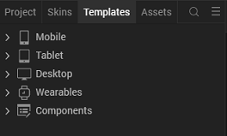

  - Right-click Components, and then select Import Component. The Import Component dialog box appears.

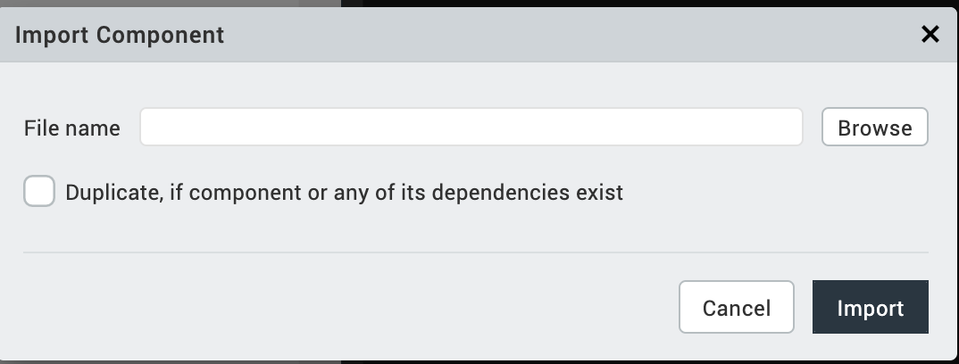

  - Click Browse to navigate to the location of the component, select the component, and then click Import. The component and its associated widgets and modules are added to your project.

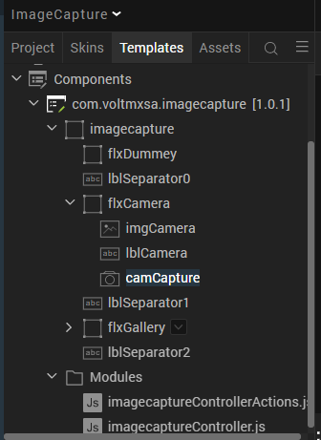

Once you have imported a component to your project, you can easily add the component to a form. For more information, refer Add a Component to a Form

D. Building and previewing the app

After performing all the above steps, you can build your app and run it on your device. For more information, you can refer to the Building and Viewing an Application section of the Volt MX User Guide.
You can then run your app to see the Image Capture work in real time.

3. REFERENCES

A. Dynamic Usage

You can also add Image Capture component dynamically. To do so,
  - In the Project Explorer, on the Projects tab, click Controllers section to access the respective Form Controller. Create a method and implement the code snippet like the sample code mentioned below.

/* Creating Image Capture component instance */

var imgCaptureInstance = new com.voltmxsa.imagecapture ({

"clipBounds": true,
"height": "100%",

"id": "imagecapture",

"isVisible": true,

"left": "0dp",

"top": "0dp",

"width": "100%",

"zIndex":1

}, {}, {});

/*Setting the component's properties*/

imgCaptureInstance.skinFlxCamera="sknFlxCompCamera";
imgCaptureInstance.sknLblCamera="sknLblCompCamera";
imgCaptureInstance.sknFlxGallery="sknFlxCompGallery";
imgCaptureInstance.sknLblGallery="sknLblCompCamera";
imgCaptureInstance.sknLblSeparator0="sknLblCompImgSeparator";
imgCaptureInstance.sknLblSeparator2="sknLblCompImgSeparator";
imgCaptureInstance.toggleBackground(true);
imgCaptureInstance.onImageSelection = function(){

alert(" onImageSection executed");
};
/*Adding the Image Capture component to a Form*/

this.view.add(imgCaptureInstance);

In the code snippet, you can edit the properties of the component as per your requirement. For more information, see Setting Properties.

2. Save the file.

B. Properties
The properties provided on the Component tab allows you to customize the elements in the Image Capture component. These elements can be UI elements, service parameters, and so on. You can set the properties from the Volt MX Iris Properties panel on the right-hand side. You can also configure these properties using a JavaScript code.

General Properties

Skins Section

1. Header

  - Camera flex Background Skin(sknFlxCompCamera)
Description: | Specifies the skin that is applied to the flex container of Camera.
Syntax: | sknFlxCompCamera
Type: | String
Read/Write: | Read + Write
Example: | this.view.imagecapture.skinFlxCamera="sknFlxCompCamera";
Remarks: | The default value for the property is “sknFlxCompCamera”.

  - Camera text and color(sknLblCompCamera)

Description: | Specifies the skin that is applied to the label of Camera.
Syntax: | sknLblCompCamera
Type: | String
Read/Write: | Read + Write
Example: | this.view.imagecapture.sknLblCamera="sknLblCompCamera";
Remarks: | The default value for the property is “sknLblCompCamera”.

  - Gallery flex Background Skin(sknFlxCompGallery)

Description: | Specifies the skin that is applied to the flex container of Gallery.
Syntax: | sknFlxCompGallery
Type: | String
Read/Write: | Read + Write
Example: | this.view.imagecapture.sknFlxGallery="sknFlxCompGallery";
Remarks: | The default value for the property is “sknFlxCompGallery”.

  - Gallery text and color(sknLblCompGallery)

Description: | Specifies the skin that is applied to the label of Gallery.
Syntax: | sknLblCompGallery
Type: | String
Read/Write: | Read + Write
Example: | this.view.imagecapture.sknLblGallery="sknLblCompGallery";
Remarks: | The default value for the property is “sknLblCompGallery”.

  - Separator flex Background Skin(sknLblCompImgSeparator)

Description: | Specifies the skin that is applied to the separator flex container.
Syntax: | sknLblCompImgSeparator
Type: | String
Read/Write: | Read + Write
Example: | this.view.imagecapture.sknLblSeparator0="sknLblCompImgSeparator";
Remarks: | The default value for the property is “sknLblCompImgSeparator”.

6. Separator flex Background Skin(sknLblCompImgSeparator)

Description: | Specifies the skin that is applied to the separator flex container.
Syntax: | sknLblCompImgSeparator
Type: | String
Read/Write: | Read + Write
Example: | this.view.imagecapture.sknLblSeparator2=" sknLblCompImgSeparator ";
Remarks: | The default value for the property is “sknLblCompImgSeparator”.

7. Background skin of flex dummy(sknFlxInspectionGreyOverlay)

Description: | Specifies the skin that is applied to the background color flex container.
Syntax: | sknFlxInspectionGreyOverlay
Type: | String
Read/Write: | Read + Write
Example: | this.view.imagecapture. sknFlxBackground=" sknFlxInspectionGreyOverlay ";
Remarks: | The default value for the property is “sknFlxInspectionGreyOverlay”.
C. APIs

- toggleBackground

Description: | This is the custom method to display the background colour of component
Syntax: | toggleBackground()
Parameters: | True or False
Return Value: | None
Example: | this.view.imagecapture.toggleBackground(true);

D. Events

  - onImageSelection

Description: | The event is invoked when a user wants to select the image.
Syntax: | onImageSelection()
Example: | this. view. imagecapture. onImageSelection= function () {  alert (“onImageSelection executed”);  };

Project Settings:

We need to give permissions for Android Mobile/Tablet to open Camera and Gallery

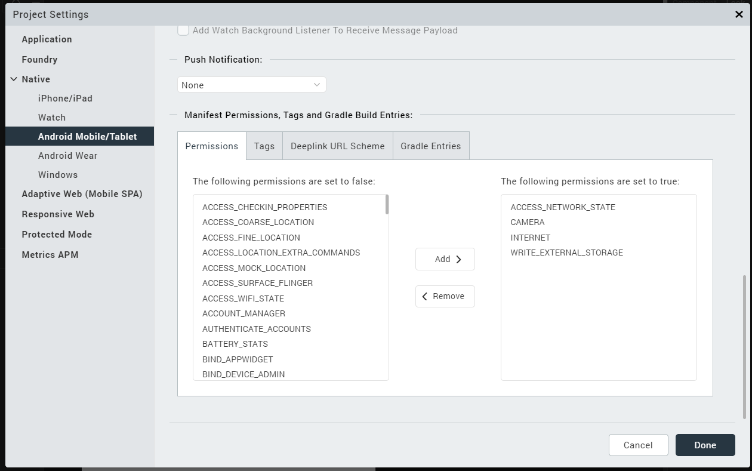

We need to give permissions for iPhone / iPad to open Camera and Gallery
in infoplist_configuration file.

\WorkspaceName\ProjectName\resources\common\ infoplist_configuration

{
"NSCameraUsageDescription" : " This app uses Camera ",

"NSPhotoLibraryUsageDescription" : "This app uses photo library"
}

4. REVISION HISTORY

App version 1.0.1:

A. Limitations

No Limitations.

B. Known issues

Web capture is not present in Chrome browser.

