Date: 04-Aug-2025

ID Document Extraction

VERSION: 1.0.0

Overview
The ID Document Extraction Component is a reusable module designed to analyze and extract key information from identity documents like Driver License, PAN Card etc. We are using the ID document model from the prebuilt capabilities of Azure AI Document Intelligence to implement the required functionality.

Use case:
- KYC for Financial Institutions:
  - Streamline customer onboarding by verifying IDs during sign-up.
- Online Account Sign-ups:
  - Automate ID verification during user registration for banking, telecom, and government platforms.
- Automated Government Form Filling:
  - Extract and pre-populate data for services like passport applications, tax forms, or driver’s license renewals.

Percentage of re-use:
80-90%.

Features:
- Scans and extracts structured data from images of identity documents.
- Supports multiple document types (PAN, Aadhaar, Passport, Driver License).
- Returns extracted data as key-value pairs.
- Offers basic validation, e.g., expiry date checks.
- Easy integration with Volt MX apps using drag-and-drop or dynamic instantiation.
- Facility to customize the UI as you require.

Getting Started

Prerequisites
Before you start using the ID Document Extraction Component, ensure the following:
• HCL Foundry
• Volt MX Iris

Platforms Supported

Mobile

iOS

Android

Importing the Component

You can import the Forge components only into the apps that are of the Reference Architecture type.

To import the ID Document Extraction component, do the following:

Open your app project in Volt MX Iris.

Go to the Project Explorer and click the Templates tab.

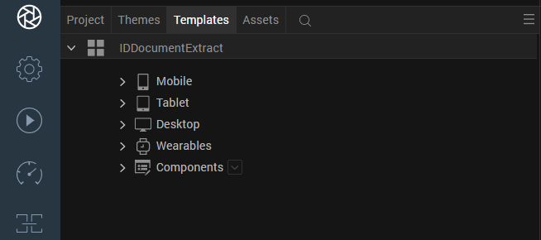

Right-click Components and select Import Component. The Import Component dialog box appears.

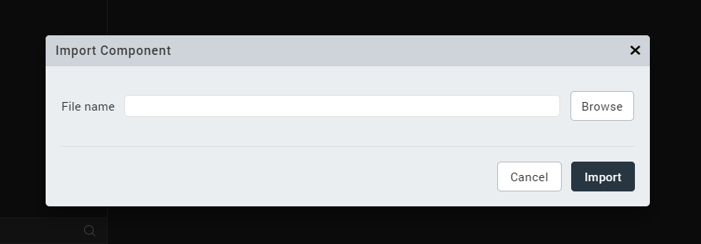

Click Browse to navigate to the location of the component, select the component, and then click Import. The component and its associated widgets and modules are added to your project.

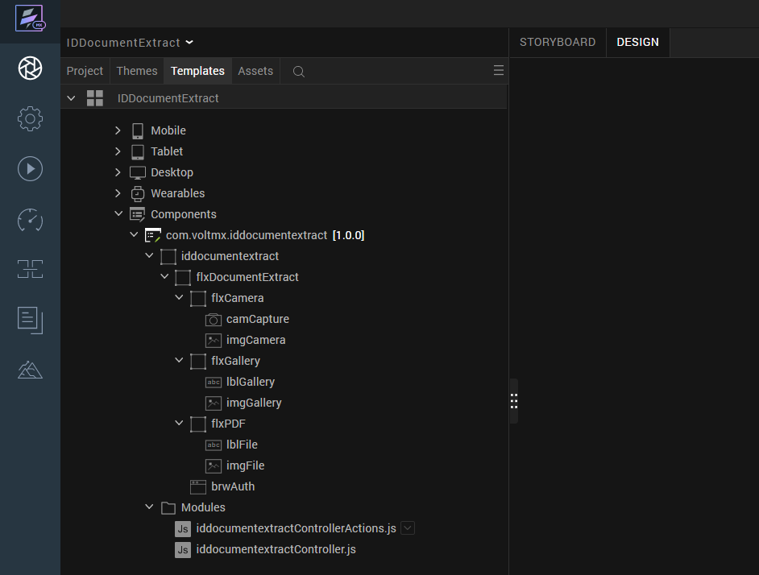

Once you have imported a component to your project, you can easily add the component to a form. For more information, refer Add a Component to a Form.

After importing the Component just ensure Iris/Edit/Manage native Function API(s)Android/PdfNfi and Iris/Edit/Mange Native Function API(s)/iOS/PdfNfi zips are updated into your project.

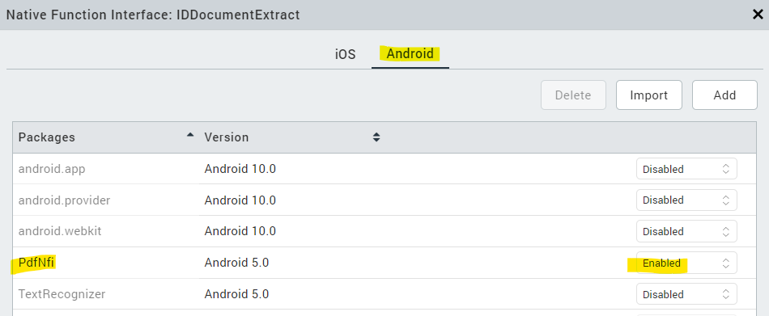

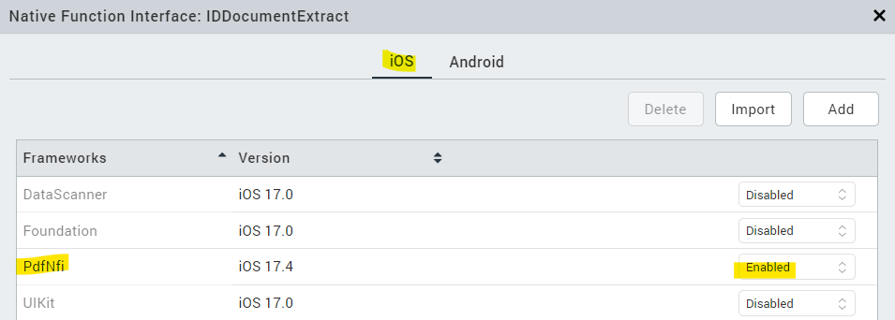

Building and previewing the app

After performing all the above steps, you can build your app and run it on your device. For more information, you can refer to the Building and Viewing an Application section of the Volt MX User Guide.

You can then run your app to see the ID Document Extractor work in real time.

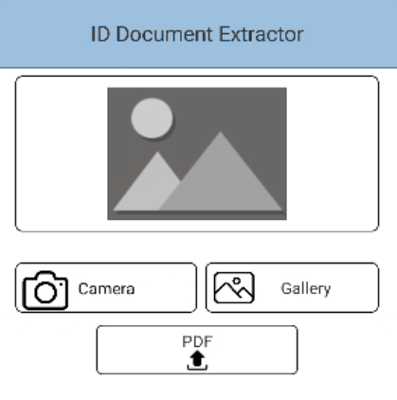

References

Dynamic Usage
You can also add ID Document Extraction Component dynamically. To do so,

In Project Explorer, on the Projects tab, click Controllers section to access the respective Form Controller. Create a method and implement the snippet code like the sample code mentioned below.

/* creating a component's Object */

createComponenet: function(){
var iddocumentextract = new com.voltmx.iddocumentextract({
id: "iddocumentextract",
isVisible: true,
top:"0dp",
left:"0dp",
width:"100%",
height:"20%",
clipBounds: true,
autogrowMode: voltmx.flex.AUTOGROW_NONE,
skin: "slFbox",
zIndex:1
},{},{});

/*Adding the id document extract component to a form*/
this.view.add(iddocumentextract);

this.view.iddocumentextract.onSuccessResult = function(callbackResult){
try{
if(callbackResult){
alert(JSON.stringify(callbackResult));
}
else{
alert("No results found");
}
}
catch(err){
alert("error= "+err);
}
}.bind(this);

this.view.iddocumentextract.getImgRawbytes= function(ImgRawBytes){
if(ImgRawBytes){
alert(ImgRawBytes)
}
else{
alert("No results found");
}
}

this.view.iddocumentextract.getRawbytesFromPDF = function(pdfRawBytes){
if(pdfRawBytes){
alert(pdfRawBytes)
}
else{
alert("No results found");
}
}
}
In the code snippet, you can edit the properties of the component as per your requirement. For more information, see Setting Properties.
2. Save the file.
Configuring Native Settings
1. While building the app for Android in Debug and Release mode, in order to open the camera and gallery. You need to add CAMERA and WRITE_EXTERNAL_STORAGE permissions in project settings.
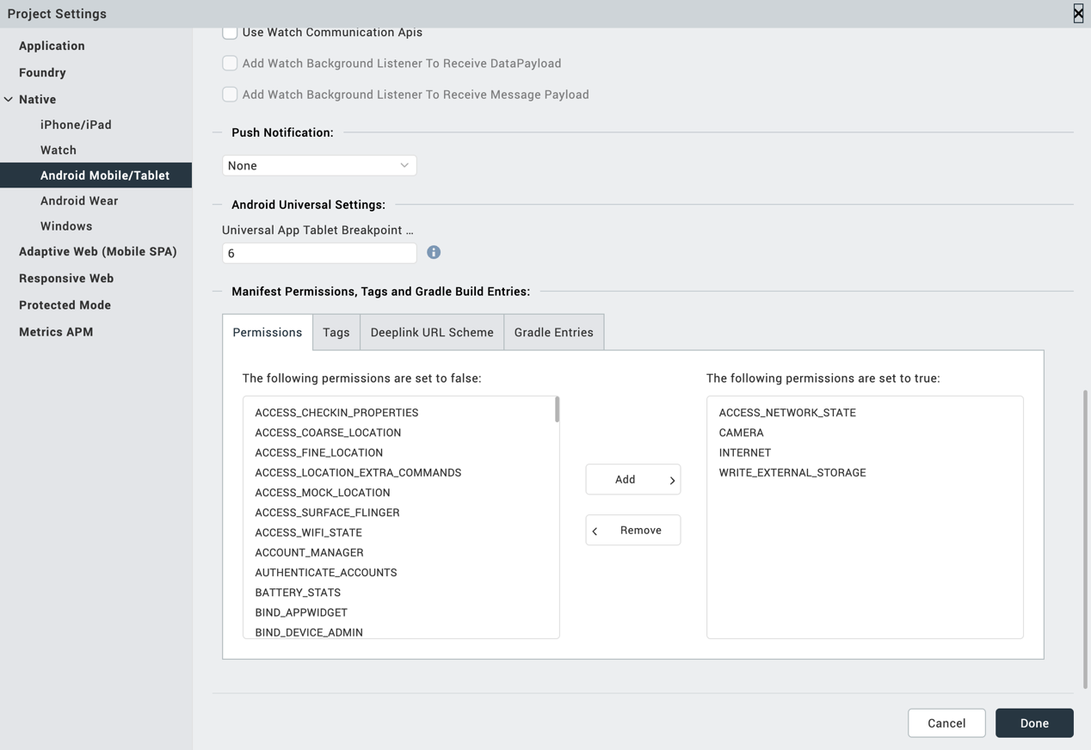

2. Enter the given snippet in Child tag entries under <manifest > tag
For Android below permissions are required in IRIS project setting > Native> Android Mobile/Tablet -> Tags (Child tag entries under tag) depending on the target version.
If target version is 33 and above below media permission must be added.
- <uses-permission android:name="android.permission.READ_MEDIA_IMAGES"/>
If target version is 34 and above below permission must be added along with other media permissions.
- <uses-permission android:name="android.permission.READ_MEDIA_VISUAL_USER_SELECTED"/>
Configuring Native Settings (iOS)
To configure the native settings for iOS, follow these steps:
- From the Project explorer, go to Assets and expand Media.
- Right-click Common, and then select Resource Location. Volt MX Iris opens the common resources folder in a file explorer.
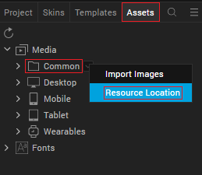

- Open the infoplist_configuration.json file with a text or code editor.
- At the end of the file, type the following code. You can change the description based on your preference.
{
"NSCameraUsageDescription" : " This app uses Camera ",
"NSPhotoLibraryUsageDescription" : "This app uses photo library"
}
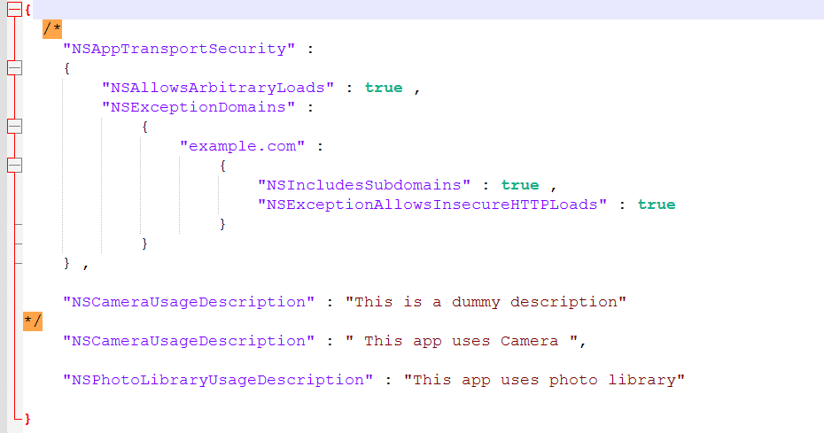
- Save the file.

Events
The component invokes events when its corresponding action is performed. You can configure any logic you want the component to perform whenever an event occurs. You can configure the events directly on the Actions tab or by writing a JavaScript, For more information, refer to Add Actions in the Volt MX Iris User Guide.
- onSuccessResult
Description: | Receives the extracted output (usually JSON or formatted string) after successful analysis of the image or PDF.
Syntax: | onSuccessResult
Parameters: | Output[JSON]:  Details of the final extracted document fields such as number, expiry date, name etc.
Example: | this.view.componentID.onSuccessResult = function(output)  alert ("Extracted Output:\n" + output);  }. bind(this);
2. getImgRawbytes
Description: | Triggered after a successful camera capture or gallery selection. Sends the base64 string of the captured image for further processing.
Syntax: | getImgRawbytes
Parameters: | base64 [String]: The base64-encoded image string from camera capture.
Example: | this.view.componentID.getImgRawbytes= function(base64)  {  alert ("Camera Image Base64:\n" + base64);  }. bind(this);
3. getRawbytesFromPDF
Description: | Triggered after a PDF is selected and converted to base64. Sends the base64 string of the PDF content.
Syntax: | getRawbytesFromPDF
Parameters: | base64 [String]: The base64-encoded content of the selected PDF.
Example: | this.view.componentID. getRawbytesFromPDF= function(base64)  alert ("PDF Base64:\n" + base64);  }. bind(this);

References

Endpoint Documentation
Identity document (ID) processing – Document Intelligence - Azure AI services | Microsoft Learn
Document Classifiers - REST API (Azure Azure AI Services) | Microsoft Learn

Revision History
App version 1.0.0:
  - Known Issues
None
  - Limitations
- For best results, provide one clear photo or high-quality scan per document.
- Image dimensions must be between 50 pixels x 50 pixels and 10,000 pixels x 10,000 pixels.
- If your PDFs are password-locked, you must remove the lock before submission.
- The minimum height of the text to be extracted is 12 pixels for a 1024 x 768-pixel image. This dimension corresponds to about 8-point text at 150 dots per inch (DPI).
For more info ref Doc: Identity document (ID) processing – Document Intelligence - Azure AI services | Microsoft Learn

