Date :  22-02-2024

hUNTER

version: 1.0.0

# **Overview**

## Hunter.io API focuses on finding professional email addresses associated with domains or individuals.

# **Getting Started**

## **A. Prerequisites**

## Volt Foundry

* Account and api key from hunter.
* Sign up in https://[hunter](https://hunter.io/).io/ and login into the account and get the api key.

## **B. Importing the adapter:**

**To import the Data Adapter to Volt Foundry, do the following:**

1. Sign in to the  [HCL Foundry](https://manage.hclvoltmx.com/).
2. From the left navigation menu, select **API Management**.
3. In **API Management**, select **Custom Data Adapters**.  
   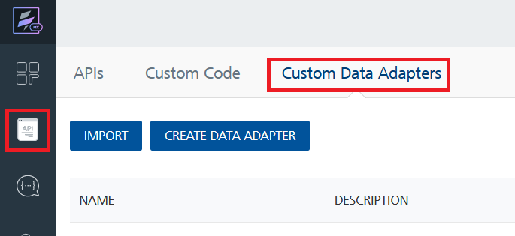
4. Click **IMPORT** to import a custom data adapter.  
   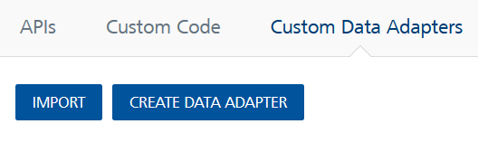
5. On the Import Data Adapter dialog box, click browser to import.  
   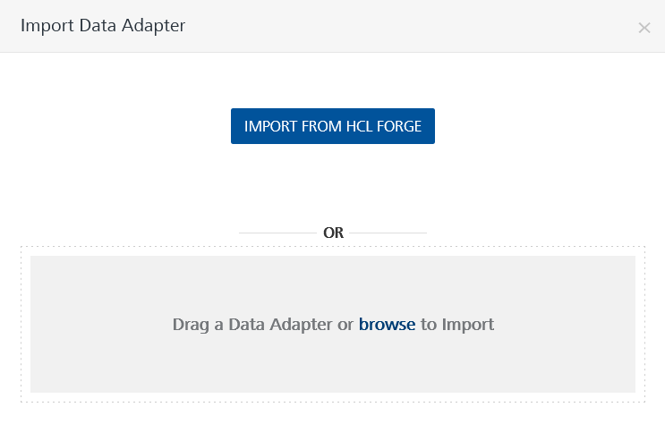
6. Select Hunter zip file and click **IMPORT**.

After you import the data adapter, Volt Foundry opens a window that shows the metadata of the data adapter.

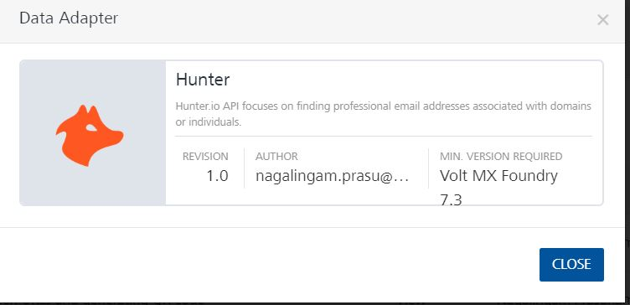

After you import the data adapter, you can view it on the Custom Data Adapters page and use it to create services on Volt Foundry.

## **C. Creating an Integration service**

After you import the data adapter into Volt Foundry, you can use it to create an Integration Service.

Follow the given steps to create an Integration service using the Hunter Adapter.

1. Sign in to the [HCL Foundry](https://manage.hclvoltmx.com/).
2. From the left navigation menu, select **API Management**.
3. In **API Management**, select **Integration**.  
   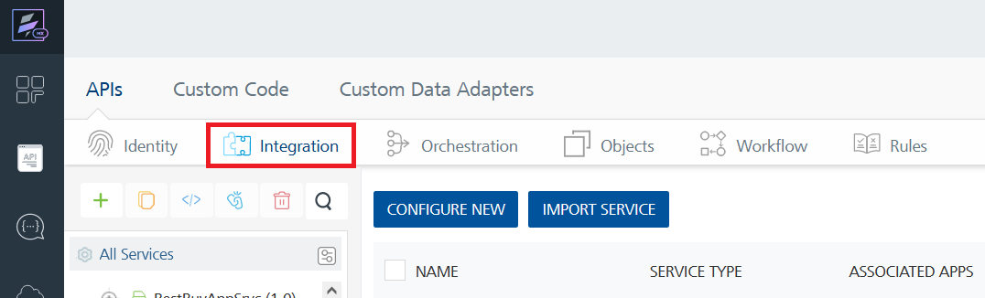
4. To create a new service, click the **+** button or the **CONFIGURE NEW** button.  
   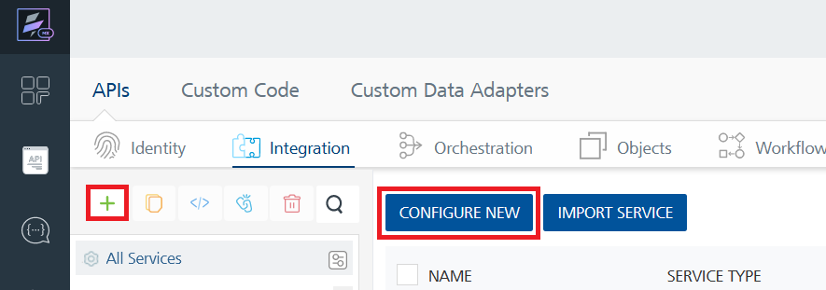
5. On the Service Definition tab, select the service type as Hunter, and click **SAVE**.
6. A screenshot of a computer

   Description automatically generated

Alternatively, you can also create a Foundry app and create an Integration service inside it.

**D. Creating and Executing operations**

After you create an integration service, you can create and execute operations using the service.

#### **Creating an operation**

* In **API Management/Foundry app you created**, in the **Integration** section, select the service that you created.
* After you select the service, navigate to the **Operation List** tab.  
  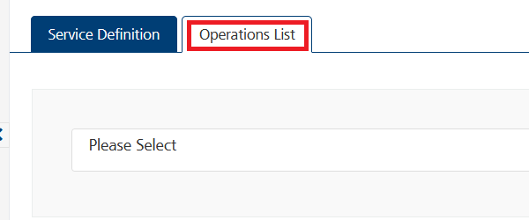
* From the drop down list, select an operation that you want to execute, and click **ADD OPERATION**.

#### **Executing an operation**

* From the **Operations List** tab, in the **Configured Operations** section, select the operation you want to execute.

* On the Operation Page, in the Request Input tab, enter a TEST VALUE for all the fields.

* Select a run-time environment and click **Save and Fetch Response** to get a response based on your inputs.  
  A screenshot of a computer

  Description automatically generated

## **E. Publishing your application:**

If you want to use the services in client applications, you need to publish an app to a run-time environment. You can create the service (as described above) in an application or import the service into an application and publish the application.

# **3. References**

## **Endpoint Documentation**

## **Domain Search**

## GET <https://api.hunter.io/v2/domainsearch?domain=intercom.com&api_key=API_KEY>

## One Key feature of hunter is to search all the email addresses corresponding to one website. You give one domain name and it returns all the email addresses using this domain name found on the internet.

|  |  |
| --- | --- |
| **domain**  Required* | Domain name from which you want to find the email addresses. For example, "stripe.com". |
| **company**  Required* | The company name from which you want to find the email addresses. For example, "stripe". Note that you'll get better results by supplying the domain name as we won't have to find it. If you send a request with both the domain and the company name, we'll use the domain name. It doesn't need to be in lowercase. |
| **limit** | Specifies the max number of email addresses to return. The default is 10. |
| **offset** | Specifies the number of email addresses to skip. The default is 0. |
| **type** | Get only personal or generic email addresses. |
| **seniority** | Get only email addresses for people with the selected seniority level. The possible values are junior, senior or executive. Several seniority levels can be selected (delimited by a comma). |
| **department** | Get only email addresses for people working in the selected department(s). The possible values are executive, it, finance, management, sales, legal, support, hr, marketing, communication, education, design, health or operations. Several departments can be selected (comma-delimited). |
| **required field** | Get only email addresses that have the selected field(s). The possible values are full_name, position, phone_number. Several fields can be selected (comma-delimited). |
| **api_key**  Required | Your secret API key. You can generate it in your dashboard. |

## **Email Finder**

## This API endpoint finds the most likely email addresses from a domain name, a first name and a last name.

## GET <https://api.hunter.io/v2/emailfinder?domain=reddit.com&first_name=Alexis&last_name=Ohanian&api_key=API_KEY>

|  |  |
| --- | --- |
| **domain**  Required* | The domain name of the company, used for emails. For example, "reddit.com". |
| **company**  Required* | The company name from which you want to find the email addresses. For example, "stripe". Note that providing the domain name gives better results as it removes the conversion from the company name. If you send a request with both the domain and the company name, the domain name will be used. The company name doesn't need to be in lowercase. |
| **first_name**  Required** | The person's first name. It doesn't need to be in lowercase. |
| **last_name**  Required** | The person's last name. It doesn't need to be in lowercase. |
| **full_name**  Required** | The person's full name. Note that you'll get better results by supplying the person's first and last name if you can. It doesn't need to be in lowercase. |
| **max_duration** | The maximum duration of the request in seconds. Setting a longer duration allows us to refine the results and provide more accurate data. It must range between 3 and 20. The default is 10. |
| **api_key**  Required | Your secret API key. You can generate it in your dashboard. |

## **Email Verifier :**

## This API endpoint allows you to verify the deliverability of an email address.

## This endpoint is rate-limited by domain name. You can check up to 200 email addresses for a domain name every 24 hours. You can check the number of requests remaining using the x-Rate-Limit-Remaining header.

## The request will run for 20 seconds. If it was not able to provide a response in time, we will return a 202 status code. You will then be able to poll the same endpoint to get the verification's result. Of course, all the requests in this case are counted only once.

## GET <https://api.hunter.io/v2/emailverifier?email=patrick@stripe.com&api_key=API_KEY>

|  |  |
| --- | --- |
| **email**  Required | The email address you want to verify. |
| **api_key**  Required | Your secret API key. You can generate it in your dashboard. |

## **Email Count** :

## This API endpoint allows you to how many email addresses we have for one domain or for one company.

## GET <https://api.hunter.io/v2/email-count?domain=stripe.com>

|  |  |
| --- | --- |
| **domain**  Required* | The domain name for which you want to know how many email addresses we have. |
| **company**  Required* | The company name for which you want to know how many email addresses we have. For example, "stripe". Note that you'll get better results by supplying the domain name as we won't have to find it. If you send a request with both the domain and the company name, we'll use the domain name. It doesn't need to be in lowercase. It must be composed of at least 3 characters. |
| **type** | Get the count of only personal or generic email addresses. |

## **Account Information**

## This API endpoint enables you to get information regarding your Hunter account at any time.

## GET <https://api.hunter.io/v2/account?api_key=API_KEY>

|  |  |
| --- | --- |
| **api_key**  Required | One of the API keys associated with your account. |

**Reference Document:**

## Refer this document for more information.

## [Hunter's API Reference V2](https://hunter.io/api-documentation/v2)

# **4. Revision History**

Adapter version 1.0.0

## **Known Issues**

**-**

## **Limitations**

**-**