Date : 07-Feb-22

Barcode generator (1.0.2)

Overview
The Barcode Generator component can be used to encode data into a barcode.
The component can encode the data into the following formats:
- CODE128
- CODE39
- EAN13
- EAN8
- EAN5
- EAN2
- UPC
- ITF14
- MSI
- MSI10
- MSI11
- MSI1010
- MSI1110
For further information, you can refer to the JsBarcode website.

Use case

Identify products in retail stores, warehouses and invoice

Features:

Generate barcode by given data and format

Percentage of re-use:
80-90% (Data can be customizable and skins are not customized but can be changed manually)

Getting Started

Prerequisites
Before you start using the barcode generator component, ensure you have the following:
- HCL Foundry
- Volt MX Iris

Platforms Supported

Mobile

iOS

Android

Tablets

iOS

Android

PWA

Importing the app

You can import the Forge components only into the apps that are of the Reference Architecture type.

To import the barcode generator component, do the following:

Open your app project in Volt MX Iris.
- In the Project Explorer, click the Templates tab.

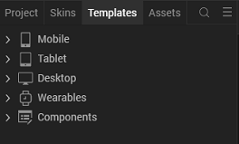

3.Right-click Components, and then select Import Component. The Import Component dialog box appears.
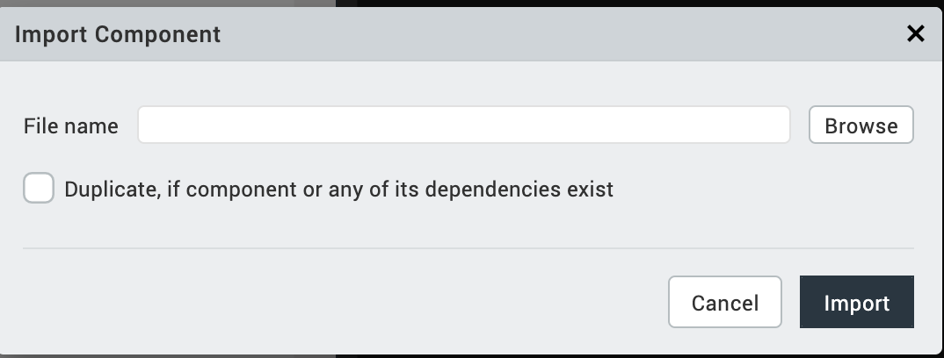
4.Click Browse to navigate to the location of the component, select the component, and then click Import. The component and its associated widgets and modules are added to your project.

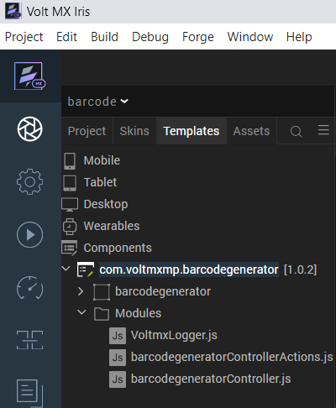
Once you have imported a component to your project, you can easily add the component to a form. For more information, refer Add a Component to a Form.

Building and previewing the app

Refer to below links:

Build & Generate Native Apps

Publish Apps to Enterprise App Store

References

Dynamic Usage
You can also add an barcode generator component dynamically. To do so:
- In the Project Explorer, on the Projects tab, click Controllers section to access the respective Form Controller. Create a method and implement the code snippet similar to the sample code mentioned below.
In the code snippet, you can edit the properties of the component as per your requirement. For more information, see Setting Properties.
var barcodegenerator = new com.voltmxmp.barcodegenerator(

{

"clipBounds": true,

"height": "60%",

"id": "barcodegenerator",

"isVisible": true,

"left": "0%",

"skin": "slFbox",

"top": "0%",

"width": voltmx.flex.USE_PREFFERED_SIZE

}, {}, {});

/* Setting the component's Pass Through and Custom properties */

barcodegenerator.dataToEncode = "voltmx";

barcodegenerator.barcodeFormat = "CODE128";

barcodegenerator.barcodeWidth = "2";

barcodegenerator.barcodeHeight = "40";

barcodegenerator.backGroundColor = "#ffffff";

barcodegenerator.lineColor = "#000000";

barcodegenerator.displayValue = true;

barcodegenerator.barcodefontStyle = "none";

barcodegenerator.barcodefontFamily = "";

barcodegenerator.barcodefontSize = "";

barcodegenerator.textAlign = "center";

barcodegenerator.textPosition = "bottom";

barcodegenerator.textMargin = "";

barcodegenerator.marginTop = "";

barcodegenerator.marginBottom = "";

barcodegenerator.marginLeft = "";

barcodegenerator.marginRight = "";

/*Adding the Barcode Generator Arrow component to a Form*/

this.view.add(barcodegenerator);

- Save the file.

Properties
You can use a component's Properties to customize and configure the elements. These elements can be UI elements, service parameters, and so on. You can set the properties from the Iris's Properties panel on the right-hand side. You can also configure these properties using a JavaScript code.
- General

Data to Encode
Category: | Custom
Description: | Specifies the data the user wants to encode in the generator.
Syntax: | dataToEncode
Type: | String
Read/Write: | Write
Example: | this.view.<componentID>.dataToEncode = "Temenos";

Barcode Format
Category: | Custom
Description: | Specifies the format of the barcode that the user wants to generate.
Syntax: | barcodeFormat
Type: | List Selector
Read/Write: | Write
Values: | - CODE128  - CODE39  - EAN13  - EAN8  - EAN5  - EAN2  - UPC  - ITF14  - MSI  - MSI10  - MSI11  - MSI1010  - MSI1110
Example: | this.view.<componentID>.barcodeFormat = "CODE128";
- Barcode Image

Barcode Single Bar Width
Category: | Custom
Description: | Specifies the width of a single bar of the barcode.
Syntax: | barcodeWidth
Type: | String
Read/Write: | Write
Example: | this.view.<componentID>.barcodeWidth = "2";

Barcode Height
Category: | Custom
Description: | Specifies the height of the barcode.
Syntax: | barcodeHeight
Type: | String
Read/Write: | Write
Example: | this.view.<componentID>.barcodeHeight = "40";

Background Color
Category: | Custom
Description: | Specifies the background color of the barcode.
Syntax: | backGroundColor
Type: | String
Read/Write: | Write
Example: | this.view.<componentID>.backGroundColor = "#ffffff";

Line Color
Category: | Custom
Description: | Specifies the colors of the bars of the barcode.
Syntax: | lineColor
Type: | String
Read/Write: | Write
Example: | this.view.<componentID>.lineColor = "#000000";

Barcode Top Margin
Category: | Custom
Description: | Specifies the top margin of the barcode.
Syntax: | marginTop
Type: | String
Read/Write: | Write
Remarks: | If you do not specify any margin, the component will pick the default margin.
Example: | this.view.<componentID>.marginTop = "";

Barcode Bottom Margin
Category: | Custom
Description: | Specifies the bottom margin of the barcode.
Syntax: | marginBottom
Type: | String
Read/Write: | Write
Remarks: | If you do not specify any margin, the component will pick the default margin.
Example: | this.view.<componentID>.marginBottom = "";

Barcode Left Margin
Category: | Custom
Description: | Specifies the left margin of the barcode.
Syntax: | marginLeft
Type: | String
Read/Write: | Write
Remarks: | If you do not specify any margin, the component will pick the default margin.
Example: | this.view.<componentID>.marginLeft = "";

Barcode Right Margin
Category: | Custom
Description: | Specifies the right margin of the barcode.
Syntax: | marginRight
Type: | String
Read/Write: | Write
Remarks: | If you do not specify any margin, the component will pick the default margin.
Example: | this.view.<componentID>.marginRight = "";
- Barcode Text

Display Value
Category: | Custom
Description: | Specifies whether you want to display the text of the barcode.
Syntax: | displayValue
Type: | Boolean
Read/Write: | Write
Example: | this.view.<componentID>.displayValue = true;

Font Style
Category: | Custom
Description: | Specifies the font style of the text of the barcode.
Syntax: | barcodefontStyle
Type: | List Selector
Read/Write: | Write
Values: | - none  - bold  - italic  - bold italic
Example: | this.view.<componentID>.barcodefontStyle = "none";

Font Family
Category: | Custom
Description: | Specifies the font family of the text of the barcode.
Syntax: | barcodefontFamily
Type: | String
Read/Write: | Write
Remarks: | If you do not specify any font, the component will pick the default font.
Example: | this.view.<componentID>.barcodefontFamily = "Arial";

Font Size
Category: | Custom
Description: | Specifies the font size of the text of the barcode.
Syntax: | barcodefontSize
Type: | String
Read/Write: | Write
Remarks: | If you do not specify any font size, the component will pick the default font size.
Example: | this.view.<componentID>.barcodefontSize = "12";

Text Align
Category: | Custom
Description: | Specifies the alignment of the text of the barcode.
Syntax: | textAlign
Type: | List Selector
Read/Write: | Write
Values: | - left  - center  - right
Example: | this.view.<componentID>.textAlign = "center";
Text Position
Category: | Custom
Description: | Specifies the position of the text of the barcode.
Syntax: | textPosition
Type: | List Selector
Read/Write: | Write
Values: | - top  - bottom
Example: | this.view.<componentID>.textPosition = "bottom";
Text Margin
Category: | Custom
Description: | Specifies the margin of the text with respect to the barcode.
Syntax: | textMargin
Type: | String
Read/Write: | Write
Remarks: | If you do not specify any margin, the component will pick the default margin.
Example: | this.view.<componentID>.textMargin = "";

Events

errorCallback

Description: | Invoked when an error occurs within the component.
Syntax: | errorCallback
Parameters: | exception [JSON] :  Details about the exception.
Example: | this.view.<componentID>.errorCallback = function(exception) {  alert("exception: "+JSON.stringify(exception));  }

Uncaught errors
For uncaught errors, you can add your own handling on function window.onerror() in barcode.html.

API’s

generate
This API generates the barcode in the drag and drop area of the component.
Category
Custom
Syntax
generate
Parameters
None
Return Value
None. It displays the generated barcode.

Revision History
App version 1.0.2:

Known Issues
N/A

Limitations
N/A

