Date : 11-Feb-22

PDF Viewer (2.6.4)

Overview
PDF Viewer is a plug and play component to display PDF files in your app. It can render PDF files from the user's device or from a web URL. Under the hood, the component uses Native function APIs.

Use case

View PDF file

Features

User can view online PDF file

User can view local PDF file on device

Percentage of re-use:
80-90%. (Data can be customizable and skins are not customized but can be changed manually)

Getting Started

Prerequisites
Before you start using the component, ensure you have the following:
- HCL Foundry
- Volt MX Iris

Platforms Supported

Mobile

iOS

Android

Tablets

iOS

Android

PWA

Notes: Should contain info on whether all platforms perform similar, or there are exceptions (say on iOS a feature behaves differently, for example, or certain API do not work in PWA etc. We can mention it here if the component has any such platform-specific deviations and link to a separate section)

Importing the app

Open your app project in Volt MX Iris.
- In the Project Explorer, click the Templates tab.

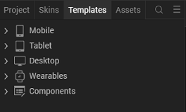

3.Right-click Components, and then select Import Component. The Import Component dialog box appears.
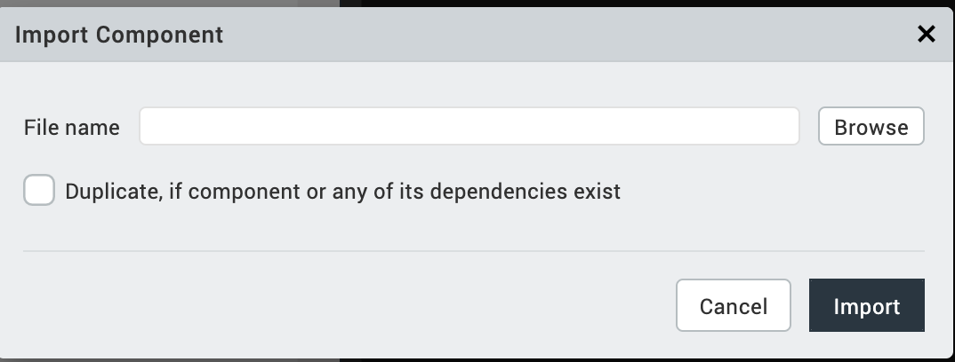
4.Click Browse to navigate to the location of the component, select the component, and then click Import. The component and its associated widgets and modules are added to your project.
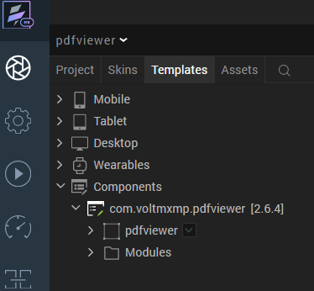

Once you have imported a component to your project, you can easily add the component to a form. For more information, refer Add a Component to a Form.

Configuring Native Settings (Android)

Run-time Permissions
On the Android platform, the PDF Viewer component requires the WRITE_EXTERNAL_STORAGE permissions.
To enable the permissions, follow these steps:
- From the left navigation bar, select Project Settings.
- From the Project Settings window, go to Native → Android Mobile/Tablet.
- Scroll down to Manifest Permissions, Tags and Gradle Build Entries.
- Set the WRITE_EXTERNAL_STORAGE permission to true.
To set a permission to true, select the permission from the left panel and click Add >.
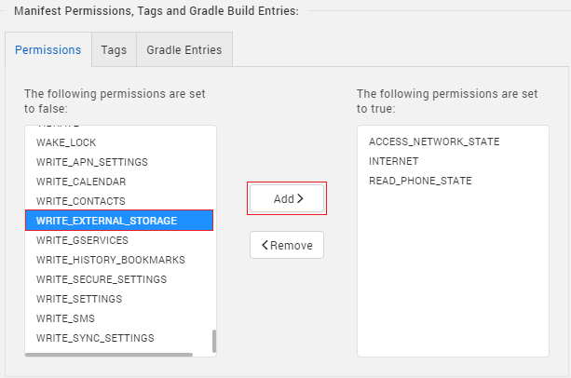

Manifest Properties
To access files that you add to your project from the device, you need to create an XML file that specifies the directories that you want to share. For more information, refer to Specifying the Sharable Directories in the XML file.
For Android, to ensure the stability of pdf online rendering, the pdf file will be downloaded into “files/” directory(voltmx.io.FileSystem.getDataDirectoryPath()) in your app’s internal storage. Please make sure this directory is specified in XML file.

<paths>
<files-path path="/" name="files"/>
</paths>
After you create the XML file, copy the file into the following folder of your project workspace: resources/mobile/native/android/xml. If the xml folder does not exist, you can create the folder.
After you copy the file to the Android folder, you need to configure the Manifest properties of the project.
To configure the Manifest properties, follow these steps:
- From the Project Settings window, navigate to Native → Android Mobile/Tablet.
- Scroll down to Manifest Permissions, Tags and Gradle Build Entries and switch to the Tags tab.
- In the Child tag entries under application tag box, type the following code:
<provider android:name="androidx.core.content.FileProvider"
android:authorities="${applicationId}.provider"
android:exported="false"
android:grantUriPermissions="true">
<meta-data android:name="android.support.FILE_PROVIDER_PATHS"
android:resource="@xml/ filepaths" />
</provider>
Note: In the code snippet, make sure that you replace filenames with the name of your XML file. Make sure that you type the name of the file without the .xml extension.
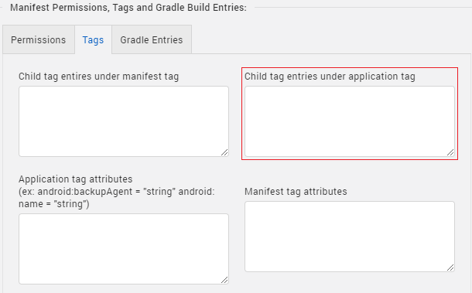

Building and previewing the app

Refer to below links:

Build & Generate Native Apps

Publish Apps to Enterprise App Store

References

Dynamic Usage
- In the Project Explorer, on the Projects tab, click Controllers section to access the respective Form Controller. Create a method and implement the code snippet similar to the sample code mentioned below.
In the code snippet, you can edit the properties of the component as per your requirement. For more information, see Setting Properties.
/* Creating a component's Object */
var pdfviewer = new com.voltmxmp.pdfviewer(
{
"clipbounds": true,
"height": "80%",
"id": "pdfviewer",
"isVisible": true,
"layoutType": voltmx.flex.FREE_FORM,
"left": "0dp",
"top": "100dp",
"width": "100%"
}, {}, {});

/* Setting the component's properties */
pdfviewer.url = "https://www.adobe.com/support/products/enterprise/knowledgecenter/media/c4611_sample_explain.pdf";
pdfviewer.pdfType = "Online";
pdfviewer.renderType = "Manual";
pdfviewer.setIphonePath = "sample";
pdfviewer.setAndroidPath = "/storage/emulated/0/Download/sample.pdf";
pdfviewer.setDesktopWeb = "desktopweb/web/localfiles/sample.pdf";
/* Adding the component to a form */
this.view.add(pdfviewer);
- Save the file.

Properties

General
Type
Description: | Specifies the type of the PDF file that you want to render at run time.
Syntax: | pdfType
Type: | - List Selector  - String
Read/Write: | Write
Values: | - Online  - Local File Path
Default Value: | Online
Remarks: | In Iris, you can set the value from a drop down list.
Example: | this.view.<componentID>.pdfType = "Online";
Render
Description: | Specifies whether you want to render the PDF file automatically.
Syntax: | renderType
Type: | - List Selector  - String
Read/Write: | Write
Values: | - Automatic  - Manual
Default Value: | Automatic
Remarks: | - If you set the value to Manual, you need to call the render API to render the PDF at run time.  - In Iris, you can set the value from a drop down list.
Example: | this.view.<componentID>.renderType = "Automatic";

Online
URL
Description: | Specifies the URL of the PDF that you want to render at run time.
Syntax: | url
Type: | String
Read/Write: | Write
Remarks: | - Changes made to this property are reflected only at run time. iOS,does not support http protocol  - For Android, make sure the “files/” directory(voltmx.io.FileSystem.getDataDirectoryPath()) in your app’s internal storage is specified in XML file. For more information, refer to Specifying the Sharable Directories in the XML file
Example: | this.view.<componentID>.url = “https://www.adobe.com/support/products/enterprise/knowledgecenter/media/c4611_sample_explain.pdf”

Local File Path
Android
Description: | Specifies the local file that you want to render on Android at run time.
Syntax: | setAndroidPath
Type: | String
Read/Write: | Write
Remarks: | - The device must have a PDF viewer installed to open the PDF file. Otherwise the component throws an exception.  - If you want to view files that you include in your Iris project, make sure that you share the file path as a URI. For more information, refer to Specifying the Sharable Directories in the XML file.  - Make sure that you place the PDF file in the specified directory before preview it on local. For example, put the sample.pdf to download folder of device.
Example: | this.view.<componentID>.setAndroidPath =  /storage/emulated/0/Download/sample.pdf";
iOS
Description: | Specifies the file that you want to render on iOS at run time.
Syntax: | setIphonePath
Type: | String
Read/Write: | Write
Remarks: | Make sure that you place the PDF file in either of the following locations:  - The raw folder -  <workspace>\<project>\resources\mobile\native\iphone\raw  - Stored in the project level storage - You need to provide the file path.  \var\mobile\Containers\Data\Application\<Application-sandboxid>\Documents\sample.pdf
Example: | this.view.<componentID>.setIphonePath = "sample";
Desktop Web
Description: | Specifies the file that you want to render on Desktop Web at run time.
Syntax: | setDesktopWeb
Type: | String
Read/Write: | Write
Example: | this.view.<componentID>.setDesktopWeb = "desktopweb/web/localfiles/sample.pdf";

Events
onErrorCallback
Description: | Invoked when an error occurs within the component.
Syntax: | onErrorCallback
Parameters: | error [JSON] :  Details about the error, such as error code and error message.
Example: | this.view.<componentID>.onErrorCallback = function(error)  {  alert("Error: "+JSON.stringify(error));  }.bind(this);

API’s

render
Description: | Renders the specified PDF at run time.
Syntax: | render()
Parameters: | None
Return Value: | None
Remarks: | - Use this API only when the render type is manual.  - Make sure that you set the following properties before you call this API.  - pdfType  - URL (if the pdfType is Online)  - Android File Path (if the pdfType is Local File Path)  - iOS File Path (if the pdfType is Local File Path)
Example: | this.view.componentID.render();

- setURL
Description: | Sets the URL of the PDF that you want to render at run time.
Syntax: | setURL(url)
Parameters: | url [String] :  The URL of the PDF that you want to render.
Return Value: | None
Example: | this.view.<componentID>.setURL(  " https://www.adobe.com/support/products/enterprise/knowledgecenter/media/c4611_sample_explain.pdf ");

- setAndroidFilePath
Description: | Sets the file path of the PDF that you want to render on Android.
Syntax: | setAndroidFilePath(path)
Parameters: | path [String] :  The file path of the PDF that you want to render on Android.
Return Value: | None
Example: | this.view.<componentID>.setAndroidFilePath(  "/storage/emulated/0/Download/sample.pdf");

- setIphoneFilePath
Description: | Sets the file path of the PDF that you want to render on iOS.
Syntax: | setIphoneFilePath(path)
Parameters: | path [String] :  The file path of the PDF you want to render on iOS.
Return Value: | None
Remarks: | Make sure that you place the PDF file in either of the following locations:  - The raw folder -  <workspace>\<project>\resources\mobile\native\iphone\raw  - Stored in the project level storage - You need to provide the file path.  \var\mobile\Containers\Data\Application\<Application-sandboxid>\Documents\sample.pdf
Example: | this.view.<componentID>.setIphoneFilePath("sample");
- setDesktopWeb
Description: | Sets the file path of the PDF that you want to render on Desktop Web.
Syntax: | setDesktopWeb(path)
Parameters: | path [String] :  The file path of the PDF that you want to render on Desktop Web.
Return Value: | None
Remark: | Make sure that you place the PDF file in the following location:  - The local file folder -  <project>\ web\localfiles\sample.pdf
Example: | this.view.<componentID>.setDesktopWebFilePath("desktopweb/web/localfiles/sample.pdf");

Revision History
App version 2.6.4:

Known Issues

No known issues

Limitations
- To change the URL dynamically in the same form, you need to use the setURL API instead of setting the URL property.
- To change the path dynamically in the same form, you need to use the setIphoneFilePath and setAndroidFilePath APIs instead of setting the setAndroidPath and setIphonePath properties.
- To render a PDF on Desktop Web, you need to use the setDesktopWeb API

