Date : 21-Feb-22
Common Retail Screens (1.0.1)
- Overview
The Common Retail Screens App includes several of the most common Retail/eCommerce use-cases, encapsulated as screens.

Use case

The Common Retail Screens App provides the basic workflow screens of common retail system. The workflow includes
- Login App to check promotion information, store location.
- Manage profile information, set up security question.
- Get help via email, phone, short message.
- Send mail to reset password.

B. Features
The Common Retail Screens App includes several screens. Each screen presents a simple flow. All screens have a consistent User-Interface design and can be used together seamlessly.
The screens are:
- Basic Login
- Forgot Password
- Promotion
- Sliding Menu
- Store Locator
- Settings
- Manage Profile
- Security Questions
- Help Options
For more information, you can refer to Common Retail Screens App Functionality.

C. Percentage of re-use:
70-80% (Data is customized and can be changed manually)

Getting Started

A. Prerequisites
Before you start using the Common Retail Screens App, ensure you have the following:
- HCL Foundry
- Volt MX Iris

B. Platforms Supported

Mobile

iOS

Android

Tablets

PWA

C. Importing the App
You can import the Forge Apps only into the apps that are of the Reference. Architecture type.

To import the Common Retail Screens App, do the following:
- Launch Volt MX Iris.
- Click project, and then select Import. The Import dialog box appears.
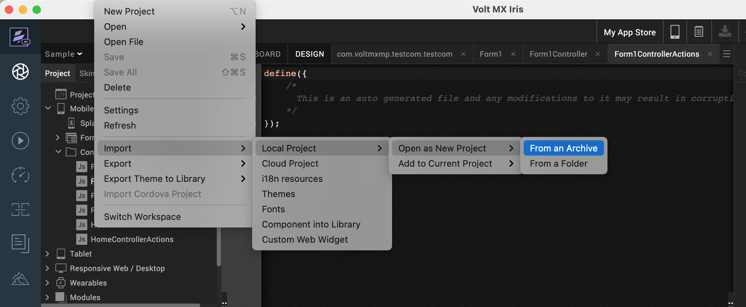
- Click From an Archive to navigate to the location of the project, select the files, and then click Import.
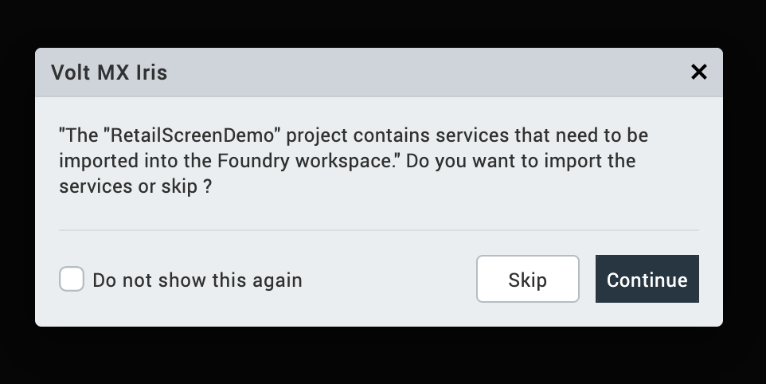
- Click button Continue to import Foundry service. Then the project and its associated components are imported.

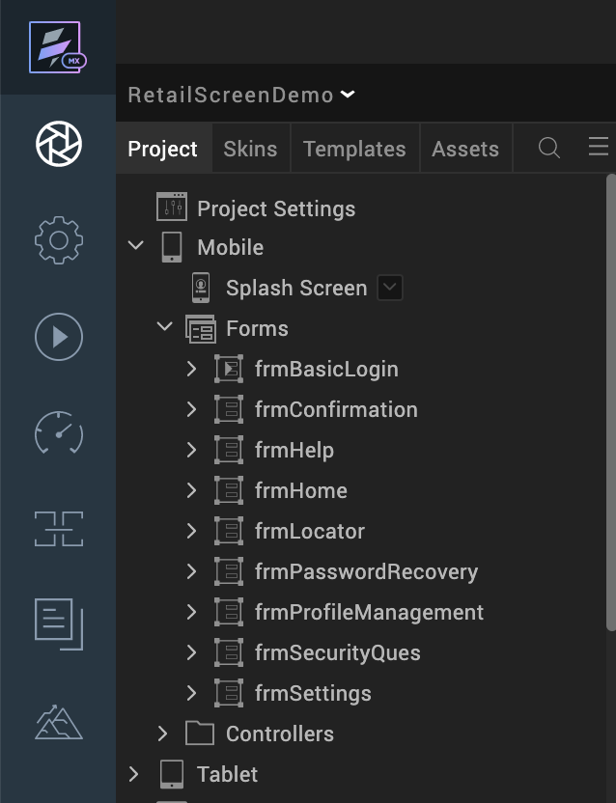

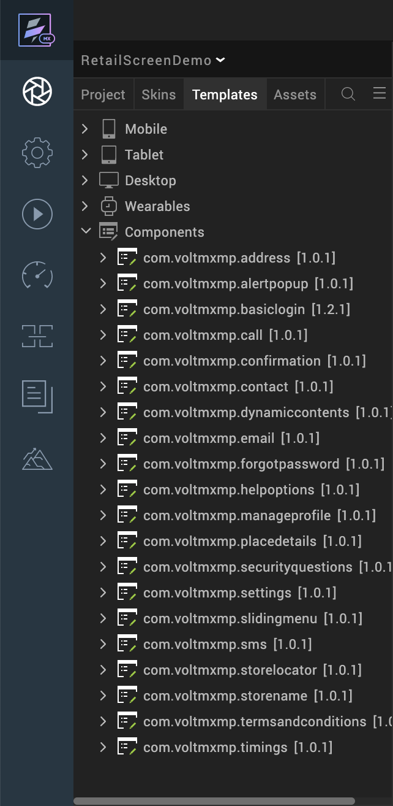

D. Add test user on Foundry server
Login Foundry server with your account, search your App, the default App name looks like RetailScreenDemo.
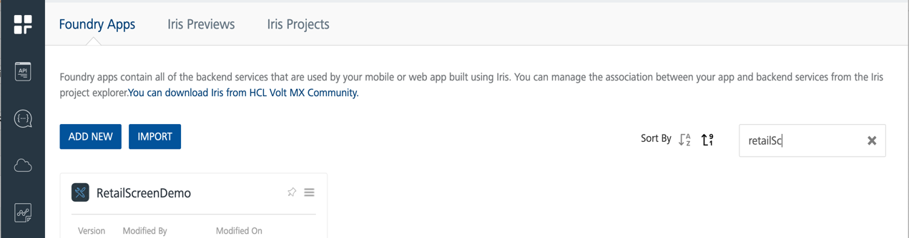

- Double click RetailScreenDemo, click userrepository, and test user.
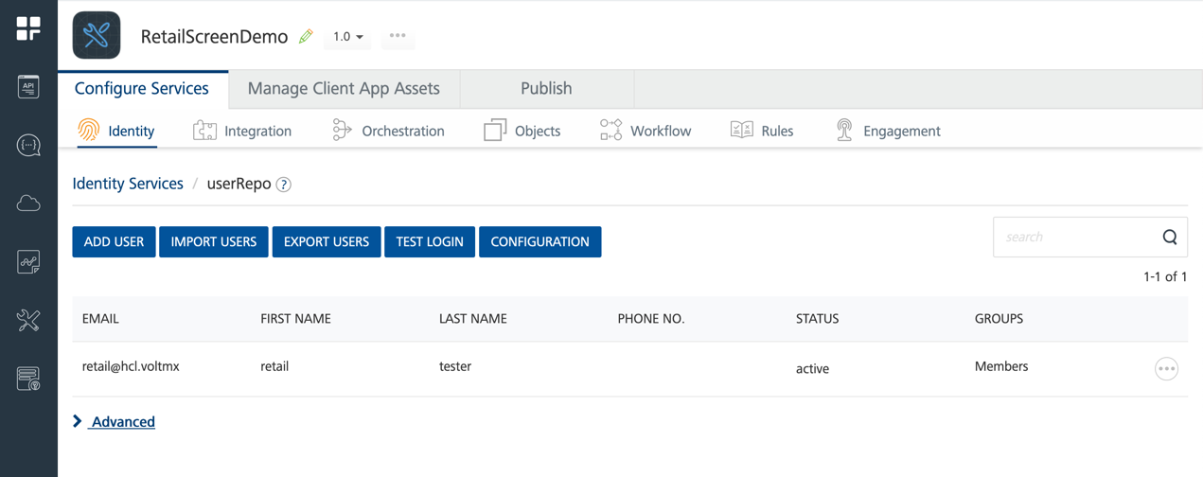

Publish RetailScreenDemo App.

E. Generate and configure Map Key
Follow the following guide to generate Map key and fill them on the Project setting page. Generate And Configure Map Key
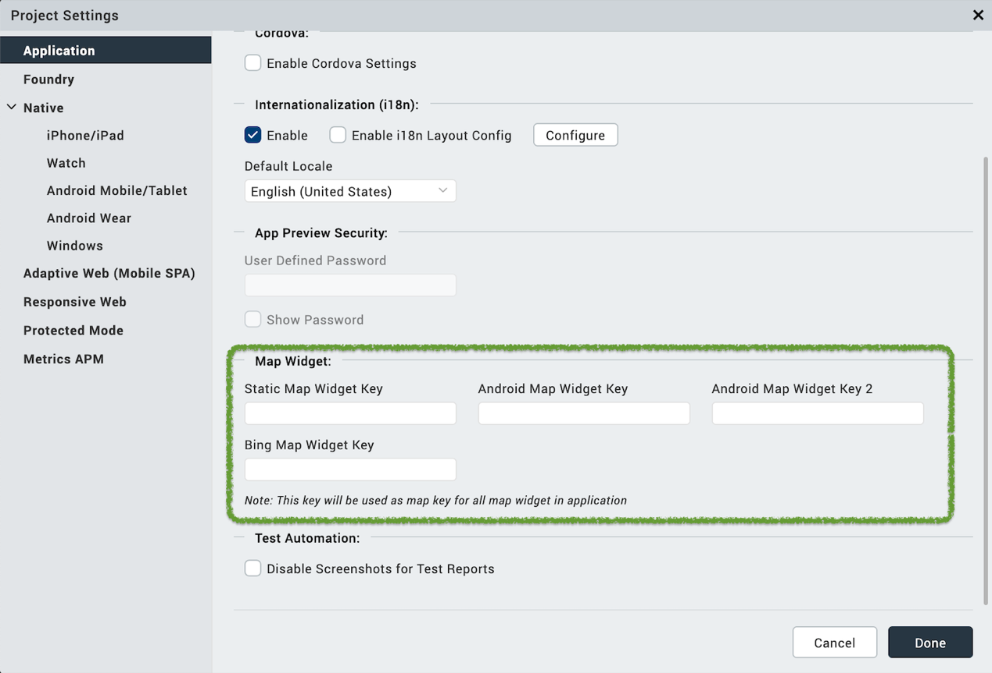

F. Building and previewing the app
After performing all the above steps, you can build your app and run it on your device. For more information, you can refer to the Building and Viewing an Application section of the Volt MX Iris User Guide.
You can then run your app to see the Common Retails Screens App work in real time.

App Functionality

Login Screen
Login page has several functions.
- Sign in with correct username and password navigates user to Promotion page.
- Click Remember Me, user credentials is stored locally.
- Click Forgot password navigate user to password recover screen.
- Click the three buttons at the bottom pop up related information.
- Click eye icon displays password.
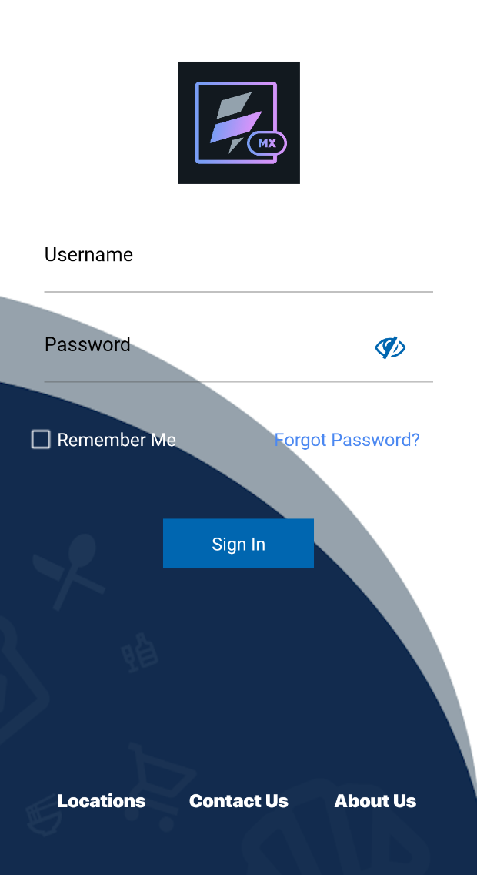

Promotion Screen
After sign in, Promotion Screen displays.
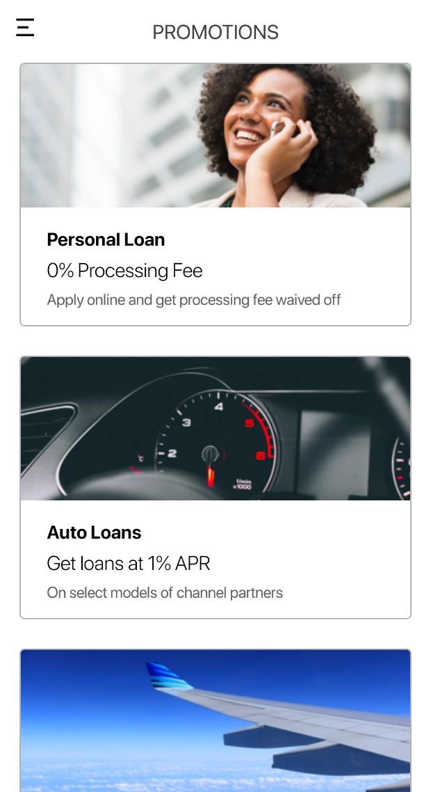

Slide Menu Screen
Click menu icon at the top left corner of Promotion Screen. Slide menu Screen displays.
- User avatar, name and email account is displayed on the top.
- Menu is listed in the middle, click each menu navigate to different screens.
- Logout icon is displayed at the bottom
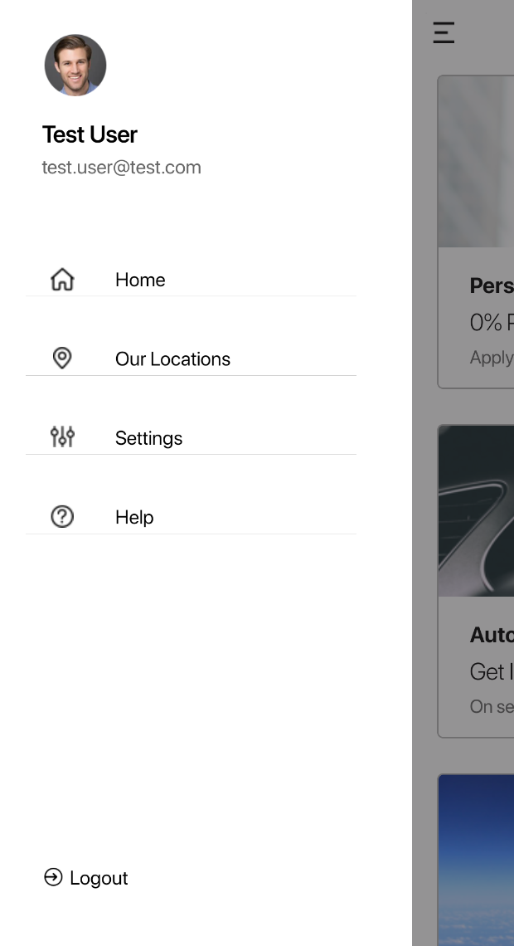

Store Locators Screen
Go to Store Locators Screen by clicking menu - Our Locations on Promotion Screen. The Store locations can be displayed in List or in Map.
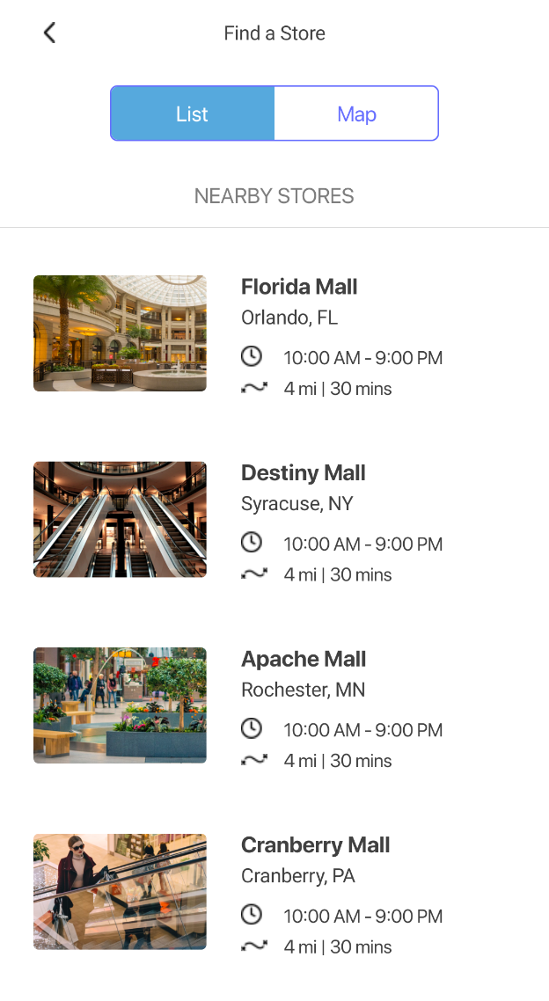
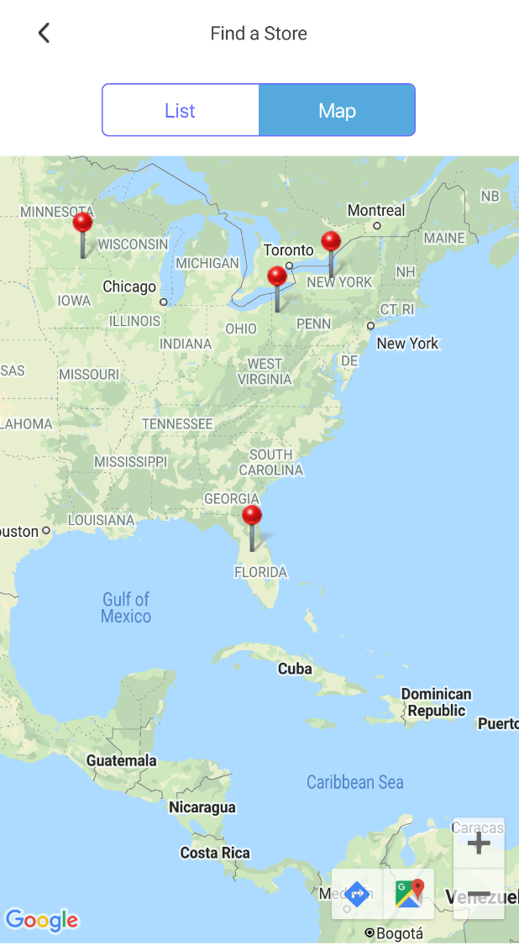

Settings Screen
Go to Settings Screen by clicking menu – Settings on Slide Menu Screen
- Click Manage Profile navigates to Manage Profile Screen
- Click Security Questions navigates to Security Question Screen
- Click Terms and Conditions navigates to Terms screen
- Click About Us, Contact Us pop up related information
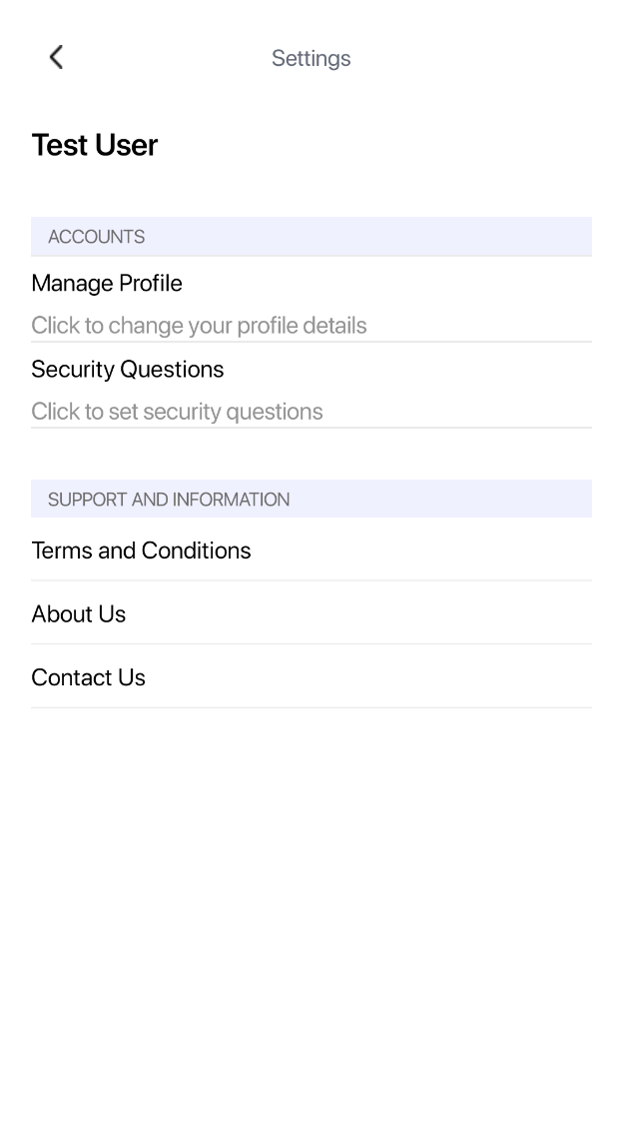

Mange Profile Screen
User can click edit to update Private Information or Address Details.
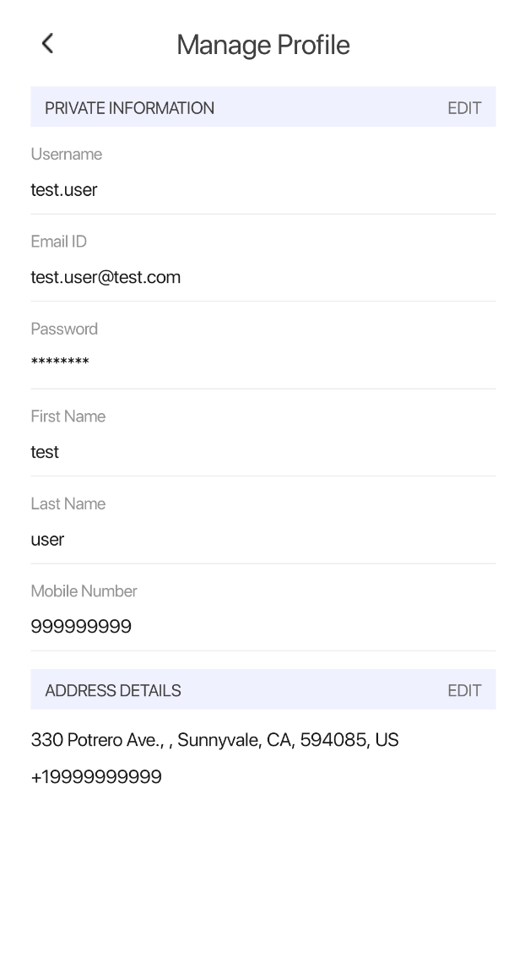

Security Questions Screen
Setup security questions.
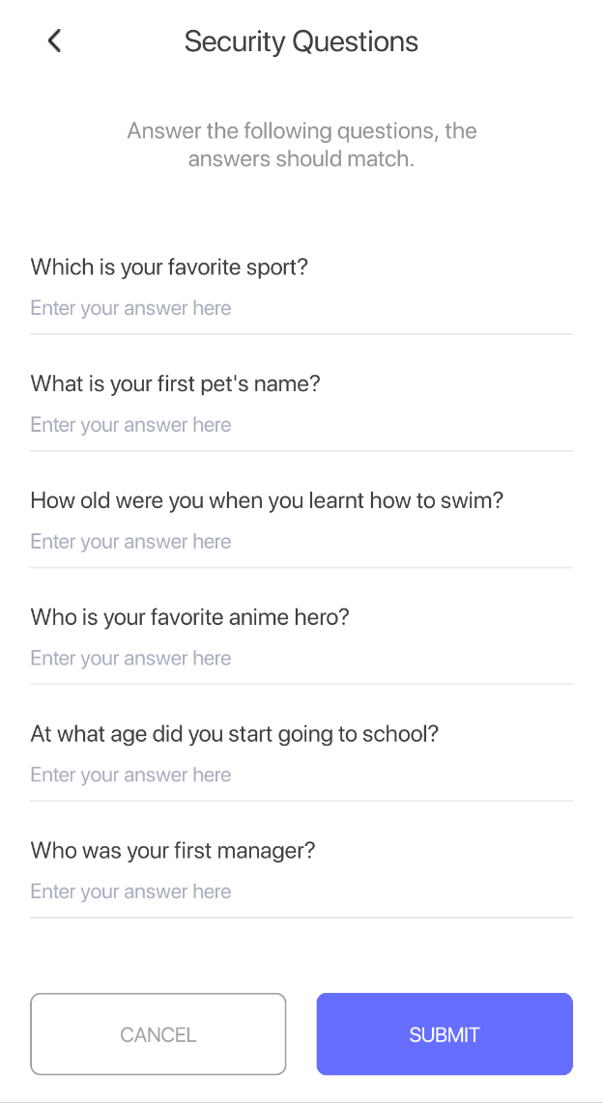

Confirmation Screen
Click button submit, confirmation screen displays.
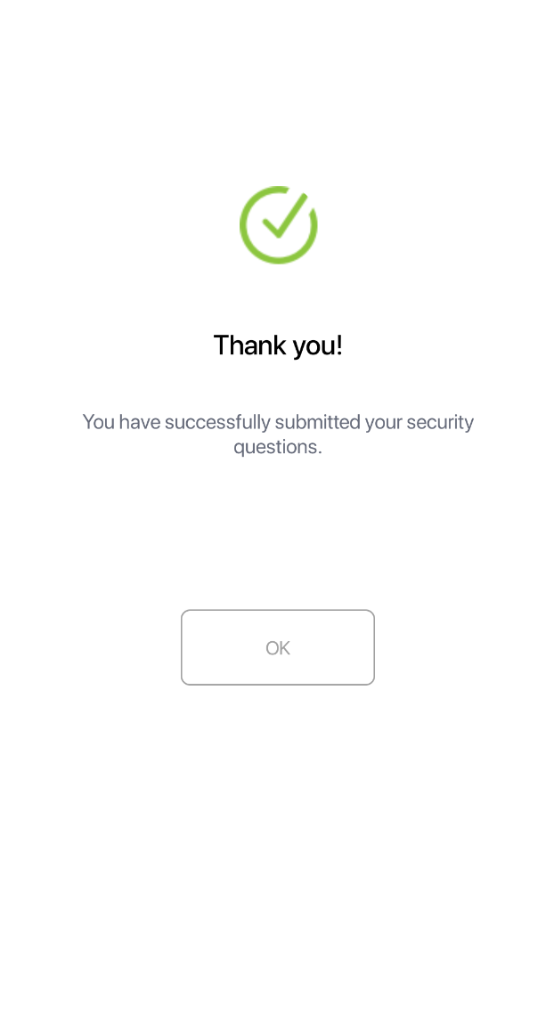

Terms And Condition Screen

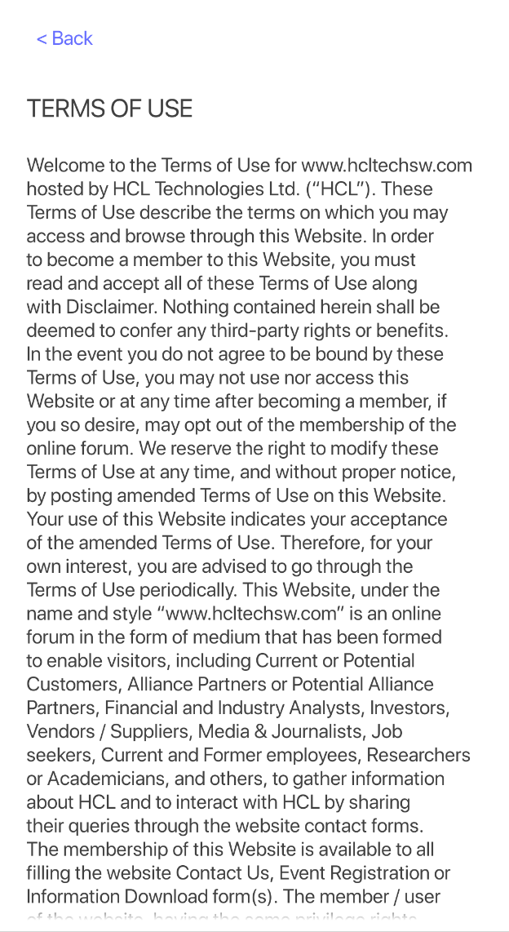

Help Options Screen

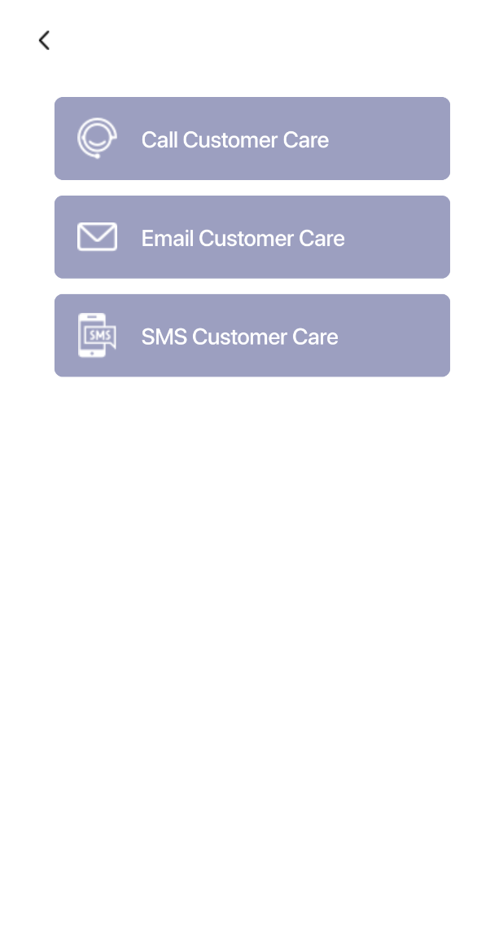

Forgot Password Screen

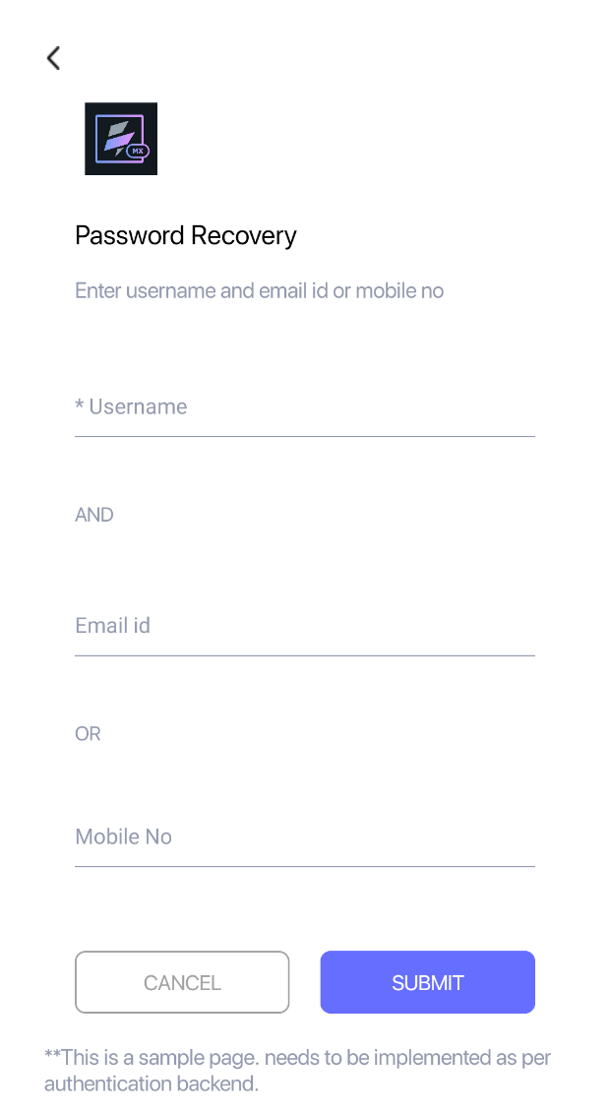

Revision History
App version 1.0.1

Known Issues

No issues

B. Limitations

Availability of Maps services is contingent on viability of the maps license key. Please check Using Map API for more information.

