Date : 02-APR-26
Horizontal Bar Chart-SingleBar,Multi Bar
VERSION: 1.0.0

- OVERVIEW
Horizontal Bar Charts (Single Bar and Multi Bar) are used to represent data through horizontally aligned bars, making it easy to compare values across different categories. This component supports both single-series and multi-series datasets, enabling clear visualization of individual metrics as well as grouped comparisons. It is especially useful for displaying ranked data, survey results, performance metrics, and category-based comparisons where longer labels require improved readability and better layout handling.
Note: When you use createChart() API, the values provided through component properties are invalid.

This upgrade from v2.8 to v4.5 introduces major improvements such as modular plugin management, simplified configuration syntax, and enhanced rendering performance.

- Usecase:

- Display data in a horizontal bar chart format to compare categories, highlight differences in values, and rank items clearly across groups.

B. Percentage of re-use:
90% (Data and skins can be customizable)
C. Features:
- Ready-to-use Chart
- Useful component for project analysis
- Easy to plug into your app
- Facility to modify the UI

GETTING STARTED
A. Prerequisites
Before you start using the Horizontal bar chart component, ensure you have the following:
- HCL Foundry
- Volt MX Iris

B. Platforms Supported

i. Mobile

1. iOS

2. Android

ii. Tablets

iii. PWA

Importing the Component

You can import the Forge components only into the apps that are of the Reference Architecture type.

To import the Horizontal bar chart component, do the following:

Open your app project in Volt MX Iris.
- In the Project Explorer, click the Templates tab.

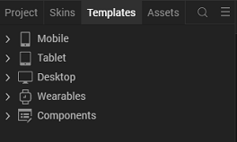

3.Right-click Components, and then select Import Component. The Import Component dialog box appears.
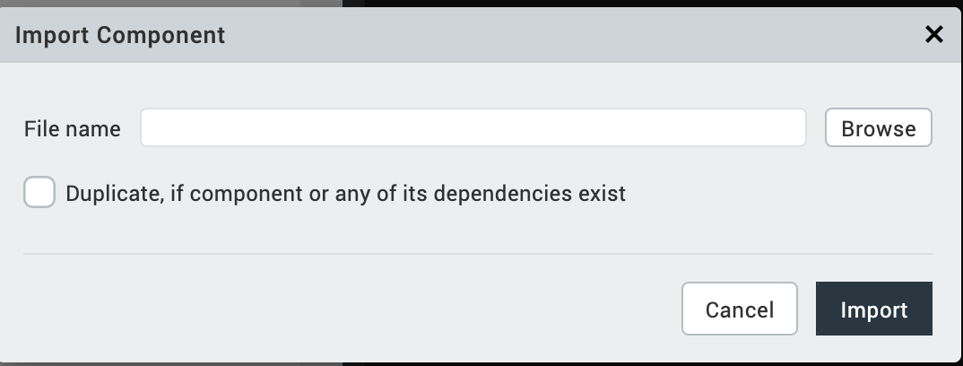

4.Click Browse to navigate to the location of the component, select the component, and then click Import. The component and its associated widgets and modules are added to your project.
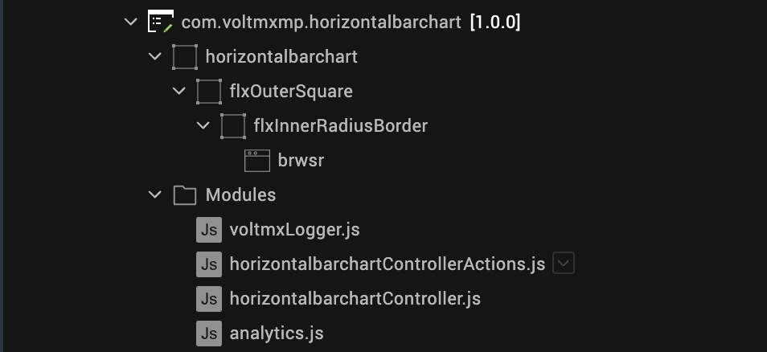

Once you have imported a component to your project, you can easily add the component to a form. For more information, refer Add a Component to a Form.

DISCLAIMER :
1. All chart components are built to work with a specific version of the Chart.js library. It is mandatory to use the same Charts.js file and charts_lib.js across all chart components within the application.
2.Mixing different versions of Chart.js (for example, using one version for a Vertical Bar Chart and another for a Scatter or Mixed Chart) may lead to rendering issues, configuration conflicts, unexpected behavior, or complete component failure.
3.To ensure stability, compatibility, and consistent performance, always verify that all chart components reference and load the identical Chart.js version.
4.When you create a new project and import two chart components, Volt MX sometimes generates both charts and copycharts folders inside the web directory. This duplication causes one component to stop working if one folder is removed incorrectly. To fix this, keep only one folder (for example, charts) and delete copycharts. Then, in Volt MX Iris, open the component that is not working. Select its Browser widget, go to Properties → Look → Local File, and update the path to point to the remaining charts folder. Finally, clean and rebuild the project to apply changes properly.
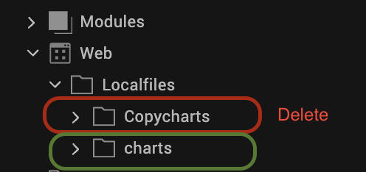
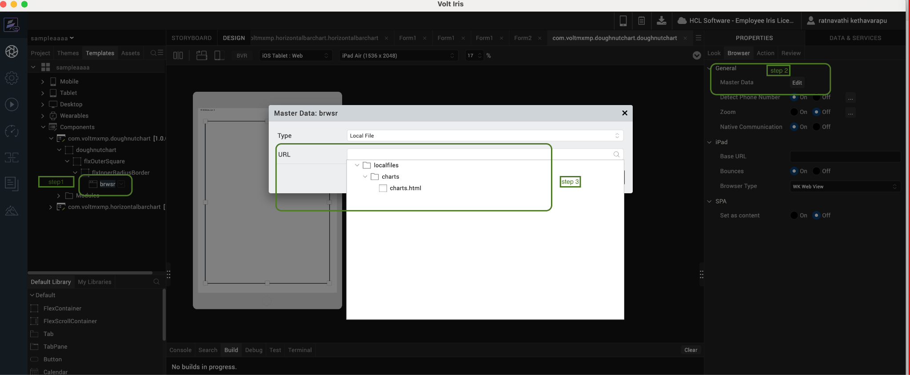

3.REFERENCES

A. Dynamic Usage
You can also add an Horizontal bar chart component dynamically. To do so:
- In the Project Explorer, on the Projects tab, click Controllers section to access the respective Form Controller. Create a method and implement the code snippet similar to the sample code mentioned below.
In the code snippet, you can edit the properties of the component as per your requirement. For more information, see Setting Properties.

define(function() {

return {

onNavigate: function() {

this.createComponent();

},

createComponent: function() {

/* Creating the component's object */

var chartjs = new com.voltmxmp.horizontalbarchart({

"height": "100%",

"id": "chartjs",

"isVisible": true,

"left": "0dp",

"masterType": constants.MASTER_TYPE_USERWIDGET,

"isModalContainer": false,

"skin": "slFbox",

"top": "0dp",

"width": "100%",

"appName": "Testchart",

"viewType": "chartjs",

"overrides": {}

}, {}, {});

chartjs.enableTitle = true;

chartjs.enableLegend = true;

chartjs.duration = 1000;

chartjs.noOfColumns = "2";

// ✅ Multi-bar format

chartjs.gridChartDataSet = {

"data": [

{

"bgColor": "#ffffff",

"chartType": "Horizontal Bar",

"color": "#2196F3",

"data": "[85,90,78,88,92]",

"labels": "[Maths,Science,English,History,Geography]",

"title": "Student Scores Comparison",

"label": "Student A"

},

{

"bgColor": "#ffffff",

"chartType": "Horizontal Bar",

"color": "#FF5722",

"data": "[80,85,82,84,89]",

"labels": "[Maths,Science,English,History,Geography]",

"label": "Student B"

}

]

};

chartjs.fontsize = "12";

chartjs.renderType = true;

chartjs.titlePosition = "top";

chartjs.legendPosition = "top";

chartjs.easing = "easeOutQuart";

chartjs.fontfamily = "Helvetica";

chartjs.fontstyle = "normal";

chartjs.fontcolor = "black";

this.view.add(chartjs);

}

};

});

- Save the file.
B. Properties
The properties provided on the Component tab allow you to customize the UI elements in the HorizontalBarchart component. You can set the properties directly on the Component tab or by writing a JavaScript.
1. Render Automatic
Category: | Custom
Description: | Specifies the type of rendering (automatic or forced). If you use a true component, the chart is rendered automatically. But in other cases, the render API must be called to display the charts.
Syntax: | renderType
Type: | boolean
Read/Write: | Write
Example: | this.view.<component_id>.renderType = true;
2. Data set
Category: | Custom
Description: | Specifies the input data set such as color, labels, and chart type. The data is then displayed in a chart format. Every row in the datagrid generates a chart.
Syntax: | gridChartDataSet
Type: | Data Grid
Read/Write: | Read + Write
Example:
  this.view. < component_id > .gridChartDataSet = {
  "data":
  [ {
  "bgColor": "#ffffff",
  "chartType": "Horizontal Bar",
  "color": "#77be43",
  "data": "[199,250,220,255,230]",
  "labels": "[Travel,Food & Dining,Shopping,Bills,Health]",
  "title": "Budget (USD)"
  }
  ]
- Enable Legend
Category: | Custom
Description: | Enables the visibility of the chart legends.
Syntax: | enableLegend
Type: | Boolean
Read/Write: | Write
Example: | this.view.<component_id>.enableLegend = true;
- No of Columns

Note: For a single chart component, you should always set noOfColumns = 1 (or just pass 1 as the first argument to createChart). This matches the property definition and usage in your controller.
Category: | Custom
Description: | Specifies the number of columns to be displayed in Responsive Web and Tablet. Not applicable for Mobile. In Mobile, the charts are always displayed in one column.
Syntax: | noOfColumns
Type: | String/Integer
Read/Write: | Write
Example: | this.view.<component_id>.noOfColums = 1;

- Legend Position
Category: | Custom
Description: | Enables you to set the position of the legends in the chart.
Syntax: | legendPosition
Type: | String
Read/Write: | Write
Example: | this.view.<component_id>.legendPosition = "top";
- Enable Title
Category: | Custom
Description: | Enables the visibility of the chart title.
Syntax: | enableTitle
Type: | Boolean
Read/Write: | Write
Example: | this.view.<component_id>.enableTitle = true;

7. Title Position
Category: | Custom
Description: | Enables you to set the position of the title in the chart.
Syntax: | titlePosition
Type: | String
Read/Write: | write
Example: | this.view.<component_id>.titlePosition= "top";
8. Duration
Category: | Custom
Description: | Specifies the time taken by the animation in milliseconds. If animation is not required, you must set the value of duration as 0.
Syntax: | duration
Type: | Integer
Read/Write: | write
Example: | this.view.<component_id>.duration = 1000;
9. Easing
Category: | Custom
Description: | Sets the type of animation in the chart.
Syntax: | easing
Type: | String
Example: | this.view.<component_id>.easing = "easeOutQuart";
Read/Write: | write

10. Font Color
Category: | Custom
Description: | Specifies the font color of the displayed text.
Syntax: | fontcolor
Type: | String
Example: | this.view.<component_id>.fontcolor = "#232425";
Read/Write: | write

10. Font Size
Category: | Custom
Description: | Specifies the font size of the displayed text. By default, the size is measured in pixels (px).
Syntax: | fontsize
Type: | String
Example: | this.view.<component_id>.fontsize = "12";
Read/Write: | write
11. Font Family
Category: | Custom
Description: | Specifies the font family of the displayed text.
Syntax: | fontfamily
Type: | String
Read/Write: | write
Example: | this.view.<component_id>.fontfamily = "Arial";
12. Font Style
Category: | Custom
Description: | Specifies the font style of the displayed text.  Note:  The fontstyle property does not apply to tooltip, footer, and title of the chart.
Syntax: | fontstyle
Type: | String
Read/Write: | write
Example: | this.view.<component_id>.fontstyle = "normal";
C. Events
The Horizontal bar chart component invokes events when its corresponding action is performed. You can configure any logic that you want the component to perform whenever an event occurs. The events can be configured directly from the Actions tab or by writing a JavaScript snippet, For more information, refer Add Actions.
1. errorCallback
Category: | Custom
Description: | The event is invoked when an error occurs.
Syntax: | errorCallback
Example: | this.view. < component_id > .errorCallback = function(errorObject) {  alert(errorObject);  }
- APIs
You can use the following APIs for Horizontal bar chart component:
1. render
Description: | Renders or displays the charts as per the data provided through Properties. This API is called initially to render any chart.
Syntax: | render()
Example: | this.view.<component_id>.render();
2. createChart
Description: | Creates and displays charts based on the data that you provide in the parameters.  The createChart API helps you to create
Syntax: | createChart(noOfColumns,dataObject,globalConfigurations)
Parameters: | - dataObject  Specifies the data and other configuration options for every chart. For more information on configuration options for different chart types, click here.  dataObject : {  "<chart_ID>" : {  "type" : "chart type",  "data" : "chart Data",  "options" : "chart options"  }  }  - globalConfigurations  Global configurations allow you to change options globally across all the charts generated using the component, avoiding the need to specify options for each instance. These properties control styling, fonts, legends, and more. For more information on the globalConfigurations parameter, click here.  {  "defaultColor" : "#234354",  "defaultFontColor" : "#000000",  "animation" : {  "duartion" : 1000,  "easing" : "easeOutQuart"  },  "events" : ["mosuemove"],  "hover" : {  "animationDuration" : 400,  "mode" : "nearest"  },  "layout" : {  "padding" : {  "top" : 0  }  },  "legend" : {  "display" : true  },  "plugins" : {  "responsive" : true  },  "title" : {  "display" : true,  "fontStyle" : "bold"  },  "tooltips" : {  "backgroundColor" : "#000000",  "caretSize" : 5  }  }
Example: | define({  onBtnRenderChartClick: function() {  try {  this.renderCharts();  } catch(e) {  alert("Error in button click: " + e.message);  }  },  renderCharts: function() {  try {  // Remove existing chart if present  if (this.view.chartjsDynamic) {  this.view.remove(this.view.chartjsDynamic);  }  // Create the horizontal bar chart component  var chartjs = new com.voltmxmp.horizontalbarchart({  "clipBounds": true,  "height": "80%",  "id": "chartjsDynamic",  "isVisible": true,  "left": "0dp",  "top": "100dp",  "width": "100%",  "zIndex": 1  }, {}, {});  // Add to form  this.view.add(chartjs);  // IMPORTANT: Set properties before calling createChart  chartjs.enableTitle = true;  chartjs.titlePosition = "left";  chartjs.enableLegend = true;  chartjs.legendPosition = "top";  // Prepare horizontal bar chart data  var chartData = [  {  title: "Top Spending Categories (USD)",  chartType: "horizontalBar",  labels: "[Rent,Tours,Food,music,dance]",  data: "[1200,450,380,250,180]",  color: "#e74c3c",  label: "Monthly Expenses"  }  ];  // Prepare data object for createChart API  var dataObject = {  data: chartData  };  // Global configurations  var globalConfig = {  animation: {  duration: 1000,  easing: "easeOutQuart"  }  };  // Always use 1 column for a single chart component chartjs.createChart(1, dataObject, globalConfig);  alert("Horizontal bar chart rendered successfully!");  } catch (exception) {  alert("Error rendering chart: " + exception.message);  }  }  });
For more information on how to create a chart by using Chart.js, click here.

4. REVISION HISTORY
App version :1.0.0

- Known Issues
No known issues

