Date : 28-Oct-21
History FORM (1.0.1)
- Overview
Let’s you view past records for any entity to understand the asset’s performance and better plan for future use-cases. This is the most common use-case for any work request/service request scenario, in which the user needs access to historical records to understand the task in hand. Can be integrated into any entity in the data model for which historical records need to be maintained and displayed as a reference.

Use case

Maintaining Records

Asset’s performance and better plan for future

Workout or Daily Planner App

B. Features

A sample form displayed in a recent first format(The sorting order is configurable).

All the historical inspection values (per service request) displayed in the form

fully customisable look and skin properties to rebrand and redesign the form for your requirement

JSON input format

C. Percentage of re-use:
70-80% (Data and skins are customized and can be changed manually)

Getting Started

Prerequisites
Before you start using the History Form component, ensure you have the following:
- HCL Foundry
- Volt MX Iris

Platforms Supported

Mobile

iOS

Android

Tablets

PWA

Importing the Component

You can import the Forge components only into the apps that are of the Reference Architecture type.

To import the History Form component, do the following:

Open your app project in Volt MX Iris.
- In the Project Explorer, click the Templates tab.

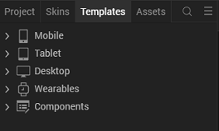

3.Right-click Components, and then select Import Component. The Import Component dialog box appears.
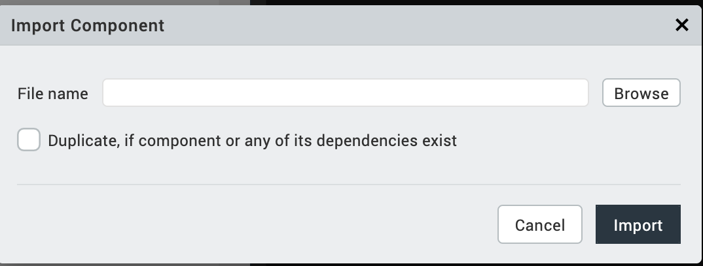
4.Click Browse to navigate to the location of the component, select the component, and then click Import. The component and its associated widgets and modules are added to your project.
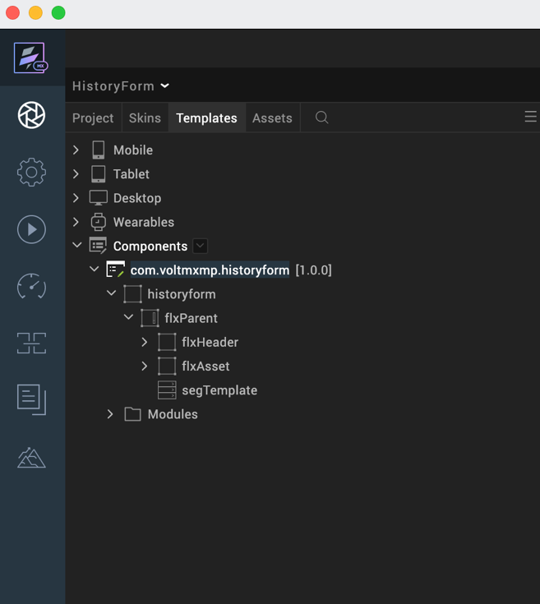

Once you have imported a component to your project, you can easily add the component to a form. For more information, refer Add a Component to a Form.

Building and previewing the app
After performing all the above steps, you can build your app and run it on your device. For more information, you can refer to the Building and Viewing an Application section of the Volt MX Iris User Guide.
You can then run your app to see the History Form work in real time.

3. References

A. Dynamic Usage
If you want to use the History Form component dynamically, you will need to import the component into your project Templates. Follow the given steps to do so

Download the component from HCL VoltMX Marketplace as a zip file.

Go to the Templates tab in your project explorer.

Right click on Components and select Import Component.

Navigate to where you downloaded your zip file and import it into Iris.

After you import the component into your project templates, you can add it to your app dynamically. To do so, follow the given steps

Access the FormController of the form you want to add the component into.

Create a function called createComponent(); and write the code inside it to create and configure the component.

You can refer to the given sample code for more information.
/*Creating a component's Object */
var Historyform = new com.voltmx.historyform(
{
"clipBounds": true,
"height": "100%",
"id": " historyform ",
"isVisible": true,
"left": "0dp",
"top": "0dp",
"width": "100%",
"zIndex": 1

}, {}, {});

//Configuring the component properties
Historyform.headerText = "Asset 6A578C";
Historyform.headerImageSrc = "voltmxqfs_close_1.png”;
Historyform.headerIDText="TRANS”;
Historyform.headerCategoryText="Transformers";

//Adding the component to the form
this.view.add(Historyform);
},
- Save the file.

B. Properties
The properties provided on the Component tab allow you to customize the UI elements in the History Form component. You can set the properties directly on the Component tab or by writing a JavaScript.
1. Master Data(masterdata)
Description: | Specifies the list of data sources to the History Form.
Syntax: | masterdata
Type: | Data Grid
Read/Write: | Write
Example: | var sampleData=  [  [{  "lblDate": "13th July,",  "lblTime": "8:10 hrs",  "lblInspectionValue":"ins007",  "lblInspectionID":"inspectionID"  },  [{  "lblRowHeader": "Temperature",  "lblRowHeaderValue": "100"  }, {  "lblRowHeader": "Climate",  "lblRowHeaderValue": "Good"  },  {  "lblRowHeader": "Result",  "lblRowHeaderValue": "PASS"  }]  ],  [{  "lblDate": "14th July,",  "lblTime": "8:20 hrs",  "lblInspectionValue":"ins234",  "lblInspectionID":"inspectionID"  },  [{  "lblRowHeader": "Temperature",  "lblRowHeaderValue": "100"  }, {  "lblRowHeader": "Result",  "lblRowHeaderValue": "PASS"  }]  ],  [{  "lblDate": "15th July,",  "lblTime": "8:30 hrs",  "lblInspectionValue":"ins567",  "lblInspectionID":"inspectionID"  },  [{  "lblRowHeader": "Climate",  "lblRowHeaderValue": "Good"  }, {  "lblRowHeader": "Result",  "lblRowHeaderValue": "PASS"  }]  ]  ];

- Header Text(titleText)
Category: | Pass Through
Description: | Specifies the title of the History Form.
Syntax: | titleText
Type: | String
Read/Write: | Read + Write
Example: | this.view.componentID.titleText = "Title";

- Close Button Visibility(iconVisibility)
Category: | Pass Through
Description: | Specifies the icon visibity of the History Form.
Syntax: | iconVisibility
Type: | Boolean
Read/Write: | Read + Write
Example: | this.view.componentID.iconvisibility =true;

- Close Button Source(iconSrc)
Category: | Pass Through
Description: | Specifies the close button image of the History Form.
Syntax: | iconSrc
Type: | Src
Read/Write: | Read + Write
Example: | this.view.componentID.iconSrc = "voltmx_close.png";

- Asset Text(headerText)
Category: | Pass Through
Description: | Specifies the Asset Text of the History Form.
Syntax: | headerText
Type: | String
Read/Write: | Read + Write
Example: | this.view.componentID.headerText = "sample text";

- ID Text(headerIDText)
Category: | Pass Through
Description: | Specifies the ID Text of the History Form.
Syntax: | headerIDText
Type: | String
Read/Write: | Read + Write
Example: | this.view.componentID.headetIDText = "Title";

- Category(headerCategoryText)
Category: | Pass Through
Description: | Specifies the Category text of the History Form.
Syntax: | headerCategoryText
Type: | String
Read/Write: | Read + Write
Example: | this.view.componentID.headerCategoryText = "sample header";

C. Events
-- None of the events are exposed.

API’s
This API sets the data to the History Form. You need to give the input data as a parameter.
You need to define this setData in the form controller and call this in the template controller using this syntax

SetData

Description: This method is used to create records for the component.
Syntax: setData(data)
Parameters: data (type - json)
Return Value: None
Example: this.view.componentID.setData (sampleData);
Remarks: Keys in the json should always be same.
Sample Input Format
You need to add this in the Form controller.
postShow:function(){

var sampleData=
[
[{
"lblDate": "13th July,",
"lblTime": "8:10 hrs",
"lblInspectionValue":"ins007",
"lblInspectionID":"inspectionID"
},
[{
"lblRowHeader": "Temperature",
"lblRowHeaderValue": "100"
}, {
"lblRowHeader": "Climate",
"lblRowHeaderValue": "Good"
},
{
"lblRowHeader": "Result",
"lblRowHeaderValue": "PASS"
}]
]
]
this.view.historyform.setData(sampleData);

}

In the given JSON format:
- title is a String that specifies the Title of the history form.
- SampleData is a JSON Array that represents the number of sessions in an event.
The code that specifies about the calling of set data function in the Template controller.
For example
setData : function(data){
this.view.segTemplate.data=data;
}

Revision History
App version 1.0.1

A. Known Issues

B. Limitations
- Land Scape mode is not supported

