Date : 14-Apr-26

HELICONE

VERSION: 1.0.0

OVERVIEW
Helicone API is an AI gateway and observability platform that provides a unified interface to interact with multiple large language and multimodal AI models through a single REST API. It enables developers to integrate, manage, and monitor AI model usage efficiently without being tied to a single provider.
Helicone supports models from providers such as OpenAI, Anthropic, and Google, along with open-source models like Llama and Mistral. The API is compatible with OpenAI-style request formats, making it easy to migrate or integrate existing applications.
It supports a wide range of AI capabilities including text generation, chat completions, embeddings, and multimodal inputs (text and images). Developers can send HTTP requests to Helicone, which intelligently routes them to the appropriate model provider.
In addition to model access, Helicone provides advanced features such as request logging, analytics, caching, retry mechanisms, rate limiting, and cost tracking. It also supports both Bring Your Own Key (BYOK) and managed billing options for flexible usage control.
Helicone is ideal for building scalable AI-powered applications such as chatbots, content generators, AI assistants, translation systems, and multimodal solutions, while maintaining visibility, performance monitoring, and cost optimization.

Use case:
- Multi-Model Chatbots & Virtual Assistants – Build conversational AI by routing requests to models like Llama, Mistral, or providers such as OpenAI and Anthropic through a single API.
- Unified Text Generation & Summarization – Generate content such as emails, blogs, and summaries using different models via one OpenAI-compatible interface.
- Smart Model Routing & Optimization – Dynamically route requests to the best-performing or lowest-cost model based on latency, pricing, or use case requirements.
- AI Request Logging & Monitoring – Track all API requests and responses with detailed logs, enabling debugging, auditing, and performance analysis.
- Cost Tracking & Usage Analytics – Monitor token usage and costs across multiple providers to optimize spending and improve efficiency.
- Caching & Performance Optimization – Reduce latency and cost by caching repeated AI responses and reusing them when applicable.
- Failover & Reliability Handling – Automatically retry or switch providers if a request fails, ensuring high availability for AI applications.
- Prompt Testing & Experimentation – Iteratively test prompts across different models and compare outputs to improve quality and accuracy.
- Multimodal AI Applications – Build applications that support text and image inputs by integrating multiple providers through a single gateway.
- AI Observability & Debugging Tools – Gain insights into request performance, latency, and errors with dashboards and analytics.
- Scalable AI Integrations – Easily integrate AI into web and mobile applications using REST APIs without managing multiple provider SDKs.

Features:
- Multiple Model Access:
Access a wide range of AI models from providers like OpenAI, Anthropic, Google, and open models such as Llama and Mistral through a single unified API gateway.
- Unified Text Generation & Chat:
Generate high-quality text, perform chat completions, summarization, and conversational AI interactions using an OpenAI-compatible API format.
- Smart Model Routing:
Dynamically route requests to different models or providers based on cost, latency, or performance requirements for optimized results.
- AI Request Logging & Observability:
Track and monitor all API requests and responses with detailed logs, enabling debugging, auditing, and performance analysis.
- Cost Tracking & Usage Analytics:
Monitor token usage, request counts, and overall costs across multiple providers to optimize budget and usage.
- Caching & Performance Optimization:
Improve response time and reduce costs by caching repeated requests and reusing responses when applicable.
- Failover & Reliability Handling:
Ensure high availability with automatic retries and fallback to alternative providers if a request fails.
- OpenAI-Compatible REST API:
Easily integrate with existing applications using standard HTTP requests and JSON responses without major code changes.
- Prompt Testing & Experimentation:
Test and compare prompts across multiple models to evaluate output quality and refine AI responses.
- Scalable & Developer-Friendly:
Provides a flexible and scalable infrastructure for building AI-powered applications without managing multiple APIs separately.

GETTING STARTED

Prerequisites
Before you start using the Helicone Adapter, ensure you have the following:

- HCL Foundry
- Helicone API Key Account - Get a Helicone API key
Step 1: Create a Helicone Account
- Navigate to the Helicone website.
- Sign up using your email, Google, or GitHub account.
- Log in to access the Helicone Dashboard.
Step 2: Generate a Helicone API Key
- Go to the Dashboard.
- Navigate to Settings → API Keys.
- Click on Create API Key.
- Copy and securely store the generated API key.
Step 3: Choose API Usage Method
Helicone supports two methods for using APIs:
Option A: Bring Your Own Key (BYOK) – Recommended
- Obtain an API key from your preferred provider:
  - OpenAI
  - Anthropic
  - Google
- Use Helicone as a gateway by setting the base URL:
https://ai-gateway.helicone.ai/v1
- Include the following headers in your request:
  - Helicone-Auth: Bearer <HELICONE_API_KEY>

Option B: Helicone Managed API Key (Pass-through Billing)
- Add billing details in the Helicone Dashboard.
- Use the generated Helicone API key directly.
- Include the following header in your request:
  - Authorization: Bearer <HELICONE_API_KEY>

B. Importing the Data Adapter

You can import the Helicone Data Adapter into HCL Foundry directly from the Volt MX Forge website or by importing the data adapter zip file.

To import Data Adapter to Volt Foundry, do the following:
- Sign in to the HCL Foundry.
- From the left navigation menu, select API Management.
- In API Management, select Custom Data Adapters.

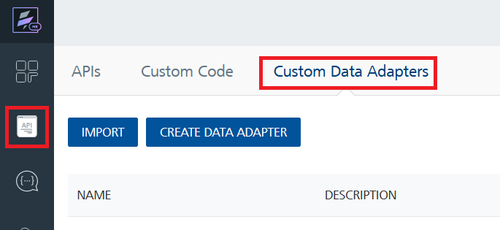

4. Click IMPORT to import a custom data adapter.
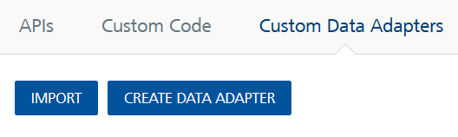
5. On the Import Data Adapter dialog box, click browser to import.

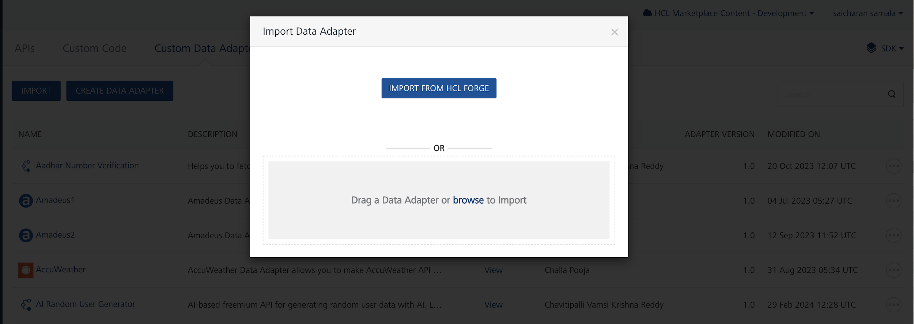
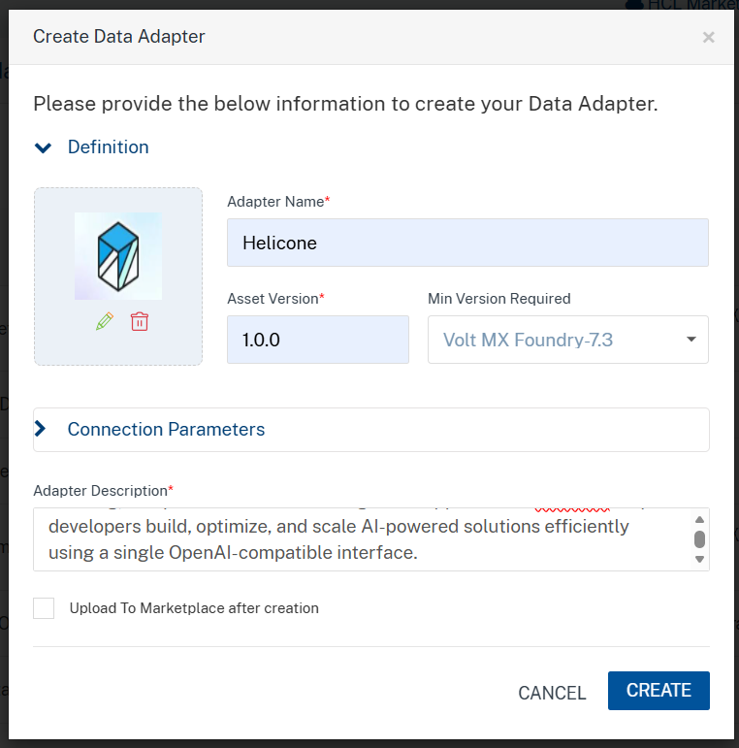

6. Click IMPORT FROM HCL FORGE. The Import Data Adapter from HCL Forge dialog appears with a list of available data adapters.
Click Import. Helicone Data adapter is listed on the Custom Data Adapters page.
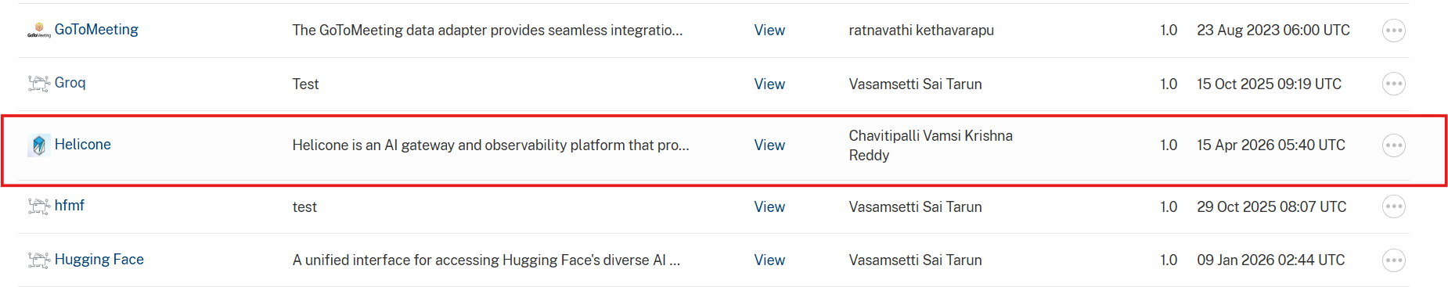
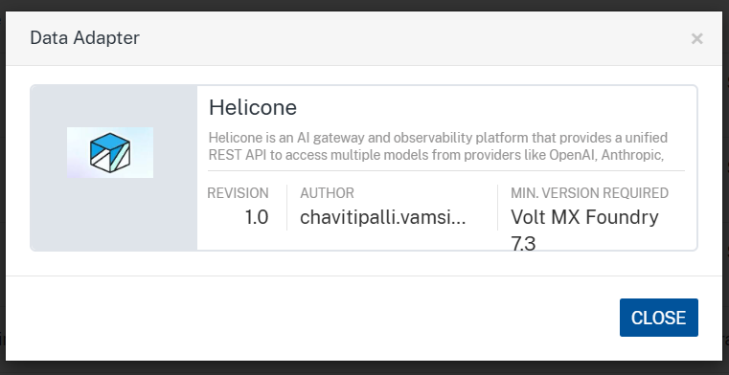
To import the data adapter zip file, do the following:
- Perform steps 1 to 4 in the above procedure
- Drag the data adapter zip file into the Drag a Data Adapter box.
Or
Click browse. The Open dialog appears.
Navigate to the location where you downloaded the data adapter (zip file) on your computer, select the data adapter, and click Open. The Import Data Adapter dialog shows the selected data adapter.
Note: Click Remove if the selected data adapter is not the one that you want to import.

C. Creating an Integration Service with Helicone:
After you import Helicone Data Adapter into Foundry, you must create an integration service with service type Helicone.
To create an integration service with Helicone, do the following:
- Log on to your HCL Foundry. The Dashboard page appears by default.
- In the left pane, click the API Management menu. The APIs tab opens by default.
- Click the Integration tab. The Integration tab opens with a list of existing integration services.
- Click CONFIGURE NEW. The Service Definition tab opens.
- In the Name box, type a unique name for your service.
- From the Service Type list, Helicone.
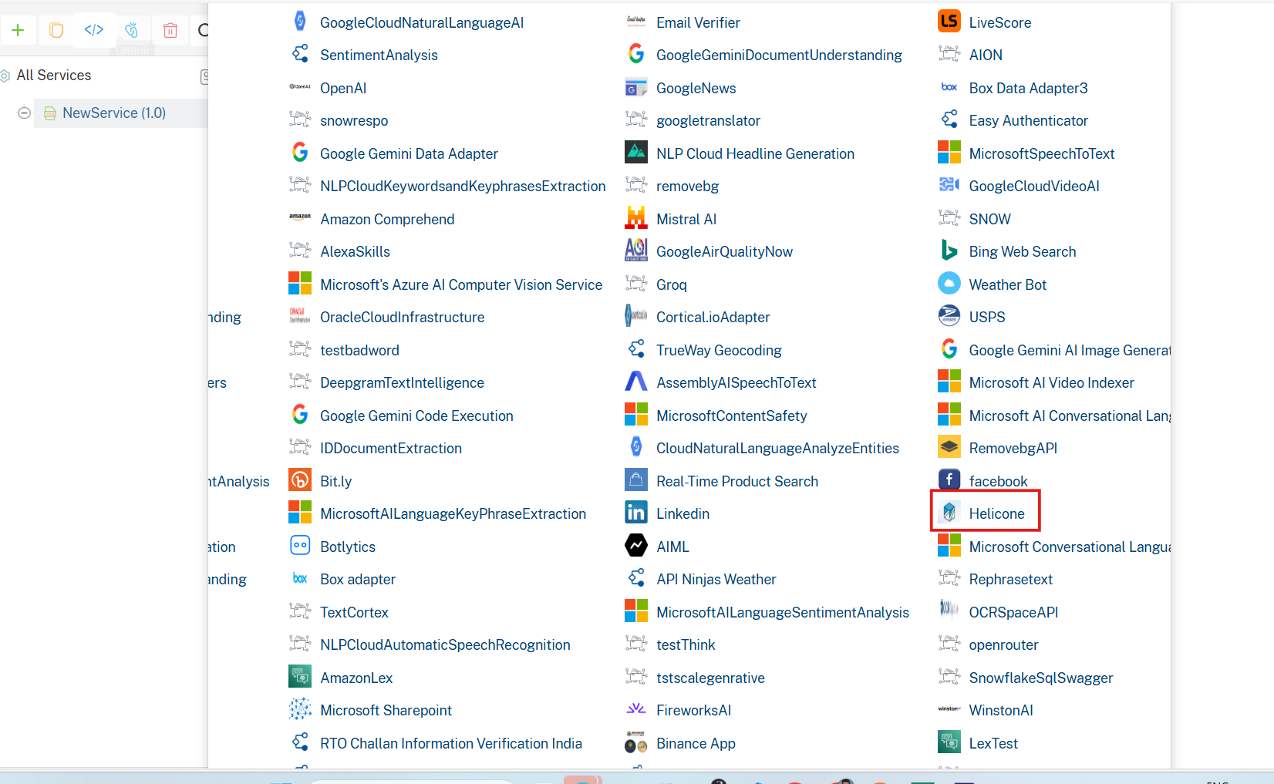
- Click Save

D. Creating an Operation
To make any API call in the HCL Foundry console, you must create an operation for the respective API and then execute the operation. Executing an operation involves making the API call and displaying the response.
This section provides steps to create an operation for the Helicone.
Steps to create an operation for the Helicone:
- Log on to your HCL Foundry. The Dashboard page appears by default.
- In the left pane, click the API Management menu. The APIs tab opens by default.
- Click the Integration tab. The Integration page appears with a list of existing integration services.
- From the list of integration services, select the integration service that you have created with the service type Helicone. The Service Definition tab of the selected integration service opens by default.
- Click the Operations List tab. The Operations List tab opens.
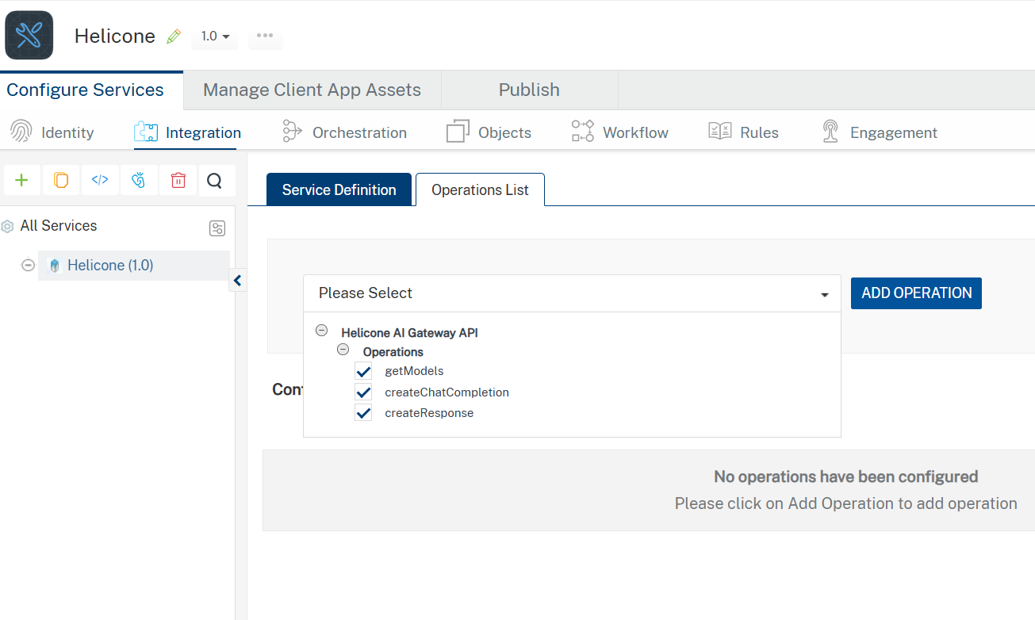
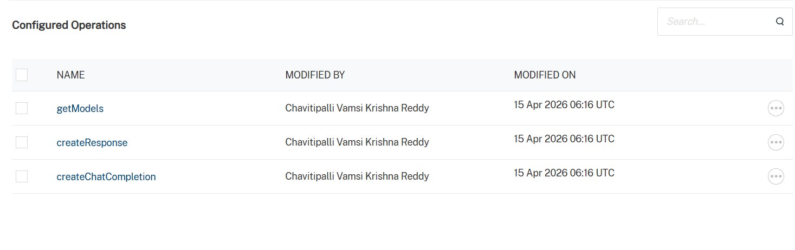
- Select All the operations. Click Add Operations.

E. Executing Operation
Executing an operation involves making the API call by setting the necessary parameters and displaying the response. The procedure to execute any operation is the same, but the request parameters of the APIs vary. This section provides steps to execute the createChatCompletion(explained in Creating an Operation).
Steps to execute the translateText operation:
- Log on to your Hcl Foundry. The Dashboard page appears by default.
- In the left pane, click the API Management menu. The APIs tab opens by default.
- Click the Integration tab. The Integration tab opens with a list of existing integration services.
- From the list of integration services, select the integration service that you have created with service type Helicone. The Service Definition tab of the selected integration service opens by default.
- Click the Operations List tab.
- In the Name box, the name of the operation is displayed by default. If you want, you can change the name.
- On the Request Input tab, in the Body section, for the following parameters, specify the values in the respective boxes under the Test Value column.
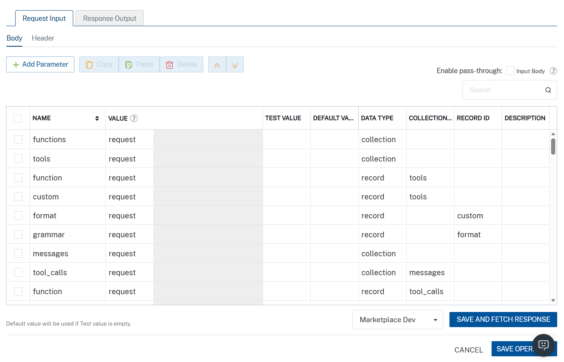
Parameter | Description | Syntax Example
model (Required) | Specifies which AI model to use for the request. Available models depend on your Scaleway configuration. | "model": "gemini-2.5-flash"
messages (Required) | Array of conversation messages. Each message must include a role (system, user, or assistant) and content. | "messages": [  { "role": "system", "content": "You are a helpful assistant." },  { "role": "user", "content": "Say hello in one sentence." }  ]
temperature (Optional) | Controls randomness of output. Lower values produce deterministic responses; higher values increase creativity. | "temperature": 0.7
max_completion_tokens  (Optional) | Maximum number of tokens the model can generate in the response. | -9007199254740991 <= x <= 9007199254740991
top_p (Optional) | Nucleus sampling parameter that controls diversity by limiting token selection to a probability mass. | "top_p": 1
stream (Optional) | Enables real-time streaming response when set to true. | "stream": true
stop (Optional) | Specifies sequences where the API will stop generating further tokens. | "stop": ["\n", "###"]
presence_penalty (Optional) | Penalizes new tokens based on whether they appear in the text so far, encouraging new topics. | "presence_penalty": 0.6
frequency_penalty (Optional) | Penalizes repeated tokens based on their frequency in the text so far. | "frequency_penalty": 0.5
Additionally, the messages parameter (array of objects) must be passed completely within the messages value as a properly structured JSON array.
- Click Header sub-tab. The Header section opens.
- For Authorization, In the box under the DEFAULT VALUE column, type the API Key generated from prerequisites section
- Syntax: Authorization: Bearer <YOUR_API_KEY>
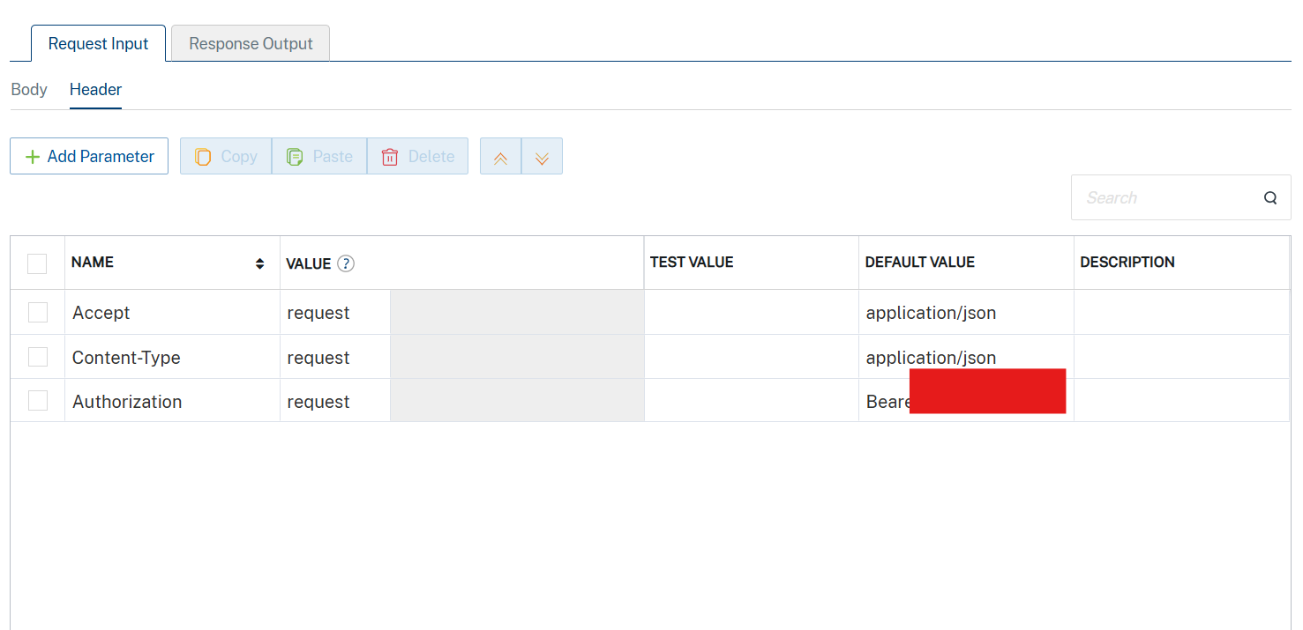

- Click SAVE AND FETCH RESPONSE. The Output Result dialog appears with the response. Otherwise, the Output Result shows an error.
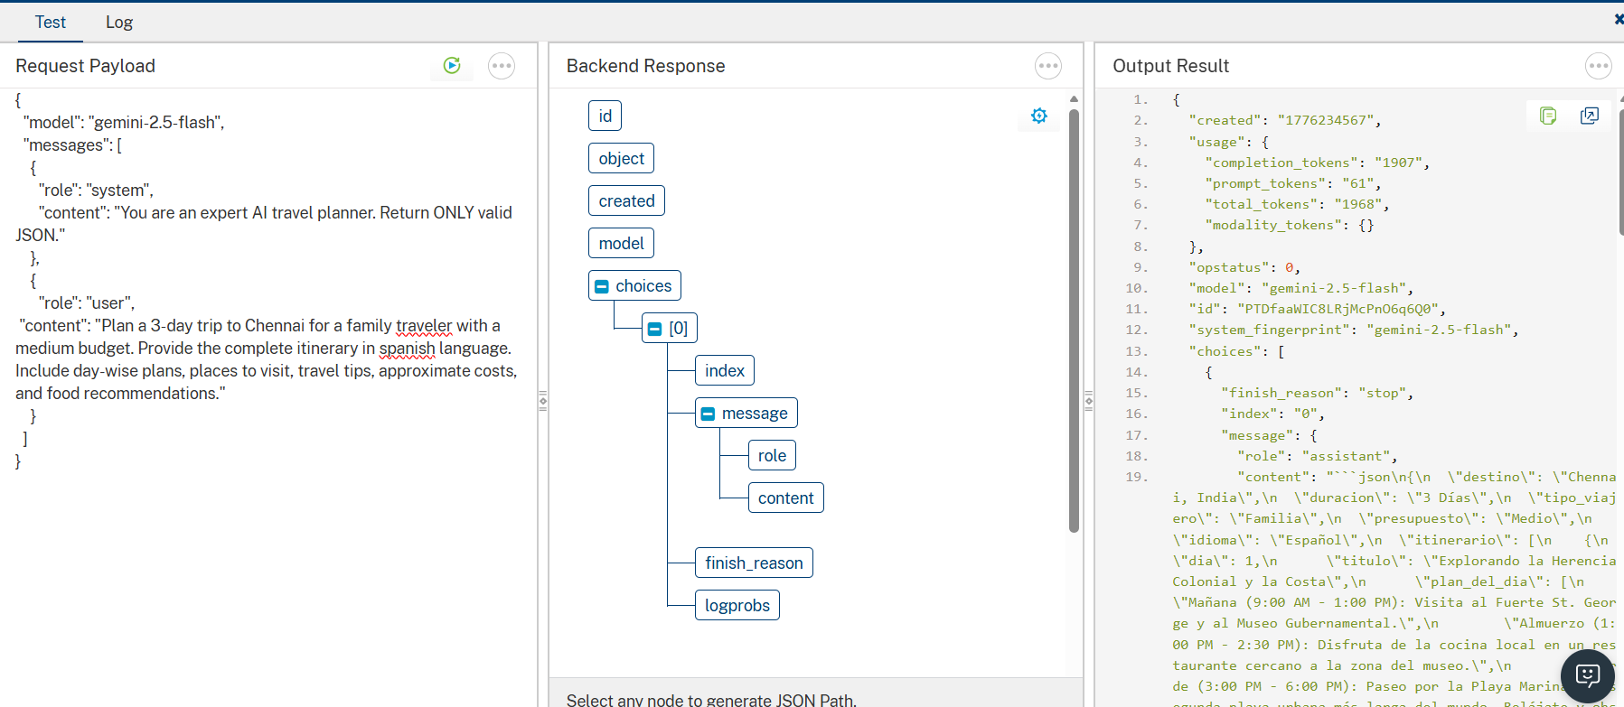

3. Publishing the App in VoltMX FOUNDRY:
After adding the Helicone Data Adapter to your app and configuring the necessary configurations, you must publish the app to HCL Foundry. For more information, refer to Publish a foundry app.
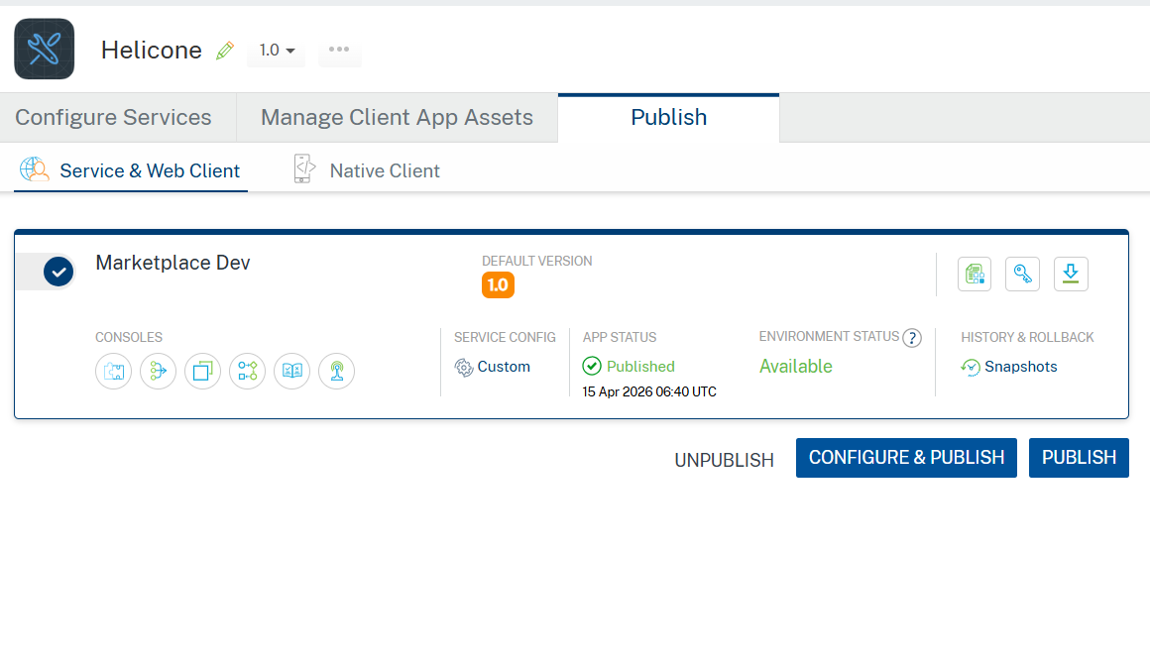

4. REFERENCES

Endpoint documentation
Helicone Account

5. REVISION HISTORY
Adapter version 1.0.0:

Known Issues
In VoltMX Foundry, always provide values for required parameters. Optional parameters should only be included when you have valid values. Avoid sending empty strings, empty objects, or empty arrays for optional fields, as this may lead to validation errors. The request example includes all available parameters only for reference.

Limitations
None

