Date :  23-02-2024

Hearthstone  
Version: 1.0.0

# **Overview**

This Hearthstone API provides up to date Hearthstone data pulled directly from the game. It has endpoints for all the card data, including images, card backs and more.

# **Getting Started**

## **Prerequisites**

* Volt Foundry
* [**Rapid API Account**](https://rapidapi.com/omgvamp/api/hearthstone/)
* X-RapidAPI-Key, X-RapidAPI-Host

## **Importing the adapter**

**To import the Data Adapter to Volt Foundry, do the following:**

1. Sign in to the  [HCL Foundry](https://manage.hclvoltmx.com/).
2. From the left navigation menu, select **API Management**.
3. In **API Management**, select **Custom Data Adapters**.

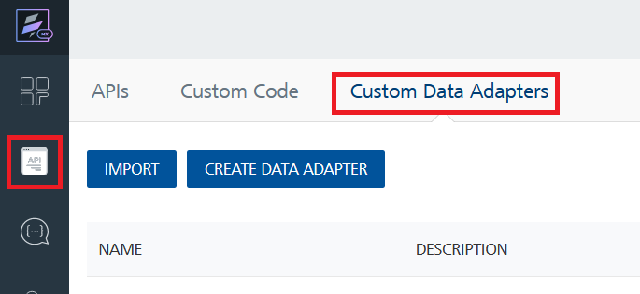

1. Click **IMPORT** to import a custom data adapter.

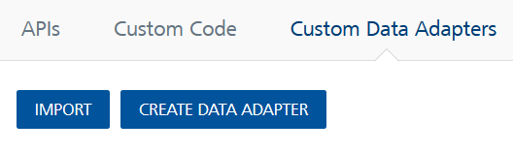

1. On the Import Data Adapter dialog box, click browser to import.

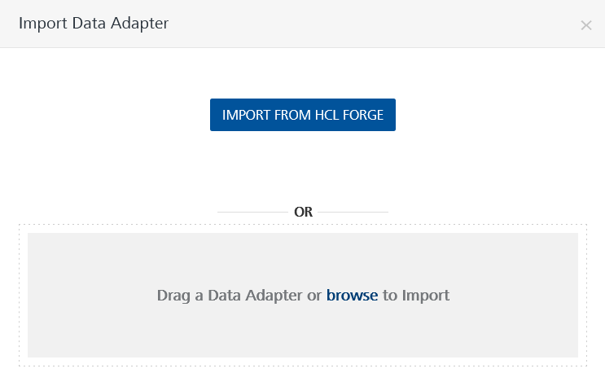

1. Select Hearthstone API zip file and click **IMPORT**.

After you import the data adapter, Volt Foundry opens a window that shows the metadata of the data adapter.

After you import the data adapter, you can view it on the Custom Data Adapters page and use it to create services on Volt Foundry.

## **Creating an Integration service**

After you import the data adapter into Volt Foundry, you can use it to create an Integration Service.

Follow the given steps to create an Integration service using the Hearthstone API Adapter.

1. Sign in to the [HCL Foundry](https://manage.hclvoltmx.com/).
2. From the left navigation menu, select **API Management**.
3. In **API Management**, select **Integration**.

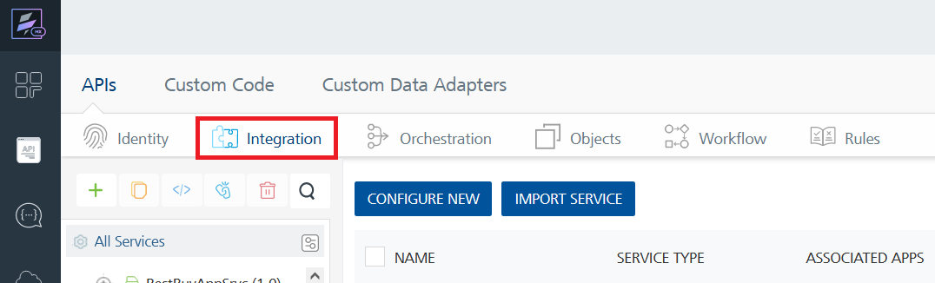

1. To create a new service, click the **+** button or the **CONFIGURE NEW** button.

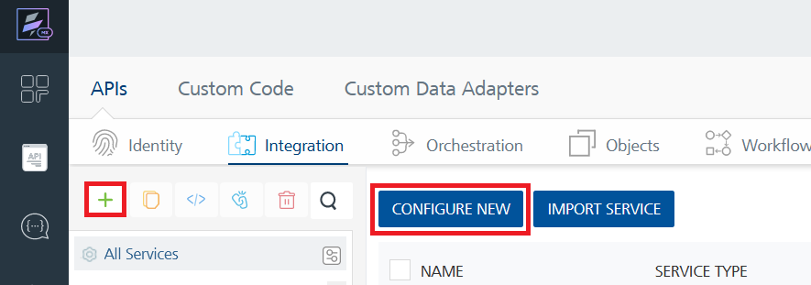

1. On the Service Definition tab, select the service type as Hearthstone API and click **SAVE**.

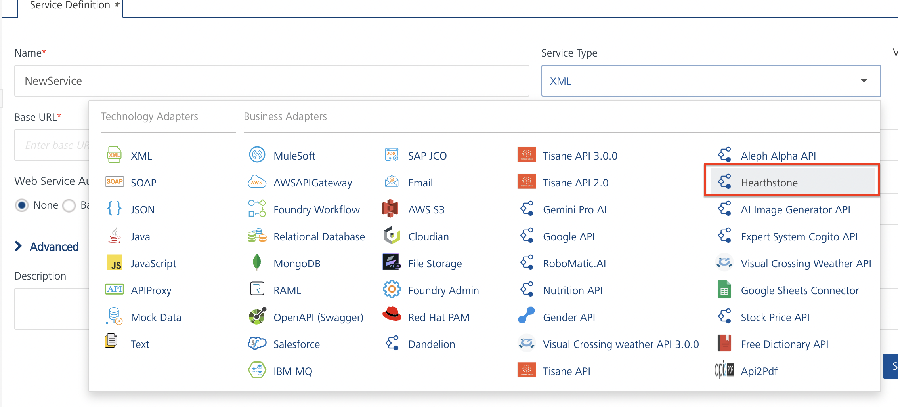

Alternatively, you can also create a Foundry app and create an Integration service inside it.

1. **Creating and Executing operations**

After you create an integration service, you can create and execute operations using the service.

#### **Creating an Operation**

* In **API Management/Foundry app you created**, in the **Integration** section, select the service that you created.
* After you select the service, navigate to the **Operation List** tab.

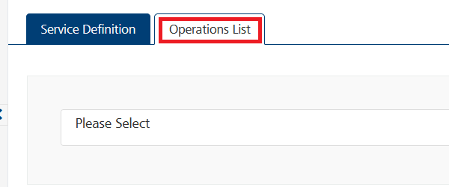

* From the drop down list, select an operation that you want to execute, and click **ADD OPERATION**.

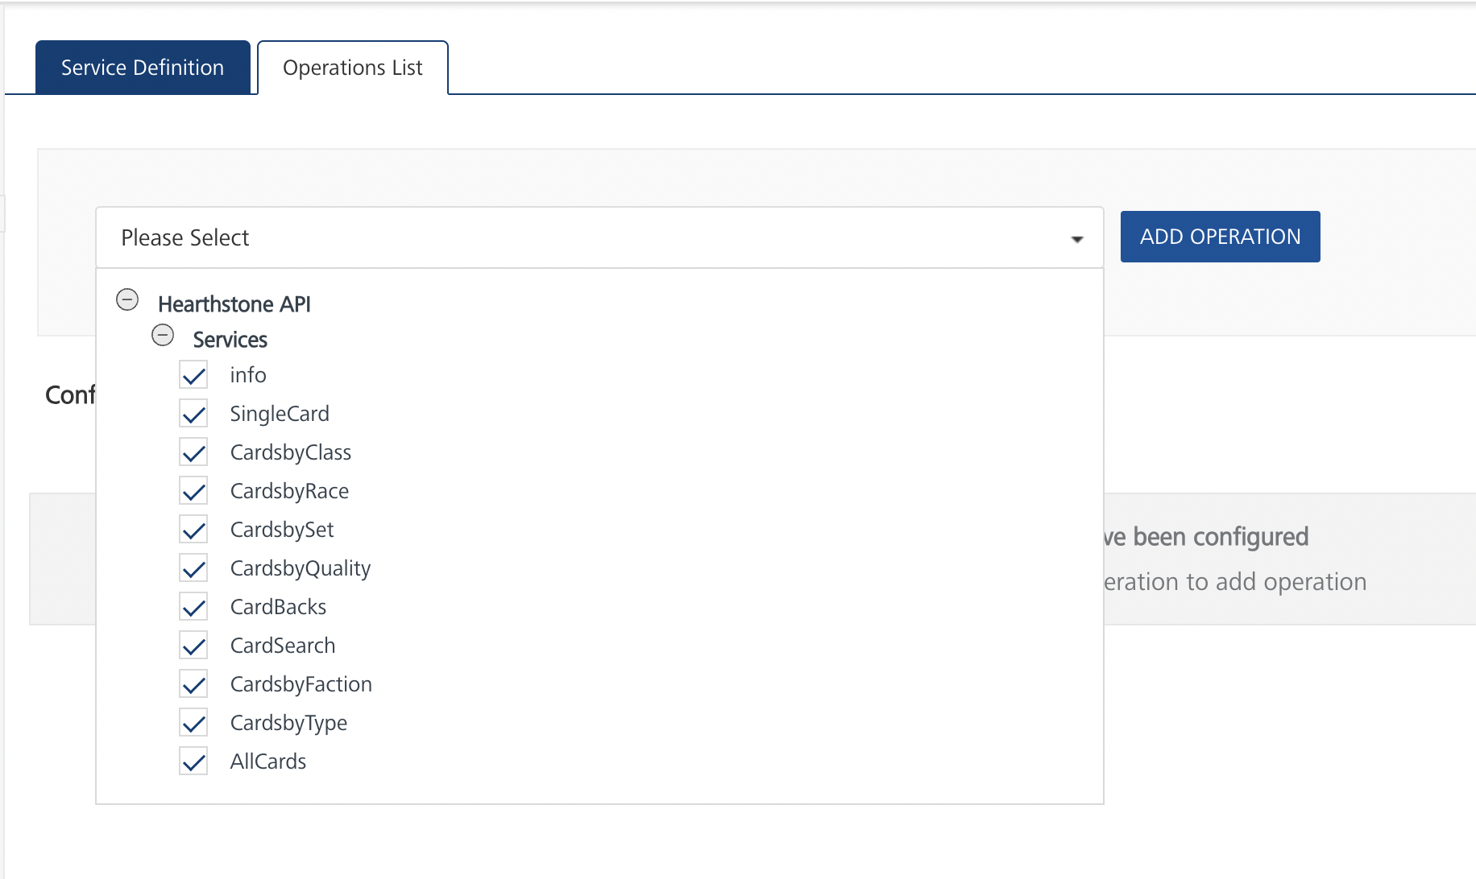

#### **Executing an operation**

* From the **Operations List** tab, in the **Configured Operations** section, select the operation you want to execute.

* On the Operation Page, in the Request Input tab, enter a TEST VALUE for all the fields.

**Request Header:**

**Authorization:** X-RapidAPI-Key, X-RapidAPI-Host [in header]: API Key associated with your RapidAPI account, required for authentication. To get keys – Login in to [Rapid API Account](https://rapidapi.com/omgvamp/api/hearthstone) -> You can view your keys.  
  
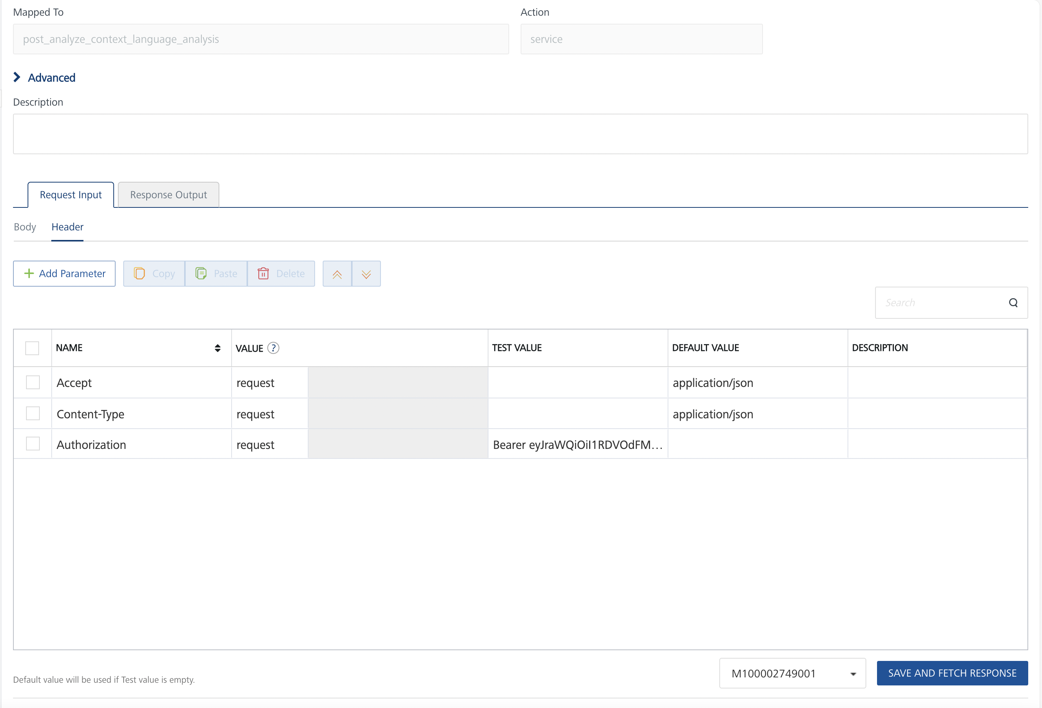

* Select a run-time environment and click **Save and Fetch Response** to get a response based on your inputs.

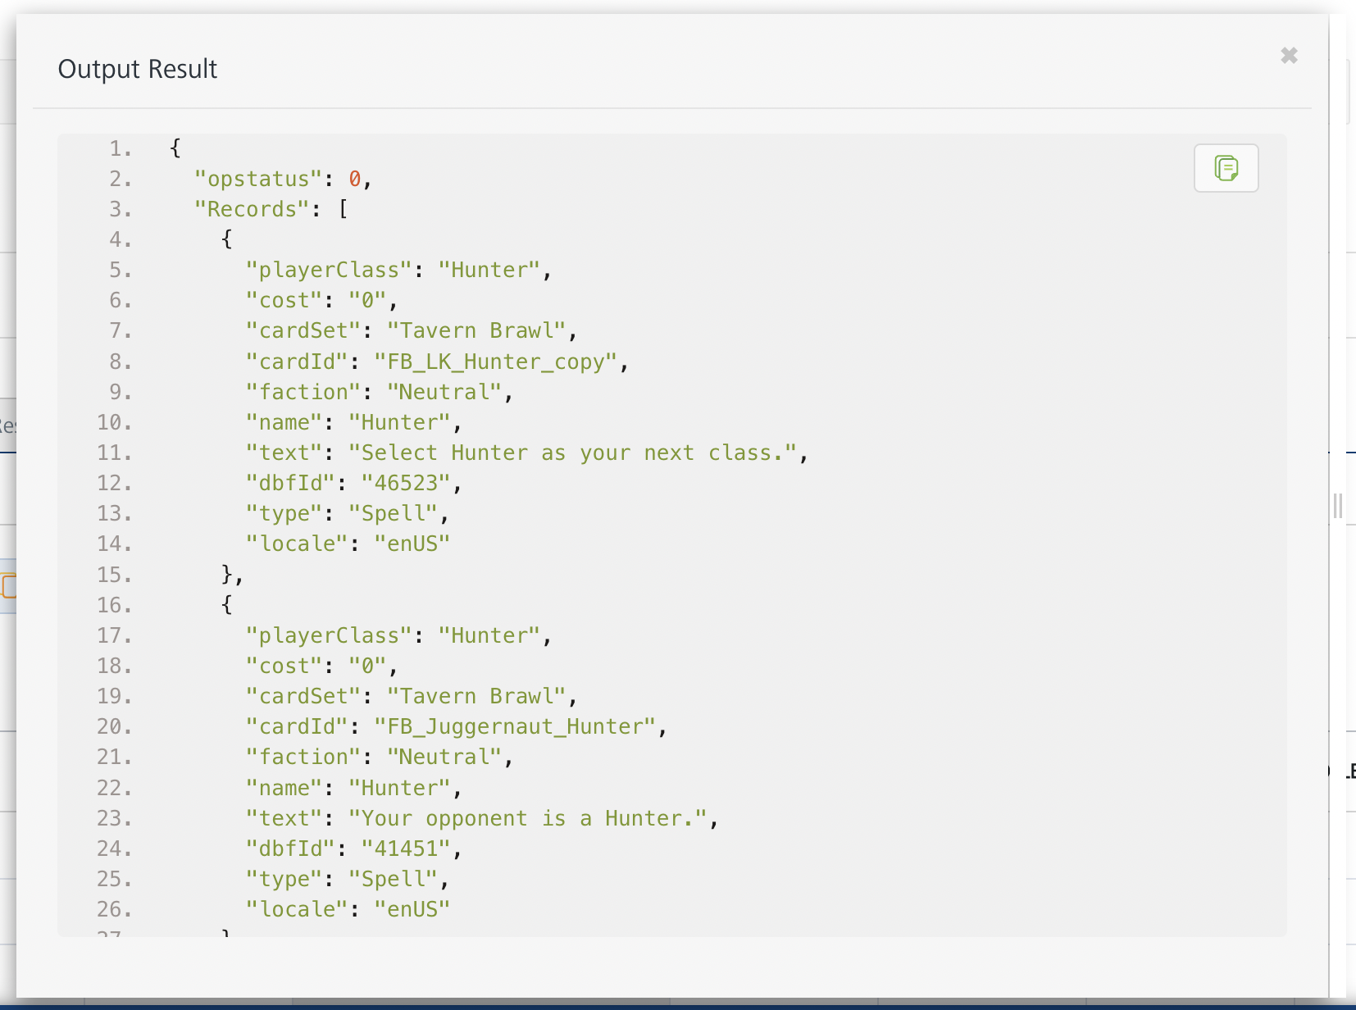

## **Publishing your application**

If you want to use the services in client applications, you need to publish an app to a run-time environment. You can create the service (as described above) in an application or import the service into an application and publish the application.

# **References**

## **Endpoint Documentation**

### **Requests Input Parameters for “SingleCard” operation**

| **Parameter** | **Description** |
| --- | --- |
| X-RapidAPI- Key(string) | [Required] [Header]API Key associated with your account. |
| X-RapidAPI-Host (string) | [Required] [Header]The host parameter specifies the domain name or IP address of the RapidAPI endpoint. In the context of the Hearthstone API, the default host is set to ‘omgvamp-hearthstone-v1.p.rapidapi.com’. This parameter is necessary for routing the request to the appropriate API endpoint. |
| name (string) | [Required] The name or ID of the card. Example values: Ysera, EX1_572. |
| callback (string) | [OPTIONAL] Request data to be returned as a JsonP callback. |
| collectible (number) | [OPTIONAL] Set this to 1 to only return collectible cards. |
| locale (string) | [OPTIONAL] What locale to use in the response. Default locale is enUS. Available locales: enUS, enGB, deDE, esES, esMX, frFR, itIT, koKR, plPL, ptBR, ruRU, zhCN, zhTW, jaJP, thTH. |

## **Response Output Parameters for “SingleCard” operation**

| **Field** | **Description** | **Type** |
| --- | --- | --- |
| cardId | Identifier of the card | string |
| name | Name of the card | string |
| cardSet | The card set the card belongs to | string |
| type | Type of the card (e.g., Minion, Spell, Weapon) | string |
| faction | Faction of the card (if applicable) | string |
| rarity | Rarity of the card (e.g., Legendary, Epic, Rare) | string |
| cost | Mana cost required to play the card | integer |
| attack | Attack value of the minion (if applicable) | integer |
| health | Health value of the minion (if applicable) | integer |
| text | Description of the card's effect or ability | string |
| flavor | Flavor text associated with the card | string |
| artist | Artist who created the card's artwork | string |
| collectible | Indicates whether the card is collectible or not | boolean |
| elite | Indicates whether the card is an elite card | boolean |
| race | Race of the card (if applicable) | string |
| img | URL to the image of the card | string |
| imgGold | URL to the golden version of the card image (if available) | string |
| locale | Locale of the card data (e.g., enUS for English, esES for Spanish) | string |

## **Reference Document:** Refer this document<https://hearthstoneapi.com/#endpoints>

## to know the request input, request header and response output parameters for the other operations.

# **Revision History**

Adapter version 1.0.0:

## **Known Issues**

* No Known Issues

## **Limitations**

* No Limitations