29-Oct-2021
hamburger menu (1.2.2)

- Overview
Hamburger Menu adds a menu to your application. You can click or tap the hamburger icon to open a menu that contains a header, a list of menu items, and a footer. Every menu item has an icon and a label.
You can add and edit menu items, change the header text or the footer text, and add actions to execute when a menu item is clicked. You can use the Hamburger Menu component in scenarios where you want to save screen space without losing out on functionality.

A . Use case
To hide the navigation menu to the edge of the screen and reveal it only after a user’s action. This pattern can be particularly useful if you want your user to focus on the main content.

- Features
The component allows you to hide the navigation menu to the edge of the screen and reveal it only after a user’s action
C . Percentage of re-use:
90%

- . GETTING STARTED

A . Prerequisites
Before you start using the Hamburger Menu component, ensure the following:
- HCL Foundry
- Volt MX Iris

B. Platforms Supported
- Mobile
- iOS
- Android
- Tablets
- PWA

C . Importing the Component
You can import the Forge components only into the apps that are of the Reference Architecture type.

To import the Hamburger Menu component, do the following:
1.Open your app project in Volt MX Iris.
2.In the Project Explorer, click the Templates tab.

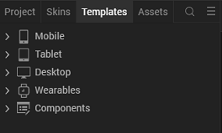

3.Right-click Components, and then select Import Component. The Import Component dialog box appears.
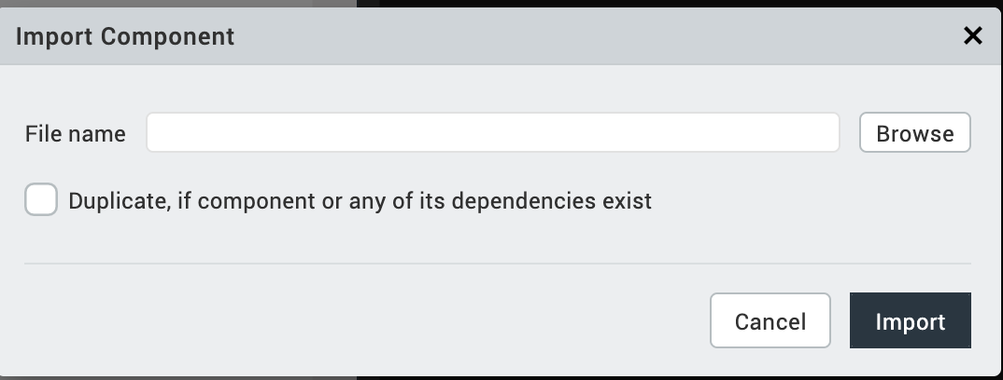
4.Click Browse to navigate to the location of the component, select the component, and then click Import. The component and its associated widgets and modules are added to your project.

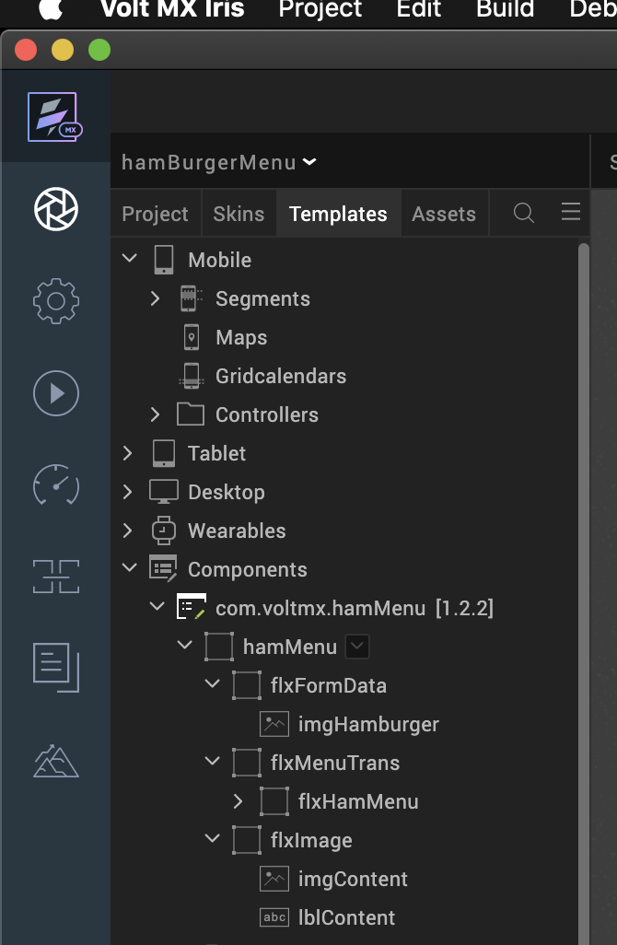

Once you have imported a component to your project, you can easily add the component to a form. For more information, refer Add a Component to a Form.

- Building and previewing the app
After performing all the above steps, you can build your app and run it on your device. For more information, you can refer to the Building and Viewing an Application section of the Iris User Guide.
You can then run your app to see the Hamburger Menu work in real time.

- REFERENCES

- Dynamic Usage
You can also add a Hamburger Menu component dynamically. To do so,
- In the Project Explorer, on the Projects tab, click Controllers section to access the respective Form Controller. Create a method and implement the code snippet similar to the sample code mentioned below.

define({

//Type your controller code here

onNavigate: function(){

var HamMenu = new com.voltmx.hamMenu({

"clipBounds": true,

"height": "100%",

"id": "hamMenu",

"isVisible": true,

"left": "0dp",

"top": "0dp",

"width": "100%",

"zIndex": 1
},{},{});

HamMenu.flxHamMenuwidth="50%";

HamMenu.sknHamMenu="voltmxsmhamMenu";

/*Adding the component to a Form*/

this.view.add(HamMenu);

var sampleData = [{lblMenuItem: "Home"},

{lblMenuItem: "Accounts"},

{lblMenuItem: "Contacts"},

{lblMenuItem: "Users"}
];

this.view.hamMenu.setData(sampleData);

/* Defining events for the component */
this.view.hamMenu.onMenuItemClick= this.onRowClick;

},
onRowClick:function(){

this.view.hamMenu.setMenuVisibility(false);

}
});

In the code snippet, you can edit the properties of the component as per your requirement. For more information, see Setting Properties.
- Save the file.

B. Properties
You can use a component's Properties to customize and configure the elements. These elements can be UI elements, service parameters, and so on.
You can set the properties from the Iris Properties panel on the right hand side. You can also configure these properties using a JavaScript code.
1.Menu Items

Description : Specifies the list of menu items that you want to display on the component

Syntax : menuItems

Type : Master Data
Array of JSON

Read/Write : Read + Write

On Iris , you can specify the menu items from Master Data

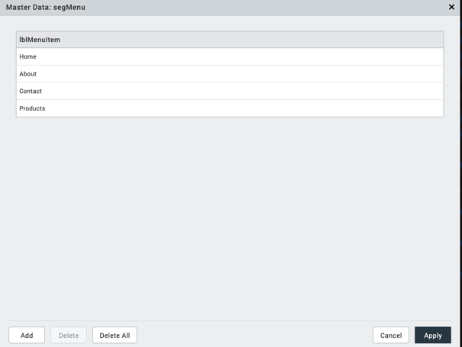

Example :

var sampleData = [{lblMenuItem: "Home"},

{lblMenuItem: "Accounts"},

{lblMenuItem: "Contacts"},

{lblMenuItem: "Users"}
];

this.view.hamMenu.setData(sampleData);

2.Flex Hamburger Menu Width (flxHamMenuWidth)

Description : This property enables the consumer to change the Flex Width of the Hamburger Menu component

Syntax : flxHamMenuWidth

Type : Flex Container

Read/Write : Read + Write

Example : HamMenu.flxHamMenuwidth="50%";

3.Flex Hamburger Menu skin(flxHamMenuskin)

Description : This property enables the consumer to change the Flex Skin of the Hamburger Menu component.

Syntax : flxHamMenuskin

Type : Flex Container

Read/Write : Read + Write

Example : HamMenu.sknHamMenu="voltmxsmhamMenu";

- Events

The component invokes events when its corresponding action is performed. You can configure any logic you want the component to perform whenever an event occurs. You can configure the events by writing a JavaScript

1.onMenuItemClick

Description: | Invoked when the user taps or clicks a menu item.
Syntax: | onMenuItemClick
Parameters: | menuItemObject  Contains the following keys.  - menuItemIndex : The index of the menu item.  - menuItemText : The text from the label of the menu item.

Example : this.view.hamMenu.onMenuItemClick= this.onRowClick;

onRowClick:function(){
this.view.hamMenu.setMenuVisibility(false);
}

- APIs

The following APIs pertain to the Hamburger Menu component:

- setMenuVisibility
Description : Sets the visibility of the Menu for the form.

Syntax. : setMenuVisibility(formReference)

Parameters : isVisible

Example : this.view.hamMenu.setMenuVisibility(false);

- setData

Description : Sets the Data to the Form.

Syntax. : setData(formReference)

Parameters : data

Example : this.view.hamMenu.setData(sampleData);

MarketPlace URl : https://marketplace.kony.com/items/hamburger-menu

FigmaLink : https://www.figma.com/file/JhKHQDUGrVQzKCA3XKON4j/UI-Components?node-id=312%3A6778

- REVISION HISTORY
App version 1.2.2

