Date : 10-OCT-25

GROQ APPLICATION

VERSION: 1.0.0

OVERVIEW
Groq API is part of the GroqCloud ecosystem, offering ultra-fast inference for large language models (LLMs) through an OpenAI-compatible API interface. It allows developers to interact with state-of-the-art models such as LLaMA 3, Mixtral, and Gemma, delivering natural language understanding and generation tasks at unprecedented speed and efficiency.Built on Groq’s Language Processing Units (LPUs), the API focuses on low-latency text processing, making it ideal for real-time applications like chatbots, assistants, and intelligent automation.

Use case:
- Real-Time Chat and Conversations: Power responsive virtual assistants, support bots, and conversational UIs.
- Content Generation: Create articles, summaries, and descriptions instantly.
- Code Assistance: Generate, explain, or refactor source code efficiently.
- Knowledge Extraction: Summarize and structure text data for insights and analytics.
- Interactive Applications: Enable dynamic AI-driven user experiences requiring rapid LLM responses.

Features:
- Ultra-Low Latency: Powered by Groq LPUs, providing millisecond-level response times.
- OpenAI-Compatible API: Drop-in replacement for OpenAI endpoints with minimal code changes.
- High Model Variety: Supports advanced models like llama3-70b-8192, mixtral-8x7b, and gemma-7b-it.
- Scalable and Efficient: Designed for production-scale workloads with predictable performance.
- Secure and Simple Authentication: Uses API key–based bearer token access.
- Developer Friendly: Works seamlessly with OpenAI SDKs (Python, Node.js) and third-party tools such as Postman.

2. GETTING STARTED

Prerequisites
Before you start using the Groq Application, ensure you have the following:

- HCL Foundry
- Volt MX Iris

Devices
- Mobile

Platforms
- Android
- IOS

Importing the App
To import the Groq App to Volt MX Iris, do the following:

To import the Groq App, do the following:
- Launch Volt MX Iris.
- Click project, and then select Import. The Import dialog box appears.
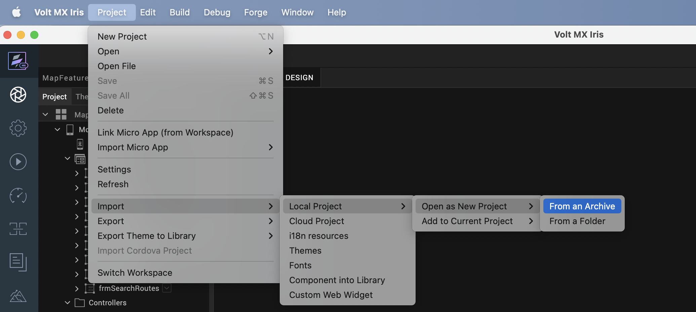

- Click From an Archive to navigate to the location of the project, select the files, and then click Import.
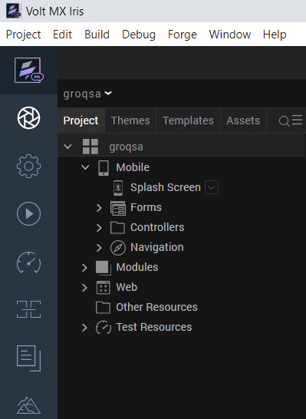
After you import the application, you can view the associated Foundry app connected at the Data & Services section.
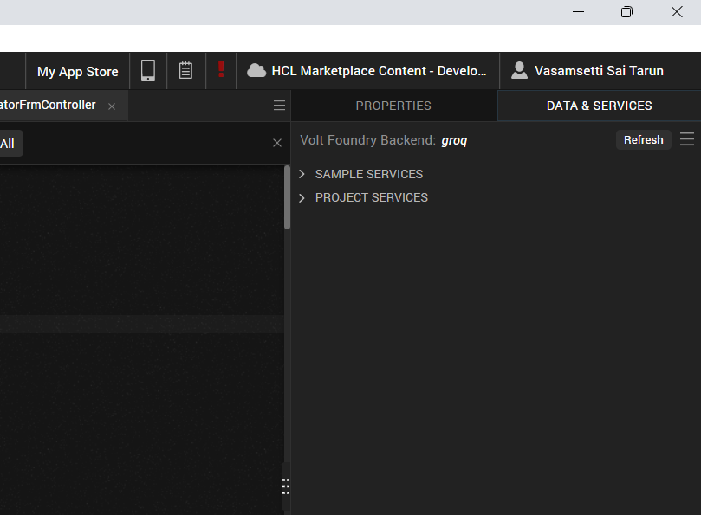

Building the app
From the menu bar, go to Build and then select Build Native Local.

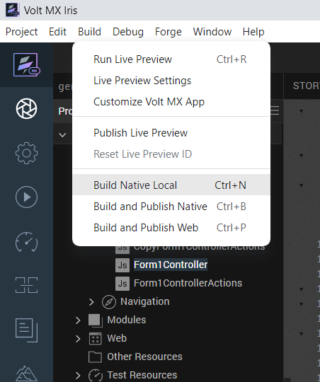

For Mobile, select Android and iOS. Click Build.

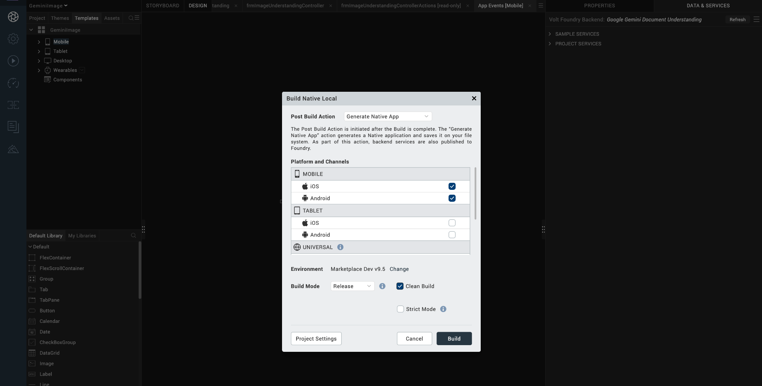

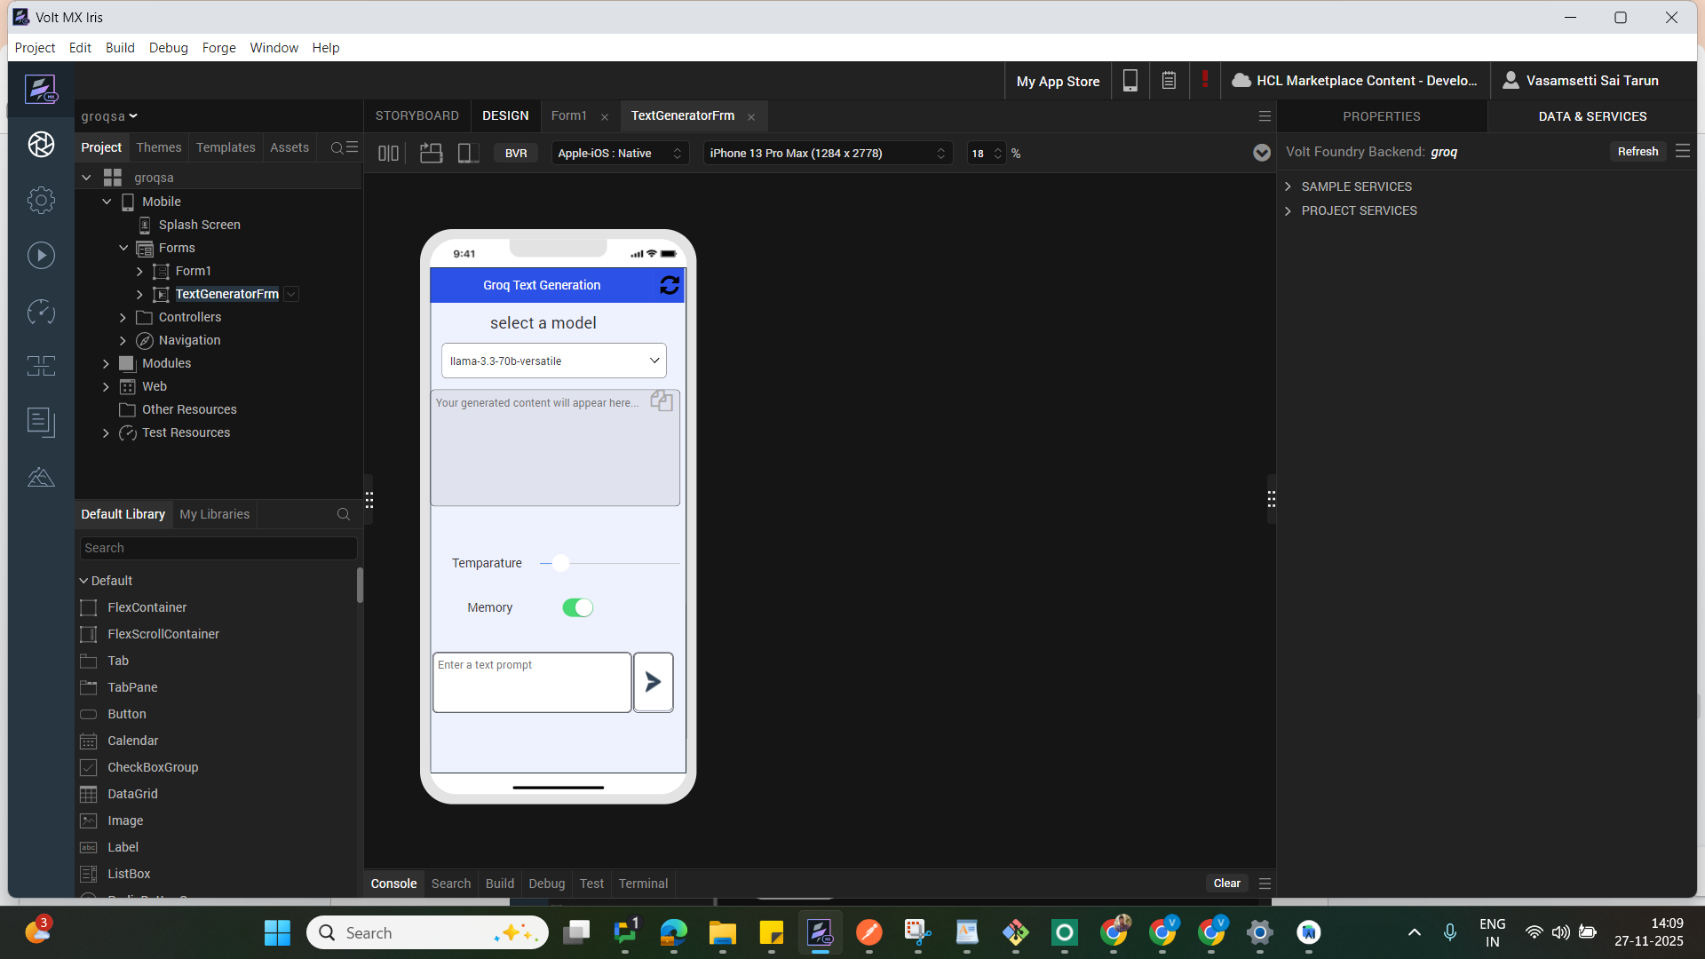

After the build is successful, run the app on your mobile device.

F. App Functionality

When you build and run the app, you can enter a text prompt, and retrieve AI-generated responses.
Home Screen (frmHome)
The user enters a text prompt or query .
The entered query, and the AI-generated result are all displayed in the UI for reference.
Groq API processes textual inputs to generate a context-aware response.
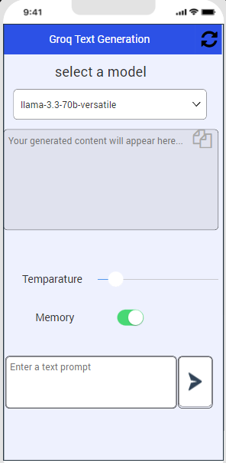
Response Handling
- Displays the AI-generated response .
- Shows the user’s entered query.
Error Handling
- If the app fails, the app displays a failure alert and resets the response area, allowing the user to retry with a new prompt.

REVISION HISTORY
App version 1.0.0

A. Limitations
NA

B. Known Issue
NA

